WEEK 1 | PROJECT PLANNING

Project Planning and Strategy Development
A structured roadmap for a reproducible R-based classification project
Prepared by | Programme | Submission date
Aman Yadav | Virtual Data Science with R Apprentice | 05 November 2026

Project theme: Wine Cultivar Classification Using Chemical Measurements
Dataset: UCI Wine Recognition (178 records, 13 numeric predictors, 3 cultivar classes).

1. Executive overview
This project will investigate whether a wine sample can be assigned to one of three cultivars using 13 measured chemical constituents. The work uses the UCI Wine Recognition dataset and an R workflow covering data acquisition and provenance, quality checks, exploratory analysis, preprocessing, predictive modelling, validation, interpretation, and final communication. The project is scoped as a reproducible learning and analysis exercise rather than a production grading or commercial decision system.

2. Problem statement and objectives
Problem statement: Given the measured chemical profile of a wine sample, can a statistical classifier distinguish among the three cultivar classes represented in the dataset?
- Profile the dataset and document its source, variables, class balance, and limitations.
- Assess missingness, duplicate records, data types, value ranges, and potential outliers before analysis.
- Use exploratory data analysis to describe distributions, class differences, and relationships among measurements.
- Prepare reproducible data transformations, preserving raw data and preventing test-set leakage.
- Train at least two classification models in R and compare their performance on a fixed hold-out test set.
- Translate model results into evidence-based findings, limitations, and next-step recommendations.

3. Background and rationale
The UCI Wine dataset contains chemical measurements for wines grown in the same region in Italy but derived from three cultivars. The UCI repository lists 178 instances and 13 attributes, including alcohol, malic acid, ash, magnesium, phenols, flavanoids, color intensity, hue, optical-density ratio, and proline. It is a suitable teaching dataset because it is compact, tabular, numeric, and has a clearly defined three-class target. The varying scales of the measurements also make preprocessing decisions, especially standardization, relevant.
The repository associates the dataset with earlier work on comparing statistical pattern-recognition approaches. That context motivates evaluating more than one classifier rather than treating a single model as definitive. A linear discriminant model provides a classical statistical baseline, while multinomial logistic regression provides a probability-based linear classifier. Their comparison is useful for understanding model assumptions and validation, not for claiming universal superiority.

4. Scope and deliverables
In scope | Out of scope
Dataset profiling and reproducible R scripts | Commercial price prediction or brand identification
EDA, cleaning, transformations and feature scaling | Health, safety, or regulatory decisions about wine
LDA and multinomial logistic regression comparison | Production deployment or real-time integration
Hold-out evaluation, plots, report and GitHub-ready project | Claims about geographic provenance beyond the dataset classes

Core deliverables: five weekly Word reports; raw and processed CSV files; R scripts; EDA and model figures; evaluation outputs; a README with setup instructions; and task-specific submission descriptions.

5. Project phases and estimated schedule
Week / phase | Main activities | Planned effort | Acceptance evidence
1. Planning | Problem definition, dataset source review, scope, timeline, roles, risks | 30–35 h | Approved plan and project roadmap
2. EDA | Dataset profiling, descriptive statistics, distributions, correlations, plots | 30–35 h | EDA report, summary tables and 4+ visuals
3. Wrangling | Quality audit, type correction, clean names, factor encoding, outlier review, scaling | 30–35 h | Before/after snapshots, audit CSVs and reproducible code
4. Modelling | Fixed split, train-only scaling, LDA and multinomial logistic regression, metrics and diagnostics | 30–35 h | Model report, metrics, confusion matrices and ROC plots
5. Reporting | Integrated interpretation, recommendations, reflection, final documentation and packaging | 30–35 h | Final report, README, source bundle and submission text

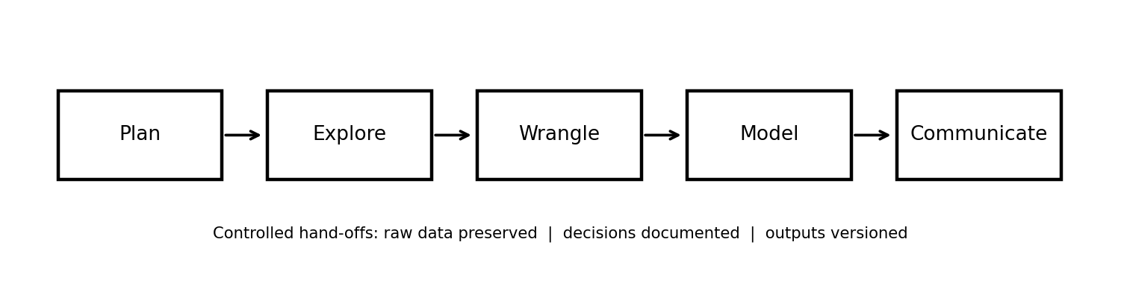
Figure 1. Five-stage project roadmap.

6. Roles and responsibilities
Role assumed by the individual analyst | Responsibilities
Project manager | Maintain scope, schedule, task log, risks, version control and submission checklist.
Data analyst | Inspect the dataset, calculate descriptive statistics, interpret distributions and communicate findings.
R programmer | Write reusable scripts, manage packages, create plots, and implement preprocessing and models.
Validation / quality reviewer | Check row counts, missingness, duplicates, leakage controls, metric calculations and report consistency.

7. Methodology and quality controls
- Preserve the downloaded/source-form CSV as read-only; write all changes to data/processed/.
- Use explicit variable names, factor levels, file paths, and a fixed split-assignment file.
- Stratify the hold-out split so all cultivar classes are represented in training and test sets.
- Estimate centering and scaling parameters using training records only, then apply them unchanged to test records.
- Report accuracy and macro-averaged precision, recall, F1, and one-vs-rest AUC; inspect confusion matrices and class-specific errors.
- Record software/package versions and use a README so another analyst can reproduce the workflow.

8. Risk management
Risk | Potential effect | Mitigation / response
Small sample size (178 records) | Unstable estimates and overfitting | Use a restrained model set, stratified hold-out, macro metrics, and explicitly limit generalization claims.
Class imbalance | Accuracy may conceal weaker class performance | Report class distribution, per-class confusion, macro precision/recall/F1 and one-vs-rest AUC.
Data leakage during scaling | Optimistic test performance | Fit center and scale on training data only; apply those parameters to test data.
Outlier removal without evidence | Loss of meaningful chemistry variation | Flag IQR observations for review; retain unless a documented data error is established.
Package/version differences | Non-identical results across computers | Use recommended packages, fixed inputs/split, record versions, and report reproducibility notes.
Incomplete source provenance | Unclear attribution or interpretation | Cite UCI dataset and original contributors; document that brand/price variables are unavailable.

9. Evaluation and success criteria
Area | Success criterion
Clarity | Problem, target, predictors, scope and assumptions are explicit.
Comprehensiveness | All project phases, roles, timing, deliverables and risks are covered.
Practicality | The project uses a compact dataset and a feasible R workflow with fixed inputs.
Technical quality | Data quality is checked, preprocessing is documented, and validation avoids leakage.
Communication | Tables, figures, captions, references and limitations support the conclusions.

Data provenance and execution note
The packaged CSV is derived from the public UCI Wine Recognition data distributed in scikit-learn, with cultivar labels restored to the UCI 1–3 coding. The data checks in this project found 178 records, 13 numeric predictors, no missing cells, and no duplicated observations. The dataset is a small benchmark and does not represent every wine or market.
Execution transparency: This authoring workspace did not include an R runtime. The R scripts are supplied for local reproduction but were not executed here. Embedded plots and model benchmark figures were produced from the same packaged data with equivalent Python implementations. Model metrics are labelled reference benchmarks, not R-native results. Run src/run_all.R in R and replace the benchmark metrics with outputs/model_metrics_R.csv if strict R execution evidence is required.

References
- Aeberhard, S., & Forina, M. (1992). Wine [Dataset]. UCI Machine Learning Repository. https://doi.org/10.24432/C5PC7J
- UCI Machine Learning Repository. (n.d.). Wine dataset (ID 109). https://archive.ics.uci.edu/dataset/109/wine
- scikit-learn developers. (n.d.). Wine recognition dataset documentation. https://scikit-learn.org/stable/modules/generated/sklearn.datasets.load_wine.html

