WEEK 2 | EXPLORATORY ANALYSIS

Exploratory Data Analysis and Visualization
Understanding distributions, class patterns and relationships in wine measurements
Prepared by | Programme | Submission date
Aman Yadav | Virtual Data Science with R Apprentice | 05 November 2026

Project theme: Wine Cultivar Classification Using Chemical Measurements
Dataset: UCI Wine Recognition (178 records, 13 numeric predictors, 3 cultivar classes).

1. Objective and dataset overview
The objective of this phase is to explore the Wine Recognition data before choosing and fitting models. The dataset contains 178 wine observations, 13 numeric physicochemical predictors and a categorical target identifying one of three cultivars. The class counts are 59, 71 and 48, respectively. The analysis is descriptive: it looks for patterns and potential data issues without treating visual association as causal evidence.
Dataset property | Observed value
Records / variables | 178 rows; 14 columns including target
Predictors | 13 numeric chemical measurements
Target | Cultivar 1, Cultivar 2, Cultivar 3
Class counts | Cultivar 1: 59; Cultivar 2: 71; Cultivar 3: 48
Missing values | 0 in the packaged data
Duplicate observations | 0 full-row duplicates in the packaged data

2. EDA workflow
- Import the raw CSV and inspect dimensions, column names, data types and first records.
- Calculate class frequencies and descriptive statistics (mean, standard deviation, quartiles, minimum and maximum).
- Review individual feature distributions and compare selected measurements across cultivar groups.
- Calculate Pearson correlations among numeric predictors and inspect relationships for possible redundancy.
- Create labelled figures and interpret them in the context of the classification question.

3. Class distribution
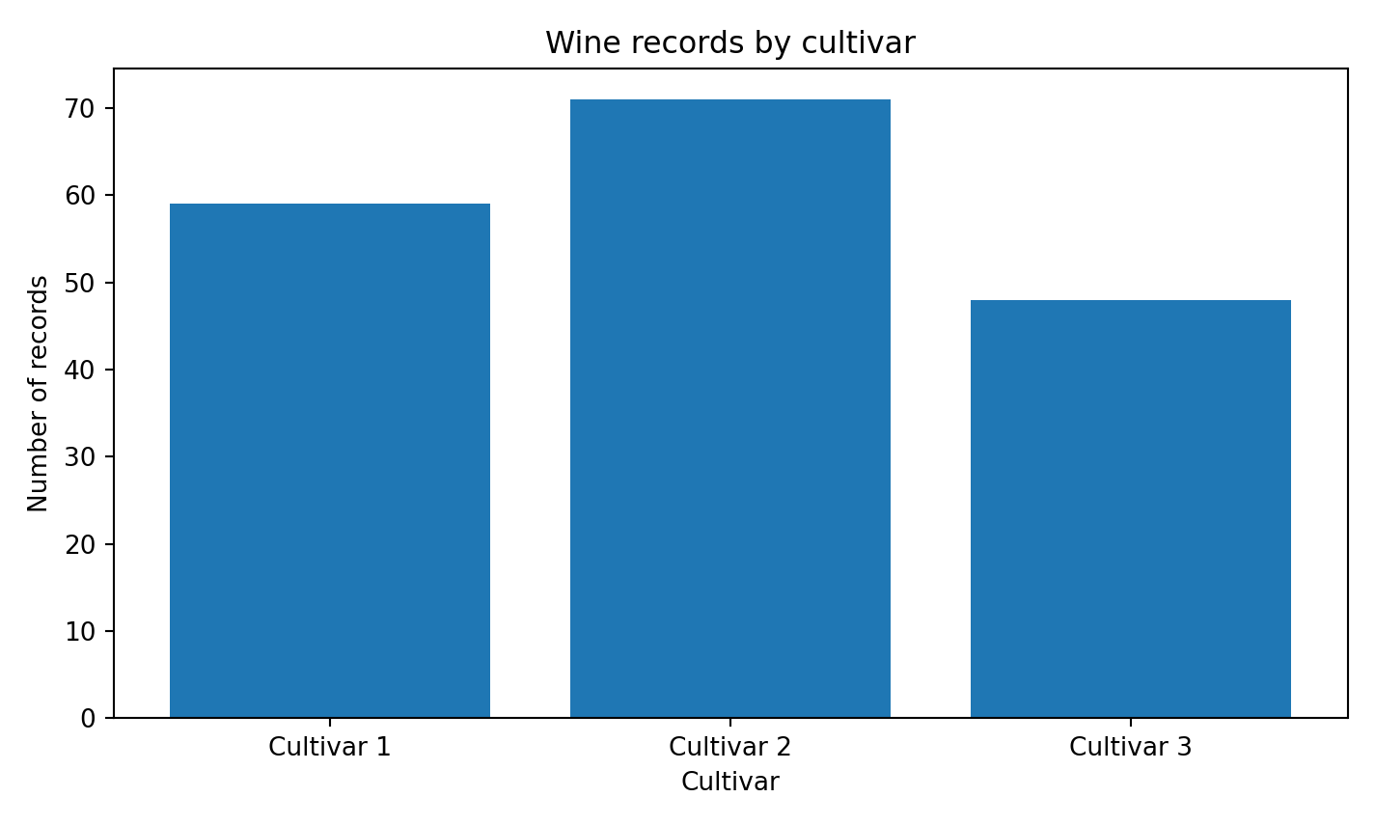
Figure 1. Number of observations in each cultivar class.
The target is moderately imbalanced: Cultivar 2 has the largest group (71; about 39.9%), followed by Cultivar 1 (59; about 33.1%) and Cultivar 3 (48; about 27.0%). No class is absent or extremely rare, but the class proportions should be preserved in the train/test partition. Macro-averaged metrics are preferable to relying on accuracy alone.

4. Feature distributions and group comparisons
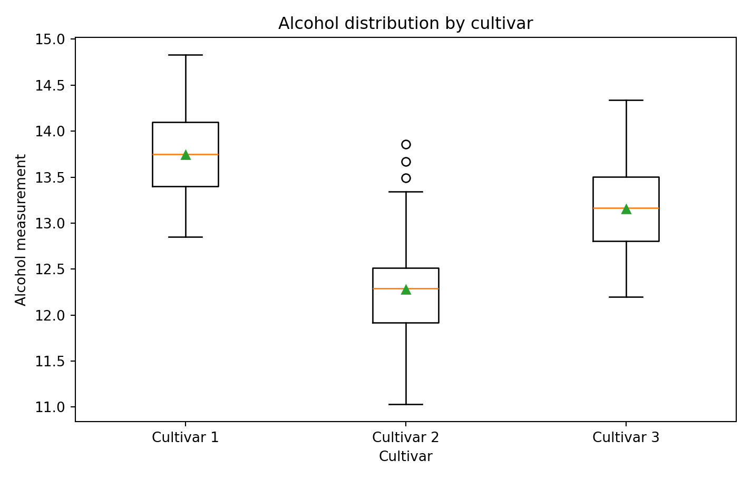
Figure 2. Alcohol measurements grouped by cultivar.
The boxplot shows that alcohol values differ across the groups, while the within-group spread indicates that no single measurement should be assumed to perfectly determine cultivar. In the packaged data, mean alcohol is approximately 13.74 for Cultivar 1, 12.28 for Cultivar 2 and 13.15 for Cultivar 3. These are dataset-specific group summaries, not universal chemical thresholds.
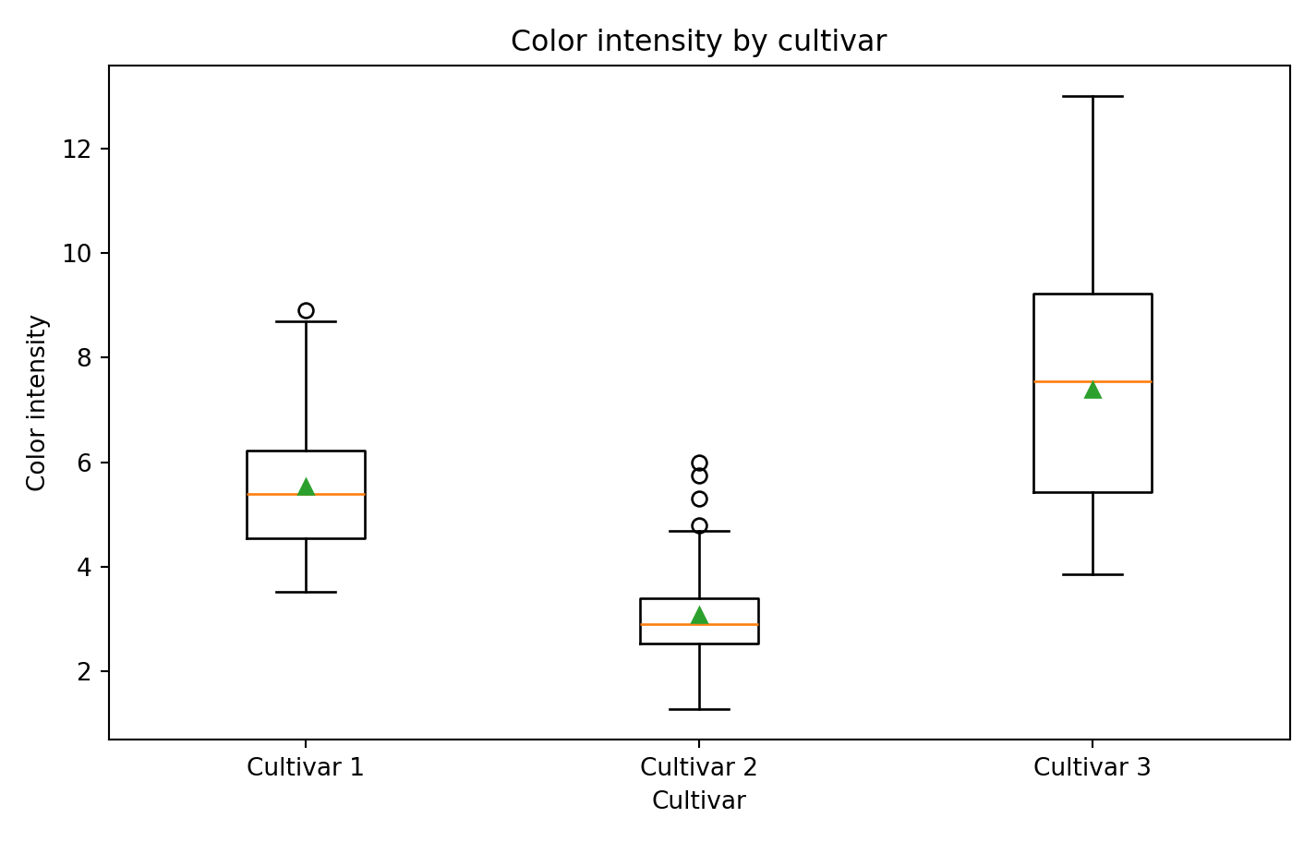
Figure 3. Color intensity grouped by cultivar.
Color intensity provides another potentially informative distinction: the mean values are approximately 5.53, 3.09, and 7.40 for Cultivars 1, 2 and 3. The distributions overlap, so this variable is best considered jointly with other measurements.

5. Relationships among numeric measurements
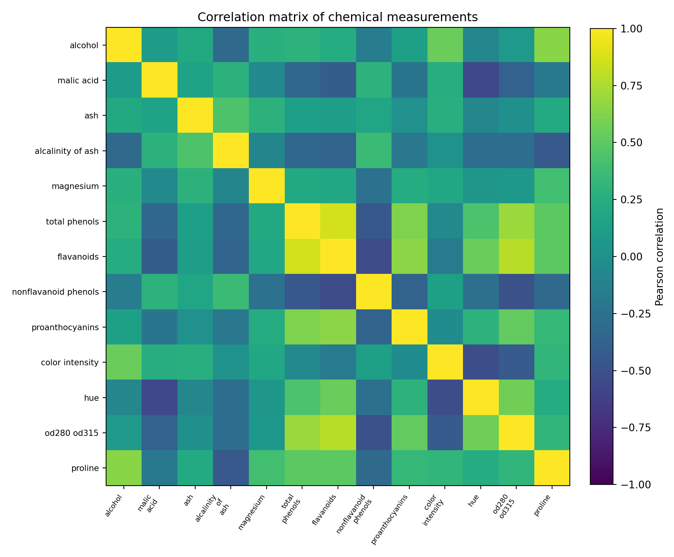
Figure 4. Pearson correlation matrix for the 13 numeric predictors.
The strongest absolute pairwise correlation in this dataset is between total_phenols and flavanoids (r = 0.86). This suggests that some predictors carry overlapping information. Correlation is not proof of causation and does not by itself require dropping a feature; it is a diagnostic to consider when interpreting linear models.
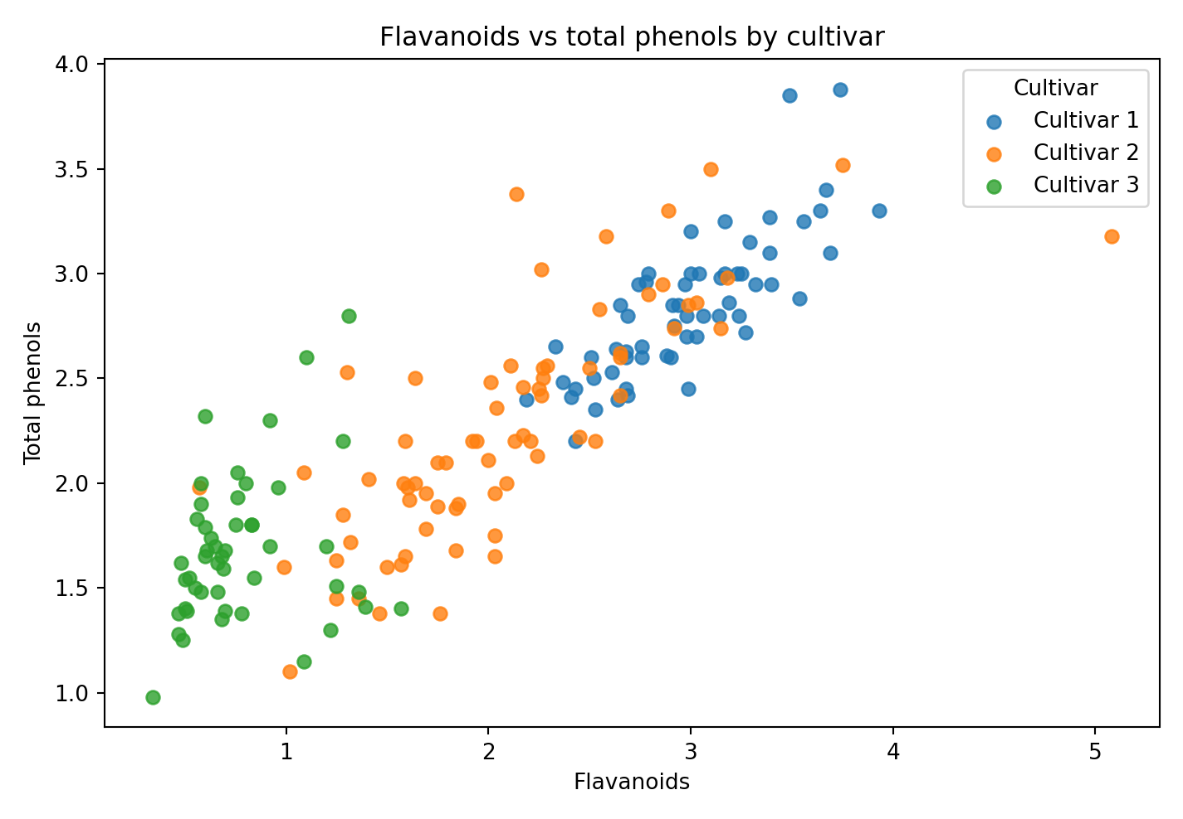
Figure 5. Flavanoids and total phenols plotted by cultivar.
The scatter plot shows a strong positive relationship between flavanoids and total phenols and visible group structure. This supports examining these variables in combination. It also suggests that multiple measurements may be needed for robust class separation.

6. Descriptive statistics (selected variables)
Feature | Mean | Std. dev. | Min | Median | Max
alcohol | 13.00 | 0.81 | 11.03 | 13.05 | 14.83
malic acid | 2.34 | 1.12 | 0.74 | 1.87 | 5.80
flavanoids | 2.03 | 1.00 | 0.34 | 2.13 | 5.08
color intensity | 5.06 | 2.32 | 1.28 | 4.69 | 13.00
proline | 746.89 | 314.91 | 278.00 | 673.50 | 1680.00

7. Key insights and implications
- The class distribution is not perfectly equal; stratified splitting and macro-level evaluation are appropriate.
- Alcohol, color intensity, flavanoids, total phenols and proline show useful descriptive differences among the three groups.
- Several predictors are correlated, so a model comparison should consider stability and multivariate structure rather than single-variable rankings.
- The sample is small and curated; the patterns are useful for a teaching classification exercise but do not establish broad market generalization.
- No missing cells or duplicate observations were found in the packaged data, so imputation or record deletion is not justified at this stage.

8. R code excerpts
d <- read.csv("data/processed/wine_clean.csv")
summary(d)
table(d$cultivar)
aggregate(alcohol ~ cultivar, data=d, mean)
boxplot(color_intensity ~ cultivar, data=d,
xlab="Cultivar", ylab="Color intensity")
cor(d[sapply(d, is.numeric)], use="complete.obs")
The full reproducible base-R plotting code is in src/02_eda.R. It writes class distribution, boxplots, a correlation heatmap and a phenol scatter plot to reports/figures/.

Data provenance and execution note
The packaged CSV is derived from the public UCI Wine Recognition data distributed in scikit-learn, with cultivar labels restored to the UCI 1–3 coding. The data checks in this project found 178 records, 13 numeric predictors, no missing cells, and no duplicated observations. The dataset is a small benchmark and does not represent every wine or market.
Execution transparency: This authoring workspace did not include an R runtime. The R scripts are supplied for local reproduction but were not executed here. Embedded plots and model benchmark figures were produced from the same packaged data with equivalent Python implementations. Model metrics are labelled reference benchmarks, not R-native results. Run src/run_all.R in R and replace the benchmark metrics with outputs/model_metrics_R.csv if strict R execution evidence is required.

References
- Aeberhard, S., & Forina, M. (1992). Wine [Dataset]. UCI Machine Learning Repository. https://doi.org/10.24432/C5PC7J
- UCI Machine Learning Repository. (n.d.). Wine dataset (ID 109). https://archive.ics.uci.edu/dataset/109/wine
- scikit-learn developers. (n.d.). Wine recognition dataset documentation. https://scikit-learn.org/stable/modules/generated/sklearn.datasets.load_wine.html

