WEEK 4 | PREDICTIVE MODELLING

Model Building and Predictive Analysis
Comparing classical statistical classifiers for three-class cultivar recognition
Prepared by | Programme | Submission date
Aman Yadav | Virtual Data Science with R Apprentice | 05 November 2026

Project theme: Wine Cultivar Classification Using Chemical Measurements
Dataset: UCI Wine Recognition (178 records, 13 numeric predictors, 3 cultivar classes).

1. Predictive problem
The target is the wine cultivar class (Cultivar 1, Cultivar 2 or Cultivar 3). The predictors are the 13 numeric chemical measurements. This is a supervised three-class classification problem. The evaluation objective is to compare two distinct statistical approaches on records not used to fit either model.

2. Model selection rationale
Model | Why selected | Strengths | Limitations
Linear Discriminant Analysis (LDA) | Classical multivariate classifier; estimates class separation using within-class covariance. | Compact, interpretable baseline; naturally supports multiple classes and posterior probabilities. | Relies on distribution/covariance assumptions; can be sensitive to unusual observations and unequal covariance structures.
Multinomial logistic regression | Probability-based linear classifier for three or more categories. | Produces class probabilities; supports clear evaluation and is a useful linear comparison. | Assumes linear relationships between predictors and class log-odds; may miss nonlinear boundaries.

3. Training and validation design
- Use the cleaned dataset with 178 records and 13 numeric predictors.
- Use the supplied stratified hold-out assignment: 124 training records (approximately 70%) and 54 test records (approximately 30%).
- Fit predictor centering and scaling using training records only; apply the same transformation to the test records.
- Fit LDA and multinomial logistic regression on the training data.
- Generate test-set predictions and class probabilities for each model.
- Compare accuracy, macro precision, macro recall, macro F1, macro one-vs-rest AUC, and confusion matrices.
Partition | Records | Purpose
Training | 124 | Estimate model parameters and preprocessing values.
Test | 54 | Estimate out-of-sample performance once after model fitting.

The test partition contains 18 observations from Cultivar 1, 21 from Cultivar 2 and 15 from Cultivar 3. The supplied split file keeps the same row membership across reruns and implementations.

4. Reference benchmark results
The table below is a reference benchmark produced with equivalent LDA and multinomial logistic implementations in scikit-learn, using the packaged dataset and fixed split. It is not labelled as an R execution result. The corresponding R code is in src/04_modeling.R and writes R-native metrics to outputs/model_metrics_R.csv when run locally.
Model | Accuracy | Macro precision | Macro recall | Macro F1 | Macro OVR AUC
Linear Discriminant Analysis | 0.963 | 0.967 | 0.968 | 0.966 | 0.999
Multinomial Logistic Regression | 0.981 | 0.982 | 0.984 | 0.983 | 0.999

5. Confusion matrices and class errors
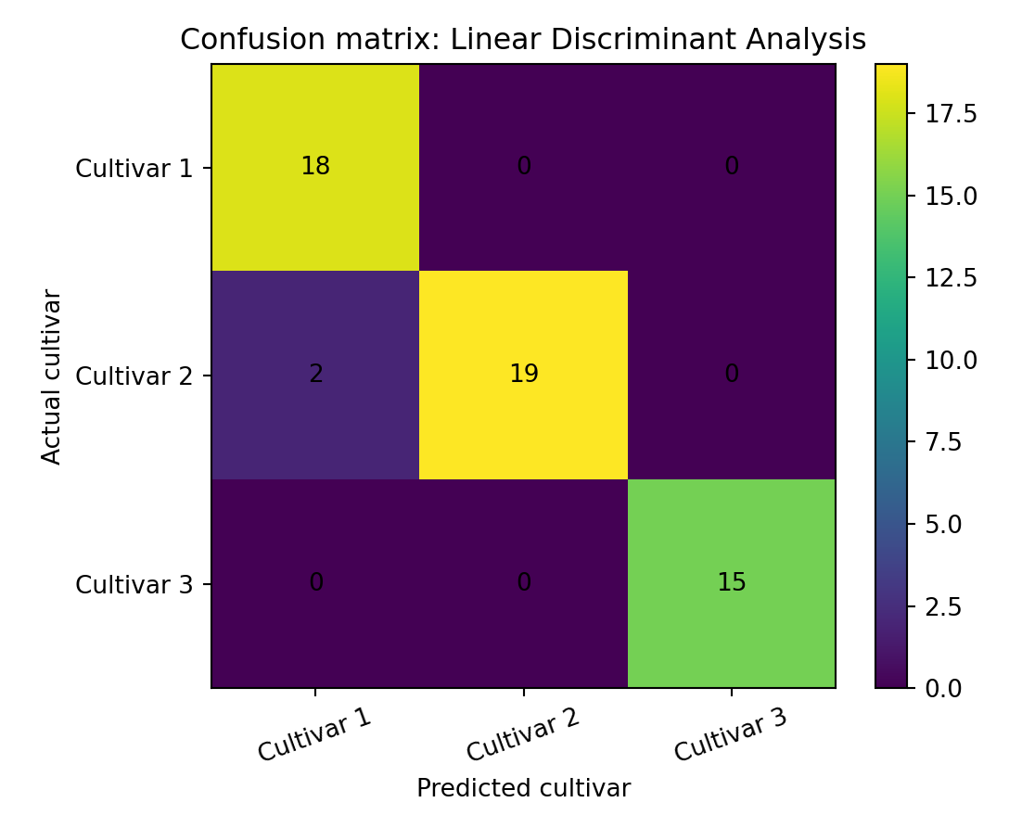
Figure 1. LDA reference confusion matrix.
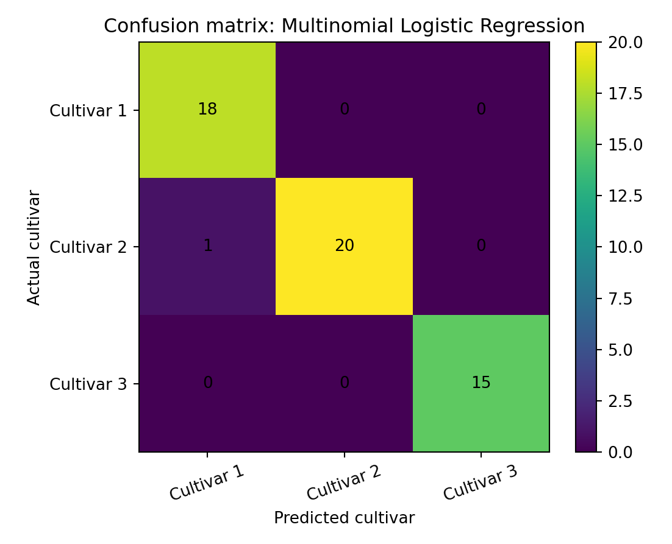
Figure 2. Multinomial logistic regression reference confusion matrix.
In the reference benchmark, LDA correctly classified 52 of 54 test records; two Cultivar 2 records were predicted as Cultivar 1. Multinomial logistic regression correctly classified 53 of 54; one Cultivar 2 record was predicted as Cultivar 1. Both models correctly classified every Cultivar 3 case in this test partition. These counts are specific to the selected split and must not be treated as population guarantees.

6. ROC diagnostics
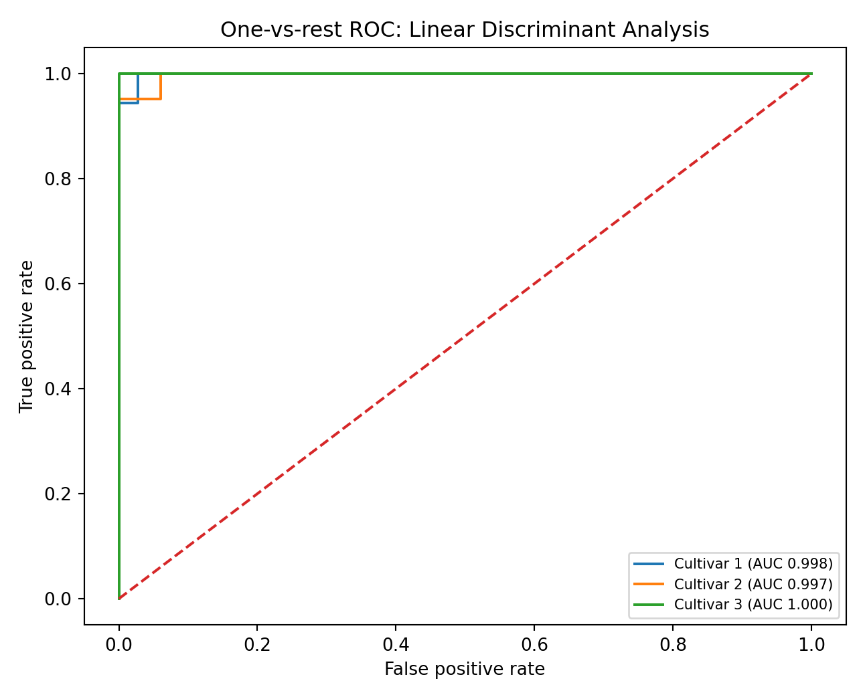
Figure 3. LDA one-vs-rest ROC curves.
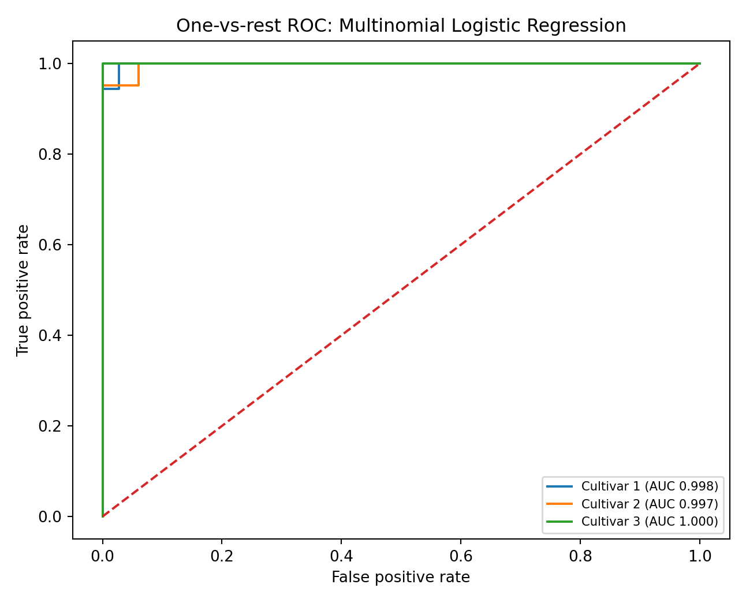
Figure 4. Multinomial logistic regression one-vs-rest ROC curves.
The reference macro one-vs-rest AUC is approximately 0.999 for both methods. The near-perfect ranking performance is consistent with a well-separated benchmark dataset, but the small sample means that a single split can give optimistic or unstable estimates. The ROC curves complement threshold-specific confusion matrices; they do not remove the need for external validation.

7. Interpretation and model comparison
Multinomial logistic regression has the higher reference accuracy (0.981 versus 0.963) and macro F1 (0.983 versus 0.966) on this fixed test partition. The difference is one additional correctly classified record, so it should not be overstated. Both models show high discrimination on this dataset. A larger external dataset, repeated stratified cross-validation, and calibration checks would be needed before claiming that one model is reliably better.

8. Bias, limitations and future improvements
- The dataset is small (178 records) and curated; performance may be optimistic relative to samples collected under different conditions.
- The three labels represent the cultivars in this dataset and should not be generalized to all varieties or regions.
- The class distribution is moderately uneven; macro metrics are reported to avoid letting the largest class dominate the summary.
- LDA and multinomial logistic regression are linear methods and may not capture nonlinear interactions.
- Future work could use repeated stratified cross-validation, regularization tuning, calibration assessment, and an independent validation dataset.
- Feature selection and sensitivity analysis could examine whether a smaller predictor set preserves performance.

9. R code excerpt
library(MASS)
library(nnet)
lda_fit <- MASS::lda(x = train_x, grouping = train_y)
lda_pred <- predict(lda_fit, newdata = test_x)
multinom_fit <- nnet::multinom(cultivar ~ ., data = train_model,
trace = FALSE, maxit = 1000)
multinom_pred <- predict(multinom_fit, newdata = test_x, type = "class")
The complete script contains the fixed split check, training-only scaling, probability extraction, macro metrics, confusion matrices and one-vs-rest ROC plots.

Data provenance and execution note
The packaged CSV is derived from the public UCI Wine Recognition data distributed in scikit-learn, with cultivar labels restored to the UCI 1–3 coding. The data checks in this project found 178 records, 13 numeric predictors, no missing cells, and no duplicated observations. The dataset is a small benchmark and does not represent every wine or market.
Execution transparency: This authoring workspace did not include an R runtime. The R scripts are supplied for local reproduction but were not executed here. Embedded plots and model benchmark figures were produced from the same packaged data with equivalent Python implementations. Model metrics are labelled reference benchmarks, not R-native results. Run src/run_all.R in R and replace the benchmark metrics with outputs/model_metrics_R.csv if strict R execution evidence is required.

References
- Aeberhard, S., & Forina, M. (1992). Wine [Dataset]. UCI Machine Learning Repository. https://doi.org/10.24432/C5PC7J
- UCI Machine Learning Repository. (n.d.). Wine dataset (ID 109). https://archive.ics.uci.edu/dataset/109/wine
- scikit-learn developers. (n.d.). Wine recognition dataset documentation. https://scikit-learn.org/stable/modules/generated/sklearn.datasets.load_wine.html

