WEEK 5 | FINAL PROJECT REPORT

Reporting, Insights and Presentation
An integrated summary of the wine cultivar classification project
Prepared by | Programme | Submission date
Aman Yadav | Virtual Data Science with R Apprentice | 05 November 2026

Project theme: Wine Cultivar Classification Using Chemical Measurements
Dataset: UCI Wine Recognition (178 records, 13 numeric predictors, 3 cultivar classes).

Executive summary
This project examined whether 13 chemical measurements can distinguish three wine cultivar classes in the UCI Wine Recognition dataset. The integrated workflow covers project planning, exploratory analysis, data-quality assessment, preprocessing, supervised model development, evaluation, and recommendations. The packaged dataset contains 178 observations and 13 numeric predictors. It has no missing cells or duplicated full observations in the checks performed. Exploratory plots indicate that measurements such as flavanoids, total phenols, alcohol, color intensity and proline vary across cultivars. Two classical classifiers were compared using a fixed stratified hold-out split. In an explicitly labelled Python reference benchmark, multinomial logistic regression achieved 98.1% accuracy and LDA achieved 96.3%; both had macro one-vs-rest AUC close to 1.00 on the 54-record test set. These results are promising for this compact benchmark but are not evidence of general performance on all wines.

1. Project question and scope
Research question: Can the cultivar class of a wine sample be predicted from its 13 recorded chemical measurements? The scope is limited to the three classes in the UCI dataset. The project does not infer wine quality, brand, price, health effects, or regulatory suitability.

2. Data and methodology
Component | Approach
Source | UCI Wine Recognition dataset (178 records; 13 numeric attributes; 3 cultivar labels).
Quality review | Missing values, duplicates, data types, valid target levels, ranges and IQR outlier flags.
Cleaning | Snake_case field names, stable record_id, numeric predictors and factor target.
EDA | Class frequencies, descriptive statistics, feature distributions, correlations and scatter plots.
Preprocessing | Stratified 70/30 split; standardization parameters fitted on training records only.
Models | Linear Discriminant Analysis and Multinomial Logistic Regression.
Evaluation | Accuracy, macro precision/recall/F1, macro one-vs-rest AUC, confusion matrices and ROC curves.

3. Key descriptive findings
- The data contain 178 records: 59 in Cultivar 1, 71 in Cultivar 2, and 48 in Cultivar 3.
- Mean alcohol values by class are 13.74, 12.28, and 13.15.
- Mean flavanoids values are 2.98, 2.08, and 0.78; the third class has a notably lower mean in this sample.
- Mean color intensity is 5.53, 3.09, and 7.40.
- The strongest observed pairwise correlation is between flavanoids and total phenols, indicating that some chemical measurements are related.
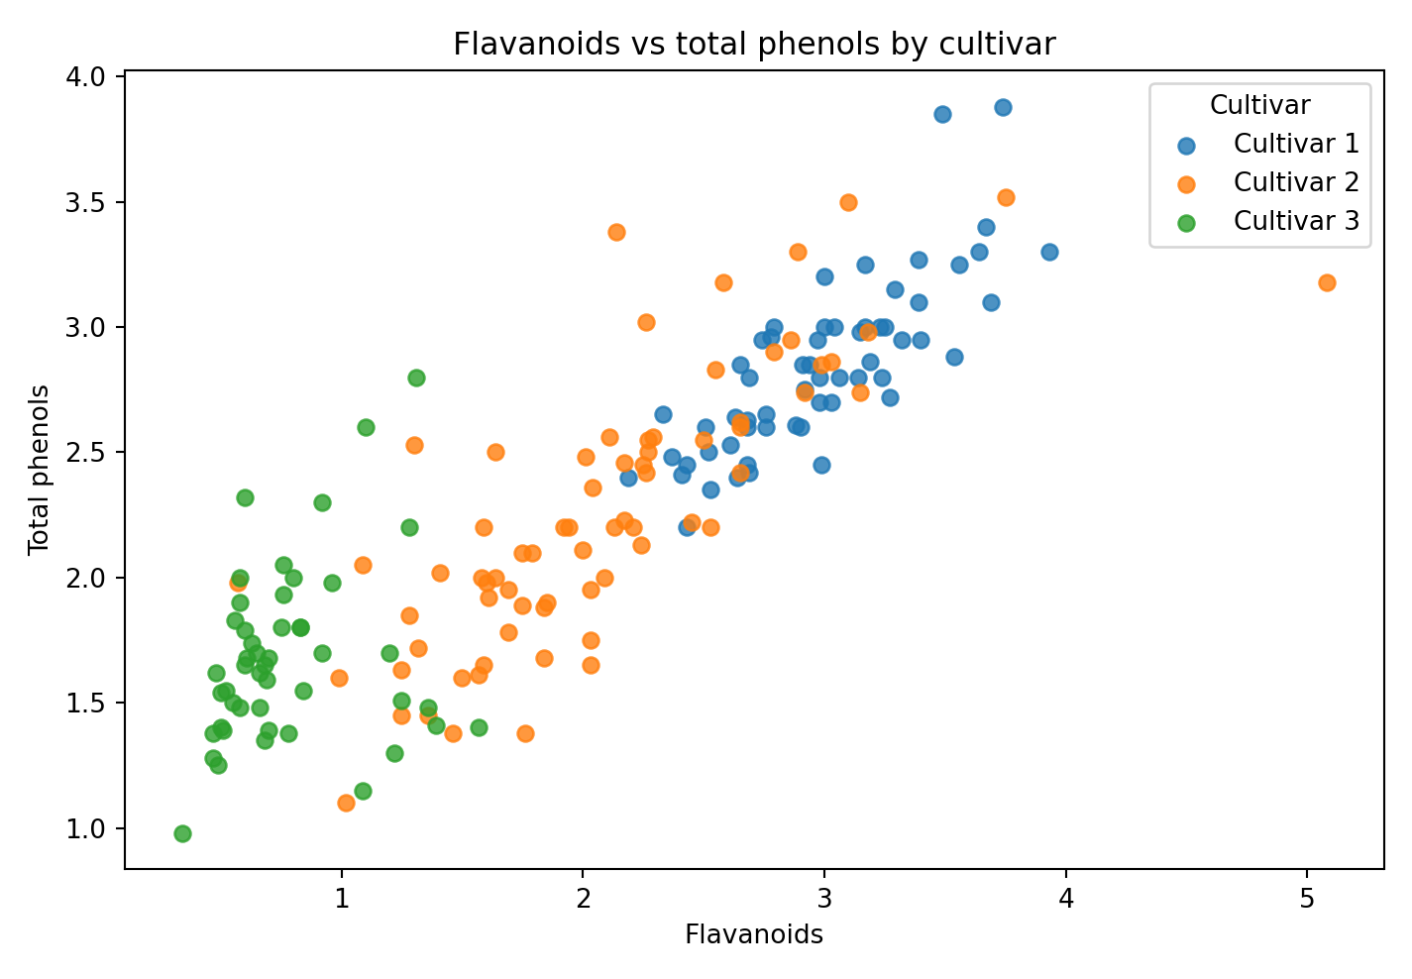
Figure 1. Cultivar patterns in flavanoids and total phenols.

4. Data preparation results
The data audit found 0 missing cells and 0 duplicated full observations. The IQR screening produced 21 feature-value flags across the numeric predictors. Flagged observations were retained because the rule alone does not prove a measurement is erroneous. The modelling workflow standardizes using training-only means and standard deviations to avoid leakage.

5. Predictive model results
Model | Accuracy | Macro P | Macro R | Macro F1 | Macro AUC
Linear Discriminant Analysis | 0.963 | 0.967 | 0.968 | 0.966 | 0.999
Multinomial Logistic Regression | 0.981 | 0.982 | 0.984 | 0.983 | 0.999

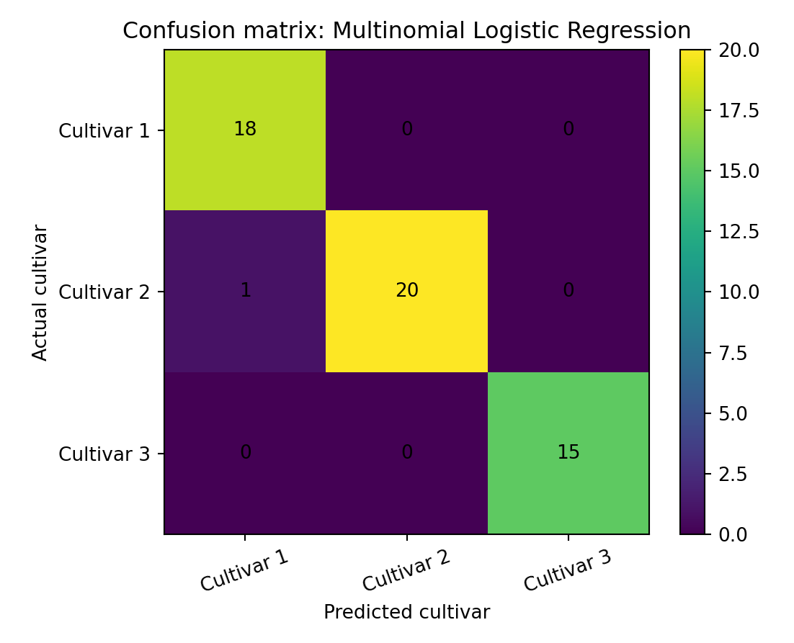
Figure 2. Reference confusion matrix for multinomial logistic regression.
On the fixed 54-record test split, the reference multinomial model misclassified one Cultivar 2 record as Cultivar 1, while LDA misclassified two Cultivar 2 records as Cultivar 1. Other test records were correctly assigned in these reference runs. The models should be compared again using the R-native outputs after executing the supplied scripts.

6. Actionable recommendations
- Treat the current models as exploratory decision-support prototypes only; do not deploy them for commercial classification without an external validation study.
- Collect additional samples across batches, producers, regions and measurement instruments to test whether the class patterns persist.
- Run repeated stratified cross-validation and report variability (for example, mean and standard deviation of macro F1 and AUC).
- Check model calibration and class-specific error costs before using predicted probabilities in a workflow.
- Investigate feature selection and correlated predictors to improve interpretability while preserving performance.
- Keep raw data, split assignments, scripts and generated outputs version-controlled; record the R and package versions for reproducibility.

7. Limitations
The sample size is small, the dataset is curated, and the three classes are limited to the records supplied by UCI. The measured variables are chemical constituents; contextual attributes such as producer, vintage, brand and price are not available. The hold-out benchmark is a single split, and no independent external dataset was used. The current workspace did not have R installed; therefore, the R scripts are supplied but the embedded model results are clearly marked as equivalent Python reference benchmarks rather than R-native executions.

8. Reflection on learning
The project demonstrates that a data science workflow is more than fitting an algorithm. The dataset must be understood, quality issues checked, transformations documented, and the validation design protected from leakage. Exploratory plots helped identify class differences and correlated predictors, while the model comparison showed why confusion matrices and macro metrics are useful alongside accuracy. A key practical lesson is to preserve the raw source, keep preprocessing reproducible, and distinguish observed benchmark performance from a claim about real-world generalization. The project also highlighted the importance of being transparent about execution environments and rerunning the supplied R scripts before presenting R-native scores as final results.

9. Reproducibility and project files
The accompanying project bundle includes raw and processed CSV files, the fixed split assignment, data-quality tables, six R scripts, plots, reference model metrics, README instructions, and task-specific descriptions. From the project root, install MASS and nnet if needed and run Rscript src/run_all.R. The R-native outputs are written to outputs/ and R-generated figures to reports/figures/.

Data provenance and execution note
The packaged CSV is derived from the public UCI Wine Recognition data distributed in scikit-learn, with cultivar labels restored to the UCI 1–3 coding. The data checks in this project found 178 records, 13 numeric predictors, no missing cells, and no duplicated observations. The dataset is a small benchmark and does not represent every wine or market.
Execution transparency: This authoring workspace did not include an R runtime. The R scripts are supplied for local reproduction but were not executed here. Embedded plots and model benchmark figures were produced from the same packaged data with equivalent Python implementations. Model metrics are labelled reference benchmarks, not R-native results. Run src/run_all.R in R and replace the benchmark metrics with outputs/model_metrics_R.csv if strict R execution evidence is required.

References
- Aeberhard, S., & Forina, M. (1992). Wine [Dataset]. UCI Machine Learning Repository. https://doi.org/10.24432/C5PC7J
- UCI Machine Learning Repository. (n.d.). Wine dataset (ID 109). https://archive.ics.uci.edu/dataset/109/wine
- scikit-learn developers. (n.d.). Wine recognition dataset documentation. https://scikit-learn.org/stable/modules/generated/sklearn.datasets.load_wine.html

