EXPLORING WEATHER TRENDS

Data Collection using SQL Queries
To get the nearest city near me, I checked for all the cities for my country using this command
SELECT * from city_list WHERE country = 'India'
Then I collected the data for City Delhi using the following command
SELECT * from city_data WHERE city = 'Delhi'
and saved it as a csv with name City_Data.csv
And for the global data I ran the following command
SELECT * from global_data
and saved it as csv with name Global_Data.csv

Tools Used
I used Python for the analysis and I used Pandas and matplotlib libraries to read manipulate and Visualise the charts.

- Python
- Jupyter Notebook
- Pandas
- Matplotlib

Reading Data into Pandas DataFrame

import pandas as pd # for data manipulation
import matplotlib.pyplot as plt # for ploting the Charts

Data Preparation

# Joining Two tables on Year
final_df= global_data.merge(city_data, how='left', on= "year", suffixes=('_global', '_city')).drop(['city', 'country'], axis= 1)

# Setting Year as Index
final_df.set_index('year', inplace= True)

Plotting the Weather Trends

title='Yearly Temperature Trends'
ylabel='Yearly Average Temperature'
xlabel='Year'
fig, ax = plt.subplots()
final_df.plot(figsize=(12,5), ax=ax , title= title).autoscale(axis='x',tight=True)
ax.legend(["Global Average Temperatures", "City Average Temperatures"]);
ax.set(xlabel=xlabel, ylabel=ylabel);
plt.savefig('original.png')
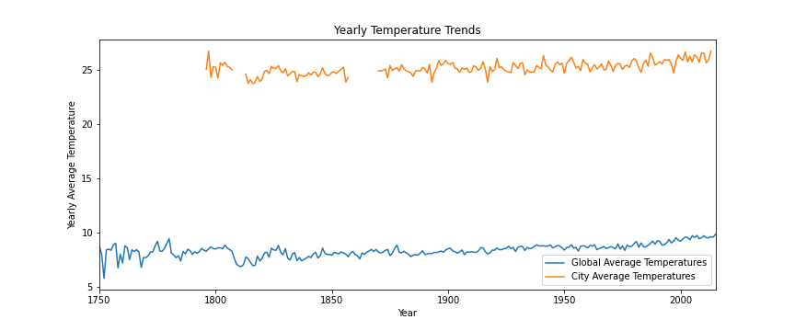

Calculating Moving Average
Using Pandas the calculating the moving average is very easy we just need to call .rolling() off of the DataFrame.

Six Years Moving Average
title='Six Year Moving Average Temperature Trends'
ylabel='Yearly Average Temperature'
xlabel='Year'
fig, ax = plt.subplots()
final_df.rolling(window=6).mean().plot(figsize=(12,5), ax=ax , title= title).autoscale(axis='x',tight=True)
ax.legend(["Global Average Temperatures", "City Average Temperatures"]);
ax.set(xlabel=xlabel, ylabel=ylabel);
plt.savefig('6yearsMA.png')

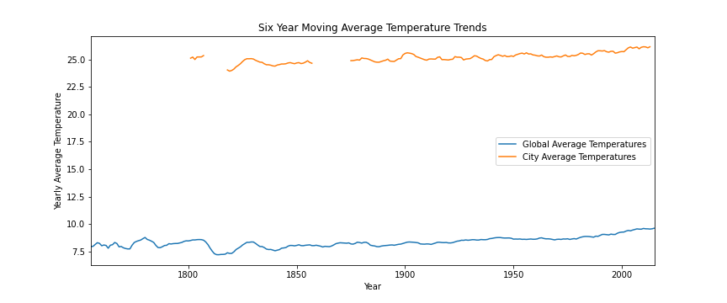
Twelve Years Moving Average
title='Twelve Year Moving Average Temperature Trends'
ylabel='Yearly Average Temperature'
xlabel='Year'
fig, ax = plt.subplots()
final_df.rolling(window=12).mean().plot(figsize=(12,5), ax=ax, title= title).autoscale(axis='x',tight=True)
ax.legend(["Global Average Temperatures", "City Average Temperatures"]);
ax.set(xlabel=xlabel, ylabel=ylabel);
plt.savefig('12yearsMA.png')
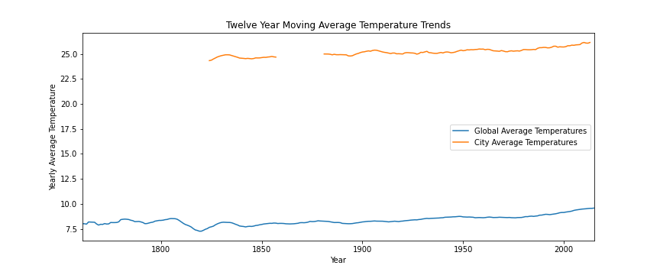
Observations:
- Orange line shows the trends of my city and blue one for global average temperature.
- Certainly my city’s temperature is way higher than the global average because my city is near to tropic of cancer.
- My city’s temperature is parallelly increasing with the global temperatures and dip and ups in global temperature also corresponds to my city temperature.
- Global temperature is increasing over time and as well my city’s temperature.

