# Heuristic Analysis

A picture speaks for itself. Here is my chart with three heuristic functions compared to the ID_Improved.

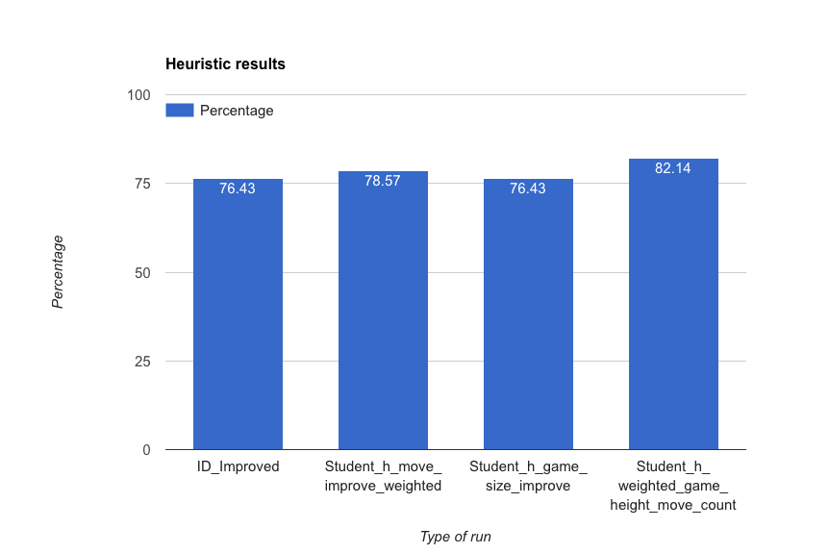

The three heuristic functions I used are –

1. **Move Improved Weighted (Student_h_move_improve_weighted)**: This is like improved_score version, only that you apply random weights. This is for a trial to see what works and what does not. I saw that this one works much better for small number of games.
2. **Game Size Improve (Student_h_game_size_improve)**: This is Heuristic to improve by using game move and height ratio as compared to the opponent's moves. Again for small games (1, 2) this works better than ID_Improved.
3. **Move Count Game Height Weighted (Student_h_weighted_game_height_move_count)**: Game size, using the middle ground of the game to decide the improvement.  
   else it is just simple improved_score. This is by far my best attempt.