# Heuristic Analysis

A picture speaks for itself. Here is my chart with three heuristic functions compared to the ID_Improved.

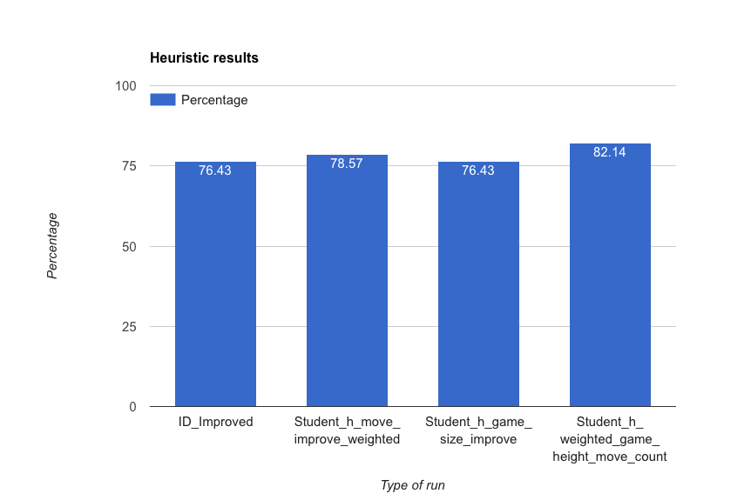

The three heuristic functions I used are –

1. **Move Improved Weighted (Student_h_move_improve_weighted)**: This is like improved_score version, only that you apply random weights. This is for a trial to see what works and what does not. I saw that this one works much better for small number of games.  
     
   **Reason**: I chose this because it was simple enough so will be fast and is a slight improvement over the imporved_score heuristic. So faster yet more aggressive version. However, the reason I will not choose this over the remaining two because this is not as dynamic as I’d like heuristics to be and it fairs approximately the same as the base case.
2. **Move Count Game Height Weighted (Student_h_weighted_game_height_move_count)**: This is Heuristic to improve by using game move and height ratio as compared to the opponent's moves. Again for small games (1, 2) this works better than ID_Improved.   
     
   **Reason**: This was done to see how dynamic can the heuristics get. Apparently, you can use all sorts of game move count, game height, game size etc. to dynamically plug-in the weights. This definitely requires more calculation.

1. **Game Size Improve (Student_h_game_size_improve)**: Game size, using the middle ground of the game to decide the improvement else it is just simple improved_score. This is by far my best attempt.  
     
   **Reason**: Obviously, gives a better score.   
     
   This is a more dynamic heuristic, which takes into account how far into the game the players are. So if the game is somewhere around 30% to 70% done, we use dynamic heuristics with game height and move count (as above).   
     
   This means that when the game is in a middle state, it is more fluid and dynamic because there is a good ratio of possibilities for players vs. results. It takes into account the game play on both players when needed.   
     
   For the remaining, it is just a normal static difference in players’ moves. That is, for beginning of board and towards the end of the board we only have normal difference.  
     
   This is slightly tougher to calculate, and understand but is more adjusting to the fact that we might not need a complex calculation in the beginning or at the end of the game.  
     
   Note: Actually I messed up with the tally and I meant to use the 3rd heuristic -- **Student_h_game_size_improve.**