GATI SHAKTI VISHWAVIDYALAYA, VADODARA

MLOps LAB ASSIGNMENT
Assignment 4 — Advanced MLflow
Experiment Tracking, Model Signatures, Registry and Lifecycle
Name: Aman Kumar Jha
Roll Number: 24AI009
Programme/Branch: B.Tech — Artificial Intelligence and Data Science
College: Gati Shakti Vishwavidyalaya, Vadodara
Course: MLOps Laboratory
Date: 9 October 2026

1. Objective
To understand and implement MLflow experiment tracking for a regression task; compare at least three candidate models; explain signatures, artifacts, autologging, registry versions and lifecycle states; and define an evidence-based promotion rule.

2. Scenario and dataset
The supplied assignment allows reuse of a prior dataset or a small public/synthetic CSV. No Sessions 3–4 dataset was present with the supplied assignment PDF, so this report uses a clearly identified synthetic house-price dataset for reproducibility. It contains 500 rows, five numeric predictors (area_sqft, bedrooms, age_years, distance_km, amenities_score) and the target price_lakh. The CSV is 13,535 bytes; SHA-256: d6e2cb6c4e9a7220ada184a85cf43bb6f3f24ec182b9c865a365c407595c8c0b. It is synthetic and must not be interpreted as real market data.

3. Theory and concepts
Model signature: a schema describing expected model inputs and outputs, inferred or supplied when logging a model. It helps tools validate request structure and types, but it cannot prove that values are realistic, unbiased, current, or semantically correct.
Artifacts: files associated with an experiment run, such as a model, residual plot, evaluation report, or configuration. Artifacts make a run inspectable and help explain model behaviour.
Autologging: an MLflow integration that automatically records supported parameters, metrics, models, and metadata for supported libraries. The exact fields depend on the MLflow flavor and installed version, so the run must be inspected rather than assuming everything is captured.
Model Registry: a shared catalogue of named model versions with source-run links, descriptions, tags, and lifecycle metadata. A version identifies one registered revision; an alias or stage communicates intended use.
Version vs lifecycle: Version 1, 2, and 3 are separate registered model revisions; they are not Git tags. Candidate/Staging means validation is pending or underway, Production means approved for use, and Archived/Retired means superseded or no longer intended for deployment. MLflow registry APIs vary by version: older installations may use stages, while newer workflows commonly use aliases and tags.

4. Environment and project setup
The reproducible project bundle contains data/dataset.csv, src/train.py, src/evaluate.py, configs/config.yaml, reports/figures/, reports/model_comparison.csv, requirements.txt and README.md. The code was evaluated with the available local Python/scikit-learn environment. MLflow was not installed in the report-building environment; therefore, no MLflow UI run, registry version, or screenshot is represented as completed evidence.
Recommended setup: create a virtual environment; install requirements.txt; run mlflow --version; run python src/evaluate.py and python src/train.py; then run mlflow ui and inspect the experiment. Exact environment commands and Windows notes are included in the project README.

5. Experiment methodology
The data was split into 80% training and 20% test data using random_state=42. Three tree-based regressors were trained with different configurations. The primary selection criterion was the lowest test-set RMSE; MAE and R² were retained as supporting metrics. The models use the same split to make the comparison fair.
Models: (1) RandomForestRegressor, 100 trees, unrestricted depth; (2) RandomForestRegressor, 200 trees, maximum depth 8; (3) ExtraTreesRegressor, 200 trees, maximum depth 10. The script logs metrics and model information to MLflow when MLflow is installed, and logs residual plots and metric CSV artifacts. It also enables scikit-learn autologging.

6. Results and comparison
The metrics below are actual scikit-learn evaluation outputs generated from the synthetic CSV in this environment. They are not claimed to be MLflow UI output.
Model | MAE | RMSE | R²
RandomForest_200_depth8 | 6.4408 | 8.1859 | 0.6922
RandomForest_100 | 6.5489 | 8.2886 | 0.6845
ExtraTrees_200_depth10 | 6.7656 | 8.5354 | 0.6654
Lowest RMSE: RandomForest_200_depth8 (RMSE 8.1859; MAE 6.4408; R² 0.6922).
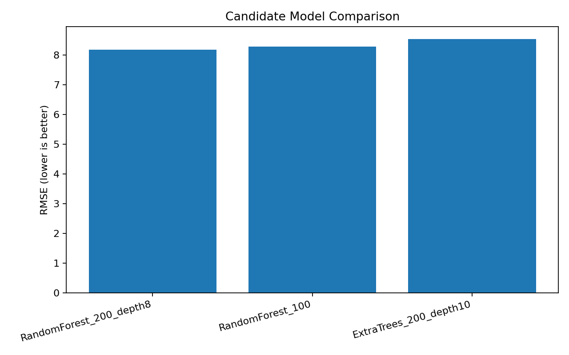
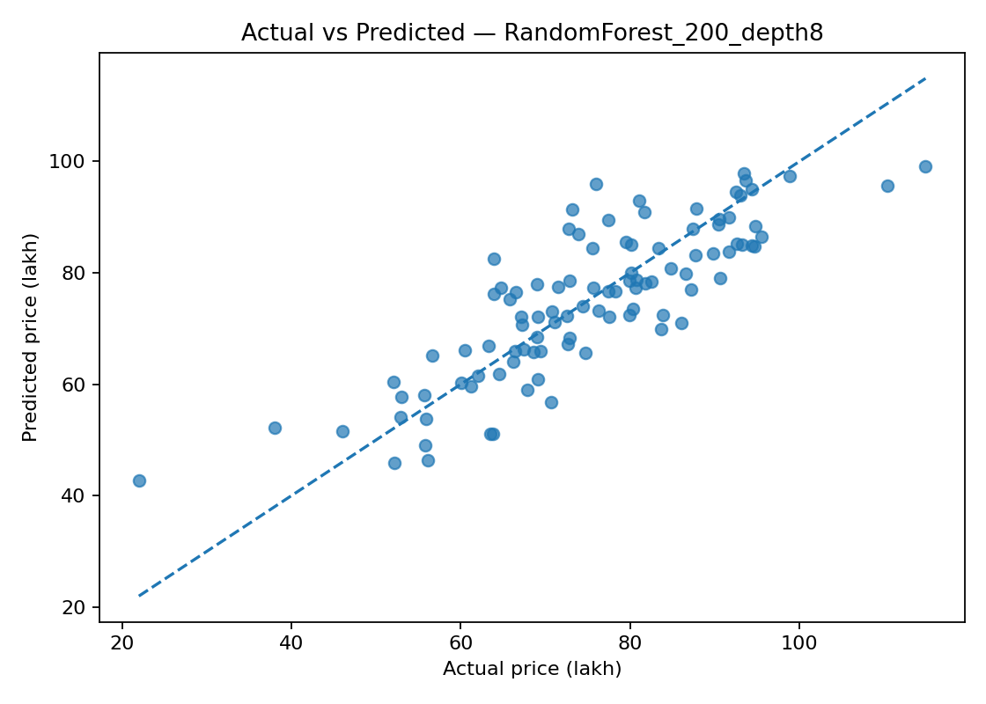
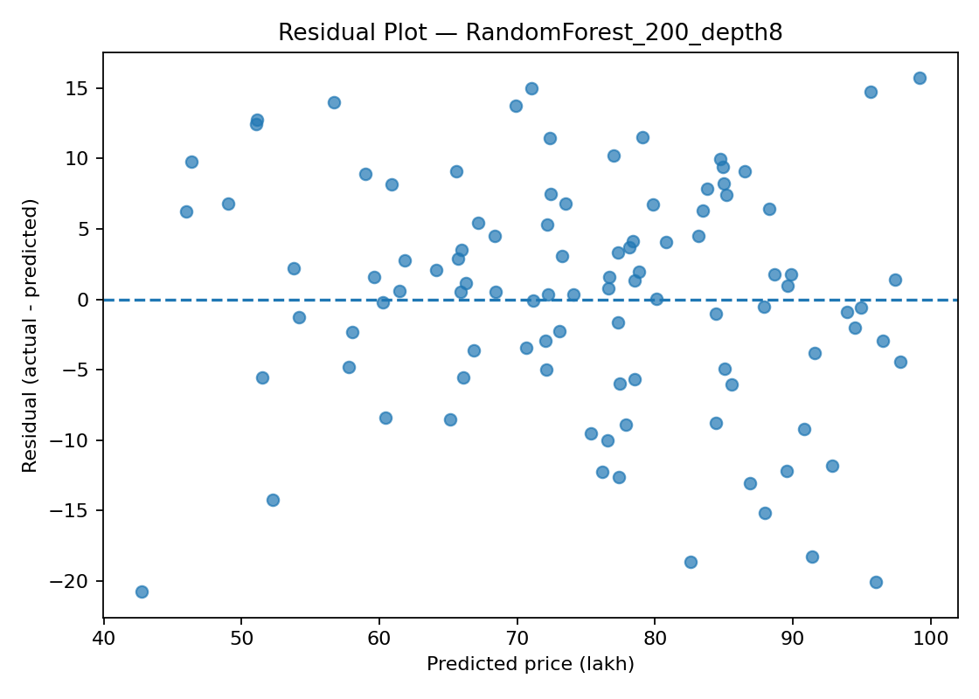

7. Model signature and malformed input
The selected model has five expected numeric input columns: area_sqft, bedrooms, age_years, distance_km and amenities_score. The prediction output is one numeric value, price_lakh. The training script uses infer_signature on representative input data and logs an input example. If a future API sends only three columns or changes a numeric column to an incompatible type, signature/schema validation may reject the request or expose a schema mismatch before prediction. A signature does not guarantee that the input is within valid ranges or that the prediction is accurate.

8. Registry versions and lifecycle decision
Required registry work: register three logged model artifacts under the same name, for example HousePriceModel, and verify three distinct versions. Record the actual source run IDs from MLflow, metrics, descriptions, and intended use. Because MLflow was unavailable here, the registry table below records the evaluated candidate configurations and explicitly leaves actual run IDs/version IDs for capture after running the bundle; these are not fabricated registry records.
Acceptance rule: choose the candidate with the lowest held-out RMSE, but promote only after checking dataset representativeness, error costs, data quality, latency, stability, and fairness. Under the available offline evaluation, RandomForest_200_depth8 is the provisional candidate. It must not be called Production until registry-backed validation is completed. A teammate should retrieve the production alias from the configured registry and use its model URI, rather than guessing from a local filename.
Candidate/version | Source run ID | Key metric (RMSE) | Change | Decision
Candidate 1 / v1 after registration | Capture from MLflow | 8.2886 | Random Forest, 100 trees | Compare
Candidate 2 / v2 after registration | Capture from MLflow | 8.1859 | Random Forest, 200 trees, depth 8 | Provisional candidate
Candidate 3 / v3 after registration | Capture from MLflow | 8.5354 | Extra Trees, 200 trees, depth 10 | Compare / do not promote

9. Artifacts and autologging verification
Two diagnostic artifacts were generated: an actual-vs-predicted plot and a residual plot; a model-comparison plot and test_predictions.csv are also included. The training script logs per-run metric CSV and residual plots as MLflow artifacts. After execution, inspect the MLflow run's parameters, metrics, model artifact, signature, input example, and automatically logged fields. Capture screenshots of the experiment comparison, each run's artifacts, and the registered model versions/lifecycle state.

10. Challenges and limitations
MLflow and DVC were not installed in the environment used to generate these reports, and the supplied PDF did not include a prior dataset or an existing Git repository. Therefore, model metrics and plots were run locally with scikit-learn, while MLflow tracking/registry evidence must be captured by executing the provided code on the student's machine. This distinction avoids claiming unperformed tracking operations or inventing screenshots.

11. Conclusion
The experiment compares three reproducible model candidates and selects RandomForest_200_depth8 provisionally because it has the lowest RMSE (8.1859) on the held-out synthetic test set. MLflow can preserve run-level parameters, metrics, artifacts, model signatures, and registry versions so a team can identify the intended model. The production decision remains conditional on actual registry setup and validation.

12. References
MLflow Tracking: https://mlflow.org/docs/latest/ml/tracking/
MLflow Model Registry: https://mlflow.org/docs/latest/ml/model-registry/
MLflow model signatures and input examples: https://mlflow.org/docs/latest/ml/model/signatures/
MLflow scikit-learn integration: https://mlflow.org/docs/latest/ml/traditional-ml/sklearn/
scikit-learn model evaluation: https://scikit-learn.org/stable/modules/model_evaluation.html
Assignment source: MLOps Lab Assignment 4–5, supplied PDF, pages 1–6.

