Handwritten Word Spotting with Corrected Attributes
Aman Joshi
2018201097
Abhijeet Panda
2018201044
Praveen Balireddy
2018201052

Abstract

Multi-writer word spotting is a technique to find a query word in a dataset compromised of document images written by different writers. Here we have implemented an attribute-based approach that leads to a low-dimensional,, fixed-length representation of word images and strings, which seamlessly allows one to indistinctly perform query-by-example, where the query is an image, and query-by-string, where the query is a string. We have also implemented a calibration scheme to correct the attributes scores based on Canonical Correlation Analysis that improves the results. We have tested our code on publicly available IAM dataset.

Introduction

The objective of word spotting is to find all instances of a given word in a potentially large dataset of document images. This is typically done in a query-by-example (QBE) scenario, where the query is an image of a handwritten word and it is assumed that the transcription of the dataset and the query word is not available. In a multi-writer setting, the writers of the dataset documents may have completely different writing styles than the writer of the query. Multi-writer word spotting can therefore be seen as a particular case of semantic content based image retrieval (CBIR). However it is more difficult, as difference of a single character is considered as negative result.
Different writers may have a completely differenty writing styles, making the same word look completely different. For computing features of image Fisher Vector representation computed over SIFT descriptors extracted densely form the word images is used. The word strings are encoded as PHOCs which are learned with SVM. They are then finally calibrated using CCA.

Implementation

Implementation of our method has following steps -

1. Computing Fisher Vectors
2. Encoding words as PHOCs
3. Attributes learning using SVM
4. Doing Calibration using CCA
5. Query by string or image.

Step 1: Computing Fisher Vector

Fisher Vectors can be understood as a bag of words that encodes higher order statistics, and has been shown to be a good encoding method. First SIFT features are calculated densely over the image. For calculating SIFT features we have used phow, it is Dense SIFT calculated at various levels by gaussian smoothinng of image. Let I=(x1,…,xN) be a set of D dimensional feature vectors extracted from image let Θ=(μk,Σk,πk : k=1,…,K) be parametes of K Gaussians fitting the

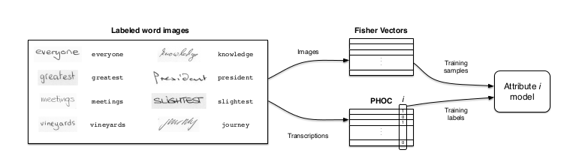
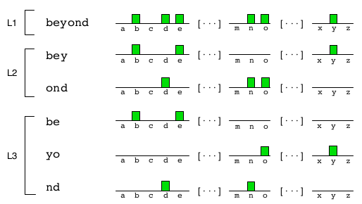

Figure 2: PHOC histogram of a word at levels 1, 2, and 3. The final PHOC histogram is the concatenation of these partial histograms.

Step 3: Training one vs rest SVM

SVM is trained using the Fisher Vector calculated in step1 and PHOCs calcualted in step2. To train the attributes
we use a one-versus-rest linear SVM with a SGD solver. We’ve used sklearn’s SGD solver. The optimal regularization parameter λ cames to 1e-4.

Step 4: Calibrating Scores

Although the SVM results are writer independent, special care has to put when comaparing different words, since the scores of one attribute may dominate over the scores of other attributes scores is neccessary. This is particularly true when we will be performing QBS.
Figure 3: Training process for i-th attribute model. An SVM classifier is trained using the Fisher vector
representation of the images and the i-th value of the PHOC representation as label.

distribution of descriptors. The GMM associates each vector xi to model k in the mixture model. For each model k, consider the mean and covariance deviation vectors.

Where j=1,2,..,D spans the vector dimensions. The FV of image I is stack of above vectors.
Φ(I) = [...uk...vk...]^{T}
For computing FV we tried our implementation as well as used vlfeat library. Vlfeat library was fast because its basic implementaion is in C.

Step 2: Encoding words as PHOCs

It is binary histogram encodes whether a particular character appears in the represented word or not. By using a spatial pyramid we add some coarse localization, e.g., this character appears on the first half of the word, or this character appears in the last quarter of the word (see Fig. 1). The proposed approach embeds
text strings into a d−dimensional binary space. It encodes a particular character appears in a particular spatial region of the stringThe histogram can also encode bigrams or other combinations of characters. When computing the attribute representation, we use levels 2, 3, and 4, as well as 75 common bigrams at level 2, leading to 384 dimensions.

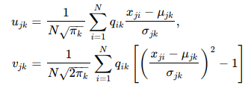

We have calibrated scores jointly, since this can better exploit the correlation between different attributes. In commpn subspace where they are maximally correlated.
To achieve this goal we’ve used Canonical Correlation Analysis to embed the attribute scores and the binary attributes in a common subspace where they are maximally correlated(Fig. 3)
Step 3: Colorization

Once the segmented regions are obtained, we can colorize them using various methods. We have implemented three ways to colorize these segmented areas. These are stroke-preserving colorization, pattern-to-shading, and multi-color transtion, based on the user decision.
Color Replacement

For the intensity-continuous region, filling color can be trivially done by replacing the black or white color by
the user color on the scribble. But, this may also overcolor the strokes on the intensity continuos regions. Thus, instead of directly floodfilling the region we have preserved the strokes.

Stroke-Preserving Colorization

In the pattern continuos regions we cannot naively replace the region eith color as we also need to preserve the pattern (strokes) used by the artists to retain the meaning of that region. Therefore, such regions are colorized by bleeding colors out of the strokes/patterns. The user color is multiplied with the halting term hI in the YUV space.

(5)

Pattern to Shading

Sometimes, we want color filling to be like shading ,i.e, it should vary and not remain constant at all places. As color
can readily reproduce such shading effect, we can convert the pattern to smooth color shading.

Where,

