JS Events
1. onclick Event :
The onclick event occurs when the user clicks on an element.
<!DOCTYPE html>
<html>
<body>

<h2 onclick="changeText(this)">Click on this text!</h2>

<script>
function changeText(id) {
console.log(id);
id.innerHTML = "Ooops!";
}
</script>

</body>
</html>
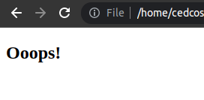

2. ondblclick :
The ondblclick event occurs when the user double-clicks on an element.
<!DOCTYPE html>
<html>
<body>

<p ondblclick="myFunction()">Double-click on this.</p>

<p id="demo"></p>

<script>
function myFunction() {
document.getElementById("demo").innerHTML = "Hello World";
}
</script>

</body>
</html>
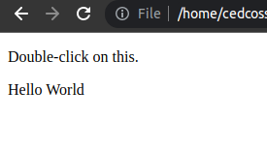

3. onmousedown :
The onmousedown event occurs when a user presses a mouse button over an element.

<!DOCTYPE html>
<html>
<body>

<p id="myP" onmousedown="mouseDown()">
Click on the text!
</p>

<script>
function mouseDown() {
document.getElementById("myP").style.color = "red";
}
</script>

</body>
</html>
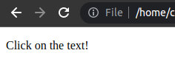

4. onmouseup :
The onmouseup event occurs when a user releases a mouse button over an element.

<!DOCTYPE html>
<html>
<body>

<p id="myP" onmouseup="mouseUp()">
Click on the text!
</p>

<script>
function mouseUp() {
document.getElementById("myP").style.color = "green";
}
</script>

</body>
</html>
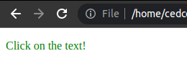

5. onmouseenter :
The onmouseenter event occurs when the mouse pointer is moved onto an element.

<!DOCTYPE html>
<html>
<body>

<p onmouseenter="bigText(this)">The function bigImg() is triggered when the user moves the mouse pointer onto the image.</p>

<script>
function bigText(x) {
x.style.fontSize = "50px";
}
</script>

</body>
</html>
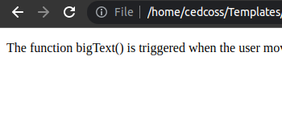

JS Methods

1. includes() : The includes() method returns true if a string contains a specified string. Otherwise it returns false.
The includes() method is case sensitive.

<!DOCTYPE html>
<html>
<body>

<p>Find "World":</p>

<p id="demo"></p>

<script>
let text = "Hello World, welcome to the universe.";
let result = text.includes("World");

document.getElementById("demo").innerHTML = result;
</script>

</body>
</html>

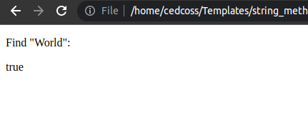

2. replace() : The replace() method searches a string for a value or a regular expression. The replace() method returns a new string with the value(s) replaced.
The replace() method does not change the original string.

<!DOCTYPE html>
<html>
<body>

<p id="demo">Mr Blue has a blue house.</p>

<script>
let str = document.getElementById("demo").innerHTML;
let res = str.replace("blue", "red");
document.getElementById("demo").innerHTML = res;
</script>

</body>
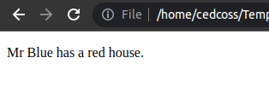
</html>

3. split() : The split() method splits a string into an array of substrings. The split() method returns the new array. The split() method does not change the original string. If (" ") is used as separator, the string is split between words.
<!DOCTYPE html>
<html>
<body>

<p id="demo"></p>

<script>
let text = "my name is aman.";
const myArray = text.split(" ");

document.getElementById("demo").innerHTML = myArray;
</script>

</body>
</html>
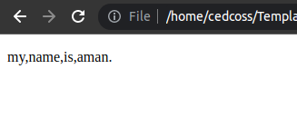

4. concat() : The concat() method concatenates (joins) two or more arrays.
The concat() method returns a new array, containing the joined arrays.
The concat() method does not change the existing arrays.

<!DOCTYPE html>
<html>
<body>

<p id="demo"></p>

<script>
const arr1 = ["aman", "Lion"];
const arr2 = ["Email", "Tabbu", "Linux"];

const children = arr1.concat(arr2);
document.getElementById("demo").innerHTML = children;
</script>

</body>
</html>
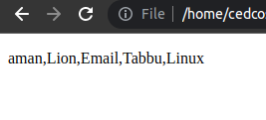

5. pop() :
The pop() method removes (pops) the last element of an array.
The pop() method changes the original array.
The pop() method returns the removed element.

<!DOCTYPE html>
<html>
<body>

<p>pop() removes the last element of an array.</p>

<p id="demo"></p>

<script>
const fruits = ["Banana", "Orange", "Apple", "Mango"];
fruits.pop();
document.getElementById("demo").innerHTML = fruits;
</script>

</body>
</html>

