**CSS Selectors**

CSS selectors are used to "find" (or select) the HTML elements you want to style.There are 7 types of css selectors.

1. Element Selector : The element selector selects HTML elements based on the element name.

2. Id Selector : The id selector uses the id attribute of an HTML element to select a specific element. The id of an element is unique within a page, so the id selector is used to select one unique element!. To select an element with a specific id, write a hash (#) character, followed by the id of the element.

3. Class Selector : The class selector selects HTML elements with a specific class attribute. To select elements with a specific class, write a period (.) character, followed by the class name.

4. Universal Selector : The universal selector (*) selects all HTML elements on the page.

5. General Sibling Selector : The general sibling selector selects all elements that are next siblings of a specified element.

6. Descendant Selector : The descendant selector matches all elements that are descendants of a specified element.

7. Child Selector : The child selector selects all elements that are the children of a specified element.

8. Adjacent Sibling Selector : The adjacent sibling selector is used to select an element that is directly after another specific element.

Code

<!DOCTYPE html>

<html lang="en">

<head>

<meta charset="UTF-8">

<meta http-equiv="X-UA-Compatible" content="IE=edge">

<meta name="viewport" content="width=device-width, initial-scale=1.0">

<title>CSS selectors</title>

<style>

/* 1. element selector */

body {

background-color: blueviolet;

}

/* 2. id selector */

#id1 {

background-color: #cf2525;

}

/* 3. Class Selector */

.classs {

background-color: #c48282;

}

/* 4. Universal Selector */

* {

margin: 0px;

}

/* 5. General Sibling Selector */

div~p {

background-color: brown;

}

/* 6. Descendant Selector */

div p {

background-color: burlywood;

}

/* 7. Child Selector */

#child > p {

background-color: chartreuse;

}

/* 8. Adjacent Sibling Selector */

div + p{

background-color: cornflowerblue;

}

</style>

</head>

<body>

<h1>1. element selector</h1>

<p id="id1">2. id selector output</p>

<p class="classs">3. Class Selector output</p>

<div id="child">

<p>7. Child Selector</p>

<div>

<p>To show the difference.</p>

</div>

<p>7. Child Selector</p>

</div>

<div>

<p>6. Descendant Selector</p>

<p>6. Descendant Selector</p>

<p>6. Descendant Selector</p>

</div>

<div id="adjust"></div>

<p>8. Adjacent Sibling Selector</p>

<p>5. General Sibling Selector</p>

<p>5. General Sibling Selector</p>

</body>

</html>

Output

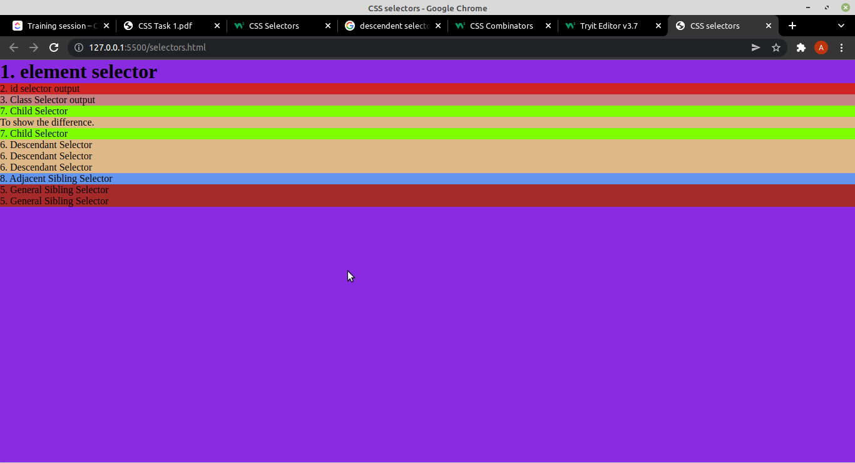

# CSS Pseudo Classes

A CSS pseudo-class is a keyword added to a selector that specifies a special state of the selected element(s). For example, :hover can be used to change a button's color when the user's pointer hovers over it.

1. :active selector : The :active selector is used to select and style the active link.

<!DOCTYPE html>

<html>

<head>

<style>

a:active {

background-color: yellow;

}

</style>

</head>

<body>

<a href="https://www.w3schools.com">W3schools.com</a>

</body>

</html>

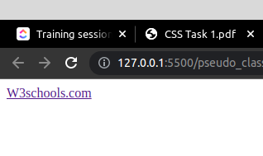

2. :first-child selector : The :first-child selector is used to select the specified selector, only if it is the first child of its parent.

<!DOCTYPE html>

<html>

<head>

<style>

p:first-child {

background-color: #999999;

}

</style>

</head>

<body>

<p>This paragraph is the first child.</p>

<p>This paragraph is not the first child.</p>

<div>

<p>This paragraph is the first child</p>

<p>This paragraph is not the first child.</p>

</div>

</body>

</html>

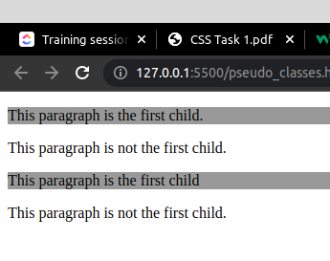

3. :first-of-type selector : The :first-of-type selector matches every element that is the first child, of a particular type, of its parent.

<!DOCTYPE html>

<html>

<head>

<style>

p:first-of-type {

background: red;

}

</style>

</head>

<body>

<p>The first paragraph.</p>

<p>The second paragraph.</p>

<p>The third paragraph.</p>

<p>The fourth paragraph.</p>

</body>

</html>

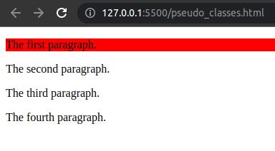

4. : focus selector : The : focus selector selector is used to select the element that has focus.

<!DOCTYPE html>

<html>

<head>

<style>

input:focus {

background-color: yellow;

}

</style>

</head>

<body>

<form>

First name: <input type="text"><br>

Last name: <input type="text">

</form>

</body>

</html>

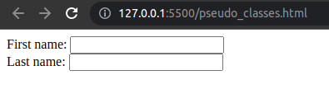

5. :hover selector : The :hover selector is used to select elements when you mouse over them.

<!DOCTYPE html>

<html>

<head>

<style>

p:hover, h1:hover, a:hover {

background-color: yellow;

}

</style>

</head>

<body>

<h1>Welcome to My Homepage</h1>

</body>

</html>

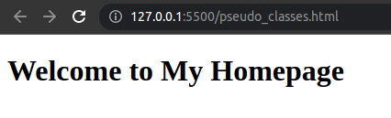

6. :last-child selector : The :last-child selector matches every element that is the last child of its parent.

<!DOCTYPE html>

<html>

<head>

<style>

p:last-child {

background: #ff0000;

}

</style>

</head>

<body>

<p>The first paragraph.</p>

<p>The second paragraph.</p>

<p>The third paragraph.</p>

</body>

</html>

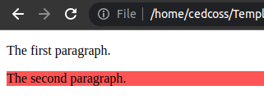

7. :last-of-type selector : The :last-of-type selector selector matches every element that is the last child, of a particular type, of its parent.

<!DOCTYPE html>

<html>

<head>

<style>

p:last-of-type {

background: #ff0000;

}

</style>

</head>

<body>

<p>The first paragraph.</p>

<p>The second paragraph.</p>

</body>

</html>

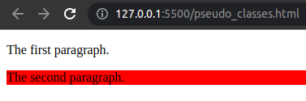

8. :link : The :link selector is used to select unvisited links.

<!DOCTYPE html>

<html>

<head>

<style>

a:link {

background-color: lightgreen;

}

</style>

</head>

<body>

<a href="https://www.w3schools.com">W3Sschools</a>

<a href="http://www.wikipedia.org">Wikipedia</a>

</body>

</html>

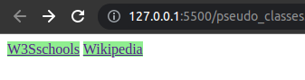

9. :not (selector) : The :not (selector) selector matches every element that is NOT the specified element/selector.

<!DOCTYPE html>

<html>

<head>

<style>

p {

color: #000000;

}

:not(p) {

color: #ff0000;

}

</style>

</head>

<body>

<h1>This is a heading</h1>

<p>This is a paragraph.</p>

<p>This is another paragraph.</p>

<div>This is div.</div>

<a href="https://www.w3schools.com" target="_blank">Link to W3Schools!</a>

</body>

</html>

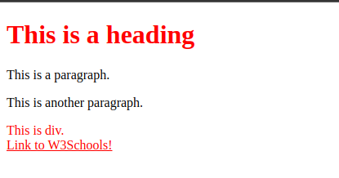

10. :nth-child(n) selector : The :nth-child(n) selector matches every element that is the *n*th child, regardless of type, of its parent. n can be a number, a keyword, or a formula.

<!DOCTYPE html>

<html>

<head>

<style>

p:nth-child(2) {

background: red;

}

</style>

</head>

<body>

<p>The nth child 1.</p>

<p>The nth child 2.</p>

</body>

</html>

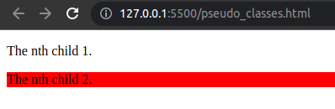

11. :nth-last-child(n) : The :nth-last-child(n) selector matches every element that is the *n*th child, regardless of type, of its parent, counting from the last child. ncan be a number, a keyword, or a formula.

<!DOCTYPE html>

<html>

<head>

<style>

p:nth-last-child(2) {

background: red;

}

</style>

</head>

<body>

<p>The nth last child 2.</p>

<p>The nth last child 1.</p>

</body>

</html>

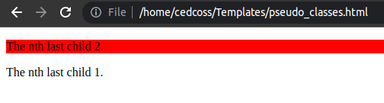

12. :nth-last-of-type(n) : The: nth-last-of-type(n) selector matches every element that is the *n*th child, of a particular type, of its parent, counting from the last child. *n* can be a number, a keyword, or a formula.

<!DOCTYPE html>

<html>

<head>

<style>

p:nth-last-of-type(2) {

background: red;

}

</style>

</head>

<body>

<p>The nth last of type 2.</p>

<p>The nth last of type 1.</p>

</body>

</html>

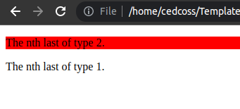

13. :nth-of-type(n) : The: nth-of-type(n) selector matches every element that is the *n*th child, of a particular type, of its parent. *n* can be a number, a keyword, or a formula.

<!DOCTYPE html>

<html>

<head>

<style>

p:nth-of-type(2) {

background: red;

}

</style>

</head>

<body>

<p>The nth-of-type 1.</p>

<p>The nth-of-type 2.</p>

</body>

</html>

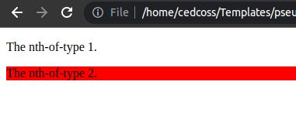

14. :only-of-type : The :only-of-type selector matches every element that is the only child of its type, of its parent.

<!DOCTYPE html>

<html>

<head>

<style>

p:only-of-type {

background: red;

}

</style>

</head>

<body>

<div><p>This is the only p child.</p></div>

<div><p>This is the p child.</p><p>This is the p child.</p></div>

</body>

</html>

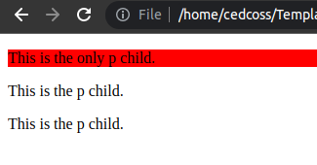

15. :only-child selector : The :only-child selector matches every element that is the only child of its parent.

<!DOCTYPE html>

<html>

<head>

<style>

p:only-child {

background: red;

}

</style>

</head>

<body>

<div><p>This is an only-child.</p></div>

<div><span>This is a span.</span><p>This is a paragraph.</p></div>

</body>

</html>

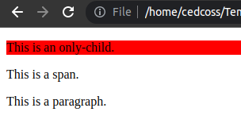

# **Pseudo Elements**

A CSS pseudo-element is a keyword added to a selector that lets you style a specific part of the selected element(s). For example, :: first-line can be used to change the font of the first line of a paragraph.

1. :: after element : The :: after selector inserts something after the content of each selected element(s).

<!DOCTYPE html>

<html>

<head>

<style>

p::after {

content: " ok";

}

</style>

</head>

<body>

<p>My name is aman</p><span>I live in lucknow</span>

<p>I live in lucknow</p>

</body>

</html>

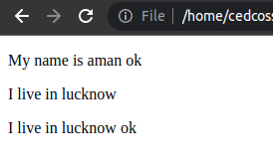

2. :: before : The :: before selector inserts something before the content of each selected element(s).

<!DOCTYPE html>

<html>

<head>

<style>

p::before {

content: "Listen ";

}

</style>

</head>

<body>

<p>My name is aman</p><span>I live in lucknow</span>

<p>I live in lucknow</p>

</body>

</html>

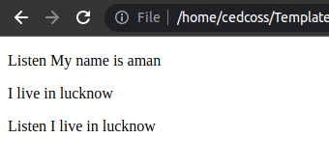

3. :: first-line : The :: first-line selector is used to add a style to the first line of the specified selector.

<!DOCTYPE html>

<html>

<head>

<style>

p::first-line {

background-color: yellow;

}

</style>

</head>

<body>

<p>Lorem ipsum dolor, sit amet consectetur adipisicing elit. Incidunt earum, voluptate corrupti fugit dicta reiciendis provident perferendis id vero aut pariatur consequuntur. Suscipit sequi nesciunt id est ratione maiores deserunt?</p>

</body>

</html>

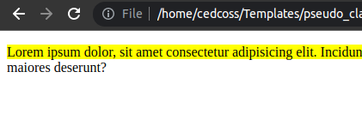

4. :: first-letter : The :: first-letter selector is used to add a style to the first letter of the specified selector.

<!DOCTYPE html>

<html>

<head>

<style>

p::first-letter {

font-size: 200%;

color: #999999;

}

</style>

</head>

<body>

<p>My name is aman.</p>

<p>I live in lucknow.</p>

</body>

</html>

