**Certain Results on Fuzzy *p*-Valent Functions Involving the Linear Operator**

**Abstract:** The idea of fuzzy differential subordination is a generalisation of the traditional idea of differential subordination that evolved in recent years as a result of incorporating the idea of fuzzy set into the field of geometric function theory. In this investigation, we define some general classes of *p*-valent analytic functions defined by the fuzzy subordination and generalizes the various classical results of the multivalent functions. Our main focus is to define fuzzy multivalent functions and discuss some interesting inclusion results and various other useful properties of some subclasses of fuzzy *p*-valent functions, which are defined here by means of a certain generalized Srivastava-Attiya operator. Additionally, links between the significant findings of this study and preceding ones are also pointed out.

**Keywords:** analytic functions; *p*-valent functions; fuzzy differential subordination; generalized Srivastava-Attiya operator

**Definition 1** ([27])**.** *A mapping* F *is said to be fuzzy subset on* Y 6= *φ, if it maps from* Y *to* [0,1]*.*

In other words, it is defined as;

**Definition 2** ([27])**.** *A pair* (*U*,F*U*) *is said to be a fuzzy subset on* Y*, where* F*U* : Y → [0,1] *is the membership function of the fuzzy set* (*U*,F*U*) *and U* = {*x* ∈ Y : 0 *<* F*U*(*x*) ≤ 1} = sup(*U*,F*U*) *is the support of fuzzy set* (*U*,F*U*)*.*

**Definition 3** ([27])**.** *Let U* *and U* *be two subsets of* Y*. Then, U*

*U* *if and only if* F*U*1 (*t*) ≤ F*U*2 (*t*)*, t* ∈ Y*, whereas, U* *and U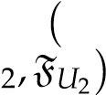 of* Y *are equal if and only if U*1 = *U*2*.*

Miller and Mocanu [28] introduced the subordination technique between two analytic functions h and g as; if h(κ) = g(*κ*(κ)), where *κ*(κ) is a Schwartz function in ∇, then h is subordinate to g, and is denoted by h ≺ g.

The generalization of subordination technique of analytic functions in terms of fuzzy notion was defined by Oros and Oros [5] as the following.

**Definition 4.** *If* h(κ0) = g(κ0) *and* F(h(κ)) ≤ F(g(κ)), (κ ∈ R ⊂ C), *where* κ0 ∈ R *be a fixed point, then* h *is fuzzy subordinate to* g*, and is denoted by* h ≺F g*.*

**Remark 1.** *If* R = ∇ *in the above definition, then the concepts of fuzzy subordination and classical subordination coincides.*

Liu [29] generalized the Srivastava-Attiya operator for multivalent functions. Let *b*when |κ| *<* 1, and *Re*(*s*) *>* 1 when |κ| = 1. This operator *Jsp*,*b* : A*p* → A*p* is given by

*p*

*Js*,*b*f(κ) = *ψp*(*s*, *b*;κ) ∗ f(κ)

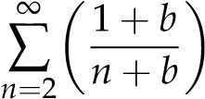*s*

= κ*p* +*an*+*p*−1κ*n*+*p*−1, (2)

where

*ψp*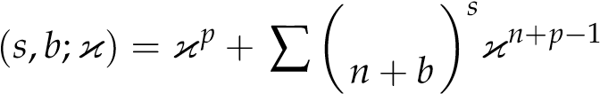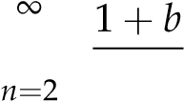 ,

is called generalized Hurwitz-Lerch Zeta function and ” ∗ ” denotes Hadamard product (or convolution).

In particular, for *p* = 1, *ψp*(*s*, *b*;κ) reduces to the Hurwitz-Lerch Zeta function *ψ*(*s*, *b*;κ). This function is investigated by various prominent scholars, referred as [30–34]. *p*

Furthermore, the generalized operator *Js*,*b* coincides with the Srivastava-Attiya operator [35]. This operator contains some well-known integral operators as special cases, for example, Alexander [36], Libera [37], Bernardi [38] and Jung et al. [39]. The following identity can be implied from (2).

. (3)

Now, we introduce the following classes by using the principle of fuzzy subordination.

We denoted by Π, the class of analytic functions g(κ) which are univalent convex functions in ∇ with g(κ) = 1 and *Re*(g(κ)) *>* 0 in ∇. Now, for g(κ) ∈ Π, F : C → [0,1], *b*, *p* ∈ N and *s* ≥ 0, we define:

**Definition 5.** *Let* f ∈ A*p. Then,* f ∈ F*Mαp*(g) *if and only if*

(1 −*p α*) κff(0κ(κ) + *α* (κf00((κκ)))0 ≺F g(κ)*.*

) *p* f

*Furthermore,*

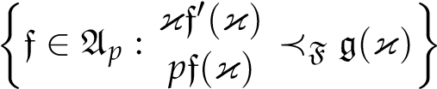*p*

F*M*0 (g) = F*STp*(g) = ,

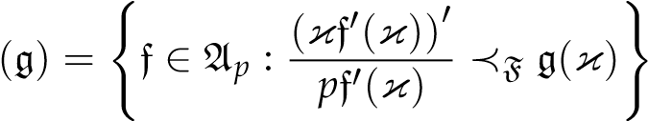*and*

*p*

F*M*1 (g) = F*CVp*.

It is noted that

# κf0

f ∈ F*CVp*(g) ⇔ ∈ F*STp*(g). (4) *p*

Particularly, for g, the classes F*CVp*(g) and F*STp*(g) reduce to the classes F*CVp* and F*STp*, of the fuzzy *p*-valent convex and the fuzzy *p*-valent starlike functions, respectively.

Here, we define some new classes of fuzzy *p*-valent functions involving the operator *p*

*Js*,*b*, given by (2), as the following.

**Definition 6.** *Let* f ∈ A*p, b >* −1 *and s be a real. Then*

F*Mαp*(*s*, *b*;g) = nf ∈ A*p* : *Jsp*,*b*f(κ) ∈ F*Mαp*(g)o*,*

F*STp*(*s*, *b*;g) = nf ∈ A*p* : *Jsp*,*b*f(κ) ∈ F*STp*(g)o*,*

*and*

F*CVp*(*s*, *b*;g) = nf ∈ A*p* : *Jsp*,*b*f(κ) ∈ *FCp*(g)o*.*

*It is clear that*

f ∈ F*CVp*(*s*, *b*;g) ⇔ κf0 ∈ F*STp*(*s*, *b*;g)*.* (5)

*p*

*p p*

*Particularly, if s* = 0*, then* F*Mα*(*s*, *b*;g) = F*Mα*(g)*,* F*STp*(*s*, *b*;g) = F*STp*(g) *and* F*CVp*(*s*, *b*;g) =

*p*

F*CVp*(g)*. Moreover, if p* = 1*, then the classes* F*Mα*(g)*,* F*STp*(g) *and* F*CVp*(g) *reduce to the classes* F*Mα*(g)*,* F*ST*(g) *and* F*CV*(g) *studied by authors in [20].*

## 2. Main Results

The proof of our main findings requires the use of the following lemma.

**Lemma 1** ([8])**.** *Let r*1*, r*2 ∈ C*, r*1 6= 0*, and a convex function* g *satisfies*

*Re*(*r*1g(*t*) + *r*2) *>* 0*, t* ∈ ∇*.*

*If h is analytic in* ∇ *with h*(0) = g(0)*, and 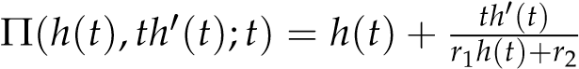 is analytic in* ∇

*with* Π(g(0),0;0) = g(0)*, then*

F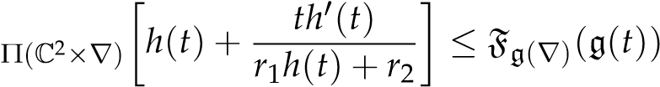

*implies*

F*p*(∇)(*h*(*t*)) ≤ Fg(∇)(g(*t*))*, t* ∈ ∇*.*

*2.1. Inclusion Properties*

**Theorem 1.** *Let* g ∈ Π*, b*, *p* ∈ N*,* 0 ≤ *α* ≤ 1*, and s be a real. Then,*

*p*

F*Mα*(*s*, *b*;g) ⊂ F*STp*(*s*, *b*;g)*.*

**Proof.** Let f ∈ F*Mαp*(*s*, *b*;g), and let

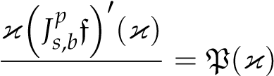*p* , (6)

*pJs*,*b*f(κ)

with P(κ) is analytic in ∇ and P(0) = 1.

We take logarithmic differentiation of (6) to get

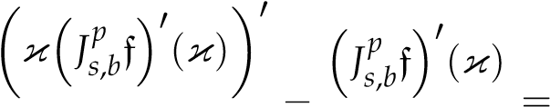 P0(κ)

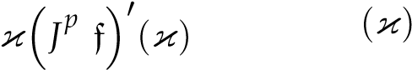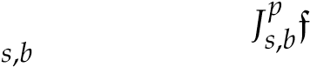 P(κ) .

Equivalently,

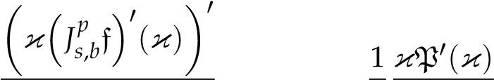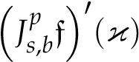 = P(κ) + *p* P(κ) . (7)

*p*

Since f ∈ F*Mαp*(*s*, *b*;g), from (6) and (7), we get

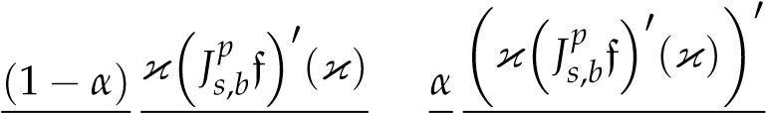

*p Jsp*,*b*f(κ) 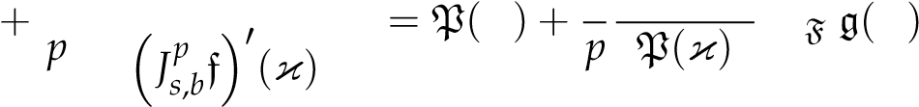κ *α*κP0(κ) ≺ κ . (8)

|  |  |
| --- | --- |
| We obtain P(κ) ≺F g(κ) on making use of (8) along with Lemma 1.  F*STp*(*s*, *b*;g). | Hence, f ∈ |

**Corollary 1.** *When p* = 1*, we get* F*M* F*STbs*(g). *Furthermore, for s* = 0*, we have*

F*Mα*(g) ⊂ F*ST*(g) *and if α* = 1*, then* F*CV*(g) ⊂ F*ST*(g)*. Moreover, for* g*, we obtain* F*CV* ⊂ F*ST.*

**Theorem 2.** *Let* g ∈ Π*, α>* 1*, b*, *p* ∈ N *and s be a real. Then,*

*p*

F*Mα*(*s*, *b*;g) ⊂ F*CVp*(*s*, *b*;g)*.*

**Proof.** Let f ∈ F*Mαp*(*s*, *b*;g). Then, by definition, we write

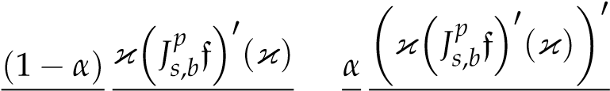 *p Jsp*,*b*f(κ) + *p 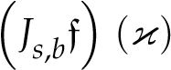p* 0 = *p*1(κ) ≺F g(κ).

Now,



*p* 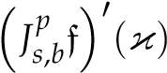 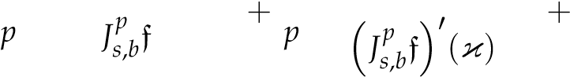(κ) *p Jsp*,*b*f(κ)

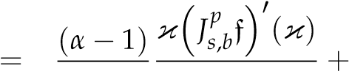 *p Jsp*,*b*f(κ) *p*1(κ).

This implies

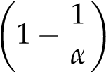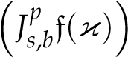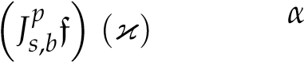 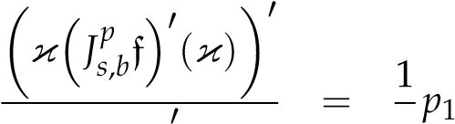(κ) + 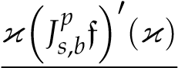

*pp*

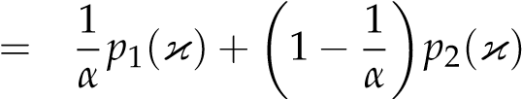.

 Since *p*1, *p*2 ≺F g(κ), 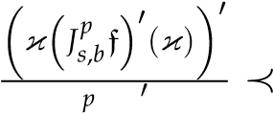F g(κ). This is our required result.

*p*

Particularly, when *p* = 1, we get F*Mαs*,*b*(g) ⊂ F*CVbs*(g). Moreover, if *s* = 0, then F*Mα*(g) ⊂ F*CV*(g) and for g, we obtain F*Mα* ⊂ F*CV*.

**Theorem 3.** *Let* g ∈ Π*,* 0 ≤ *α*1 *<α*2 *<* 1*, b*, *p* ∈ N *and s be a real. Then*

*p p*

F*Mα*2 (*s*, *b*;g) ⊂ F*Mα*1 (*s*, *b*;g)*.*

**Proof.** For *α*1 = 0, it is obviously true from the previous theorem.

Let f ∈ F*Mαp*2 (*s*, *b*;g). Then, by definition, we have

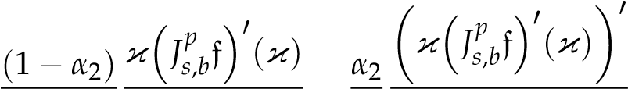 *p Jsp*,*b*f(κ) + *p 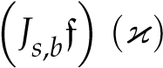p* 0 = *h*1(κ) ≺F g(κ). (9)

Now, we can easily write

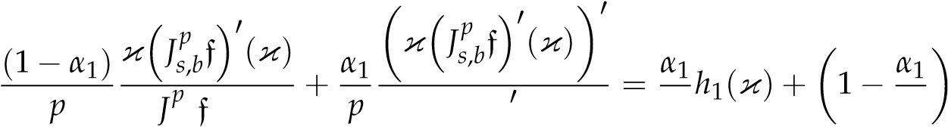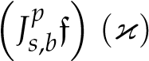*h*2(κ), (10) *s*,*b* (κ)*α*2 *α*2

where we have used (9) and 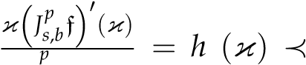*Js*,*b*f(κ) 2 F g(κ). Since *h*1, *h*2 ≺F g(κ), (10) implies

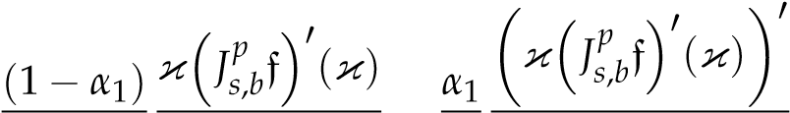 *p Jsp*,*b*f(κ) 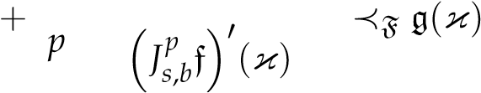. (11)

This proves the theorem.

**Remark 2.** *If α*2 = 1 *and* f ∈ F*M*1*p*(*s*, *b*;g) = F*CVp*(*s*, *b*;g)*, then the previous result gives us*

f ∈ F*Mαp*1 (*s*, *b*;g)*, for* 0 ≤ *α*1 *<* 1*.*

*Thus, on employing Theorem 1, we get* F*CVp*(*s*, *b*;g) ⊂ F*SpT*(*s*, *b*;g)*.*

Now, we discuss certain inclusion results for the subclasses defined in Definition 6.

**Theorem 4.** *Let* g ∈ Π*, s >* 0 *and b*, *p* ∈ N*. Then,*

F*STp*(*s*, *b*;g) ⊂ F*STp*(*s* + 1, *b*;g).

**Proof.** Let f ∈ F*STp*(*s*, *b*;g). Then,

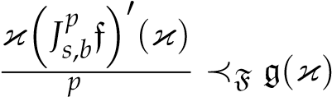.

*pJs*,*b*f(κ)

Now, we set

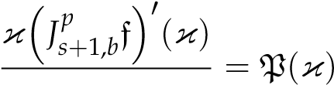*p* , (12)

*pJs*+1,*b*f(κ)

with analytic P(κ) in ∇ and P(0) = 1. From (3) and (12), we get

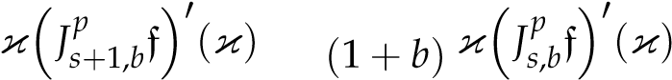 *b*

*pJs*+1,*b*f(κ) *p Jsp*+1,*b*f(κ) − *p*, *p* =

equivalently,

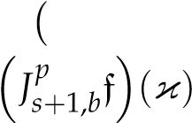*b* = P(κ) + *b* . *pp*

The logarithmic differentiation yields,

κ *Jbs f*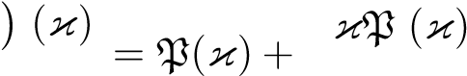0 0 . (13) *p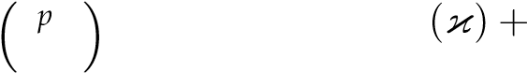 Js*,*b*f (κ) *p*P *b*

|  |  |
| --- | --- |
| Since f ∈ F*STp*(*s*, *b*;g), (13) implies |  |
| P(κ) + (κ) ≺F g(κ). κP0 | (14) |

*p*P(κ) + *b*

We get P(κ) ≺F g(κ) on using (14) along with Lemma 1. Hence, f ∈ F*STp*(*s* + 1, *b*;g).

**Theorem 5.** *Let* g ∈ Π*, s >* 0 *and b*, *p* ∈ N*. Then,*

*p p*

F*CVs*,*b*(g) ⊂ F*CVs*+1,*b*(g).

**Proof.** Let f ∈ F*CVp*(*s*, *b*;g) if and only if

κf0 ∈ F*STp*(*s*, *b*;g), (by (5)), *p*

⇒ κf0 ∈ F*STp*(*s* + 1, *b*;g), (by using Theorem 4), *p*

⇔ f ∈ F*CVp*(*s* + 1, *b*;g), (by using (5)).

In particular, for *p* = 1, we get the following result proved in [20] from the above theorems.

**Corollary 2.** *Let b* ∈ N*, s >* 0*, and let* g ∈ Π*. Then,*

F*STbs*(g) ⊂ F*STbs*+1(g)

*and*

F*CVbs*(g) ⊂ F*CVbs*+1(g).

*2.2. Properties Involving Integral*

**Theorem 6.** *Let* f ∈ A*p. Then,* f ∈ F*Mαp*(*s*, *b*;g)*, α* 6= 0*, if and only if there exists ξ* ∈ F*STp*(*s*, *b*;g) *such that*

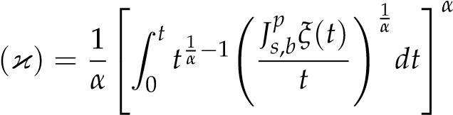*p*

*Js*,*b*f*.* (15)

**Proof.** Let f ∈ F*Mαp*(*s*, *b*;g). Then,

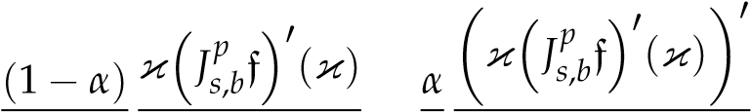 *p Jsp*,*b*f(κ) 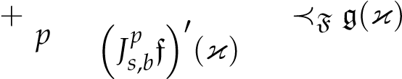. (16)

On some simple calculations of (15), we get

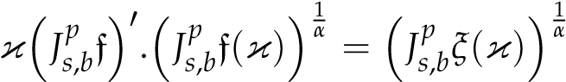. (17)

We take logarithmic differentiation and have

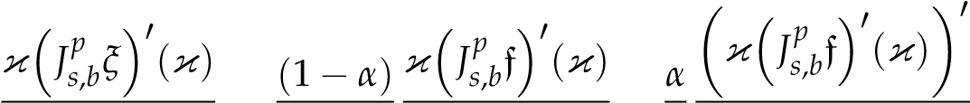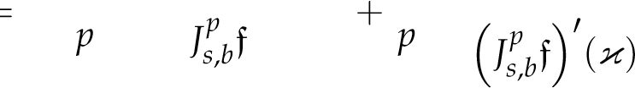*p*. (18) *pJs*,*bξ*(κ) (κ)

Our required result implies from (18).

When *p* = 1 and *s* = 0. We get the following result.

**Corollary 3** ([20])**.** *Let* f ∈ *A. Then,* f ∈ F*Mα*(g)*,* (*α* 6= 0)*, if and only if there exists ξ*0 ∈ F*ST*(g) *such that*

f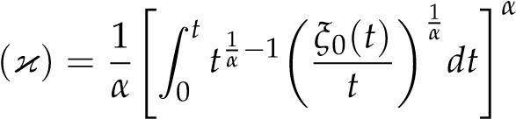*.*

**Theorem 7.** *Let* f ∈ F*Mαp*(*s*, *b*;g)*, and define*

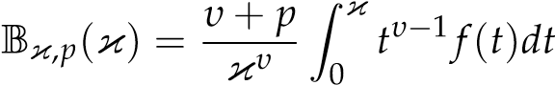. (19)

*Then,* B*υ*,*p* ∈ F*STp*(*s*, *b*;g)*.*

**Proof.** Let f ∈ F*Mαp*(*s*, *b*;g) and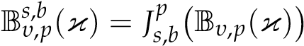. We assume

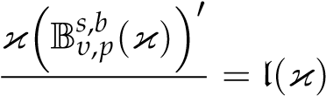

*p s*,*b* (κ) , (20)

B*υ*,*p*

where l(κ) is analytic in ∇ with l(0) = 1.

From (19), we obtain

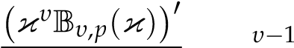= κ f(κ).

|  |  |
| --- | --- |
| This implies | *υ* + *p* |

. (21)

We use (2), (20) and (21), to get

l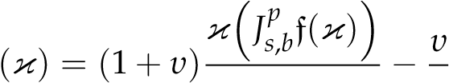, *p* *p*

We take logarithmic differentiation and obtain

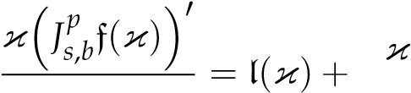l0(κ)

*pJs*,*b*f(κ) *p*l(κ) + *υ*. (22) *p*

Since f ∈ F*Mαp*(*s*, *b*;g) ⊂ F*STp*(*s*, *b*;g), (22) implies

l(κ) + *p*lκ(κl0() +κ)*υ* ≺F g(κ).

We obtain our required result by employing Lemma 1.

For *p* = 1, we have the following result.

**Corollary 4** ([20])**.** *Let* f ∈ F*Mαs*,*b*(g)*, and define*

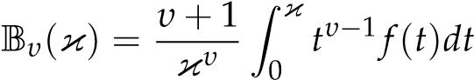.

*Then,* B*υ* ∈ F*STbs*(g)*.*

## 3. Conclusions

The concept of a fuzzy subset is used to define certain subclasses of multivalent functions. We have applied the generalized Srivastava-Attiya operator and introduced several new classes. Various properties such as, inclusion properties and properties involving integral are examined. Some proved results are also deduced from our investigations.

**Author Contributions:** Conceptualization, S.A.S. and M.V.-C.; methodology, E.E.A., A.M.A. and

M.V.-C.; validation, M.V.-C., A.M.A. and S.A.S.; formal analysis, M.V.-C. and E.E.A.; investigation, S.A.S., A.M.A. and M.V.-C.; writing–original draft preparation, S.A.S., E.E.A. and A.M.A.; writing– review and editing, A.M.A., M.V.-C. and E.E.A.; supervision, M.V.-C. and S.A.S. All authors have read and agreed to the published version of the manuscript.

**Funding:** This research received no external funding.

**Data Availability Statement:** Not applicable.

**Acknowledgments:** Pontificia Universidad Católica del Ecuador, project: “RESULTADOS CUALITATIVOS DE ECUACIONES DIFERENCIALES FRACCIONARIAS LOCALES Y DESIGUALDADES INTEGRALES” , with code 070-UIO-2022.

**Conflicts of Interest:** The authors declare no conflict of interest.

## References

1. Zadeh, L.A. Fuzzy Sets. *Inf. Control* **1965**, *8*, 338–353.
2. Oros, G.I.; Oros, G. The notion of subordination in fuzzy sets theory. *Gen. Math.* **2011**, *19*, 97–103.
3. Miller, S.S.; Mocanu, P.T. Second order-differential inequalities in the complex plane. *J. Math. Anal. Appl.* **1978**, *65*, 298–305.
4. Miller, S.S.; Mocanu, P.T. Differential subordinations and univalent functions. *Michigan Math. J.* **1981**, *28*, 157–171.
5. Oros, G.I.; Oros, G. Fuzzy differential subordination. *Acta Univ. Apul.* **2012**, *3*, 55–64.
6. Dzitac, I.; Filip, F.G.; Manolescu, M.J. Fuzzy Logic Is Not Fuzzy: World-renowned Computer Scientist Lotfi A. Zadeh. *Int. J. Comput. Commun. Control* **2017**, *12*, 748–789. [[CrossRef]](http://doi.org/10.15837/ijccc.2017.6.3111)
7. Oros, G.I.; Oros, G. Dominants and best dominants in fuzzy differential subordinations. *Stud. Univ. Babes-Bolyai Math.* **2012**, *57*, 239–248.
8. Oros, G.I.; Oros, G. Briot-Bouquet fuzzy differential subordination. *Anal. Univ. Oradea Fasc. Math.* **2012**, *19*, 83–87.
9. Haydar, E.A. On fuzzy differential subordination. *Math. Moravica* **2015**, *19*, 123–129. [[CrossRef]](http://dx.doi.org/10.5937/MatMor1501123H)
10. Lupas, A.A. A note on special fuzzy differential subordinations using generalized Salagean operator and Ruscheweyh derivative. *J. Comput. Anal. Appl.* **2013**, *15*, 1476–1483.
11. Lupas, A.A.; Oros, G. On special fuzzy differential subordinations using Salagean and Ruscheweyh operators. *Appl. Math. Comput.* **2015**, *261*, 119–127.
12. Lupas, A.A. A note on special fuzzy differential subordinations using multiplier transformation and Ruschewehy derivative. *J. Comput. Anal. Appl.* **2018**, *25*, 1116–1124.
13. Venter, A.O. On special fuzzy differential subordination using Ruscheweyh operator. *An. Univ. Oradea Fasc. Mat.* **2015**, *22*, 167–176.
14. Wanas, A.K.; Majeed, A.H. Fuzzy differential subordination properties of analytic functions involving generalized differential operator. *Sci. Int.* **2018**, *30*, 297–302.
15. Lupas, A.A.; Cãtas, A. Fuzzy Differential Subordination of the Atangana-Baleanu Fractional Integral. *Symmetry* **2021**, *13*, 1929.
16. Lupas, A.A.; Shah, S.A.; Iambor, L.F. Fuzzy differential subordination and superordination results for q-analogue of multiplier transformation. *AIMS Math.* **2023**, *8*, 15569–15584.
17. Oros, G.I. Fuzzy Differential Subordinations Obtained Using a Hypergeometric Integral Operator. *Mathematics* **2021**, *20*, 2539.
18. Oros, G.I. New fuzzy differential subordinations. *Comm. Fac. Sci. l’Univ. d’Ankara Ser. A1 Math. Stat.* **2007**, *70*, 229–240.
19. Oros, G.I. Univalence criteria for analytic functions obtained using fuzzy differential subordinations. *Turk. J. Math.* **2022**, *46*, 1478–1491.
20. Shah, S.A.; Ali, E.E.; Maitlo, A.A.; Abdeljawad, T.; Albalahi, A.M. Inclusion results for the class of fuzzy *α*-convex functions. *AIMS Math.* **2022**, *8*, 1375–1383.
21. Srivastava, H.M.; El-deeb, S.M. Fuzzy Differential Subordinations Based upon the Mittag-Leffler Type Borel Distribution. *Symmetry* **2021**, *13*, 1023. [[CrossRef]](http://dx.doi.org/10.3390/sym13061023)
22. El-Deeb, S.M.; Lupas, A.A. Fuzzy differential subordinations associated with an integral operator. *An. Univ. Oradea Fasc. Mat.* **2020**, *27*, 133–140.
23. El-Deeb, S.M.; Khan, N.; Arif, M.; Alburaikan, A. Fuzzy differential subordination for meromorphic function. *Axioms* **2022**, *11*, 534. [[CrossRef]](http://dx.doi.org/10.3390/axioms11100534)
24. Shah, S.A.; Ali, E.E.; Catas, A.; Albalahi, A.M. On fuzzy differential subordination associated with *q*-difference operator. *AIMS Math.* **2023**, *8*, 6642–6650. [[CrossRef]](http://dx.doi.org/10.3934/math.2023336)
25. Azzam, A.F.; Shah, S.A.; Alburaikan, A.; El-Deeb, S.M. Certain Inclusion Properties for the Class of *q*-Analogue of Fuzzy *α*-Convex Functions. *Symmetry* **2023**, *15*, 509. [[CrossRef]](http://dx.doi.org/10.3390/sym15020509)
26. Azzam, A.A.; Shah, S.A.; Catas, A.; Cotîrla, L.-I. On Fuzzy Spiral-Like Functions Associated with the Family of Linear Operators. *Fractal Fract.* **2023**, *7*, 145. [[CrossRef]](http://dx.doi.org/10.3390/fractalfract7020145)
27. Gal, S.G.; Ban, A.I. *Elemente de Matematica˘ Fuzzy*; Editura Universita˘¸tii din Oradea: Romania, Balkans, 1996. (In Romanian) 28. Miller, S.S.; Mocanu, P.T. *Differential Subordinations Theory and Applications*; Marcel Dekker: New York, NY, USA; Basel, Switzerland, 2000.
28. Liu, J.L. Subordinations for certain multivalent analytic functions associated with the generalized Srivastava-Attiya operator. *Integral Transform. Spec. Funct.* **2008**, *19*, 893–901. [[CrossRef]](http://dx.doi.org/10.1080/10652460802357687)
29. Choi, J.; Srivastava, H.M. Certain families of series associated with the Hurwitz–Lerch Zeta function. *Appl. Math. Comput.* **2005**, *170*, 399–409. [[CrossRef]](http://dx.doi.org/10.1016/j.amc.2004.12.004)
30. Murugusundaramoorthy, G. A Subclass of Analytic Functions Associated with the Hurwitz-Lerch Zeta Function. *Hacet. J. Math. Stat.* **2010**, *39*, 265–272.
31. Lin, S.D.; Srivastava, H.M. Some families of the Hurwitz–Lerch Zeta functions and associated fractional derivative and other integral representations. *Appl. Math. Comput.* **2004**, *154*, 725–733. [[CrossRef]](http://dx.doi.org/10.1016/S0096-3003(03)00746-X)
32. Lin, S.D.; Srivastava, H.M.; Wang, P.Y. Some expansion formulas for a class of generalized Hurwitz–Lerch Zeta functions. *Integral Transform. Spec. Funct.* **2006**, *17*, 817–827. [[CrossRef]](http://dx.doi.org/10.1080/10652460600926923)
33. Luo, Q.M.; Srivastava, H.M. Some generalizations of the Apostol–Bernoulli and Apostol–Euler polynomials. *J. Math. Anal. Appl.* **2005**, *30*, 290–302. [[CrossRef]](http://dx.doi.org/10.1016/j.jmaa.2005.01.020)
34. Srivastava, H.M.; Attiya, A.A. An integral operator associated with the Hurwitz-Lerch zeta function and differential subordination. *Integral Transform. Spec. Funct.* **2007**, *18*, 207–216. [[CrossRef]](http://dx.doi.org/10.1080/10652460701208577)
35. Alexander, J.W. Functions which map the interior of the unit circle upon simple regions. *Ann. Math. Ser. 2* **1915**, *17*, 12–22. [[CrossRef]](http://dx.doi.org/10.2307/2007212)
36. Libera, R.J. Some classes of regular univalent functions. *Proc. Am. Math. Soc.* **1969**, *16*, 755–758. [[CrossRef]](http://dx.doi.org/10.1090/S0002-9939-1965-0178131-2)
37. Bernardi, S.D. Convex and starlike univalent functions. *Trans. Am. Math. Soc.* **1969**, *135*, 429–446. [[CrossRef]](http://dx.doi.org/10.1090/S0002-9947-1969-0232920-2)
38. Jung, I.B.; Kim, Y.C.; Srivastava, H.M. The Hardy space of analytic functions associated with certain oneparameter families of integral operators. *J. Math. Anal. Appl.* **1993**, *176*, 138–147. [[CrossRef]](http://dx.doi.org/10.1006/jmaa.1993.1204)

**Disclaimer/Publisher’s Note:** The statements, opinions and data contained in all publications are solely those of the individual author(s) and contributor(s) and not of MDPI and/or the editor(s). MDPI and/or the editor(s) disclaim responsibility for any injury to people or property resulting from any ideas, methods, instructions or products referred to in the content.