Science Quest 2026
PROJECT PROPOSAL FORM

Name of School: Sir Leckraz Teelock State Secondary School

Category: Category 3

Project Title: Intelligent object recognition glasses

(Note - Your project proposal should include the following: Introduction, aims/ objectives, proposed methods/ experiments/ materials to be used, expected outcome).

1.0 Introduction (background, rationale of project)

Visually impaired individuals often face difficulties in identifying objects and obstacles around them, and traditional assistive tools provide limited information. Recent advances in artificial intelligence and wearable technology make it possible to detect objects in real time and convert visual data into audio feedback. The system promotes accessibility, independence, and safety while demonstrating how AI and coding can be applied to solve real-world problems.

(2 Marks)

2.0 Aims & Objectives

The aim of this project is to design a smart spectacle that can detect objects in front of the user and provide real-time audio feedback. The objectives are to enable object recognition, integrate a camera, microphone, and small speaker into a compact wearable design, convert detected objects into clear voice output, and create a hands-free, user-friendly device that enhances safety, accessibility, and independence.

(3 Marks)

3.0 Proposed methods/ experiments/ materials

The smart spectacles will be developed using a Raspberry Pi 4 as the main processing unit. A 1080p camera mounted on the spectacles will capture real-time images of the surroundings. These images will be processed using Gemini Live AI, which is capable of real-time visual understanding and object recognition. Gemini Live AI will analyze the visual data to identify objects, obstacles, and their relevance to the user’s movement. A Time-of-Flight (ToF) sensor will be used to measure the distance between the user and nearby obstacles, enhancing depth awareness and safety. Once an object is detected, the information will be converted into clear spoken feedback using a text-to-speech system and delivered through a small speaker integrated into the spectacles. Experimental testing will be carried out in indoor and outdoor environments to evaluate detection accuracy, response time, distance measurement reliability, and audio clarity. The system’s performance will be improved through repeated testing and calibration to ensure reliable assistance for visually impaired users.

List of Materials:
- Raspberry Pi 4
- 1080p Camera
- Speaker
- Microphone
- Power Supply for Raspberry Pi
- SD Card for PI OS
- Jumper Wires
- Time of Flight Sensor

// PHOTO //

(10 Marks)

4.0 Expected Outcomes (Impact on school/locality)

Locality
Greater Independence: Provides visually impaired locals with a low-cost tool for safer, independent navigation.

Tech Accessibility: Proves that high-end AI solutions can be built affordably for the local community.

Social Awareness: Highlights the importance of using technology to solve local accessibility barriers.

School
STEM Leadership: Inspires students to apply Python and AI to solve real-world human problems.

Innovation Culture: Encourages the school to adopt more hands-on, hardware-based coding projects.

Peer Learning: Serves as a practical model for students to learn about computer vision and "Edge AI."

(5 Marks)

Additional marks: Relevance to title, originality, creativity & Innovation
(To be assessed by the Jury Panel) (5 Marks)

Total marks: 25

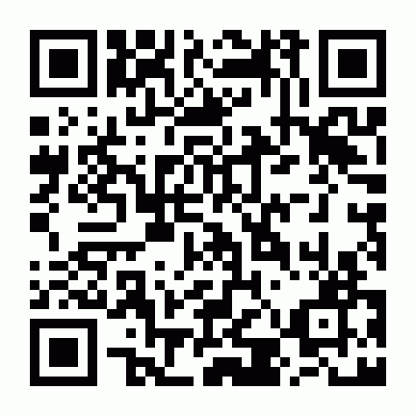

Scan the QR Code to register and upload your project proposal form.
Deadline: 16 February 2026
Contact us on education@rgsctf.org

