Bug Report Summarization Using Fuzzy Analysis

Abstract:

Introduction:

Approach:

Proposed System:
The proposed method builds a system to perform automatic summarization of bug reports through sentence scoring based on fuzzy logic.
- A Bug Report Corpus is created.
- The noisy text from each bug report is passed through a data pre-processor and high quality text is obtained.
- For each sentence in the bug report, a feature score vector is calculated. Feature score is based on eight features namely, title score, length score, term-weight score, sentence position score, sentence to sentence similarity score, proper noun score, thematic word score and numeric data score. Each of these features is explained in details in the following section.
- These feature scores are then normalized to range [0, 1].
- These normalized feature vectors are passed through the fuzzy analyser to obtain sentence ranking. A set of fuzzy rules is defined for calculating sentence rank.
- Obtained sentence ranks are used to construct the summary document based on the summary ratio.

System Architecture:

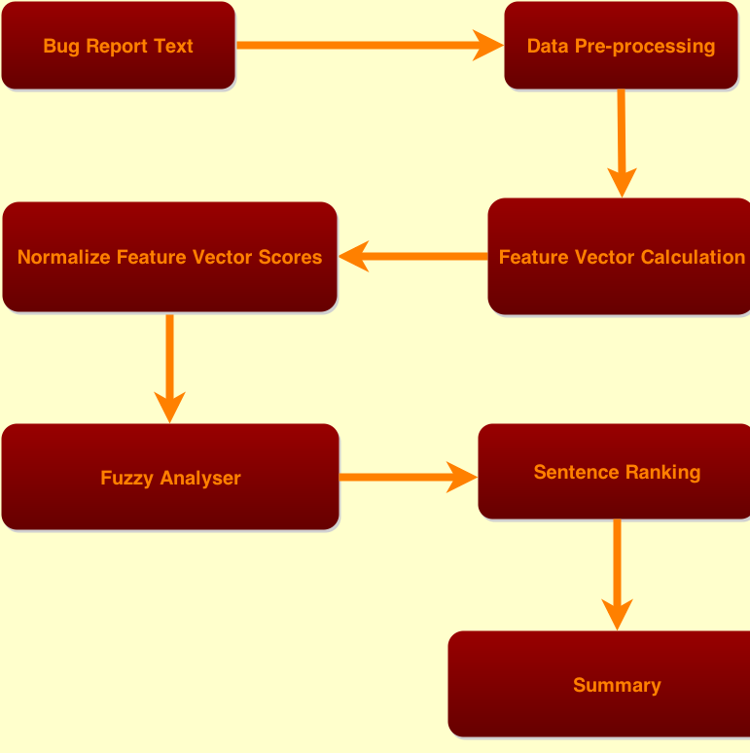
Bug Report Corpus:
A Bug Report Corpus was created by crawling Eclipse Bug Repository. The Crawled bug reports were parsed and stored in a database.

Data Pre-Processing:
Bug Report data was preprocessed in four steps:
- Sentence Segmentation/Tokenization: The entire text was broken into sentences and each sentence stored separately.
- Word Tokenization: Each sentence was broken into a series of words and stored.
- StopWords Removal: Stop words were removed from the each sentence.
- Stemming: Word stemming was performed on each sentence.

Feature Extraction
We have used eight features for each sentence, namely,. title resemblance, sentence length, term frequency, sentence position, sentence to sentence similarity , proper noun, thematic words and numerical data.
- Title feature: The ratio of the number of words in the sentence that occur in the title over the number of words in title. A sentence with higher title score is more important.
- Sentence length: The ratio of the number of words occurring in the sentence over the number of words occurring in the longest sentence of the document. The longer the sentence the more it belongs in the summary.
- Term weight: The ratio of the summary of all terms weight in the sentence over the maximum summary of the terms weight of the sentence in document. TF-ISF(Term Frequency – Inverse Sentence Frequency).
- Sentence position: The first 5 sentences in a paragraph has a score value of 5/5 for first sentence, the second sentence has a score 4/5, and so on.
- Sentence to Sentence Similarity: For a sentence s, the similarity between s and all other sentences is computed by the cosine similarity measure. The score of this feature for a sentence is obtained by computing the ratio of the summation of sentence similarity of a sentence s with each of the other sentences over the maximum value sentence similarity.
- Proper noun: The ratio of the number of proper nouns in sentence over the sentence length.
- Thematic word: The ratio of the number of thematic words in the sentence over the maximum summary of thematic words of the sentence in document.
- Numerical data: The ratio of the number of numerical data in sentence over the sentence length.

Fuzzy Analyser
Fuzzy Analyser is a system based on fuzzy logic. The trapezoidal membership function is used for fuzzification since it has been used in various systems that make use of fuzzy model [25]. It has to two parts:
- Fuzzification:
Input given to the fuzzy inference system is fuzzified, and the fuzzified value is later defuzzified to obtain an output. First, the normalized feature scored are used as input to the fuzzy inference system. The score of the eight features lies between 0 and 1. These input variables are fuzzified into three fuzzy sets namely Poor, Good and Excellent using the trapezoidal membership function. Fuzzy system makes use of a set of fuzzy rules to categorize the sentence into one of the output variables. The ‘if’ part of a rule is called the rule antecedent, and is a description of a process state in terms of a logical combination of atomic fuzzy propositions. The ‘then’ part of the rule is called the rule consequent and is a description of the control output in terms of logical combinations of fuzzy propositions.
A sample of the IF-THEN rules is given in equation:
IF (TitleScore IS Excellent) AND (ThematicWordScore IS Excellent) AND ((S2SSimilarityScore IS Good) OR (LengthScore IS Good) OR (LengthScore IS Excellent)
OR (S2SSimilarityScore IS Excellent)) THEN (SentenceRank IS High);
- Defuzzification:
The fuzzy system defuzzifies every sentence into one of the three outputs variables namely Low, Average, and High. These outputs are used to generate summary.

After the sentences are categorized, sentences are picked according to their ranks. The number of sentences picked depends on the summary ratio here taken as 30 percent.

If a bug report contains 17 sentences then the summary should contain 5 sentences. First the high ranked sentences are taken, if the number of high ranked sentences is short then the average ranked sentences are considered and then the low ranked.

Discussion:

Future Work:

References:

Rubens, N.O.: The Application of Fuzzy Logic To The Construction Of The Ranking
Function of Information Retrieval Systems. Computer Modelling and New Technolo-
gies 10(1), 20–27 (2006)

Suanmali, L., Binwahlan, M.S., Salim, N.: Sentence Features Fusion for Text Summariza-
tion using Fuzzy Logic. In: Proceedings of Ninth International Conference for Text Sum-
marization Using Fuzzy Logic, pp. 142–146 (2009)

