**Note: Screen Shots are also added to the document**

**Project Proposal: LetsChat Mobile Application**

**Muhammad AmanUllah Khan L1F21BSSE0335**

**Muhammad Nabeel L1F21BSSE0344**

**Nabeel Amir L1F21BSSE0337**

**Muhammad Bilal L1F21BSSE0339**

**GitHub Link: Click Here for**  [LetsChat GitHub Repository](https://github.com/amankhan-hub/LetsChat)

**1. Introduction:**

LetsChat is a mobile app designed for easy and secure communication within personalized friend circles. Users can authenticate using their email and password via Firebase, ensuring a smooth login experience. The app also validates email addresses to ensure they match the standard format (e.g., [abc@gmail.com](mailto:abc@gmail.com)).

**2. Objectives:**

* Create a user-friendly chat application for personalized friend circles.
* Implement Firebase authentication for secure login and registration.
* Ensure email validation to maintain data integrity.
* Store user data securely in Firebase Database upon registration.
* Enable users to manage profiles, including status updates, profile pictures, and display names.
* Design a navigation bar for easy access to friends' profile information.
* Provide a camera feature in the navigation bar for users to take and update profile pictures within the app.
* Implement a logout feature with an alert confirmation for a seamless user experience.

**3. Features:**

1. **Authentication:**

* Secure login and registration using Firebase Authentication.
* Validate email addresses to conform to standard formats.

1. **User Management:**

* Allow users to register and join their personalized chat circle upon registration.
* Store user profiles in Firebase Database for efficient data management.

1. **Profile Management:**

* Enable users to update their status messages to reflect availability.
* Provide options to change profile pictures and display names for personalization.

1. **Navigation and Interface:**

* Develop an intuitive interface with a navigation bar for easy access to various app functionalities.
* Include a camera icon in the navigation bar to allow users to take and update profile pictures seamlessly.

1. **Logout Functionality:**

* Implement a logout button with an alert dialog for user confirmation.
* Ensure secure logout to maintain data privacy.

**4. Technologies and Tools:**

* Development Platform: Android Studio
* Backend: Firebase (Authentication, Realtime Database)
* Programming Languages: Java for Android development
* UI/UX Design: Material Design guidelines for a modern and intuitive interface

**Screenshots:**

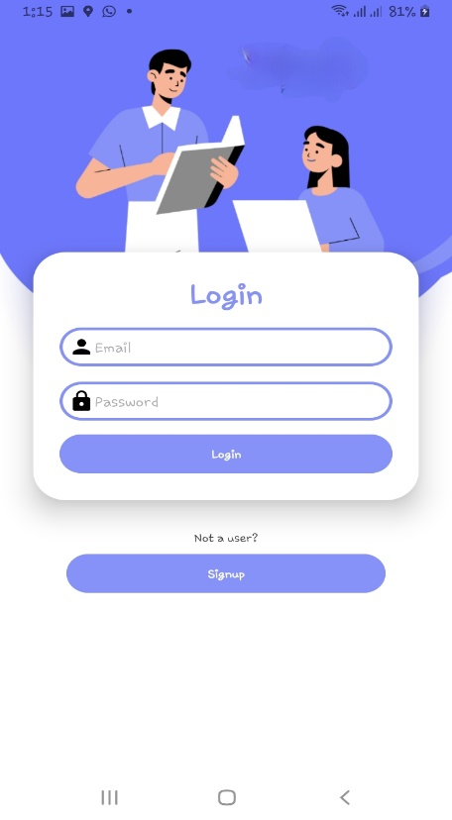 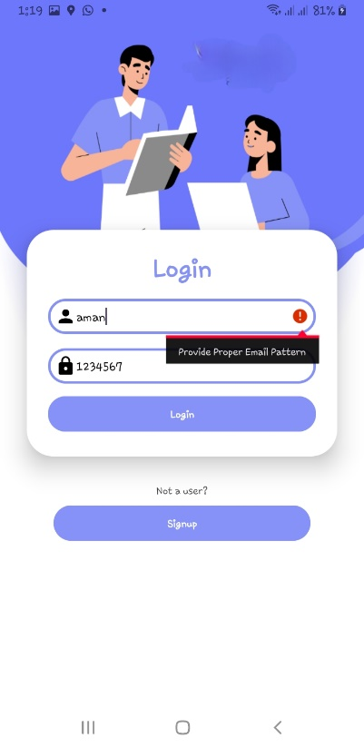

1. **Login Page 2. Login Format Checking**

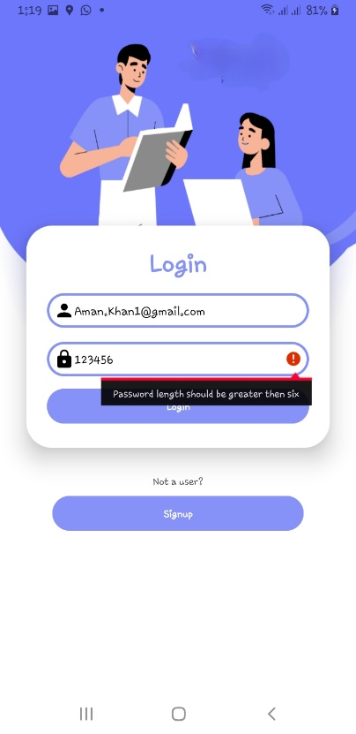 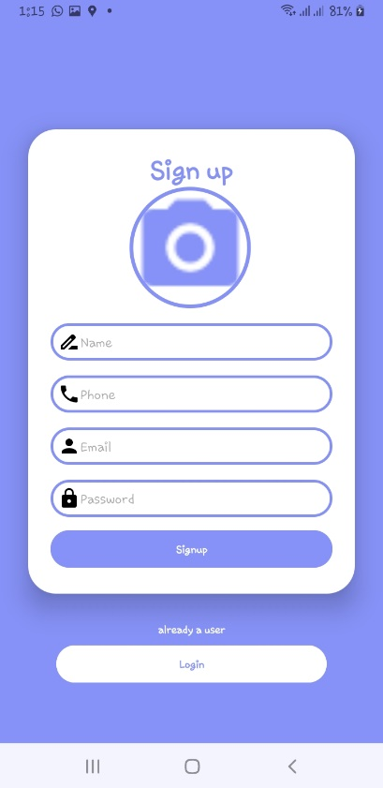

**3. Login Password Checking 4. Registration Page**

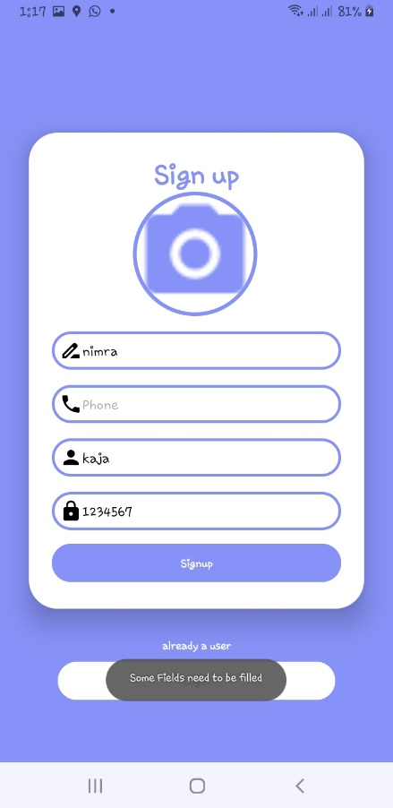 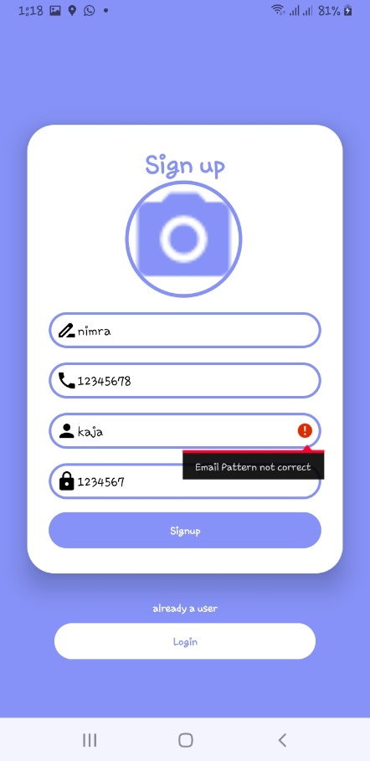

**5. Field Filled or not 6. Email Pattern being Checked**

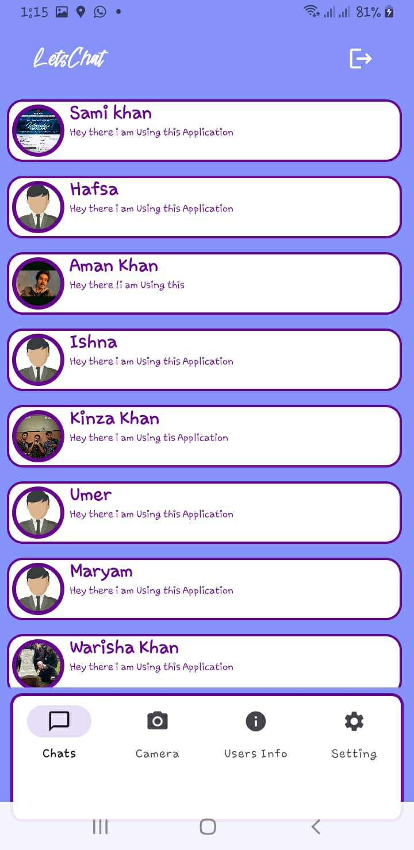 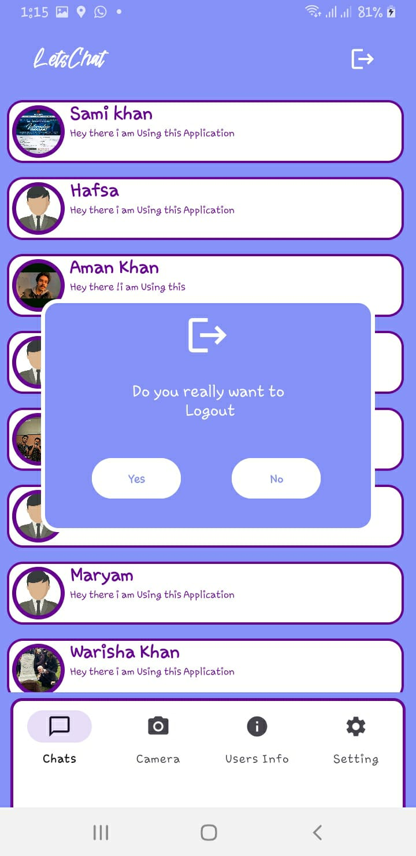

1. **People Available in Circle 8. Logout or Stay Logged in Process**

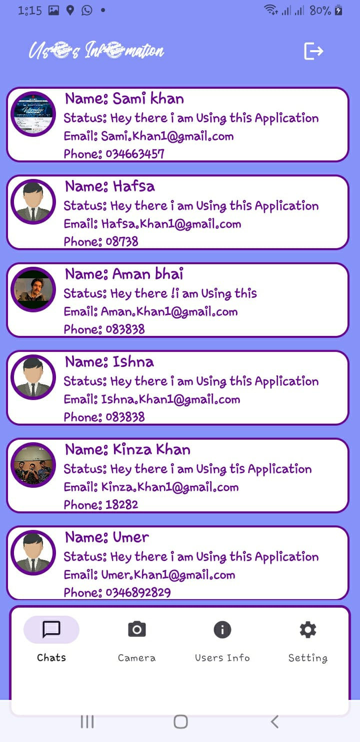 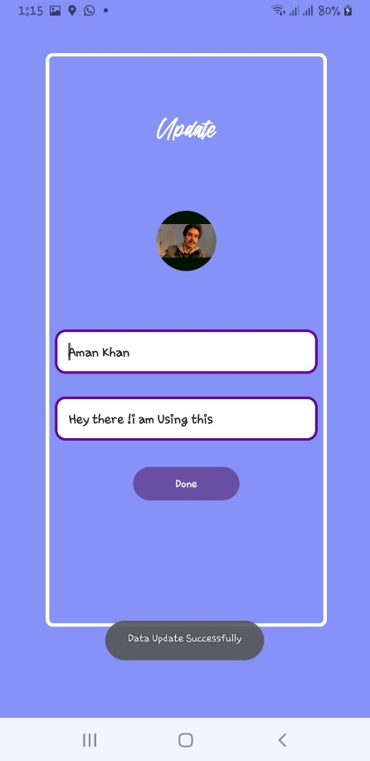

**9.Circle Information 10. Edit Status, Picture or Name**

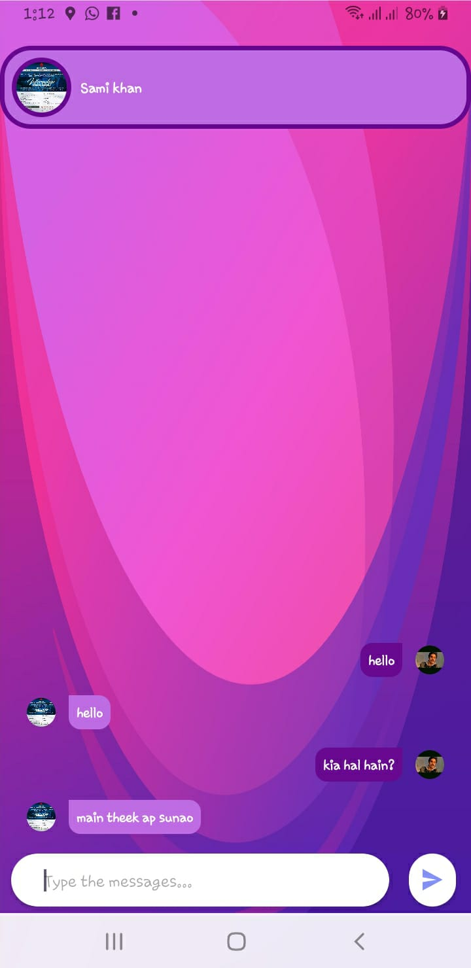 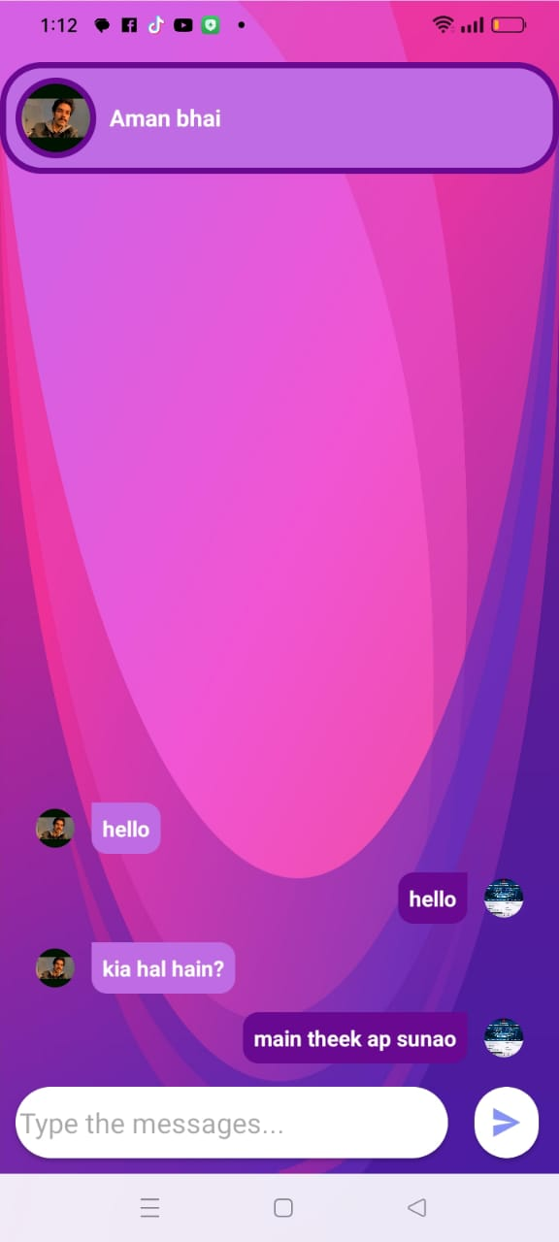

**11. Chat Window Receiver Side 12. Chat Window Sender Side**