Agentic AI Admission Assistant: An Intelligent Predictive System for Student Admission Analysis using Gemini LLM and FastAPI
Aman Khan, Ayush Nimbalkar, Indraneal Sajjankar, Sarthak Chakurkar
Department of Computer Science and Engineering, MIT School of Computing, MIT-ADT University, Loni, Pune, India
Email: amankhan10230@gmail.com, ayushnimbalkar857@gmail.com, Nealann101169@gmail.com, sarthakchakurkar21@gmail.com

Abstract—Choosing a college and course is difficult for many students because programs, eligibility rules, and levels of competition differ widely between institutions. Conventional counseling and static admission portals seldom give individual, data-based feedback on a student’s chances. This paper presents the Agentic AI Admission Assistant, a system that combines Google’s Gemini large language model (LLM), a LangGraph agent workflow, and a FastAPI backend. From a student’s name, target course, and marks, the system computes an admission score, generates a personalized advisory message, and, when the score falls below a set threshold, sends an automated alert for counselor follow-up. Results are stored in MongoDB Atlas, and n8n connects the backend to Google Sheets and email delivery through SendGrid. The score itself comes from a simple rule-based calculation, while the LLM supplies the explanation and recommendations, giving a hybrid design that is both interpretable and conversational. [VERIFY: your original abstract spoke of “accurate admission predictions” and “probabilistic analysis”. The score is rule-based and no accuracy evaluation is reported, so this wording was toned down. Add one sentence of quantitative results if you have them]
Keywords—Agentic AI, Gemini LLM, predictive analytics, admission prediction, educational technology, FastAPI, student counseling

1. Introduction
Applying to college has become more complex and competitive. Students must compare many programs, each with its own eligibility criteria and admission standards. Traditional counseling depends largely on manual guidance and general advice, which may not reflect an individual student’s background, interests, and potential. Without personalized input, students can end up confused, miss opportunities, or decide with too little information at an important point in their education. [CITATION NEEDED: add a source on the difficulty of admission decisions or the limits of traditional counseling]
Online portals and information websites usually present fixed details on admission requirements. They do not analyze a student’s own performance or suggest suitable academic paths, and they often cannot account for factors such as recent academic trends, student interests, or how competitive a particular institution is. [CITATION NEEDED: this is a claim about existing systems; support it with references or reword it as the authors’ observation] There is therefore a need for a conversational system that estimates admission chances and also gives contextual feedback and practical recommendations.
To meet this need, this work introduces the Agentic AI Admission Assistant, built on Google’s Gemini LLM and exposed through FastAPI. The system estimates an admission likelihood from inputs such as marks and target course, and then produces personalized, encouraging feedback in the manner of a human academic counselor. The agentic design lets the system carry out its steps with little manual intervention: it analyzes the student’s data, reasons over the result, and generates advice [1], [6]. [VERIFY: your original text also mentions “institutional competitiveness” as an input; the described implementation uses only marks and target course. Confirm and adjust]
The main contributions of this paper are:
- a hybrid design that pairs a transparent, rule-based admission score with LLM-generated advisory feedback;
- an agent workflow built with LangGraph and Gemini that decides when to send a counselor alert; and
- an automated pipeline, using FastAPI, n8n, SendGrid, and MongoDB Atlas, that links data entry in Google Sheets to prediction, email notification, and record keeping.
The rest of the paper is organized as follows. Section 2 reviews related work, Section 3 describes the methodology, Section 4 explains the implementation, Section 5 presents results and future work, and Section 6 concludes.

2. Literature Review
Artificial intelligence (AI) has spread quickly through higher education. A systematic review of the field identified assessment, prediction of student success, intelligent tutoring, and AI assistants as the main areas of use [11]. [[V: reference [11] is a bare web link copied from your original; add its authors, title, and publication details after reading the source]]

2.1 Predictive Analytics in Admissions
Institutions increasingly use predictive analytics to forecast application outcomes and enrollment, drawing on historical student data and statistical or machine learning models [12]. These models usually take numeric inputs such as grades, test scores, and demographic data, and return a probability of enrollment or retention. They generally offer little explanation of their reasoning, personalized advice, or conversational guidance. [[V: reference [12] is a trade website article; where possible, support this paragraph with peer-reviewed sources]]

2.2 Conversational AI and Student Support Systems
Chatbots and intelligent tutoring systems have been used to help students with course selection, academic guidance, and administrative questions [11]. They make advisory services more engaging and accessible, but many depend on scripted dialogues or fixed rules. LLMs, by comparison, can respond in natural language with more attention to context and can generate tailored answers dynamically. [CITATION NEEDED: add a source on LLM capabilities in educational guidance]

2.3 Agentic AI in Educational Decision Support
Agentic AI refers to systems that do more than react to input: they plan, reason, and act with a degree of autonomy [1], [5], [6]. Related work covers task decomposition and role assignment among cooperating agents [7], collaboration among several LLMs [9], privacy and security in multi-agent settings [8], agent-based infrastructure [10], and applications in data analytics [3] and administrative automation. [CITATION NEEDED: add the Daoud et al. paper listed in Table I to the references] In education, such a system could analyze a student’s profile, predict an outcome, give advice, and start follow-up actions. Studies on AI in admissions, course scheduling, and dropout risk also raise concerns about transparency and bias [13]. Combining analytical models with narrative feedback, that is, moving from prediction to agentic guidance, remains little explored. [[V: reference [13] is a bare arXiv link copied from your original; confirm that it supports this sentence and add its full details]]

2.4 Research Gaps
Existing systems tend to treat prediction and conversational support separately. Few frameworks combine:
- probabilistic admission modeling,
- conversational reasoning with LLMs, and
- adaptive, personalized counseling feedback.
Ethical concerns add to this gap. For instance, AI scoring of essays has been found to correlate with socioeconomic factors, which risks reinforcing existing inequalities [14]. A system that gives transparent predictions, student-centered feedback, and agentic behavior therefore remains a worthwhile research and application goal. Table I summarizes the agentic AI studies reviewed. [[V: reference [14] is a bare PubMed Central link copied from your original; add full details and confirm the claim]]
TABLE I. Summary of Reviewed Agentic AI Studies
Study | Methodology | Key insights | Advantages | Limitations
Building Autonomous AI Agents Based on AI Infrastructure; Kumar (2024) [10] | Experimental prototype testing | Autonomous agents enhance infrastructure performance | High efficiency, scalable, energy-saving | Limited to infrastructure focus
Mixture-of-Agents Enhances Large Language Model Capabilities; Wang et al. (2024) [9] | Empirical benchmarking using LLMs | Collaborative multi-LLM framework improves reasoning | Boosts reasoning, open-source, cost-effective | Coordination complexity
Trusted AI in Multi-Agent Systems: Privacy and Security Overview; Ma et al. (2023) [8] | Systematic survey and taxonomy | Privacy and security in distributed AI | Comprehensive taxonomy, strong framework | Theoretical, no real-world validation
Dynamic Role Discovery and Assignment in Multi-Agent Task Decomposition; Xia et al. (2023) [7] | Algorithmic simulation on SMAC benchmark | Dynamic roles improve multi-agent coordination | Improved win rate, adaptive cooperation | Tested only on simulated data
AI Agents vs. Agentic AI: A Conceptual Taxonomy, Applications and Challenges; Sapkota et al. (2025) [6] | Conceptual taxonomy and comparative study | Defines distinction between AI agents and agentic AI | Clear conceptual framework | Conceptual only, no experiments
Agentic AI in Data Analytics: Transforming Autonomous Insights and Decision-Making; Parab (2024) [3] | Analytical review and case-based discussion | Agentic AI automates and enhances analytics insights | Faster insights, workload reduction | Descriptive, lacks empirical testing
Agentic AI: A Comprehensive Survey of Technologies, Applications, and Future Directions; Abou Ali and Dornaika (2025) [[[V: not in your reference list; reference [2] has the same topic under a different author, see note there]]] | Meta-analysis of 90 studies (2018–2025) | Classifies symbolic, neural, and hybrid agentic AI systems | Comprehensive and multidisciplinary | No implementation frameworks provided
A Research Landscape of Agentic AI and Large Language Models; Brohi et al. (2025) [1] | Scoping review of 84 studies (2020–2025) | Links LLMs with agentic AI across sectors | Unified roadmap for agentic AI and LLMs | Conceptual synthesis only
The Agentic AI Framework: Enabling Autonomous Intelligence; Mamillapalli (2025) [4] | Conceptual and architectural framework | Proposes ethical, self-learning intelligent systems | Strong ethical integration, cross-industry use | No real-world validation
Agentic AI in Higher Education: A Low-Code Framework for Administrative Automation and Strategic Oversight; Daoud et al. (2027) [[CITATION NEEDED: missing from the reference list; also check the year, as 2027 is in the future]] | Mixed-methods case study (logs, surveys, interviews) | Implements Laila AI for real-time academic automation | Improved efficiency, fairness, and transparency | Single-institution case, short-term data

[VERIFY: in your original, Table I was an image with overlapping text in its last rows. It has been rebuilt as an editable table with the same content. Please compare it against the sources]

3. Methodology
The system estimates a student’s admission likelihood by combining rule-based score computation, LLM-based reasoning, and automated workflows. It is built from LangGraph, Gemini (Google Generative AI), FastAPI, MongoDB, and n8n. The methodology has four modules: (A) data acquisition and preprocessing, (B) admission score computation, (C) AI reasoning and decision logic, and (D) automation and alert management.

A. Data Acquisition and Preprocessing
Input collection. The system collects three details about each student:
D = {S_{n}, C_{t}, M_{s}} (1)
where S_{n} is the student’s name, C_{t} is the target course, and M_{s} is the marks obtained, in percent.
Validation and initialization. On ingestion, the system checks whether marks and course details are present. Missing or invalid values are replaced by defaults, for example M_{s} = 0.0 when no marks are given, so that processing stays consistent.
State initialization. Each input is converted into a state variable using the LangGraph CollegeState model, which holds the following fields:
State = {student_name, target_course, student_marks, prediction_score, alert_message} (2)

B. Admission Score Computation
The numerical computation is carried out by the get_admission_prediction tool. The admission score is a rule-based normalization that is proportional to the student’s marks:
P(A) = M_{s} / 100 (3)
where P(A) is the predicted admission score on a scale of 0 to 1. It is expressed as a percentage by
Chance = P(A) × 100 (4)
For example, a student with 72% marks has P(A) = 0.72 and a chance of 72%. This simple formula allows real-time computation without training a machine learning model, and it remains easy to interpret and extend with machine learning later. Because the score is a normalization of marks rather than a trained estimate, it should be read as an indicative score, not a calibrated probability.
[VERIFY: IMPORTANT. The code screenshot of tools.py (Fig. 8) does not implement Eq. (3). It returns fixed values: 0.85 for CSE with marks of 85 or more, 0.58 for marks of 70 or more, and 0.30 otherwise. Under that code, 72% marks gives 0.58, not the 0.72 in your example. Your original text said the score is relative to “a predefined benchmark”, which also does not match division by 100. Decide which description is correct and make the equation, the example, and the figure agree before submitting. The equation and example here were left as you wrote them]

C. AI Reasoning and Decision Logic
Once the score is computed, it is passed to the LangGraph reasoning node, which uses the Gemini model through LangChain to produce feedback in natural language. The reasoning step can be written as
R = f(P(A), C_{t}, M_{s}) (5)
where R is the AI-generated advisory message. The message is produced by the generate_response() module, which interprets the score range and builds a personalized reply, such as “You have a moderate chance of admission in B.Tech CSE based on your marks.” [VERIFY: name the Gemini model and version used (the main.py screenshot suggests gemini-2.5-flash) and describe the prompt, if you wish to document it]
The system then applies a threshold rule to decide whether an automated alert is needed:
Alert = Critical if P(A) < 0.6; otherwise None (6)
This rule flags low-scoring applicants for counselor follow-up.

D. Automation and Alert Management
The final_action_node in the LangGraph workflow carries out the automation steps. When P(A) < 0.6, the send_email_alert() tool triggers a structured email through the SendGrid API:
Email_{alert} = f(S_{n}, C_{t}, P(A)) (7)
The email contains the student’s name, the predicted chance, and the target course. At the same time, all prediction results, reasoning messages, and alert statuses are stored in MongoDB Atlas for persistence and traceability. If the MongoDB connection fails, the system falls back to an InMemorySaver so that agent state is kept locally. The overall pipeline is summarized in Fig. 1 and Table II.
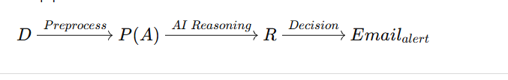
Fig. 1. Computational pipeline of the system.
TABLE II. Summary of Core Logic
Process step | Mathematical / logical operation | Output
Marks normalization | P(A) = M_{s} / 100 | Admission score (0–1)
Classification rule | P(A) < 0.6 ⇒ alert triggered | Counselor alert decision
AI message generation | R = f(P(A), M_{s}, C_{t}) | Personalized text feedback
Alert email | Email_{alert} = f(S_{n}, P(A), C_{t}) | Automated SendGrid dispatch

Overall, the methodology pairs deterministic scoring with generative AI reasoning and automated workflows. The scoring step gives numerical consistency, while LangGraph and Gemini add contextual, human-like feedback.

4. Implementation
The system was built iteratively in four phases: planning and design, AI and backend development, integration and testing, and deployment with continuous optimization. The overall workflow is shown in Fig. 2.

A. System Planning and Design
The first phase defined how the LangGraph reasoning engine, the FastAPI backend, and the automation tools (n8n, SendGrid, and MongoDB) interact. A three-layer architecture was adopted:
- AI reasoning layer: decision-making with LangGraph and Gemini;
- API layer: FastAPI communication interfaces; and
- automation layer: workflows and email operations managed through n8n.
A limited prototype was first built to validate the workflow. It supported a single course (for example, B.Tech CSE), made predictions from predefined thresholds on marks, and used one LangGraph node to generate basic responses, so that agent behavior and data flow could be checked early. The technology stack was then fixed as follows:
- Python, FastAPI, and Uvicorn for the backend;
- LangGraph with Gemini, via LangChain, for the AI engine;
- MongoDB Atlas for data storage;
- n8n for workflow orchestration;
- SendGrid for automated email delivery; and
- GitHub for version control.
Data schemas are defined with Pydantic models so that data exchange is consistent and type-safe. An example is the Student model, with the attributes name, marks, and target_course.

B. AI and Backend Development
The LangGraph agent consists of three main nodes: an ingestion node that receives and initializes student data, a reasoning node that uses Gemini to analyze eligibility and the admission outcome, and an action node that decides whether to generate a response, send an email alert, or log data. Tool nodes such as get_admission_prediction and send_email_alert are attached so the agent can take context-aware actions. [VERIFY: this section says the reasoning node uses Gemini to “predict admission probability”, while Section 3.B says the score comes from the rule-based tool. State clearly which component produces the score]
A RESTful endpoint, /predict, was implemented with FastAPI. It receives student data, runs the LangGraph workflow, and returns a structured JSON response with the admission score, the alert status, and the AI-generated advisory message (Figs. 3 and 4). All predictions and logs are stored in MongoDB Atlas, which also serves as the LangGraph checkpointer so that agent context is kept across sessions. Sensitive API keys for Gemini, MongoDB, and SendGrid are kept in a .env file and loaded at runtime with python-dotenv. Cross-Origin Resource Sharing (CORS) settings allow FastAPI, n8n, and connected clients to communicate safely.

C. System Integration and Testing
In the third phase, the components were connected and tested. The n8n platform links Google Sheets, FastAPI, and SendGrid: when a new student record is added to a sheet, n8n sends a POST request to /predict, retrieves the prediction, and triggers a personalized email through SendGrid. Email templates were designed for high, medium, and low admission scores, and they insert the student’s details and score automatically. [VERIFY: Section 3.D says an alert is sent only when the score is below 0.6, and Fig. 2 shows a different email for each case. Confirm exactly when each type of email is sent]
Each module was first tested separately for correct predictions, email triggers, and database storage. End-to-end testing then checked the data flow from Google Sheets through the full pipeline to MongoDB. A pilot test with admission counselors evaluated accuracy, response time, and the clarity of the AI feedback, and the findings were used to adjust threshold logic and improve message quality. [VERIFY: describe the pilot: number of counselors, duration, what was measured, and how feedback was collected]

D. Deployment and Continuous Optimization
The system is hosted on a local or institutional server to keep access controlled and data private. The FastAPI backend runs under Uvicorn or Gunicorn, and MongoDB Atlas provides cloud storage and remote access. Logging tracks API response times, workflow execution, and email delivery, and these logs are reviewed periodically to improve efficiency. Feedback from admissions staff and counselors guides further refinement of the prediction logic and message generation. Because the design is modular, more advanced models such as logistic regression or random forest could be added to improve prediction, and the framework could later support chatbot-based interaction, integration with institutional admission portals, and multiple programs or universities.
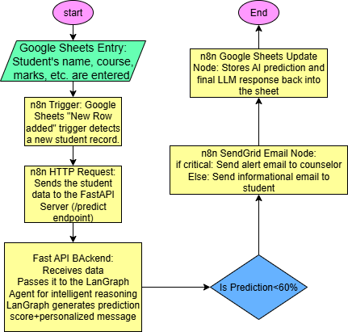
Fig. 2. Flowchart of the Agentic AI Admission Assistant workflow.

5. Results and Future Work

5.1 Results
The results below come from testing the system and from the pilot evaluation with counselors. [VERIFY: no numerical accuracy or error figures are reported in your paper. If available, add them with the dataset or test cases used]
Admission scoring and feedback. The system produces an admission score from a student’s marks and course preference and places applicants into high, moderate, and low groups, which supports faster decisions. The LangGraph and Gemini reasoning step produced coherent, readable feedback for each case (Fig. 3). [VERIFY: the original called this “accurate” prediction, but no comparison with real admission outcomes is given, so that word was removed]
Workflow automation. Through n8n, the pipeline runs from data entry in Google Sheets to score generation and email notification through SendGrid (Figs. 5 and 9). This reduced manual intervention and improved operational efficiency. [VERIFY: report any measurement behind “improved efficiency”, such as time saved]
Logging and traceability. Prediction results, AI messages, and alert statuses are stored in MongoDB Atlas, which gives consistent records that can be used to monitor performance and refine the system. In the logged test run (Fig. 5), the server fell back to the in-memory saver because no MongoDB connection string was found. [VERIFY: confirm that MongoDB Atlas storage was working in the tests you report]
Pilot evaluation and performance. In pilot testing with admission counselors, users reported faster decision cycles and found the AI responses easy to interpret. The average processing time per prediction stayed under 10 seconds. [VERIFY: provide the number of participants and how the 10-second average was measured; “real-time” was removed from the original claim because 10 seconds may not meet that description]

5.2 Limitations
The score currently depends only on marks (and, per the code, course), so it does not reflect other factors such as interests or institutional competitiveness, and it has not been compared with actual admission outcomes. Because the AI feedback is generated by an LLM, its content is not fixed and should be reviewed by counselors. Given the bias concerns in related work [13], [14], any extension that uses more personal data will need fairness checks. [VERIFY: these limitations were added by this revision from what the paper describes. Keep, edit, or remove them]

5.3 Future Work
Planned improvements are:
- integrating machine learning models, such as logistic regression or random forest, for higher accuracy;
- adding a chatbot interface for interactive student support;
- supporting multiple courses and institutions;
- introducing predictive analytics dashboards for administrators; and
- providing AI responses in multiple languages to improve accessibility.

5.4 System Screenshots
Figs. 3–9 show the main parts of the working system. [VERIFY: confirm each caption. Several figures show a real person’s name as sample data (“Virat Kohli”) and a personal email address; replace these with fictional or anonymized data]
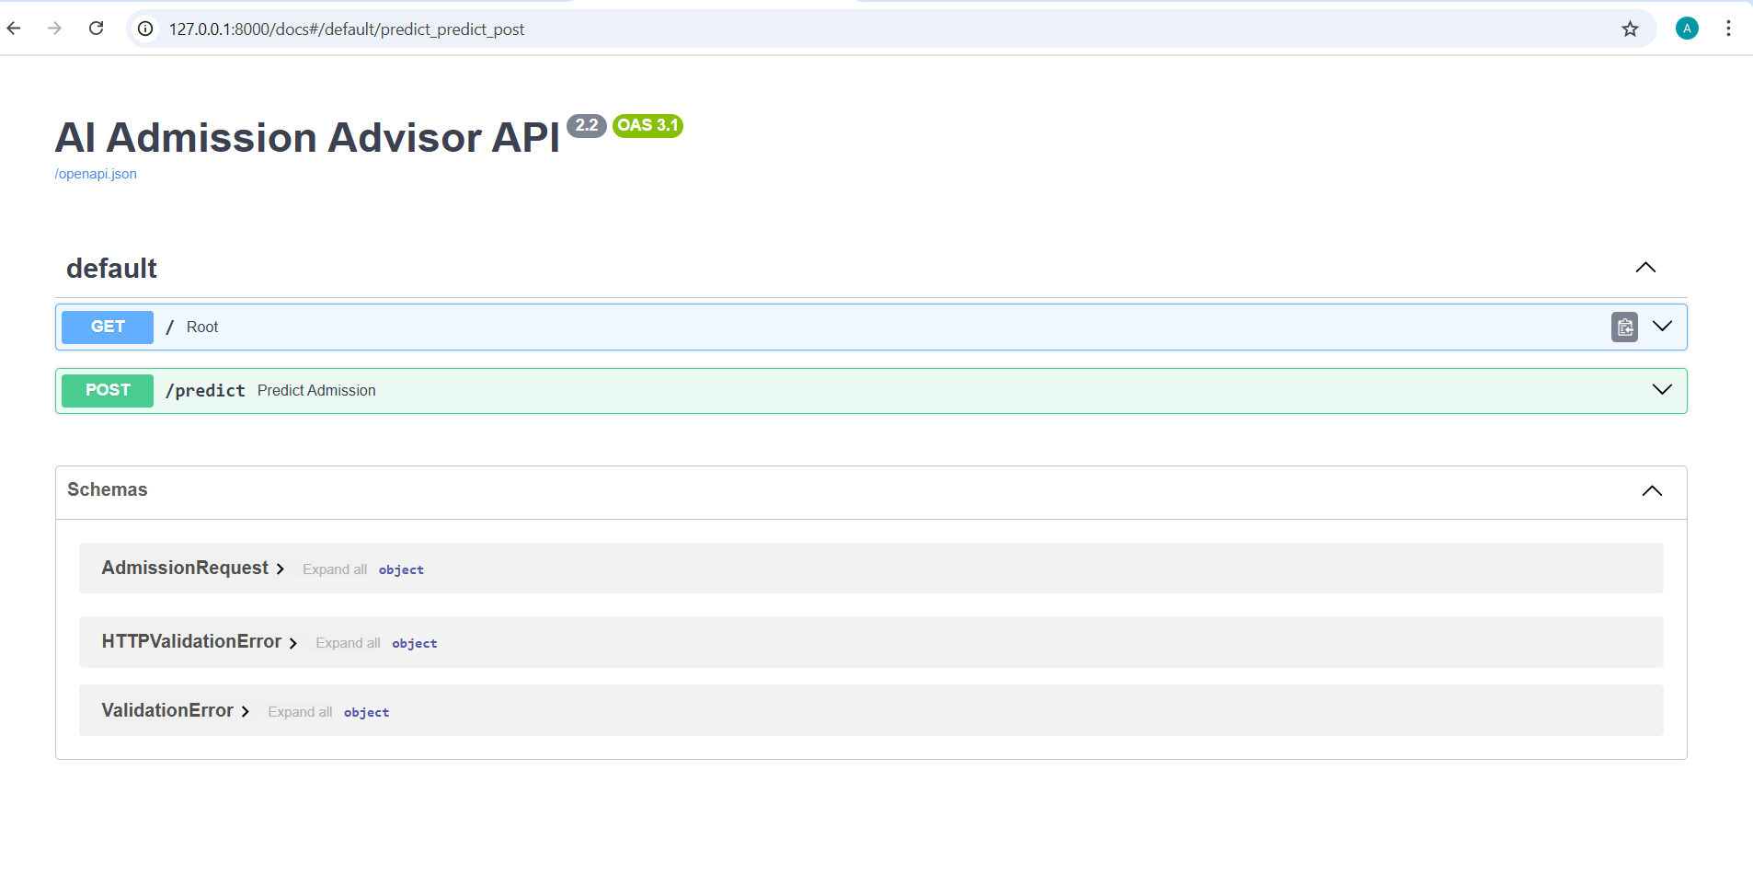
Fig. 3. Interactive FastAPI documentation showing the /predict endpoint.
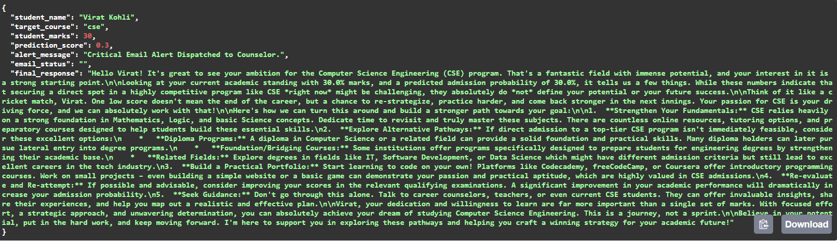
Fig. 4. Example JSON response returned by the /predict endpoint.
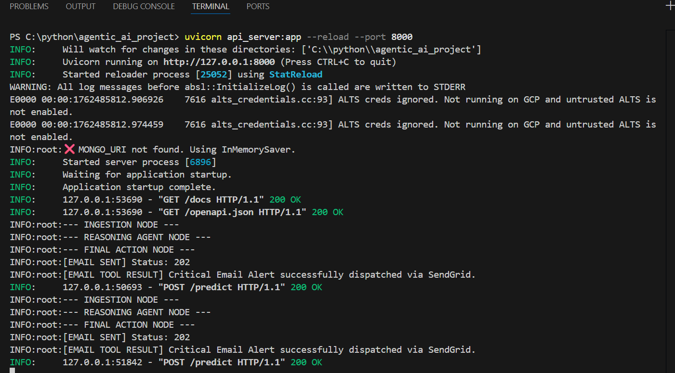
Fig. 5. Server log showing the ingestion, reasoning, and final action nodes and email dispatch.
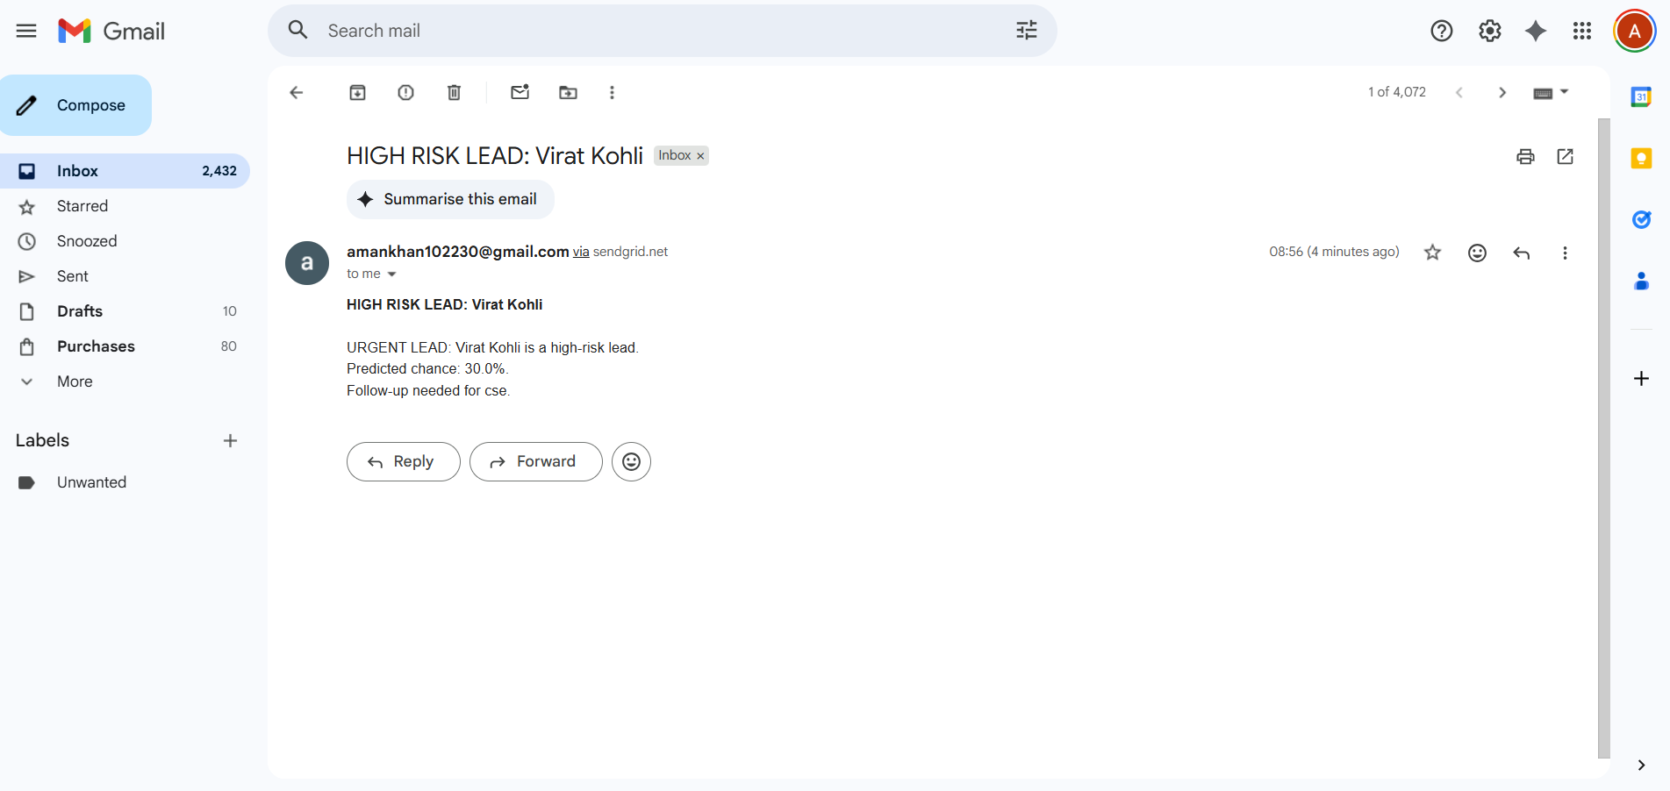
Fig. 6. Alert email received through SendGrid.
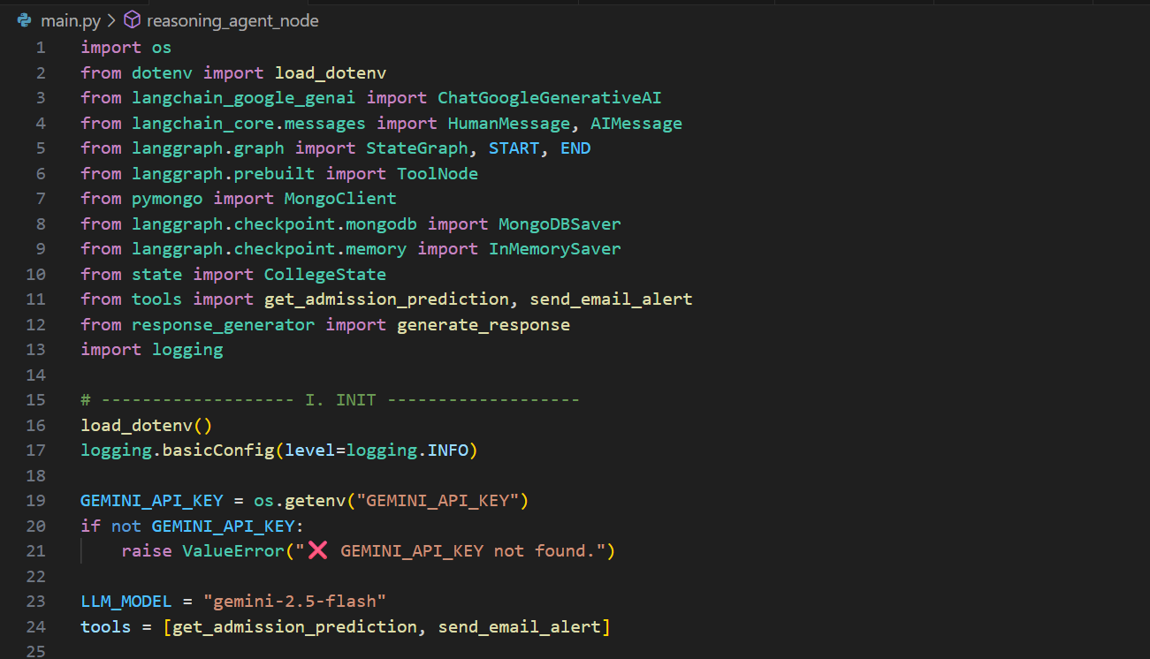
Fig. 7. Source code for the LangGraph agent setup (main.py).
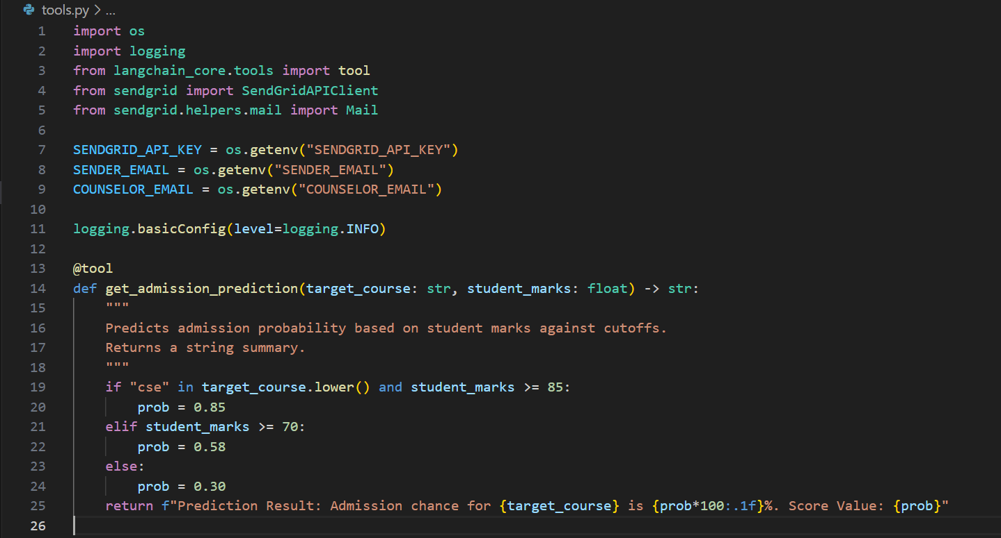
Fig. 8. Source code of the get_admission_prediction tool (tools.py).
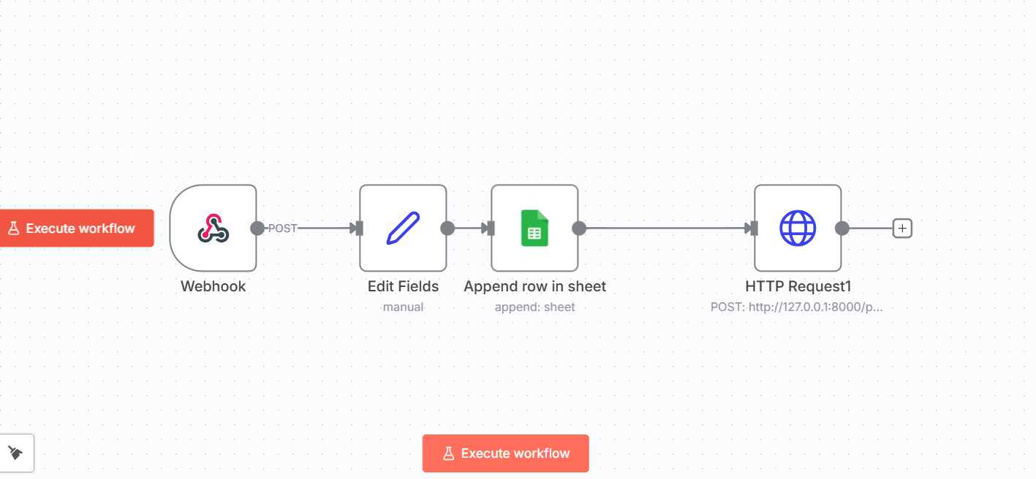
Fig. 9. n8n workflow connecting the webhook, Google Sheets, and the FastAPI request.

6. Conclusion
This paper presented the Agentic AI Admission Assistant, a system that gives students an admission score and personalized feedback, and alerts counselors when a score is low. It combines LangGraph and Gemini reasoning with FastAPI, n8n automation, and MongoDB storage in one end-to-end workflow. A transparent rule-based score provides the numerical estimate, and the LLM turns it into advice, so the system works somewhat like a virtual counselor. Automation shortens manual work, sends timely email alerts, and keeps structured digital records.
In pilot testing, counselors reported faster decisions and clear AI responses, with processing time under 10 seconds per prediction. [VERIFY: confirm these claims against your pilot data; the original conclusion said results “confirmed” significant streamlining without supporting figures] The modular design should make it possible to extend the system to more programs and institutions. Future work includes adding machine learning models for more precise predictions, a conversational chatbot interface, and analytics dashboards for administrators. With these additions, and with attention to fairness and transparency, such a system could support human counselors in making the admission process clearer and more student-centered.

References
[1] S. Brohi, Q.-u.-a. Mastoi, N. Z. Jhanjhi, and T. R. Pillai, “A research landscape of agentic AI and large language models: Applications, challenges and future directions,” Algorithms, vol. 18, no. 8, p. 499, 2025, doi: 10.3390/a18080499.
[2] A. K. Pati, “Agentic AI: A comprehensive survey of technologies, applications, and societal implications,” IEEE Access, vol. 11, pp. 1–18, 2024, doi: 10.1109/ACCESS.2025.3585609. [VERIFY: the DOI indicates a 2025 paper, which conflicts with the 2024 year and volume 11. Table I credits a paper with the same title to Abou Ali and Dornaika. Check the authors, year, volume, and pages]
[3] G. U. Parab, “Agentic AI in data analytics: Transforming autonomous insights and decision-making,” Int. J. Sci. Res. Comput. Sci. Eng. Inf. Technol., vol. 10, no. 6, pp. 1752–1759, 2024, doi: 10.32628/CSEIT241061220.
[4] S. K. Mamillapalli, “The agentic AI framework: Enabling autonomous intelligence,” Int. J. Innov. Res. Multidiscip. Prof. Stud. (IJIRMPS), vol. 13, no. 1, pp. 1–5, 2025. [Online]. Available: https://www.ijirmps.org [VERIFY: add a direct link to the article]
[5] R. Acharya and M. Gridach, “Agentic AI: A comprehensive review of methodologies, applications, and challenges,” AJA J. Artif. Intell. Res., vol. 45, no. 2, pp. 1–12, 2025. [VERIFY: confirm that this journal and article exist, and add a DOI or link]
[6] R. Sapkota, K. I. Roumeliotis, and M. Karkee, “AI agents vs. agentic AI: A conceptual taxonomy, applications and challenges,” arXiv:2505.10468, 2025.
[7] Y. Xia, J. Zhu, and L. Zhu, “Dynamic role discovery and assignment in multi-agent task decomposition,” Complex Intell. Syst., vol. 9, no. 6, pp. 6211–6222, 2023, doi: 10.1007/s40747-023-01071-x.
[8] C. Ma et al., “Trusted AI in multi-agent systems: An overview of privacy and security for distributed learning,” Proc. IEEE, vol. 111, no. 9, pp. 1097–1132, 2023.
[9] J. Wang, J. Wang, B. Athiwaratkun, C. Zhang, and J. Zou, “Mixture-of-agents enhances large language model capabilities,” arXiv:2406.04692, 2024.
[10] A. Kumar, “Building autonomous AI agents based AI infrastructure,” Int. J. Comput. Trends Technol., vol. 72, no. 11, pp. 116–125, 2024, doi: 10.14445/22312803/ijctt-v72i11p112.
[11] [VERIFY: authors, title, journal, and year] [Online]. Available: https://educationaltechnologyjournal.springeropen.com/articles/10.1186/s41239-023-00392-8
[12] [VERIFY: author, title, and date] eLearning Industry. [Online]. Available: https://elearningindustry.com/enhancing-student-enrollment-the-power-of-predictive-analytics-in-higher-education
[13] [VERIFY: authors, title, and year] arXiv:2411.15348. [Online]. Available: https://arxiv.org/abs/2411.15348
[14] [VERIFY: authors, title, journal, and year] [Online]. Available: https://pmc.ncbi.nlm.nih.gov/articles/PMC10569720/

