Task – 1

Database Creation with 1000 records status set to “completed” and others set to “in progress”

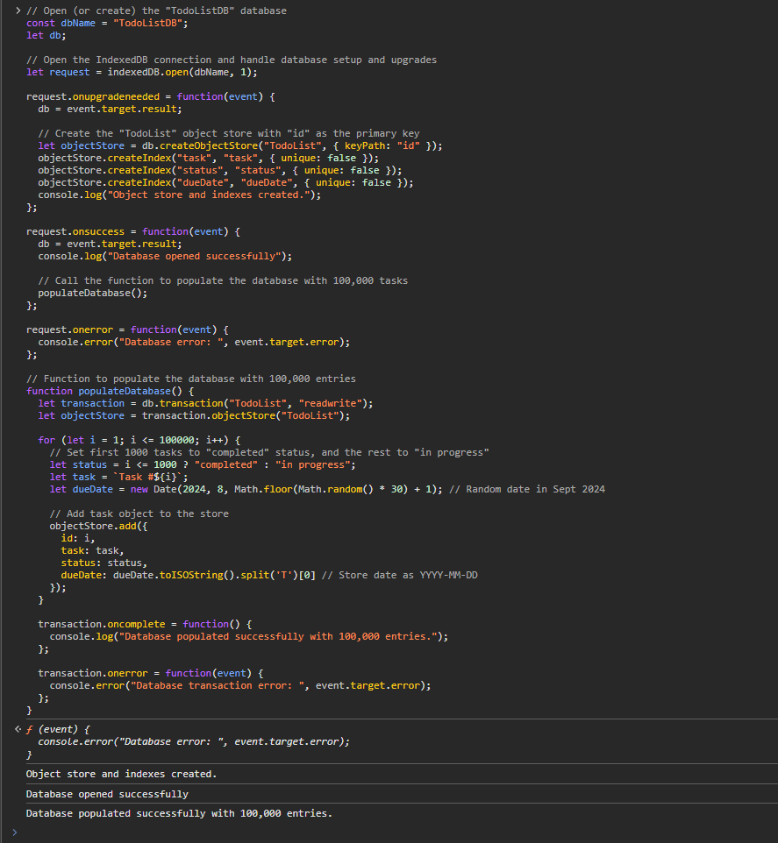

Lesson Learned

* Gaining familiarity with IndexedDB operations like opening a database, creating an object store, and adding records.

Challenges faced

* The challenge was to ensure the large volume of data was added efficiently without locking up the browser.

– Status after creating Database Successfully

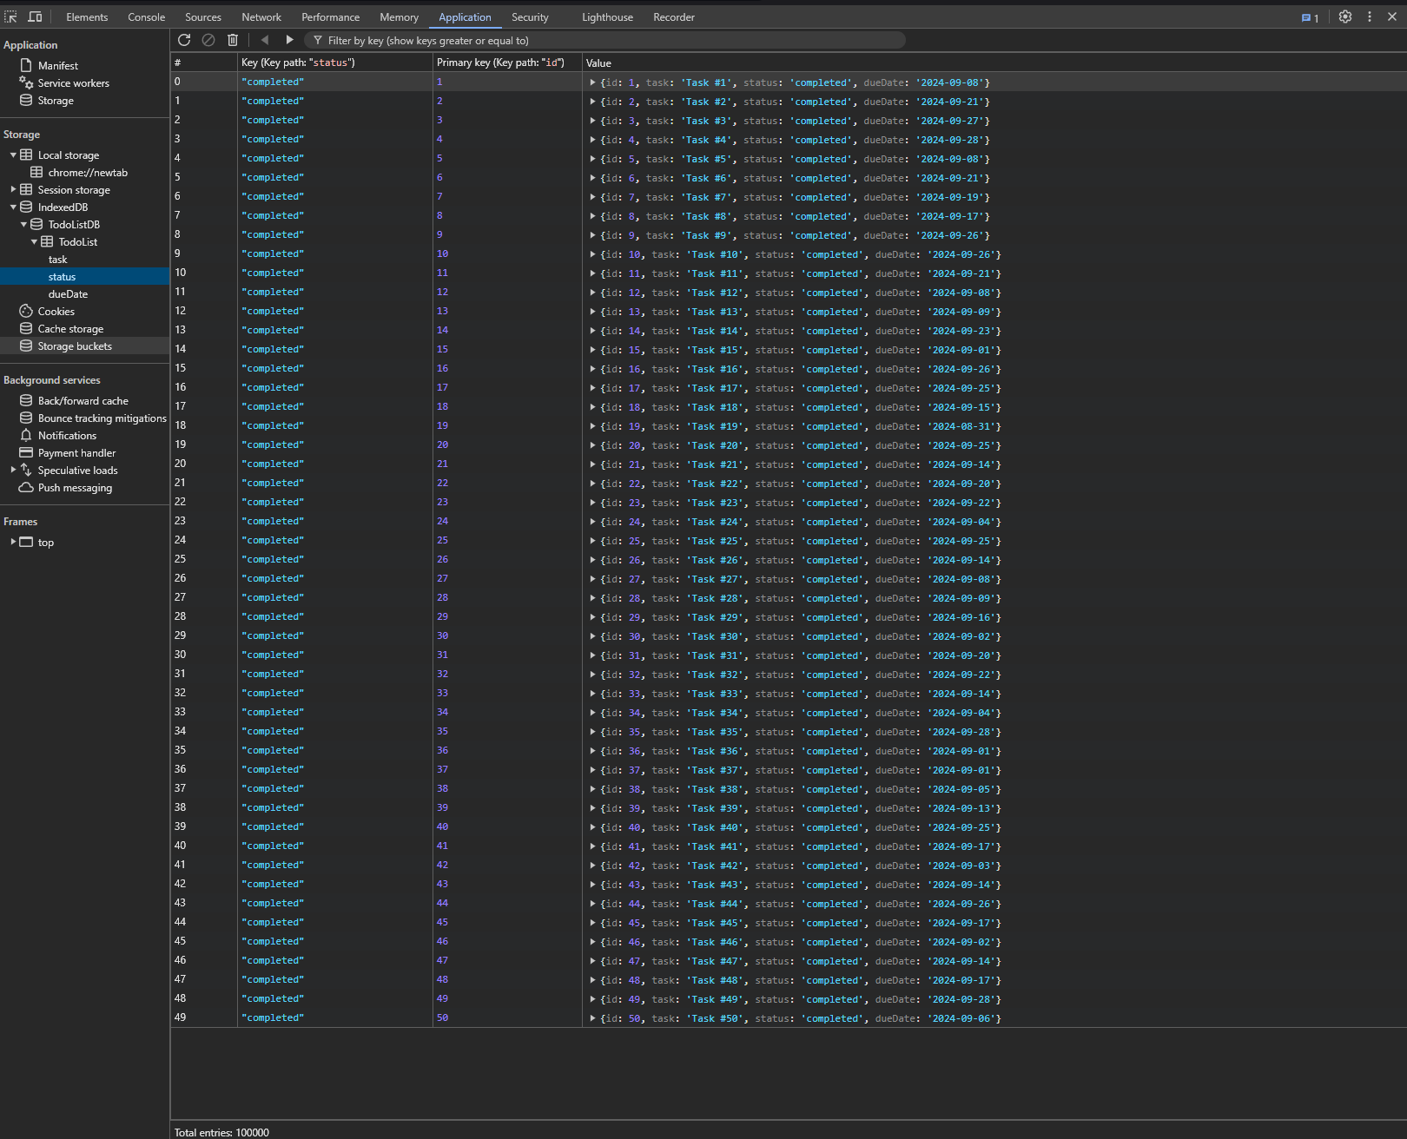

Task 2 –

Measuring time in ms required to read all the task whose status is set to completed with “readwrite” mode

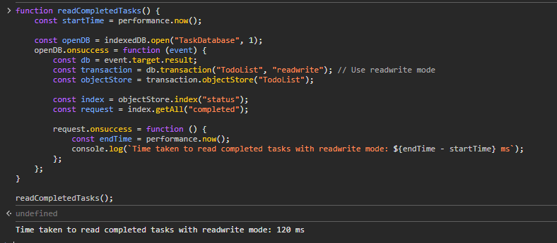

**Lesson Learned**:

* Using a mode like readwrite allows for both reading and writing, which could cause slower read operations due to locking mechanisms.
* Key Insight: Switching between different modes impacts performance significantly when dealing with large data sets.

Task 3 – Measuring time in ms required to read all the task whose status is set to completed with “readonly” mode

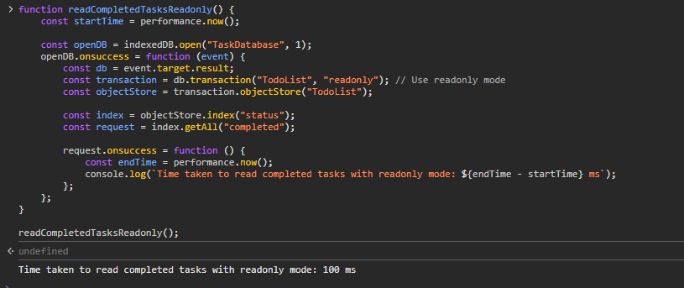

**Lesson Learned**:

* The readonly mode resulted in faster read times compared to readwrite mode due to reduced overhead and fewer locks.

**Challenge**:

* Managing the browser’s performance and ensuring smooth operation while working with a large number of records.

Task 4 –

Created Index using status field and read all the completed tasks

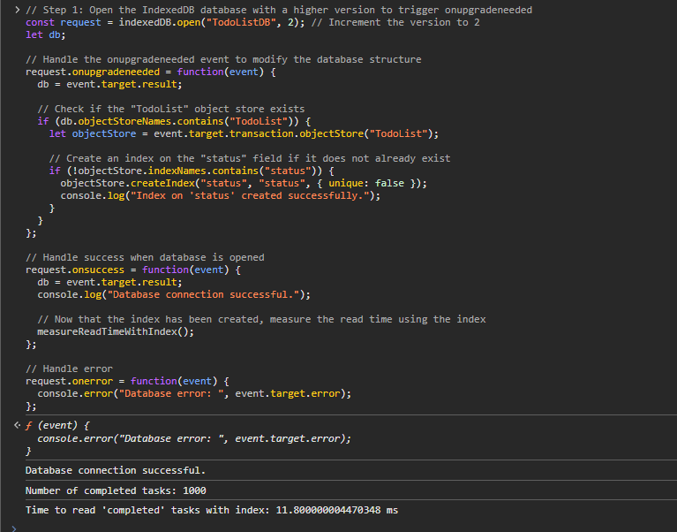

**Lesson Learned**:

* Creating an index significantly improved the speed of querying the completed tasks.
* Key Insight: Indexing is crucial for efficient querying in large data sets and should be implemented thoughtfully based on the frequency of specific queries.

Task – 5

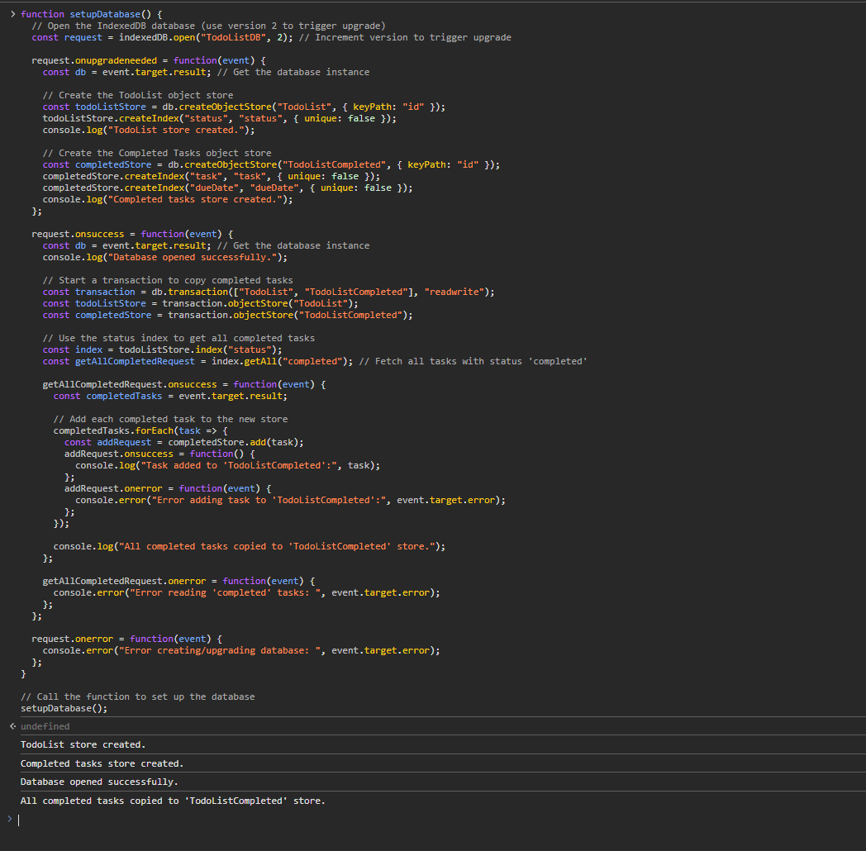

**Lesson Learned**:

* Using a dedicated object store for completed tasks made read operations more efficient since the new store contained only relevant data.

**Challenge:**

* Handling the data transfer between stores while ensuring data integrity and minimal downtime for the application.

### **Summary of Key Insights:**

* **Performance Optimization**: Switching to readonly mode and using indexing significantly reduced read times.
* **Data Management**: Using a separate object store for completed tasks proved effective for maintaining a clean and performant database structure.
* **Challenges**: Handling a large number of records within the IndexedDB required managing memory efficiently to avoid browser slowdowns.