Your College Name

Your College Logo

**SESSION 2015-16**

**SUMMER INTERNSHIP REPORT**

**DEPARTMENT OF COMPUTER SCIENCE AND ENGINEERING**



**RAJIV GANDHI PROUDYOGIKI VISHWAVIDYALAYA, BHOPAL**

**SUBMITTED BY**

**Yourname**

###### 

###### 

###### DECLARATION

***I* Yourname*, hereby declare that this industrial training work entitled “KNOWLEDGE CLOUD for Sales Knowledge Management” was carried out by me under the supervision of development team OF PREMA SOFTWARE SOLUTION, Bhopal. This TRAINING REPORT is submitted to Department of Computer Science and Engineering during the academic year 2015-16.***

**Place:**

**Date:**

Name Signature

**INDEX**

|  |  |  |
| --- | --- | --- |
| S.NO. | CONTENTS | Page No. |
| 1 | Chapter 1 |  |
|  | 1.1Introduction |  |
|  | 1.2Objectives |  |
|  | 1.3Description of project |  |
| 2 | Chapter 2 |  |
|  | Requirement Specifications |  |
|  | 2.1Hard ware Requirements |  |
|  | 2.2Software Requirements |  |
| 3 | Chapter 3 |  |
|  | Data Analysis |  |
|  | 3.1 ERD |  |
| 4 | Chapter 4 |  |
|  | Software Design |  |
|  | 4.1Development Model |  |
| 5 | Chapter 5 |  |
|  | 5.1Input |  |
|  | 5.2Output |  |
| 6 | Chapter 6 |  |
|  | Activity Plans |  |

Chapter 1

Introduction

About Prema Software Solutions

* PREMA GROUP   was incorporated in 1989 with the objective of enhancing the knowledge of students to meet the real life challenges of industry   
    
  PREMA COMPUTERS   is conducting job oriented training for students, engineers and professionals.
* Due to the demands of industry a software development division was started in 1996.   
    
  This has received a very good response from customers.

Prema Group of Companies consists of the following :

Prema Computers  
Prema Software Solutions  
Prema Software Private Ltd.

Prema Group Activity

* Software training.
* Software development.
* Software sales.
* Cad/Cam services.

Software/Project training to Industries/Colleges/Different Organizations

* Java
* VB / .NET
* C++
* Oracle
* AutoCAD
* I-DEAS
* Android

List of Clients

* L & T Powai
* Thermax pimpri
* L & T MHI Faridabad
* SSP Faridabad
* GEI INDUSTRIAL SYSTEMS LTD Bhopal
* BHEL (Jhansi , Bhopal)
* PARI Robotics (Pune)
* GEI Hamon (Bhopal)
* Applo (Delhi)
* STI (Delhi)
* Dbvison Bhopal
* CIM( Philippines )
* SBI
* LIC
* PSSCIVE
* NITTTR

ETC.

Cloud Computing

Cloud computing and storage solutions provide users and enterprises with various capabilities to store and process their data in third-party data centers. It relies on sharing of resources to achieve coherence and [economies of scale](https://en.wikipedia.org/wiki/Economies_of_scale), similar to a utility (like the [electricity grid](https://en.wikipedia.org/wiki/Electrical_grid)) over a network. At the foundation of cloud computing is the broader concept of [converged infrastructure](https://en.wikipedia.org/wiki/Converged_infrastructure) and [shared services](https://en.wikipedia.org/wiki/Shared_services).

Cloud computing, or in simpler shorthand just "the cloud", also focuses on maximizing the effectiveness of the shared resources. Cloud resources are usually not only shared by multiple users but are also dynamically reallocated per demand. This can work for allocating resources to users. For example, a cloud computer facility that serves European users during European business hours with a specific application (e.g., email) may reallocate the same resources to serve North American users during North America's business hours with a different application (e.g., a web server). This approach should maximize the use of computing power thus reducing environmental damage as well since less power, air conditioning, rack space, etc. are required for a variety of functions. With cloud computing, multiple users can access a single server to retrieve and update their data without purchasing licenses for different applications.

Proponents claim that cloud computing allows companies to avoid upfront infrastructure costs, and focus on projects that differentiate their businesses instead of on infrastructure.[4] Proponents also claim that cloud computing allows enterprises to get their applications up and running faster, with improved manageability and less maintenance, and enables IT to more rapidly adjust resources to meet fluctuating and unpredictable business demand. Cloud providers typically use a "pay as you go" model. This can lead to unexpectedly high charges if administrators do not adapt to the cloud pricing model.

The present availability of high-capacity networks, low-cost computers and storage devices as well as the widespread adoption of hardware virtualization, service-oriented architecture, and autonomic and utility computing have led to a growth in cloud computing. Companies can scale up as computing needs increase and then scale down again as demands decrease.

Cloud vendors are experiencing growth rates of 50% per annum.

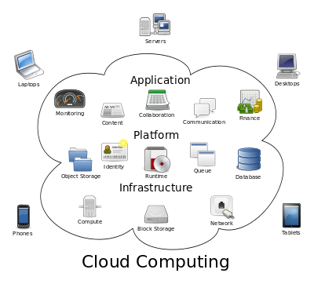

History of cloud computing

### Origin of the term

The origin of the term *cloud computing* is unclear. The expression *cloud* is commonly used in science to describe a large agglomeration of objects that visually appear from a distance as a cloud and describes any set of things whose details are not inspected further in a given context. Another explanation is that the old programs to draw network schematics surrounded the icons for servers with a circle, and a cluster of servers in a network diagram had several overlapping circles, which resembled a cloud.

In analogy to above usage the word *cloud* was used as a metaphor for the Internet and a standardized cloud-like shape was used to denote a network on telephony schematics and later to depict the Internet in [computer network diagrams](https://en.wikipedia.org/wiki/Computer_network_diagram). With this simplification, the implication is that the specifics of how the end points of a network are connected are not relevant for the purposes of understanding the diagram. The cloud symbol was used to represent the Internet as early as 1994, in which servers were then shown connected to, but external to, the cloud.

References to cloud computing in its modern sense appeared as early as 1996, with the earliest known mention in a [Compaq](https://en.wikipedia.org/wiki/Compaq) internal document.

The popularization of the term can be traced to 2006 when Amazon.com introduced the Elastic Compute Cloud.

### The 1970s

During the mid-1970s, time-sharing was popularly known as RJE (Remote Job Entry); this terminology was mostly associated with large vendors such as IBM and DEC.[citation needed] IBM developed the VM Operating System (first released in 1972) to provide time-sharing services[citation needed] via virtual machines.

### The 1990s

In the 1990s, telecommunications companies, who previously offered primarily dedicated point-to-point data circuits, began offering [virtual private network](https://en.wikipedia.org/wiki/Virtual_private_network) (VPN) services with comparable quality of service, but at a lower cost. By switching traffic as they saw fit to balance server use, they could use overall network bandwidth more effectively. They began to use the cloud symbol to denote the demarcation point between what the provider was responsible for and what users were responsible for. Cloud computing extends this boundary to cover all servers as well as the network infrastructure.

As computers became more prevalent, scientists and technologists explored ways to make large-scale computing power available to more users through time-sharing. They experimented with algorithms to optimize the infrastructure, platform, and applications to prioritize CPUs and increase efficiency for end users.

### The New Millenium: 2000s

Since 2000 cloud computing has come into existence. In early 2008, [NASA](https://en.wikipedia.org/wiki/NASA)'s [OpenNebula](https://en.wikipedia.org/wiki/OpenNebula), enhanced in the RESERVOIR European Commission-funded project, became the first open-source software for deploying private and hybrid clouds, and for the federation of clouds. In the same year, efforts were focused on providing [quality of service](https://en.wikipedia.org/wiki/Quality_of_service)guarantees (as required by real-time interactive applications) to cloud-based infrastructures, in the framework of the IRMOS European Commission-funded project, resulting in a real-time cloud environment. By mid-2008, Gartner saw an opportunity for cloud computing "to shape the relationship among consumers of IT services, those who use IT services and those who sell them and observed that "organizations are switching from company-owned hardware and software assets to per-use service-based models" so that the "projected shift to computing ... will result in dramatic growth in IT products in some areas and significant reductions in other areas.

[Microsoft Azure](https://en.wikipedia.org/wiki/Microsoft_Azure) became available in late 2008.

In July 2010, [Rackspace Hosting](https://en.wikipedia.org/wiki/Rackspace) and [NASA](https://en.wikipedia.org/wiki/NASA) jointly launched an open-source cloud-software initiative known as [OpenStack](https://en.wikipedia.org/wiki/OpenStack). The OpenStack project intended to help organizations offer cloud-computing services running on standard hardware. The early code came from NASA's [Nebula platform](https://en.wikipedia.org/wiki/Nebula_(computing_platform)) as well as from [Rackspace's Cloud Files](https://en.wikipedia.org/wiki/Rackspace_Cloud#Cloud_Files) platform.

On March 1, 2011, IBM announced the [IBM SmartCloud](https://en.wikipedia.org/wiki/IBM_cloud_computing#IBM_SmartCloud) framework to support [Smarter Planet](https://en.wikipedia.org/wiki/Smarter_Planet).[[25]](https://en.wikipedia.org/wiki/Cloud_computing#cite_note-25) Among the various components of the [Smarter Computing](https://en.wikipedia.org/w/index.php?title=Smarter_Computing&action=edit&redlink=1) foundation, cloud computing is a critical piece.

On June 7, 2012, Oracle announced the [Oracle Cloud](https://en.wikipedia.org/wiki/Oracle_Corporation#Services).[[26]](https://en.wikipedia.org/wiki/Cloud_computing#cite_note-26) While aspects of the Oracle Cloud are still in development, this cloud offering is posed to be the first to provide users with access to an integrated set of IT solutions, including the Applications ([SaaS](https://en.wikipedia.org/wiki/SaaS)), Platform ([PaaS](https://en.wikipedia.org/wiki/PaaS)), and Infrastructure ([IaaS](https://en.wikipedia.org/wiki/IaaS)) layers.

Characteristics

The National Institute of Standards and Technology's definition of cloud computing identifies "five essential characteristics":

*On-demand self-service*. A consumer can unilaterally provision computing capabilities, such as server time and network storage, as needed automatically without requiring human interaction with each service provider.

*Broad network access*. Capabilities are available over the network and accessed through standard mechanisms that promote use by heterogeneous thin or thick client platforms (e.g., mobile phones, tablets, laptops, and workstations).

*Resource pooling*. The provider's computing resources are pooled to serve multiple consumers using a multi-tenant model, with different physical and virtual resources dynamically assigned and reassigned according to consumer demand.

*Rapid elasticity*. Capabilities can be elastically provisioned and released, in some cases automatically, to scale rapidly outward and inward commensurate with demand. To the consumer, the capabilities available for provisioning often appear unlimited and can be appropriated in any quantity at any time.

*Measured service*. Cloud systems automatically control and optimize resource use by leveraging a metering capability at some level of abstraction appropriate to the type of service (e.g., storage, processing, bandwidth, and active user accounts). Resource usage can be monitored, controlled, and reported, providing transparency for both the provider and consumer of the utilized service.

Service models

Cloud computing providers offer their services according to several fundamental models:

*Infrastructure as a service (IaaS)*

In the most basic cloud-service model & according to the IETF (Internet Engineering Task Force), providers of IaaS offer computers – physical or (more often) virtual machines – and other resources. (A hypervisor, such as Xen, Oracle VirtualBox, KVM, VMware ESX/ESXi, or Hyper-V runs the virtual machines as guests. Pools of hypervisors within the cloud operational support-system can support large numbers of virtual machines and the ability to scale services up and down according to customers' varying requirements.) IaaS clouds often offer additional resources such as a virtual-machine disk image library, raw block storage, and file or object storage, firewalls, load balancers, IP addresses, virtual local area networks (VLANs), and software bundles. IaaS-cloud providers supply these resources on-demand from their large pools installed in data centers. For wide-area connectivity, customers can use either the Internet or carrier clouds (dedicated virtual private networks).

To deploy their applications, cloud users install operating-system images and their application software on the cloud infrastructure. In this model, the cloud user patches and maintains the operating systems and the application software. Cloud providers typically bill IaaS services on a utility computing basis: cost reflects the amount of resources allocated and consumed.

*Platform as a service (PaaS)*

In the PaaS models, cloud providers deliver a computing platform, typically including operating system, programming language execution environment, database, and web server. Application developers can develop and run their software solutions on a cloud platform without the cost and complexity of buying and managing the underlying hardware and software layers. With some PaaS offers like Microsoft Azure and Google App Engine, the underlying computer and storage resources scale automatically to match application demand so that the cloud user does not have to allocate resources manually. The latter has also been proposed by an architecture aiming to facilitate real-time in cloud environments. Even more specific application types can be provided via PaaS, e.g., such as media encoding as provided by services as bitcodin transcoding cloud or media.io.

*Software as a service (SaaS)*

In the [business model](https://en.wikipedia.org/wiki/Business_model) using software as a service (SaaS), users are provided access to application software and databases. Cloud providers manage the infrastructure and platforms that run the applications. SaaS is sometimes referred to as "on-demand software" and is usually priced on a pay-per-use basis or using a subscription fee.

In the SaaS model, cloud providers install and operate application software in the cloud and cloud users access the software from cloud clients. Cloud users do not manage the cloud infrastructure and platform where the application runs. This eliminates the need to install and run the application on the cloud user's own computers, which simplifies maintenance and support. Cloud applications are different from other applications in their scalability—which can be achieved by cloning tasks onto multiple [virtual machines](https://en.wikipedia.org/wiki/Virtual_machines) at run-time to meet changing work demand.[[59]](https://en.wikipedia.org/wiki/Cloud_computing#cite_note-hamdaqa-59) [Load balancers](https://en.wikipedia.org/wiki/Load_balancer) distribute the work over the set of virtual machines. This process is transparent to the cloud user, who sees only a single access point. To accommodate a large number of cloud users, cloud applications can be [*multitenant*](https://en.wikipedia.org/wiki/Multitenant), that is, any machine serves more than one cloud user organization.

The pricing model for SaaS applications is typically a monthly or yearly flat fee per user, so price is scalable and adjustable if users are added or removed at any point.

Proponents claim SaaS allows a business the potential to reduce IT operational costs by outsourcing hardware and software maintenance and support to the cloud provider. This enables the business to reallocate IT operations costs away from hardware/software spending and personnel expenses, towards meeting other goals. In addition, with applications hosted centrally, updates can be released without the need for users to install new software. One drawback of SaaS is that the users' data are stored on the cloud provider's server. As a result, there could be unauthorized access to the data. For this reason, users are increasingly adopting intelligent third-party key management systems to help secure their data.

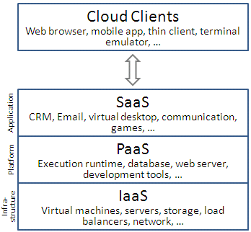

About Sales Knowledge Management

*What is the Problem?*

With the rapid growth of sales automation and such online technologies as Lotus Notes and intranets, many corporations have rushed to deploy systems for distributing information and documents of all kinds to their sales people. As markets and products change with accelerating pace, sales people must assimilate and apply vast amounts of current information about their markets, their competition, and the solutions they can offer to customers. The recognition that sales people are knowledge workers, perhaps the most overburdened of all, is gradually dawning on senior sales and marketing executives in the most forward thinking companies. It is becoming obvious to such executives that knowledgeable sales people can offer a significant competitive advantage at every stage of the sales process. Knowledge of customers' business issues, market dynamics, company vision, the competition, sales strategy, and products or services themselves, helps sales people establish and maintain credibility. They can identify the customer's pressing needs and configure optimal solutions, sell the benefits of those solutions, and guard against competitive challenges.

On the other hand, those working today in nearly all functions within business organizations suffer from severe information overload. Sales people are perhaps the most overloaded of all. Information of many types, in many different forms and media, pours in on the sales person. Dozens or even hundreds of documents are intended to provide sales people with the knowledge they need to compete. Yet because the information generally arrives from many different sources, neither its content nor format is consistent. Sales guides, training materials, audio and video tapes, sets of overhead transparencies, sales collateral, proposals, memos, emails and now documents in online databases often cover the same ground in slightly different ways, and are often very difficult to use if one is in a hurry to find needed information. The result is a scarcity of knowledge in an abundance of information.

By default, most sales people pick up the phone or seek the most convenient source of answers to their questions, e.g., the product manager's latest slide set or a brochure intended for customers. Sales people in some companies may make as many as 20-30 phone calls before they get the knowledge they need in response to specific questions. Product managers and their staff may respond to literally hundreds of phone calls and emails per week with answers to questions that they have already answered in some form or other, spending as much as 70% of their time doing so. These same marketing professionals also devote substantial portions of their work weeks to creating all kinds of "sales knowledge deliverables" &endash; whether training materials, white papers, product briefs, competitive updates, or sales guides. We often find literally dozens of documents covering similar topics written by multiple people within organizations. Lists of key messages and benefits differ for the same product. And the management and updating of information become nearly impossible. Thus, rather than maintaining a single, coherent knowledge base, the sources tend to create yet more documents in a near futile effort to update the field.

The overall result is that companies invest huge amounts in product development, marketing, and sales support, yet the messages that get to the sales force are so inconsistent that the return on those investments is not what it could be.

*Needed: Fluent Access to and Use of Sales Knowledge*

To the extent sales people must compete based on the added value of their knowledge, they must be able to easily access, learn, and apply knowledge. They may or may not need large amounts of knowledge, depending on their products, markets, and sales/marketing strategies. But certainly they need the right knowledge; those facts, questions, answers, descriptions and other knowledge nuggets that will enable them to perform each key aspect of their jobs most effectively. In fact, it is the actionable nature of this knowledge; its relevance to and ability to be used in on-the-job performance that separates it from mere information or data. Ideally, sales people should be able to access the knowledge they need, already transformed into structures and formats relevant to sales activities while easy to apply because of it relevance and form. The days in which corporations can expect their sales people to successfully fend for themselves in the jungle of information overload are coming to an end. Those companies that ensure easy access to sales-relevant knowledge will enable their sales people to perform significantly better than their competitors who do not have such easy-to-access knowledge.

*The Challenge of Sales Knowledge Management*

Managing the knowledge of a sales and marketing organization cuts across disciplines and departments and may include various functions within Marketing, Sales, Training, Sales Automation, and Customer Service. Conscious efforts in some major corporations to build a "learning organization" have yielded such job titles as Chief Knowledge Officer (CKO) and have involved cross-functional teams of various kinds. Recognition of the problem is itself a major advance. In many companies, Sales, Marketing and other functions do not cooperate effectively, and frequently blame one another for lack of effective communication.

The challenge is to make vast amounts of dynamic information both useful and accessible to sales people for use in performing specific tasks on the job. This can take the form of various learning tools and programs as well as reference resources, both hard copy and online. To realize a return on their corporate knowledge assets, executives need to provide for processes and systems that will optimize the capture and use of knowledge. Because knowledge is actionable information, used to support performance, an effective solution demands cross-functional processes for collaboration and communication.

*Knowledge Management Functions*

Managing knowledge in an organization requires three distinct but overlapping functions, plus processes and tools for maintaining and refreshing the knowledge base over time.

*Access:* Sales people must be able to access required knowledge easily, quickly, and with the confidence that they can find what they want. The classic assertion that "sales people don't read," while it may be true as compared with university professors, is actually the consequence of most organizations' failure to provide reliable, quick access to needed knowledge. We have seen repeatedly that sales people will literally ask for more information, if given hard copy or online reference resources that support rapid, reliable access. There is something like the traditional 80/20 rule with respect to the amount of knowledge a sales person must be able to access versus the amount he or she must actually learn. For many tasks, such as planning account strategy, preparing for sales calls, writing proposals, and organizing information for presentations, sales people can perform well if they simply can find needed information. They need not commit it all to memory, if there is a system that allows them to rapidly find needed information.

*Learning:* Sales people need to learn a relatively small amount of knowledge ; that which is needed face-to-face with customers or for routinely thinking through problems (e.g., key associations between potential customers' problems and product solutions). And where sales people do need to learn, they must be able to achieve what we call fluency ; that level of "second nature" knowledge that comes from regular practice.

Application: To be useful, whether accessed or learned, sales knowledge must be organized and presented in a form that supports application in practical tasks. Ideally, information for sales people will appear in formats and structures directly applicable to their jobs, e.g., issue-implications descriptions of market drivers or needs-solutions tables. Such forms of knowledge support performance, without the need for sales people to re-organize, re-write, or otherwise re-process available information.

Technology Solutions

Technology is often seen as a panacea for the problems of knowledge management. Computer based training programs are among the most prominent forms of knowledge technology. Many different software technologies attempt to address the issue of knowledge access, including traditional database programs, online documentation systems, hypertext and multimedia authoring tools, expert systems, and more recently Lotus Notes groupware, and HTML and Java-based internet and intranet technologies. So-called electronic performance support systems (EPSS) combine various types of software technology in an effort to support key on-the-job tasks. Delivery mechanisms include conventional storage in desktop or portable computers, access to networks via internal LANs, intranets, or the internet, and distribution via CD-ROM. An important requirement for field-based sales professionals is convenient and time-efficient remote access, often via telephone lines.

What is common to all of these technologies is the old adage "garbage in, garbage out." We have seen case after case where companies have naively "dumped" hundreds of documents and bits of information into one or another form of database, on the premise that merely putting this information online in electronic form will enable sales people to access. We find that such repositories are often no better than distributing information via hundreds of documents. When the information is not consistently labeled, organized, or formatted, it produces at least as much information overload as hundreds of paper documents. In fact, technology merely allows many companies to create information overload at a more rapid pace than with conventional means. In both computerized learning or access systems, the failure to identify what knowledge is actually needed for performance, to eliminate unneeded information, and to conduct analyses of how sales people will use the knowledge, neutralizes the potential benefits of technology.

Thus, technology is not a simple cure. Unless the information made available by technology is analyzed, organized, and presented in a form that optimally supports performance, it will add to rather than alleviate the problems of sales information overload. Leading edge companies, including the suppliers of database and groupware technologies who use their own systems, are only recently coming to the stark realization that technology per se is not the solution.

**Architecture**

*Knowledge Architecture: Organizing Knowledge for Use*

What is missing in nearly every effort we have seen to manage knowledge for the sales force is what we have come to call knowledge architecture. That is, a scheme for consistently and comprehensively labeling, sequencing, and structuring all the types of knowledge needed for sales. One of our clients put it most simply when she asked, "What if your newspaper were formatted and organized differently every day?" The answer, of course, is that you would find it very difficult to use and enjoy the newspaper if you could not predict how or where stock quotes, classified ads, sport statistics, entertainment news, or other important features would appear in the document. This, however, is directly analogous to how most organizations provide knowledge for their sales people, and is the problem our proprietary Product Knowledge Architecture™ was designed to address.

The key features of any knowledge architecture, according to our definition, include standards for:

*Chunking and labeling*: Just as the newspaper contains predictable "chunks" of information, labeled with the same words and phrases each day, an architecture for corporate knowledge bases should contain standard definitions of the types of content needed by users and standard words or phrases for labeling them. This feature of a knowledge architecture enables users to search for, learn about, remember, and apply knowledge of various types using known language. A standard chunking and labeling scheme also allows the organization to more easily update and maintain its knowledge resources by providing a framework for determining what knowledge has changed over time.

*Sequencing*: Standard sequences of topics, whether in reference documents, overhead transparency sets, or learning materials and presentations, support both access, or navigation, and efficient learning. The ideal is that the sequence of topics in a knowledge architecture will provide a path for first-time sequential learning, but also will allow later random access to paper or online resources.

*Formatting*: Standard page layouts and document structures, if designed to optimally support performance, make it easy to access and learn knowledge. Structures such as standard types of tables and similarly structured diagrams, if used throughout a knowledge base, enable users to obtain knowledge in a useful form. For example, standard needs-solutions tables are far easier to access and apply than are dense text about the same topics. A mature knowledge architecture contains a range of standard formats for key types of knowledge, wherever it might occur in the organization.

Linking: Standard links or cross-references connect chunks of knowledge that users may need to access or learn together, e.g., industry segments and potential customer needs. The best knowledge architectures contain standard links between related topics, a feature that is especially powerful when implemented in online technology.

It is important to recognize that, if implemented across the organization, a knowledge architecture can rationalize and improve the usefulness of a wide range of knowledge resources, including reference books and documentation, online resources, training materials and programs, marketing white papers, emails, and even audio and video tapes. Such an architecture provides the structure for systems, processes, and specific deliverables related to a particular area of knowledge and performance (e.g., sales) across the entire organization. As you will see, each of these key architectural features can be implemented in various ways with different types of software technologies.

*State of the Sales Knowledge Technology Marketplace*

Technologies of all kinds are available for providing sales knowledge. While there are many different forms of computerized learning/training tools, this white paper will focus more on technologies for access and application.

Sales force automation is an exploding market, with all kinds of tools available for managing the sales process in both simple and more complex situations and organizational structures. Within the scope of sales automation, the systems for providing sales knowledge are generally called either sales libraries or marketing encyclopedias.

Sales libraries: This term is often used to refer to databases of one kind or another that contain all kinds of different documents and information chunks intended to support sales. Ideally, it distinguishes between sales collateral, intended primarily for customers, and sales knowledge resources, intended to inform sales people.

Marketing encyclopedias: Marketing encyclopedias, strictly speaking, should contain those materials and documents intended for customers, including brochures, proposals and letters, presentation sets, demonstrations, and other customer-focused information. In fact, most organizations that we have seen mix customer materials with resources intended for the sales people, often without specifying which is which.

As these types of applications have begun to appear in the last several years, they have been implemented in a variety of ways, including proprietary systems designed and developed as modules in larger sales automation programs, conventional database technologies (i.e., Oracle's), Lotus Notes, and web-based technologies using hypertext markup language (HTML) and Java in publicly accessible sites on the Worldwide Web or private intranets. In addition, a number of knowledge classification schemes have been applied with technology designed to filter commercially available news feed services for articles and other snippets related to key markets, customers, etc. (e.g., grapeVINE Technologies).

What is most obvious in any review of the existing sales knowledge technologies is that most of them currently comprise dumping grounds; single electronic "places" where marketing and sales people can publish or deposit all kinds of information, much like the traditional 3-ring binders containing multiple documents that sales organizations often distribute to their people. Materials and information are most often organized by document type, product name, or alphabetically. And the documents themselves are generally enormously redundant, and inconsistent in organization and content. For example, at one of our high technology clients, we were able to find in their intranet over 160 documents related to a particular product set, representing a degree of information overload that was nearly impenetrable by sales people in that organization. Understandably, those who create such online resources often complain of sales people who do not use them. In fact, technology can worsen rather than improve the problem of information overload.

A final note about current technology options is that many technologists have naively believed that the problems of analyzing, organizing, and providing access (e.g., via key words) to online resources can be handled automatically using intelligent software. Various systems for parsing, keywording, and creating links automatically have been applied. However, those at the forefront of practical knowledge management for the sales force recognize that it takes human intervention and screening to meaningfully assign keywords, structure and summarize information, and create useful links. In fact, a new job classification; knowledge manager; is emerging as a critical step in the process of providing and maintaining useful knowledge and ensuring application of standards for optimal accessibility. We want sales people to be able to select, rather than search for needed information, and this requires that someone else has already filtered, formatted, and tagged or labeled it. Leveraging the work of a few knowledge managers for the benefit of many more sales people can be an extremely cost-effective strategy.

**Description Of Project**

Managing the sales Knowledge is the main moto of this project.

This project provide the data retrievals fast because of cloud architecture implementation.

Maintaining the data on the distributed file system and retrieving it through cloud database (i.e, HIVE).

**Chapter 2**

**Requirement Specifications**

**Hardware Requirement**

* **i3 -- 8 to 10 pcs**
* **RAM -- 4 GB**
* **Router --1**
* **Lan cables**

**Software Requirement**

* **Linux OS (UBUNTU 10.0.4)**
* **JDK 1.8**
* **OPEN-SSH**
* **Hadoop 2.4.0**
* **Hive 0.13**
* **MySQL 5.5**
* **Apache Tomcat 8**
* **Eclipse juno**
* **Dreamweaver**
* **Firefox**
* **CVS(Centralize version control system)**

**How we developed Cloud Environment**

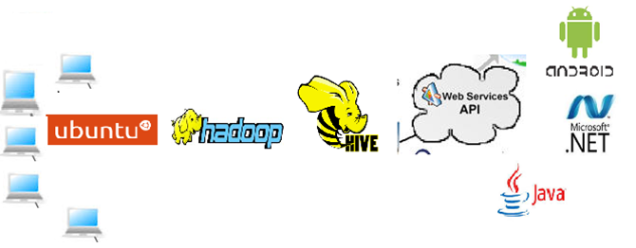

**Chapter 3**

**Data Analysis**

**ER- Diagram**

In software engineering, an entity–relationship model (ER model) is a data model for describing the data or information aspects of a business domain or its process requirements, in an abstract way that lends itself to ultimately being implemented in a database such as a relational database. The main components of ER models are entities (things) and the relationships that can exist among them.

Entity–relationship modeling was developed by Peter Chen and published in a 1976 paper.[1] However, variants of the idea existed previously,[2] and have been devised subsequently such as supertype and subtype data entities[3] and commonality relationships.

Introduction : An entity–relationship model is a systematic way of describing and defining a business process. The process is modeled as components (entities) that are linked with each other by relationships that express the dependencies and requirements between them, such as: one building may be divided into zero or more apartments, but one apartment can only be located in one building. Entities may have various properties (attributes) that characterize them. Diagrams created to represent these entities, attributes, and relationships graphically are called entity–relationship diagrams.

An ER model is typically implemented as a database. In the case of a relational database, which stores data in tables, every row of each table represents one instance of an entity. Some data fields in these tables point to indexes in other tables; such pointers represent the relationships.

**E-R Diagram of Sales Database**

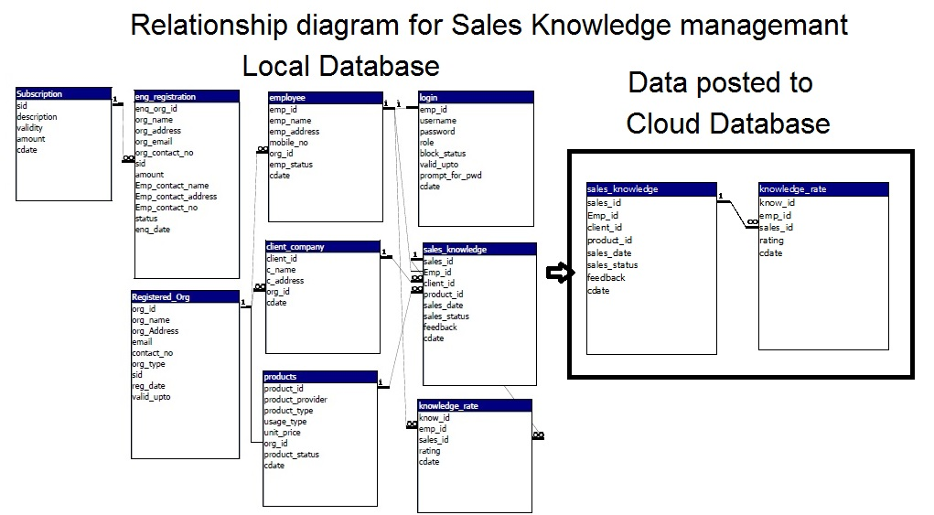

**Chapter 4**

**Software Design**

**Development Model**

***Private cloud***

Private cloud is cloud infrastructure operated solely for a single organization, whether managed internally or by a third-party, and hosted either internally or externally. Undertaking a private cloud project requires a significant level and degree of engagement to virtualize the business environment, and requires the organization to reevaluate decisions about existing resources. When done right, it can improve business, but every step in the project raises security issues that must be addressed to prevent serious vulnerabilities. Self-run data centers are generally capital intensive. They have a significant physical footprint, requiring allocations of space, hardware, and environmental controls. These assets have to be refreshed periodically, resulting in additional capital expenditures. They have attracted criticism because users "still have to buy, build, and manage them" and thus do not benefit from less hands-on management, essentially "[lacking] the economic model that makes cloud computing such an intriguing concept".

***Public cloud***

A cloud is called a "public cloud" when the services are rendered over a network that is open for public use. Public cloud services may be free. Technically there may be little or no difference between public and private cloud architecture, however, security consideration may be substantially different for services (applications, storage, and other resources) that are made available by a service provider for a public audience and when communication is effected over a non-trusted network. Generally, public cloud service providers like Amazon AWS, Microsoft and Google own and operate the infrastructure at their data center and access is generally via the Internet. AWS and Microsoft also offer direct connect services called "AWS Direct Connect" and "Azure ExpressRoute" respectively, such connections require customers to purchase or lease a private connection to a peering point offered by the cloud provider.

***Hybrid cloud***

Hybrid cloud is a composition of two or more clouds (private, community or public) that remain distinct entities but are bound together, offering the benefits of multiple deployment models. Hybrid cloud can also mean the ability to connect collocation, managed and/or dedicated services with cloud resources.

Gartner, Inc. defines a hybrid cloud service as a cloud computing service that is composed of some combination of private, public and community cloud services, from different service providers.[67] A hybrid cloud service crosses isolation and provider boundaries so that it can't be simply put in one category of private, public, or community cloud service. It allows one to extend either the capacity or the capability of a cloud service, by aggregation, integration or customization with another cloud service.

Varied use cases for hybrid cloud composition exist. For example, an organization may store sensitive client data in house on a private cloud application, but interconnect that application to a business intelligence application provided on a public cloud as a software service.[68] This example of hybrid cloud extends the capabilities of the enterprise to deliver a specific business service through the addition of externally available public cloud services. Hybrid cloud adoption depends on a number of factors such as data security and compliance requirements, level of control needed over data, and the applications an organization uses.

The specialized model of hybrid cloud, which is built atop heterogeneous hardware, is called "Cross-platform Hybrid Cloud". A cross-platform hybrid cloud is usually powered by different CPU architectures, for example, x86-64 and ARM, underneath. Users can transparently deploy applications without knowledge of the cloud's hardware diversity.This kind of cloud emerges from the raise of ARM-based system-on-chip for server-class computing.

**Chapter 5**

**Snapshots**

**Snap of Software:**

**Employee Module:**

**Login:**

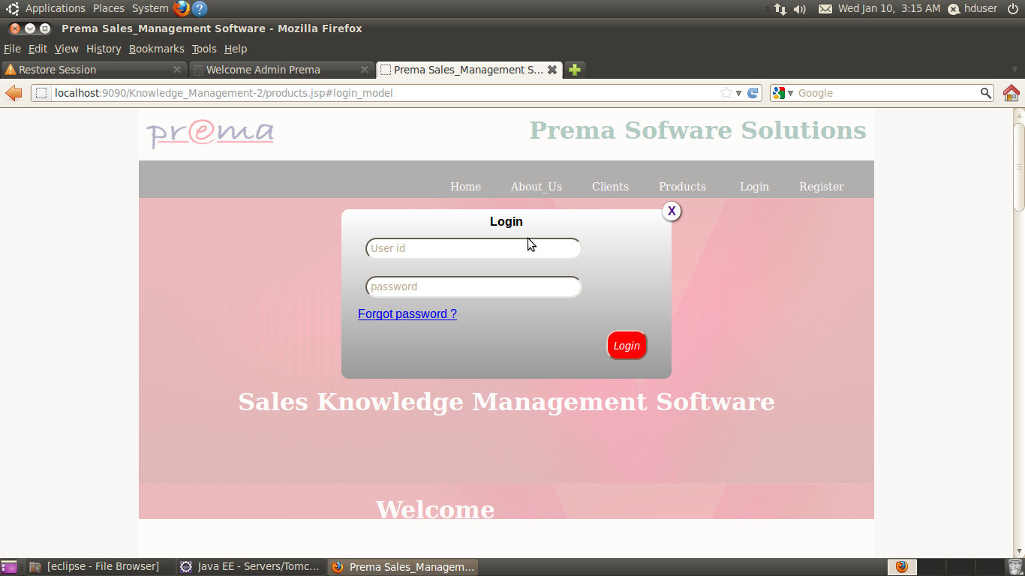

**Add Employee:**

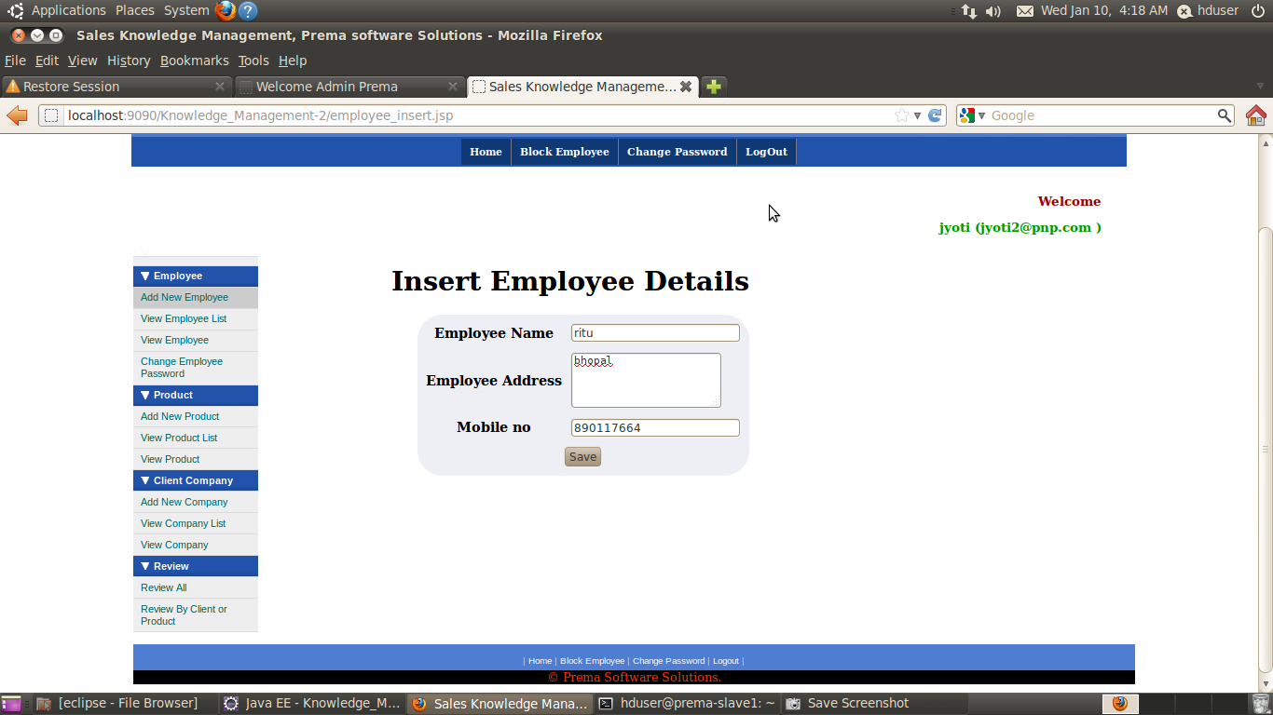

**Delete Employee:**

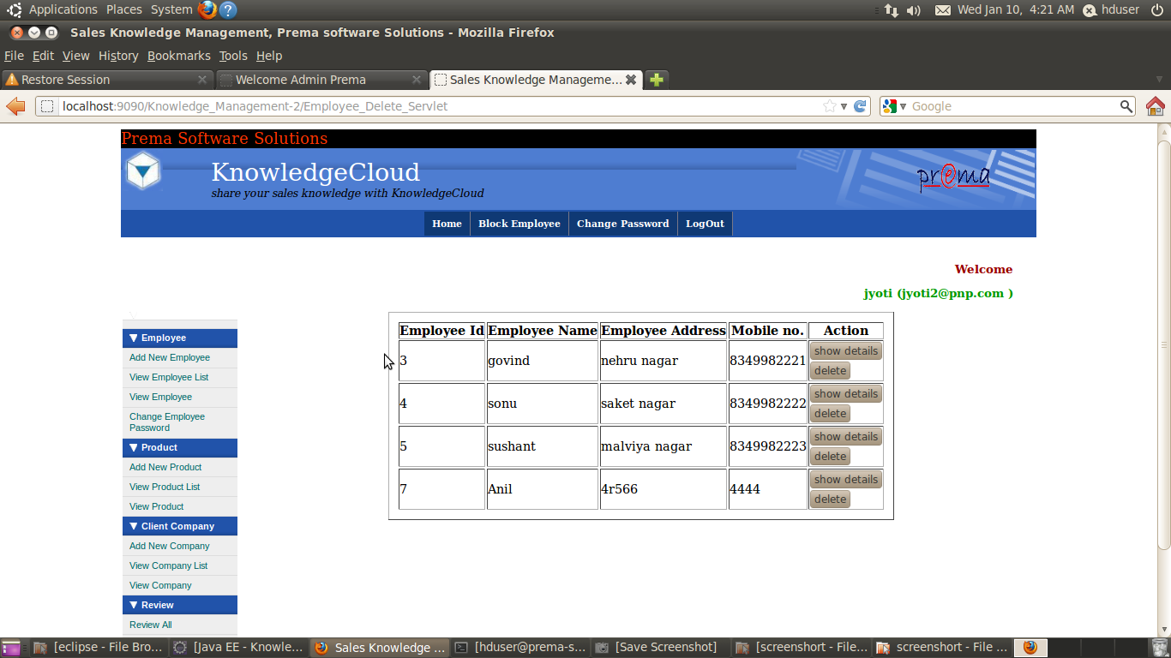

**Show Employee List:**

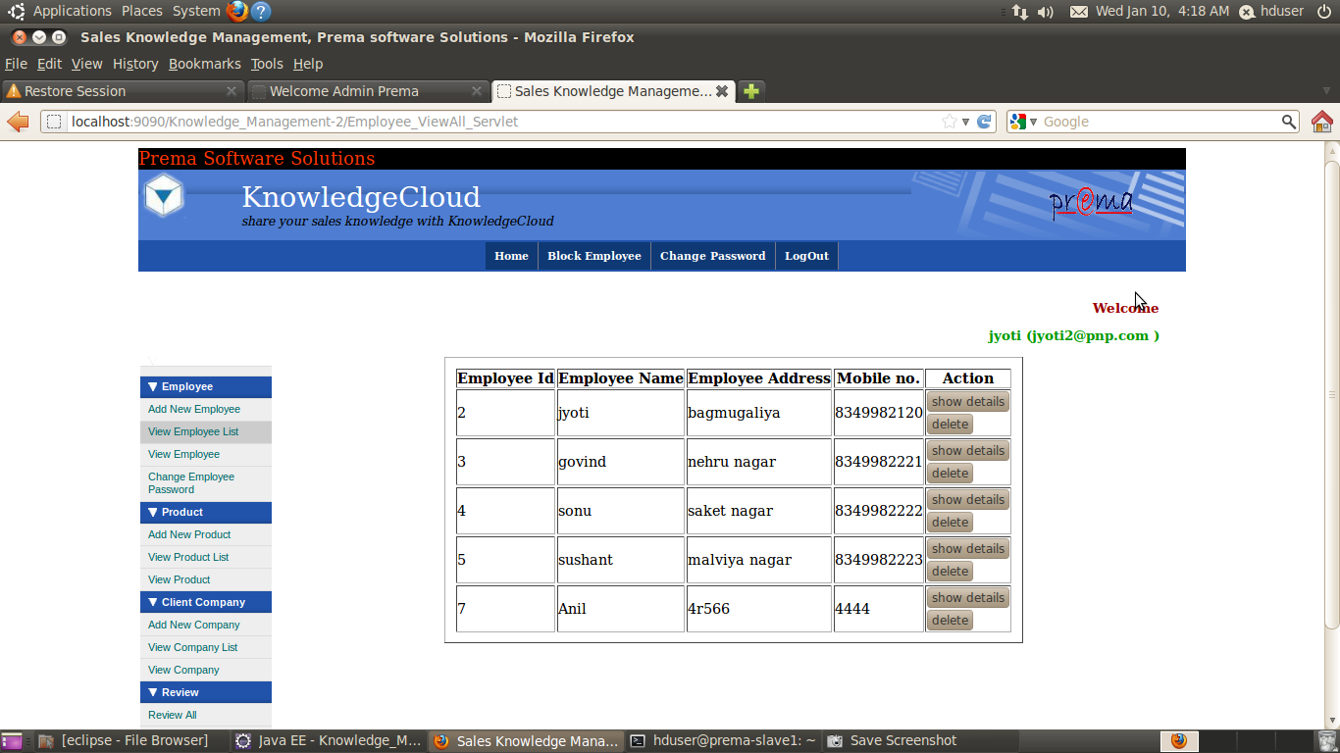

**Show Employee Details:**

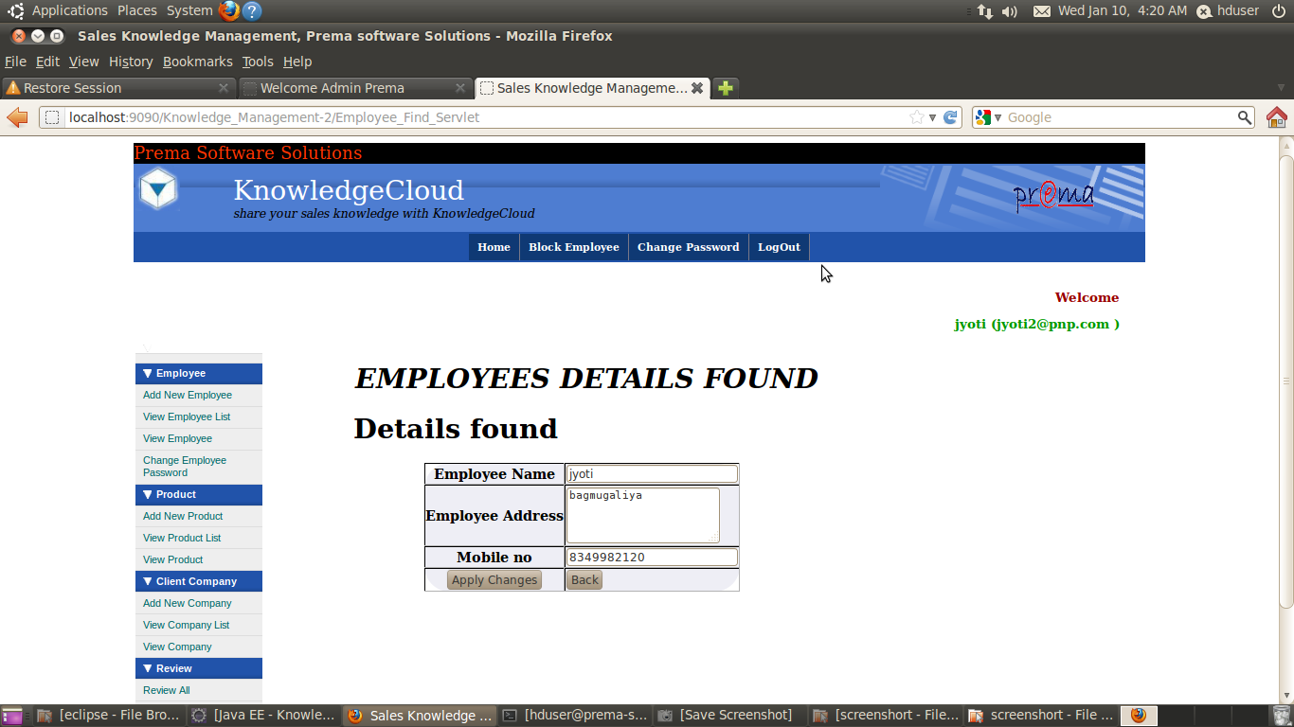

**Change Employee Password:**

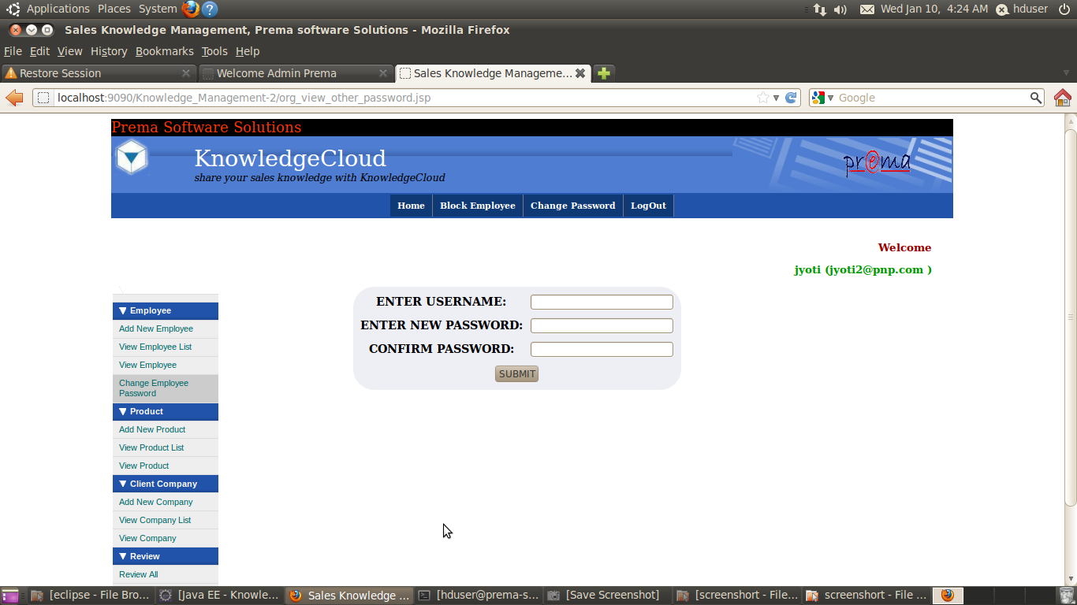

**Chapter 6**

**Day wise Activity**

15th June 2015 : Cloud Computing

16 th June 2015 :Sales Knowledge Management

17 th June 2015 :Hadoop

18 th June 2015 :Hive

19 th June 2015 :Linux Commands

22 th June 2015 : Creation Of Hadoop Environment

23 th June 2015 : Installation

24 th June 2015 :HTML,CSS

25 th June 2015 :Template Design

26 th June 2015 :Installing MySql(Database Server)

29 th June 2015 :Development of project starts

30 th June 2015 :Manage & Bean Classes

1st July 2015: Servlet &Jsps

2nd July 2015:Module wise Development

3rd July 2015:Module wise Development

6th July 2015:Store the data on Cloud Server

7th July 2015 :Module wise Development ends

8th July 2015 :Testing

9th July 2015 :Functional Testing of your module

10th July 2015: White box & Black box Testing

13th July 2015 :End to End Testing

14th July 2015 :Maintaining Graphical Interface

15th July 2015 :Validation Checks

16th July 2015 :Maintaining Login sessions

17th July 2015 :Report Prepration

#### CERTIFICATE

**This is to certify that *Yourname,* student of B.E. (CSE) IV year*,* has completed the Major Training entitled “CLOUD COMPUTING” during the academic session 2015-16 under theguidance & supervision *of* *DEPELOPMENT TEAM OF PREMA SOFTWARE SOLUTION.***

**I approve the training for submission as required for partial fulfillment for completion of the engineering degree.**

**PROJECT GUIDE (from college):**