**Introduction to Programming**

**COIT20245, Term1, 2019**

**Assessment item – Assignment 2**

**Lecturer: Tao**

**Tutor: Tao**

**Prepared by:**

**Name : Aman kumar Maharjan**

**Student Number : 12102452**

**Due Date : 31 May 2019**

## Test Plan:

Data records taken into consideration:

Even no of records

|  |
| --- |
| <ID, SBP, DBP, MAP, CATEGORY> |
| 1. <S01,120,100,106,HIGH> 2. <S010,110,56,74,NORMAL> 3. <S02,80,50,59,LOW> 4. <S03,90,80,83,NORMAL> 5. <S04,92,90,90,NORMAL> 6. <S05,40,40,40,LOW> 7. <S06,60,20,33,LOW> 8. <S07,100,70,80,NORMAL> 9. <S08,110,30,56,LOW> 10. <S09,70,60,63,LOW> |

Odd no of records

|  |
| --- |
| <ID, SBP, DBP, MAP, CATEGORY> |
| 1. <S01,120,100,106,HIGH> 2. <S02,80,50,59,LOW> 3. <S03,90,80,83,NORMAL> 4. <S04,92,90,90,NORMAL> 5. <S05,40,40,40,LOW> 6. <S06,60,20,33,LOW> 7. <S07,100,70,80,NORMAL> 8. <S08,110,30,56,LOW> 9. <S09,70,60,63,LOW> |

|  |  |  |  |  |  |
| --- | --- | --- | --- | --- | --- |
| **Case** | **Functionality** | **Input Arguments** | **Expected outcomes** | **Actual Outcomes** | **Result** |
| **Case 0:** | **Displaying menu** | Arg1=0 | Display the menu | Displayed the main menu | Pass |
| **Show the input error** | Arg1=0,  Arg2= abc | Display the no of input error | Display the no of input error | Pass |
| **Case 1:** | **Display the record** | Arg1=1,  Arg2=S01 | Display the record:  <S01,120,100,106,HIGH> | Displayed the record:  <S01,120,100,106,HIGH> | Pass |
| **Show the record not found message** | Arg1=1,  Arg2=S012 | Display the record not found message:  [ERROR]:SORRY:RECORD ID 'S015' NOT FOUND | Displayed the record not found message:  [ERROR]:SORRY:RECORD ID 'S015' NOT FOUND | Pass |
| **Show the input validation message** | Arg1=1,  Arg2= S01,  Arg3=10 | Display input validation message:  ERROR:Contains INVALID NO OF INPUT:3 MUST CONTAIN ONLY 'id' | Displayed input validation message:  ERROR:Contains INVALID NO OF INPUT:3 MUST CONTAIN ONLY 'id' | Pass |
| **Case 2:** | **Show the records in the range** | Arg1=2,  Arg2=0,  Arg3=120 | Display the records in the range:  RECORDS FOUND:10  <S01,120,100,106,HIGH>  <S010,110,56,74,NORMAL>  <S02,80,50,59,LOW>  <S03,90,80,83,NORMAL>  <S04,92,90,90,NORMAL>  <S05,40,40,40,LOW>  <S06,60,20,33,LOW>  <S07,100,70,80,NORMAL>  <S08,110,30,56,LOW>  <S09,70,60,63,LOW> | RECORDS FOUND:10  <S01,120,100,106,HIGH>  <S010,110,56,74,NORMAL>  <S02,80,50,59,LOW>  <S03,90,80,83,NORMAL>  <S04,92,90,90,NORMAL>  <S05,40,40,40,LOW>  <S06,60,20,33,LOW>  <S07,100,70,80,NORMAL>  <S08,110,30,56,LOW>  <S09,70,60,63,LOW> | Pass |
| **Show record not found in the range message** | Arg1=2,  Arg2=10,  Arg2=20, | Display the record not found message:  [ERROR]:NO RECORDS FOUND IN THE RANGE:<10,20> | Displayed the record not found message:  [ERROR]:NO RECORDS FOUND IN THE RANGE:<10,20> | Pass |
| **Show the out of range error** | Arg1= 2,  Arg2=-1,  Arg3=100, | Display the out of range message  [ERROR]:INVALID INPUT!: MUST BE IN THE RANGE 0-200 | Displayed the out of range message  [ERROR]:INVALID INPUT!: MUST BE IN THE RANGE 0-200 | Pass |
| Arg1= 2,  Arg2=1,  Arg3=210, |
| **Show the input error** | Arg1=2 | Display the no of input error:  ERROR: INVALID NO OF INPUT:1 MUST CONTAIN ONLY 'MAP1' & 'MAP2 | Displayed the no of input error:  ERROR: INVALID NO OF INPUT:1 MUST CONTAIN ONLY 'MAP1' & 'MAP2 | Pass |
|  | Arg1=2 ,  Arg2=3 | Pass |
| Arg1=2 ,  Arg2=3,  Arg3=4,  Arg5=10 | Pass |
| **Case 3** | **Show the summary i.e., highest, lowest, median** | **Even Case:**  Data length:10  Arg1=3 | Display summary statistics:  Highest MAP value: 106  Lowest MAP value: 33  Median MAP value: 68 | Displayed summary statistics:  Highest MAP value: 106  Lowest MAP value: 33  Median MAP value: 68 | Pass |
|  | **Odd Case:**  Data length=9  Arg1=3 | Display summary statistics:  Highest MAP value: 106  Lowest MAP value: 33  Median MAP value: 63 | Displayed summary statistics:  Highest MAP value: 106  Lowest MAP value: 33  Median MAP value: 63 | Pass |
|  | **Show the no of input error** | Arg1=3,  Arg2=2 | Display the no of input ERROR: INVALID NO OF INPUT:2 MUST CONTAIN ONLY '3' | Displayed the no of input ERROR: INVALID NO OF INPUT:2 MUST CONTAIN ONLY '3' | Pass |
| **Case 9** | **Exit from the system** | Arg1=9 | Exit from the system | Exit from the system | Pass |
|  | **Show the no of input error** | Arg1=9,  Arg2=2 | ERROR: INVALID NO OF INPUT:2 MUST CONTAIN ONLY '9' | ERROR: INVALID NO OF INPUT:2 MUST CONTAIN ONLY '9' | Pass |
| **Sentinel Input** | **Enter Invalid input** | Arg1= abc | Error: INVALID INPUT, Please try again | Error: INVALID INPUT, Please try again | Pass |

## Test Results:

This section contains a series of screenshots from the test plan section:

## Case 0:

Display the menu

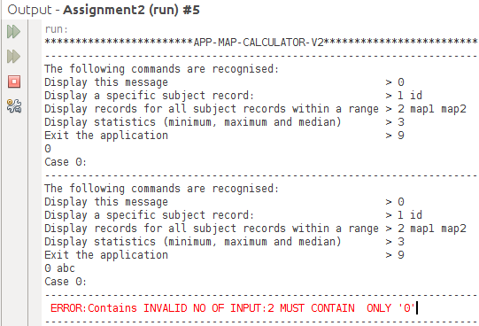

## 

## Case 1:

Find the specific record

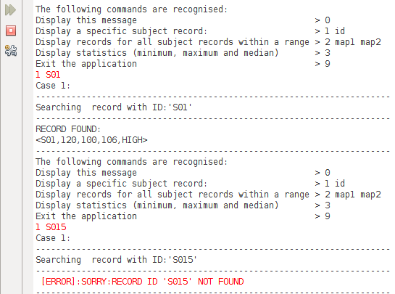

Input validation case

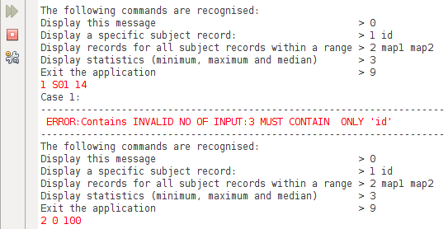

## Case 2:

Show records in the range

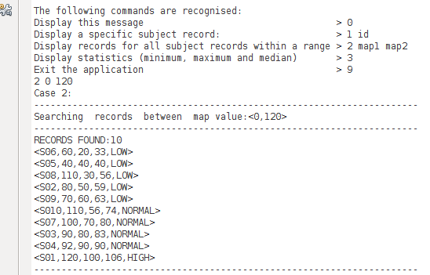

Record not found & input Validation and case

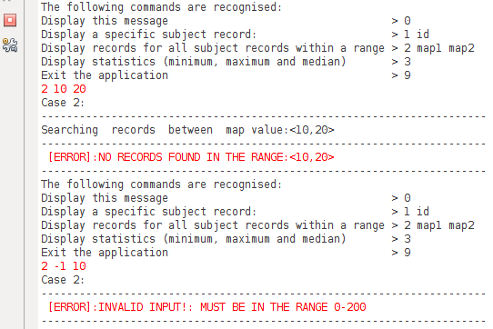

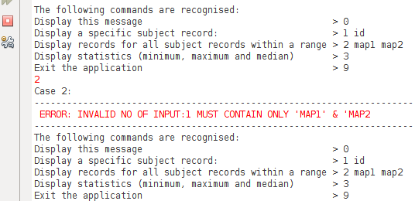

## Case 3:

Even case

## 

Odd case

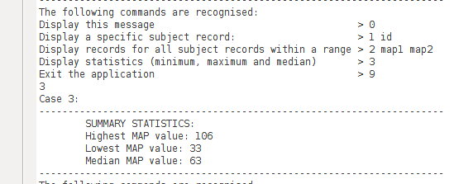

## 

## Case 9:

Exit case

# 

## Limitation:

* The program doesn’t check the input type for case 3 .For example, if we enter ‘2 abc 100’ instead of ‘2 10 100’ ,the program shows the exception

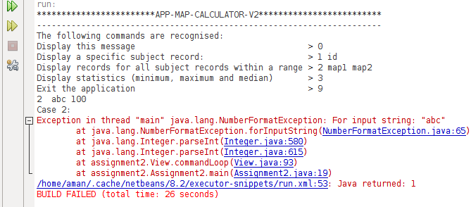

* The program has preloaded data. So it doesn’t take user input from the console. So at a time it only computes either odd or even no of data.
* The program doesn't check the validity of sbp>dpp case.
* For case 1 , the id value is case sensitive.i.e "1 S01" and "1 s01" is different