**Introduction to Programming**

**COIT20245, Term1, 2019**

**Assessment item – Assignment 1**





**Lecturer: Tao**

**Tutor: Tao**

**Prepared by:**

**Name : Aman Kumar Maharjan**

**Student Number : 12102452**

**Due Date : 26th April, 2019**

# Test Plan:

This section tabulates input values for Identifier, SBP, DBP and output values for MAP and Category. 11 sets of data have been taken into consideration.

|  |  |  |  |  |  |  |
| --- | --- | --- | --- | --- | --- | --- |
| **Iteration** | **Input** **Identifier** | **Input**  **SBP** | **Input**  **DBP** | **Actual MAP**  **Outputs** | **Expected**  **MAP Outputs** | **Category** |
| 1 | 1 | 90 | 80 | 83.3 | 83.33333 | NORMAL |
| 2 | 2 | 92 | 75 | 80.7 | 80.66667 | NORMAL |
| 3 | 3 | 80 | 50 | 60 | 60 | LOW |
| 4 | 4 | 100 | 60 | 73.3 | 73.33333 | NORMAL |
| 5 | 5 | 90 | 50 | 63.3 | 63.33333 | LOW |
| 6 | 6 | 100 | 90 | 93.3 | 93.33333 | NORMAL |
| 7 | 7 | 120 | 100 | 106.7 | 106.6667 | HIGH |
| 8 | 8 | 70 | 50 | 56.7 | 56.66667 | LOW |
| 9 | 9 | 120 | 110 | 113.3 | 113.3333 | HIGH |
| 10 | 10 | 70 | 80 | SBP<DBP  ERROR | | ERROR |
| 11 | 10 | 100 | 80 | 86.7 | 86.66667 | NORMAL |

# Test Results:

This section consist of a series of screenshots from the test plan section:

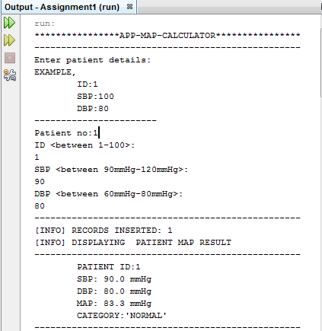

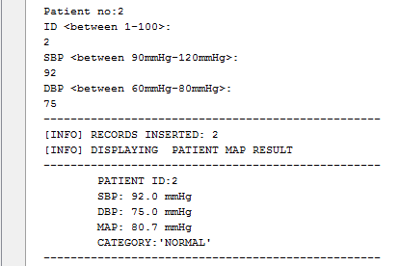

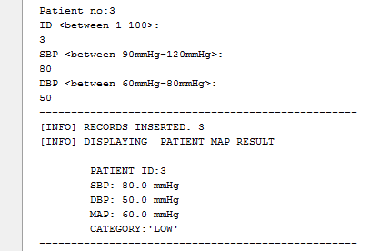

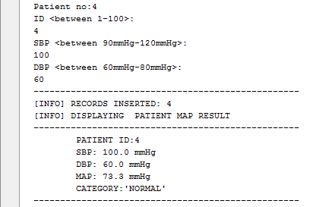

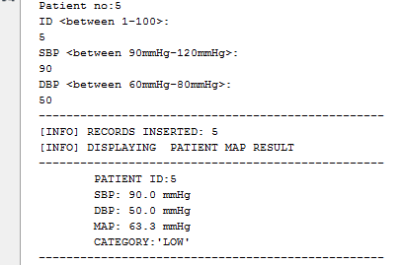

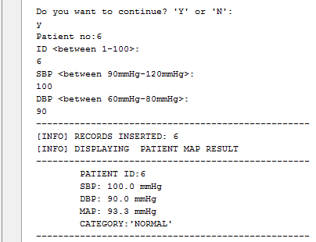

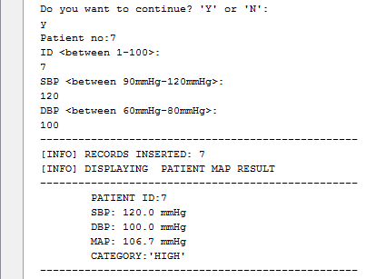

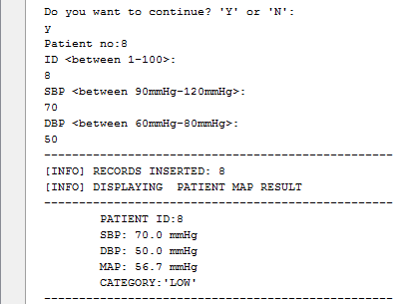

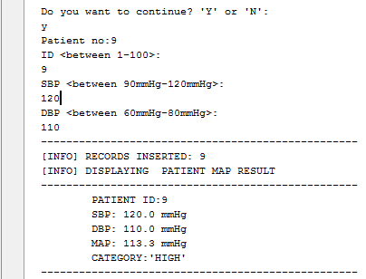

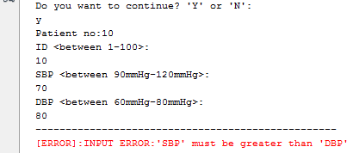

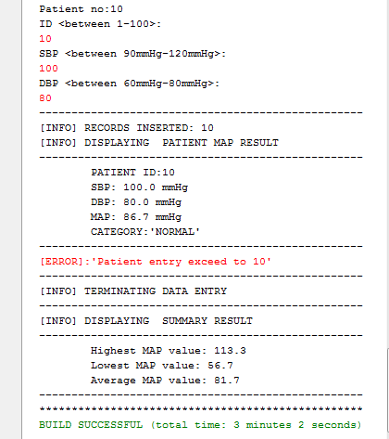

# Limitation:

The limitation section covers the limitation in term of validation and functionality of the program. It contains the following list of limitation:

* The program does not allow to record more than 10 records or less than 5 records. For e.g For the 11th record to be inserted, it will prompt “Patient entry exceed to 10’ error



* The program does not check SBP range for the healthy adult, which is typically between 90 mmHg and 120 mmHg.
  + For e.g, if we place SBP value=300, then it will not validate the SBP value as shown in the fig below.

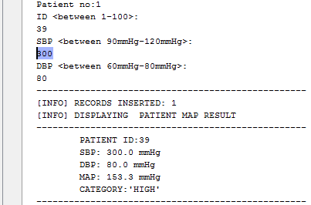

* The program does not check the DBP range for the healthy adult, which is typically between 60 mmHg and 80mmHg. For eg., If we add DBP value=50 then it will not validate as shown below

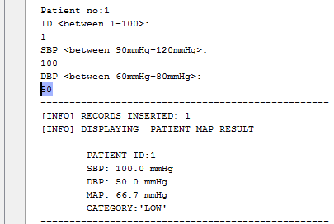

* The program does not check the user identifier between the ranges 1-100. If we put patient id=120, it will not check for the validation of the patient id as shown below:

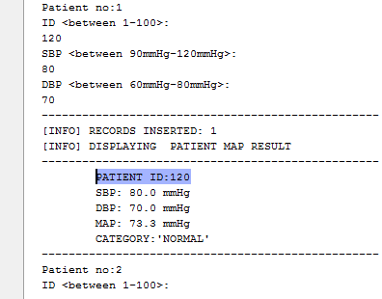

* The program will not check for duplication of the user identifier. For e.g. For the same id =1, we could add two records as shown below:

