**DATA STRUCTURES AND ALGORITHMS**

**Assignment 2**

**COIT20256, Term2, 2019**

**Assessment item – Assignment 2**

**Lecturer: Zakiullah Khan**

**Tutor: Zakiullah Khan**

**Prepared by:**

**Aman Kumar Maharjan (12102452)**

**Damodar Chaulagain (12099970)**

Contents

PART A 1

1.Database and Tables: 1

2. Test Plans 2

3. Save Button 2

4. Display Button 4

PART B 8

1. Priority Queue: 8

Observation and Conclusion 8

2. Stack 8

Observation and Conclusion 8

3. Set 8

Observation and Conclusion 9

4. Hash Map 9

Observation and Conclusion 9

# PART A

## 1.Database and Tables:

**MySQl** database is used in the system with db name “**Assignment2**”. Username for the database is “root” and password is “root”. It contains only one Table **Userenergy**. **Userenergy** table contains the fields “Id”, “Name”, “Height”, “Gender”, “AgeGroup”, “PalDescription”, “PalValue”, “Energyvalue” and “Expectedweight”.

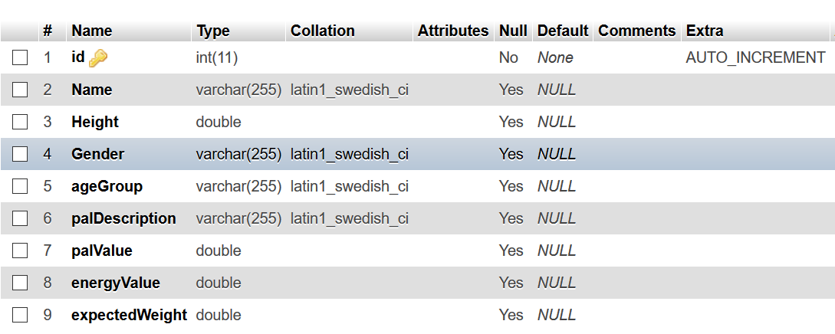

Fig: 1 Database structure

The table is created programmatically using the JDBC connection. ‘Save’ button from the program will insert the data and “Display All’ button will retrieve the data from the table.

## 2. Test Plans

1. Save button enable and disable feature
2. Save the current user energy details in database
3. After saving the data, disable Save button and enable Display all button
4. Display all the user energy needs from the database
5. Display no any records found message if there are no any records

## 3. Save Button

**1. Save button enable and disable feature**

|  |  |  |  |
| --- | --- | --- | --- |
| Test Case | Input Data | Expected Output | Result |
| ‘Save’ button enable and disable | Click on the ‘display’ button | After clicking,‘display’ button ,‘save’ button is enabled | As expected, the ‘Save” button is enabled after clicking ‘display’ button |

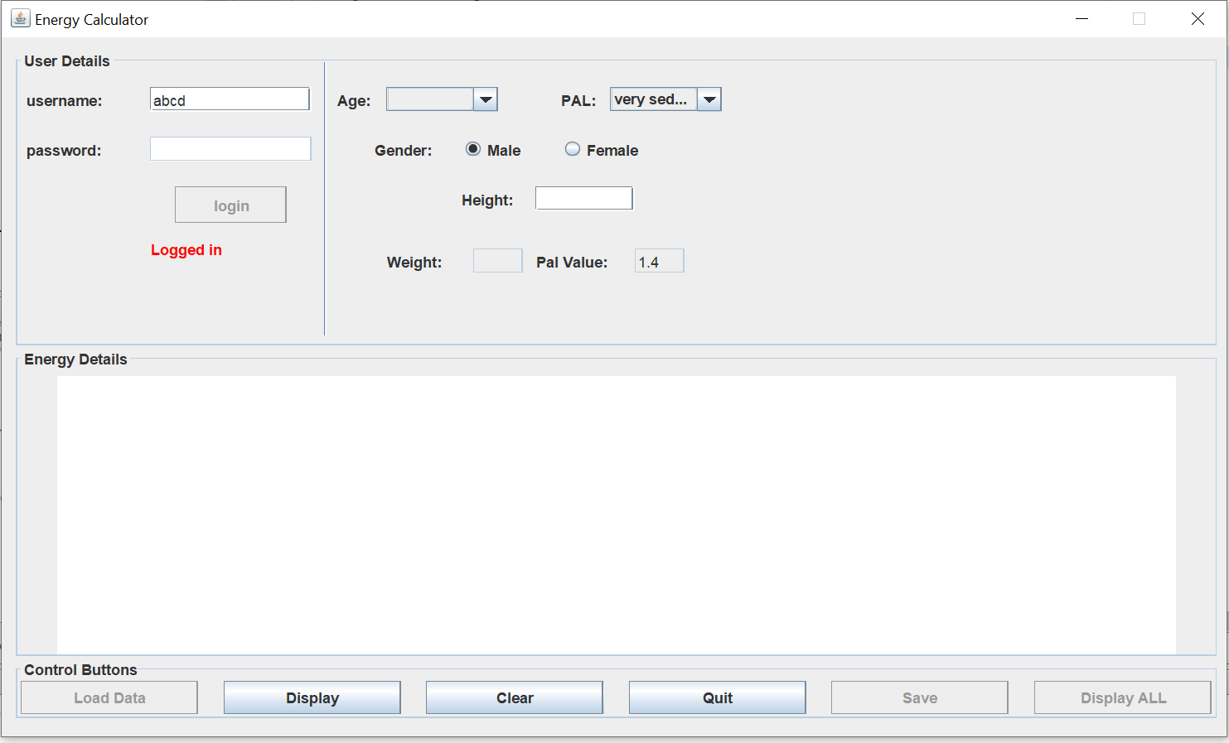

Fig:2 Before clicking display button

**After clicking display button**

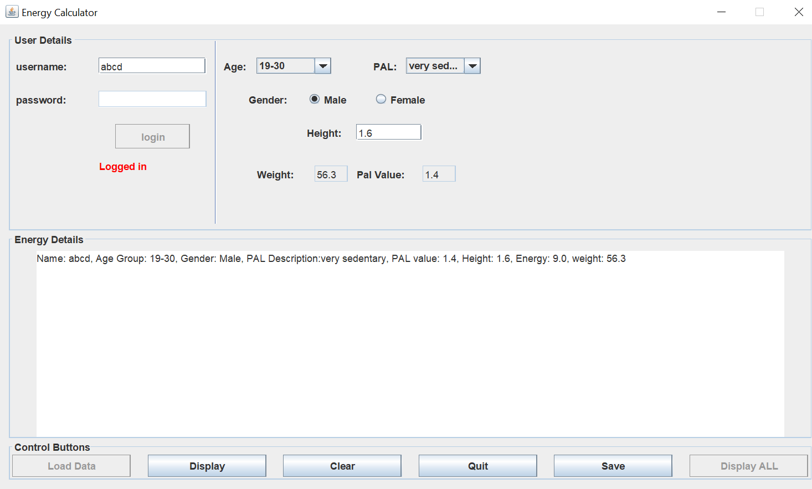

Fig:3 After clicking display button

**2. Save the current user energy details in database**

|  |  |  |  |
| --- | --- | --- | --- |
| Test Case | Input Data | Expected Output | Result |
| ‘Save’ the current user energy details | Click on the ‘save’ button | On clicking save button, the current energy details are saved with dialog message “data inserted successfully”, energy saved, and the button gets disabled | Dialog message appeared in the screen. |

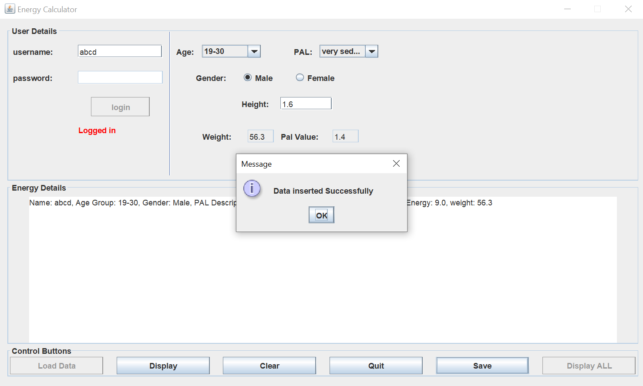  
Fig: 4 After inserting user energy needs

## **4. Display Button**

1. **After saving the data, disable Save button and enable Display all button**

|  |  |  |  |
| --- | --- | --- | --- |
| Test Case | Input Data | Expected Output | Result |
| Save button disable  and ‘display button’ enable | Click on the ‘Ok button | After clicking the Ok option on the dialog message, the save button will be disable and “Display All” button will be enabled | Save button is disabled and “Display All” is enabled |

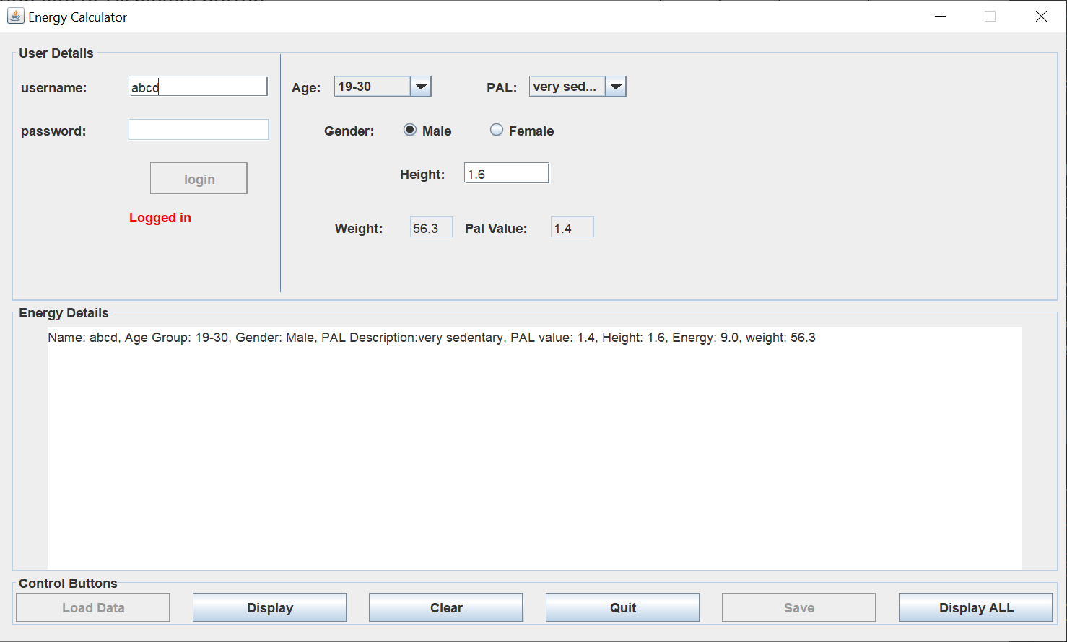

Fig: 5After pressing Ok of insert button

1. **Display all the user energy needs from the database**

|  |  |  |  |
| --- | --- | --- | --- |
| Test Case | Input Data | Expected Output | Result |
| Display all the list of User energy details from the database | Click on the “ Display All” button | Should be able to retrieve all the energy details from database and display onto the text area. | Displayed all the list of energy details on the text area. |

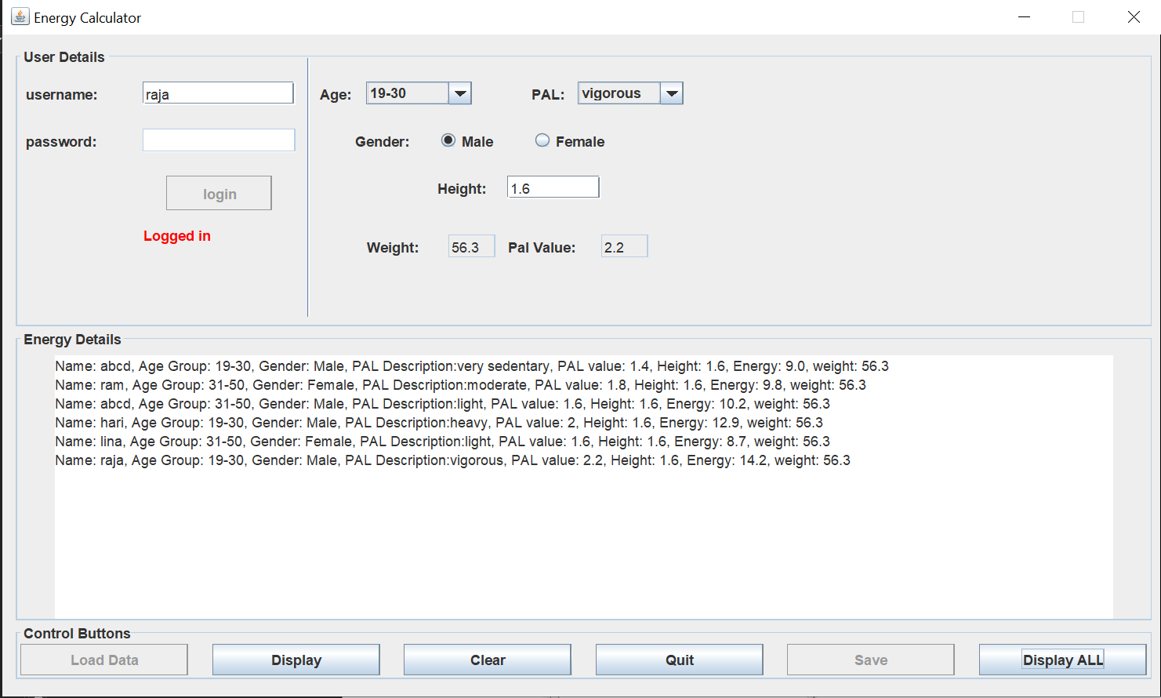

Fig: 6 After clicking Display All button

**5. Display no any records found if there are no any records**

|  |  |  |  |
| --- | --- | --- | --- |
| Test Case | Input Data | Expected Output | Result |
| Display no nay records found message on the records are empty | Click on the “ Display All” button ,  Table is empty | “No any records found” message should be displayed. | Display the “No any records found” message |

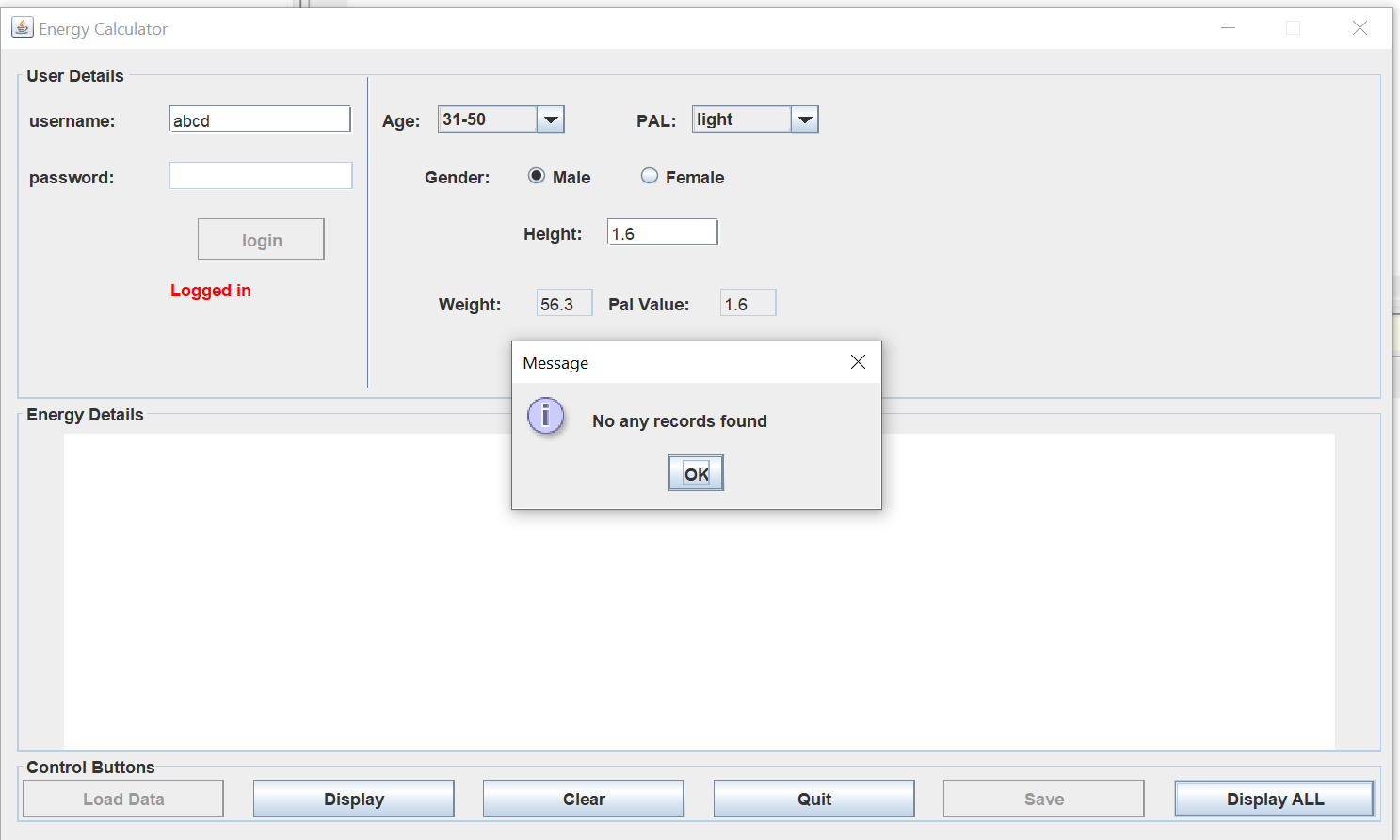

Fig: 7 Displaying message when records are empty in database

# PART B

The main program for analyzing the data structure is DataStructures.java. It loads all the student name and ids from the file name “COIT20256Ass2Data.csv”. It will load following student ids and names in the list.



Fig:8 List of names and Id’s after loading from file

## 1. Priority Queue:



Fig:9 Output of Priority Queue after it has been loaded from the file

### Observation and Conclusion

Unlike Queue, Priority Queue doesn’t follow First in First Out. It uses priority order to get the value. Highest priority will appear at the front of queue and lowest at the end of queue. In JAVA, according to natural ordering, priorities are set. Priority Queue uses peek () method to insert data .In the program, “Ajaya” has the highest priority from natural ordering. So, it appears on the first of the queue, though it was initially at the last of the list.

## 2. Stack



Fig:10 Output of Stack after moving from Priority Queue

### Observation and Conclusion

Stack follows Last In First Out while inserting and retrieving data. Push and Pop operations are performed for inserting and retrieving data. While, moving from priority queue to the Stack, ‘Ajaya’ is pushed on the bottom of stack and is popped at last. On other hand, ‘Vivek’ is pushed at the last and appears on the top of stack. So, while popping the item from the stack ‘Vivek’ is popped first instead of ‘Ajaya’.

## 3. Set



Fig:11 Output of Set after moving from stack

### Observation and Conclusion

Set does not allow duplicate elements. It contains only unique elements. Also, the insertion order is not preserved as well. In the list, “Ajaya”, “Laxman”, ‘Shimul’ are duplicate elements in the stack, which are removed after insertion in Set.

## 4. Hash Map

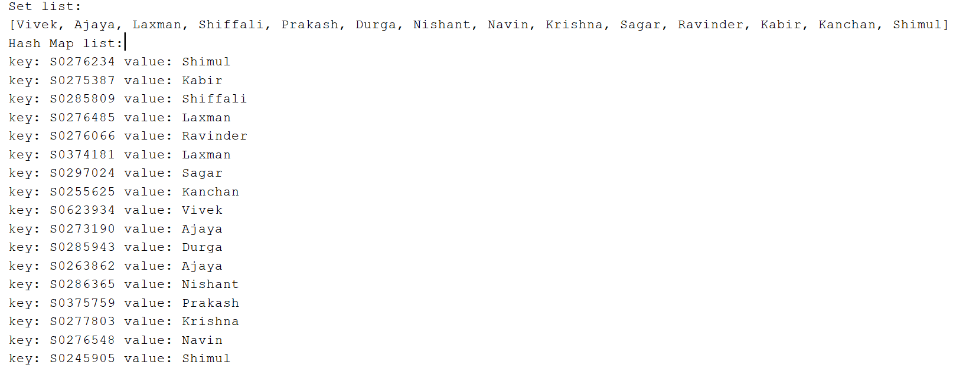

Fig: 12 Output of Hash map after it has been loaded from the file

### Observation and Conclusion

Hash map allows to store the items in key/value pair. Put method is used to add the key and value in the map. Hash map keys are unique and duplicate key are overwritten whereas duplicate values are allowed. It does not preserve any insertion order. In the program, the student Ids are the keys, whereas values are the Names of the Student.