**COIT20257: Distributed Systems: Principles and Development (T1, 2020)**

**A Simplified Master/Worker Framework**

**Assessment – 1**

**Lecturer / Tutor**

**Partha Gangavalli**

**Prepared By**

**Name: Aman Kumar Maharjan**

**SID: 12102452**

**Campus: Sydney**

**Due Date: Monday, 13 April 2020, 11:55 PM**

**Contents**

Program Compilation and Installation 1

Running the application 4

Class Repository in Master 5

Test Instruction 7

# **Program Compilation and Installation**

1. Unzip the Assignment1.zip file

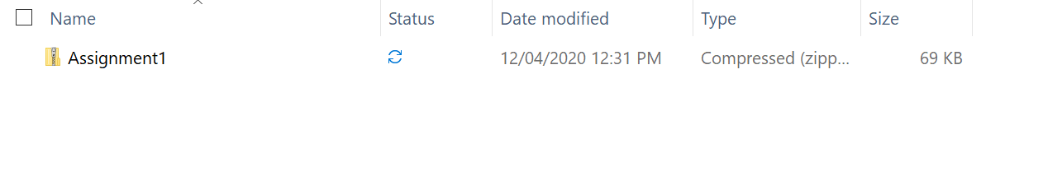

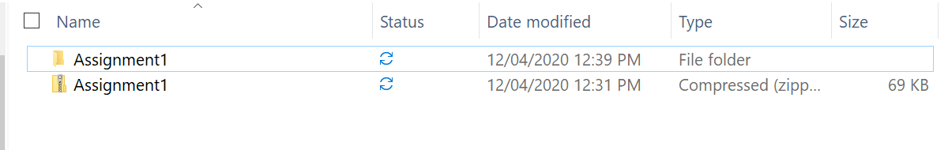

1. Inside Assignment1 folder, there are three folder ‘Worker’ and ‘Master’ and ClassFile.

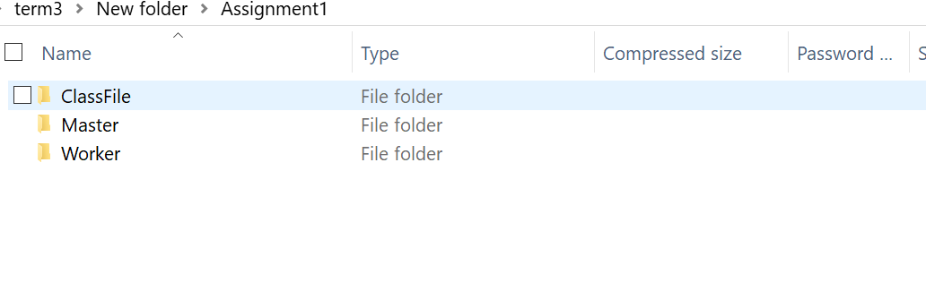

1. Open these two projects through the NetBeans.

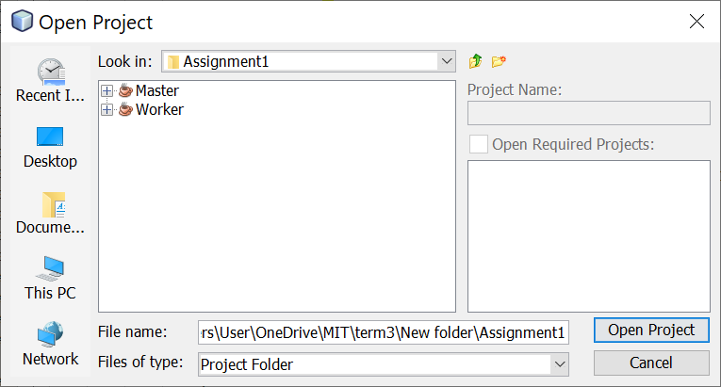

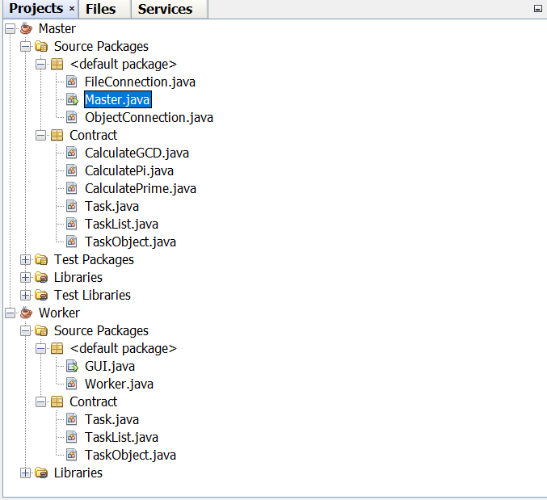

1. Clean and build both the projects, the class files are generated inside the build folder of the project.
   1. **Master**

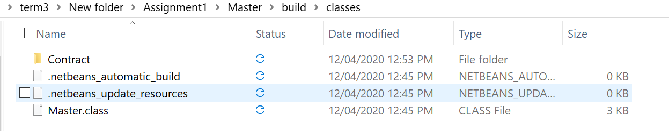

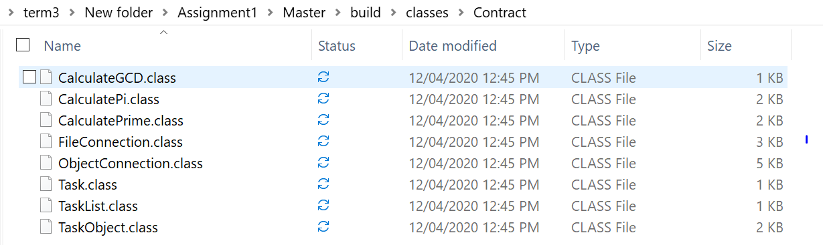

* 1. **Worker**

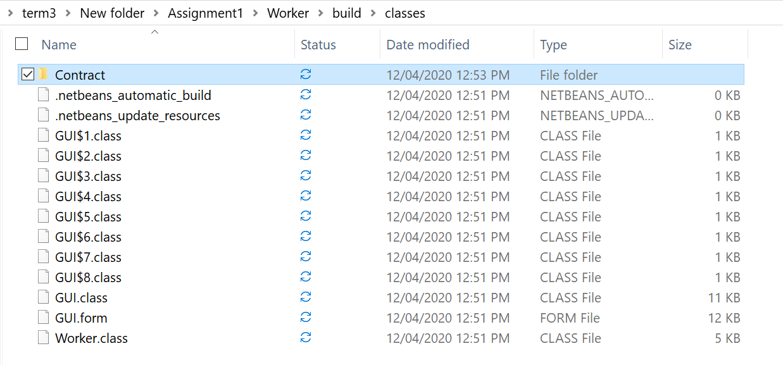

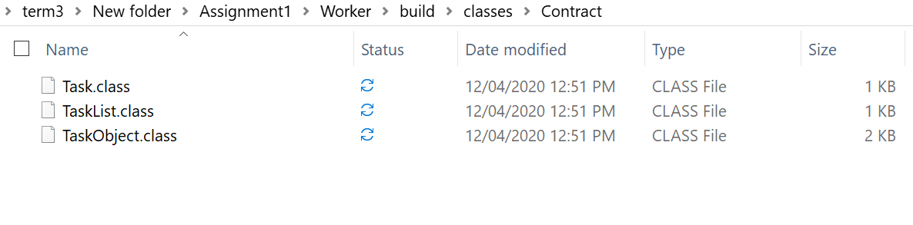

# **Running the application**

**Master**

Go to ClassFile folder and get inside Master folder. Then execute the java command to execute the Master class

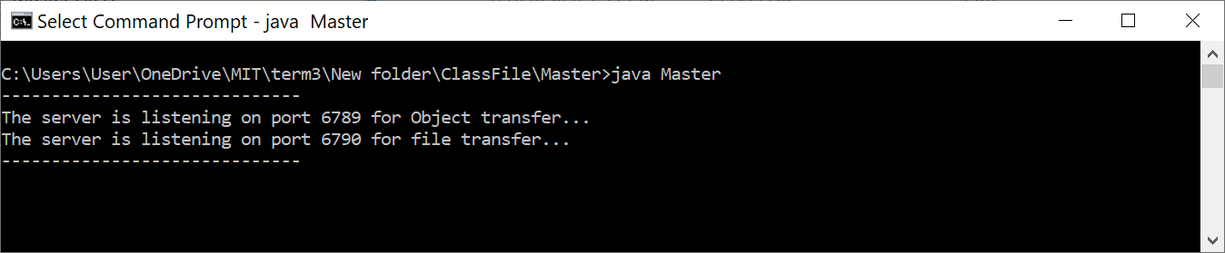

**Worker**

Go to the ClassFile folder and execute the java command to execute the GUI class. The GUI will load.

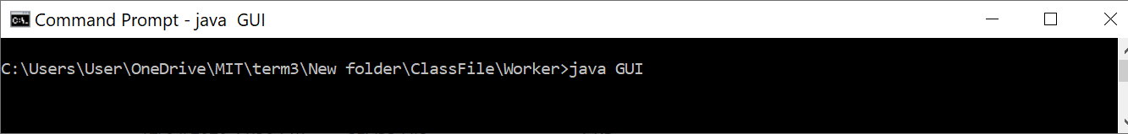

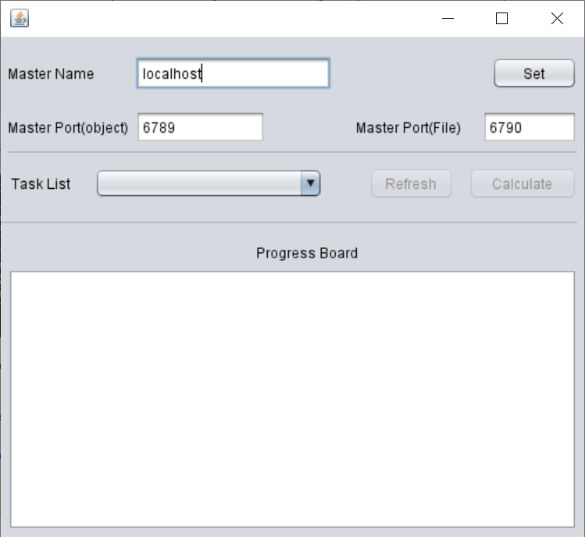

# **Class Repository in Master**

The Contract package inside the Master project is the class repository. It consists of the Task, TaskList, TaskObject, CalculateGCD, CalculatePi, CalculatePrime classes. The Worker will download the Task, TaskList and TaskObject class files from Master after the set button is clicked. Next, it creates the TaskList object to the server and retrieves the TaskList to the combobox. Based on the selection of the task name, the client sends the TaskObject to the server and retrives the result in the progress board.

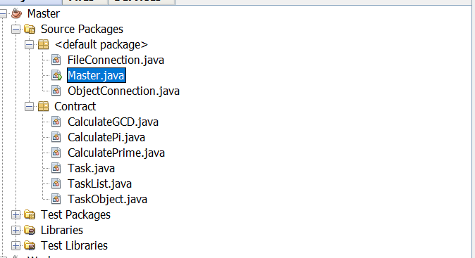

# **Test Instruction**

The following test cases have been taken into consideration.

|  |  |
| --- | --- |
| **Test Plans** | |
| 1. | Set button: File download |
| 2. | Refresh button: Get Task List in combo box |
| 3. | Calculate PI |
| 4. | Calculate Prime |
| 5. | Calculate GCD |

|  |  |  |  |
| --- | --- | --- | --- |
| **Test Case** | **Input Data** | **Expected Result** | **Actual Result** |
| Set button: File download | Set button pressed | Establish TCP connection and download the Task.class, TaskList.class and TakObject.class from the Master to the Worker. | Established TCP connection for object transfer and file downloaded on the Workers contract package |

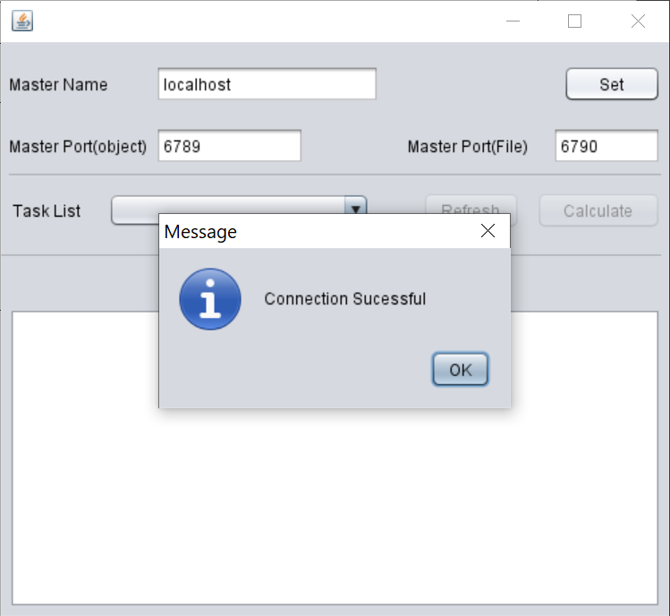

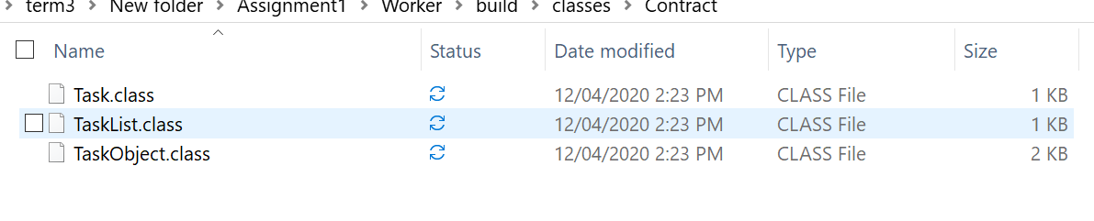

|  |  |  |  |
| --- | --- | --- | --- |
| **Test Case** | **Input Data** | **Expected Result** | **Actual Result** |
| Refresh button: Get Task List in combo box | Refresh button pressed | Get the Task Name in the combo box | Task Name appeared on the list and the calculate button is enabled |

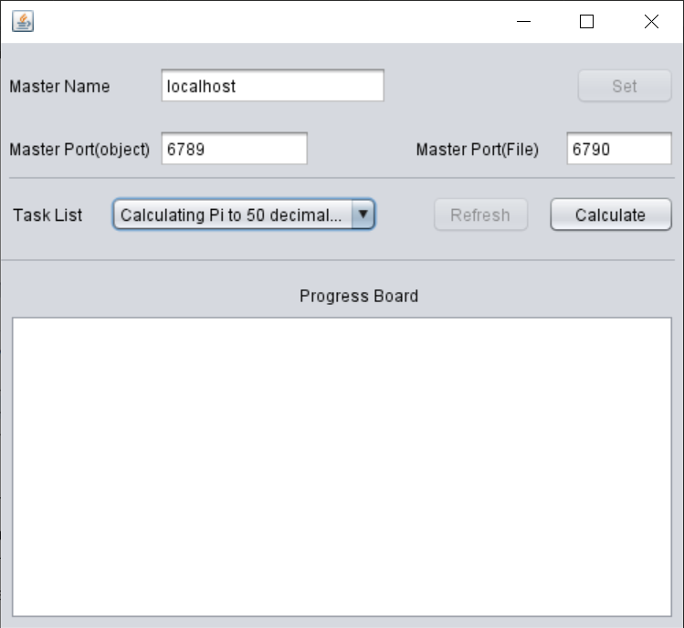

|  |  |  |  |
| --- | --- | --- | --- |
| **Test Case** | **Input Data** | **Expected Result** | **Actual Result** |
| Calculate PI | 50 | Credit 30 and result in master should display PI value to 50 digits after decimal. | Displayed credit and PI value upto 50 digits |

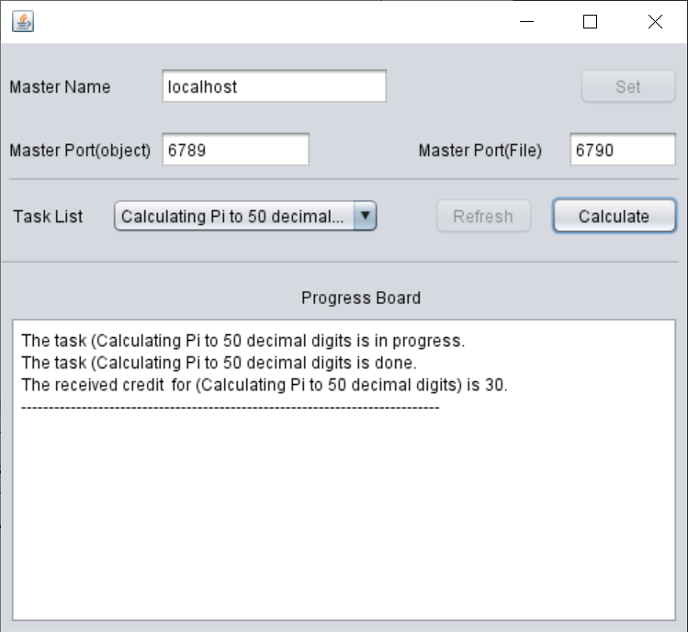

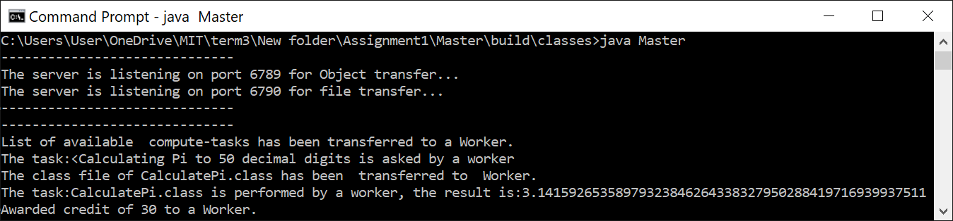

|  |  |  |  |
| --- | --- | --- | --- |
| **Test Case** | **Input Data** | **Expected Result** | **Actual Result** |
| Calculate Prime | 70 | Credit 10 and result in master should display prime number below 70. | Displayed credit 10 and prime numbers below 70. |

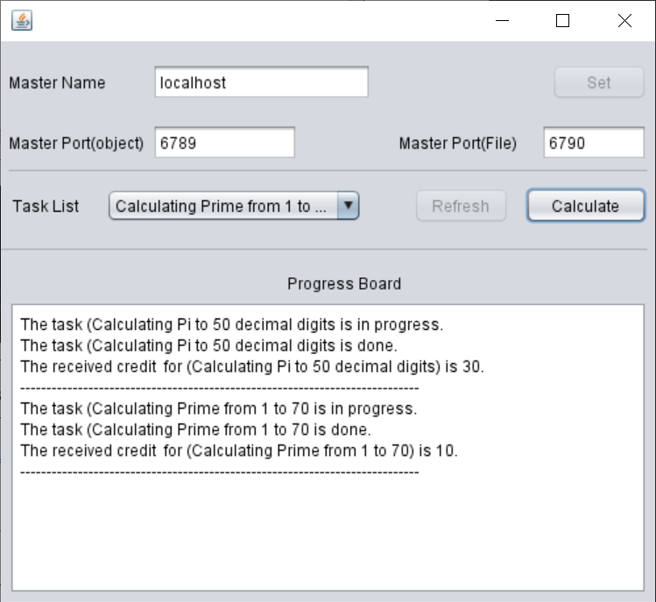

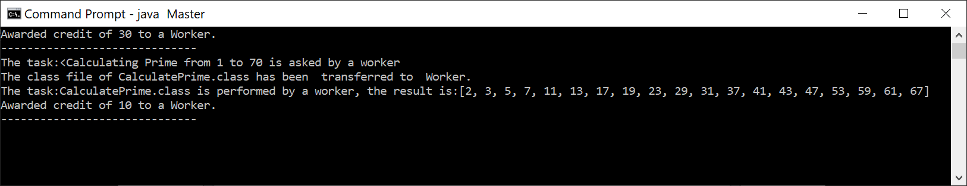

|  |  |  |  |
| --- | --- | --- | --- |
| **Test Case** | **Input Data** | **Expected Result** | **Actual Result** |
| Calculate GCD | 128 and 76 | Credit 20 and result in master should display 4 | Displayed credit 20 and displayed GCD 4 |

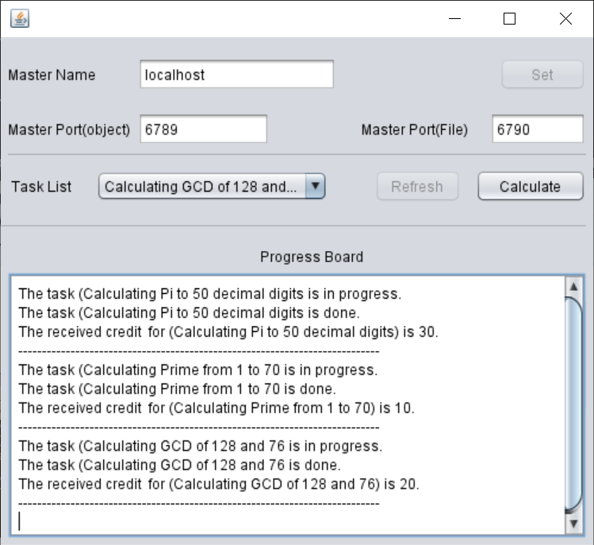

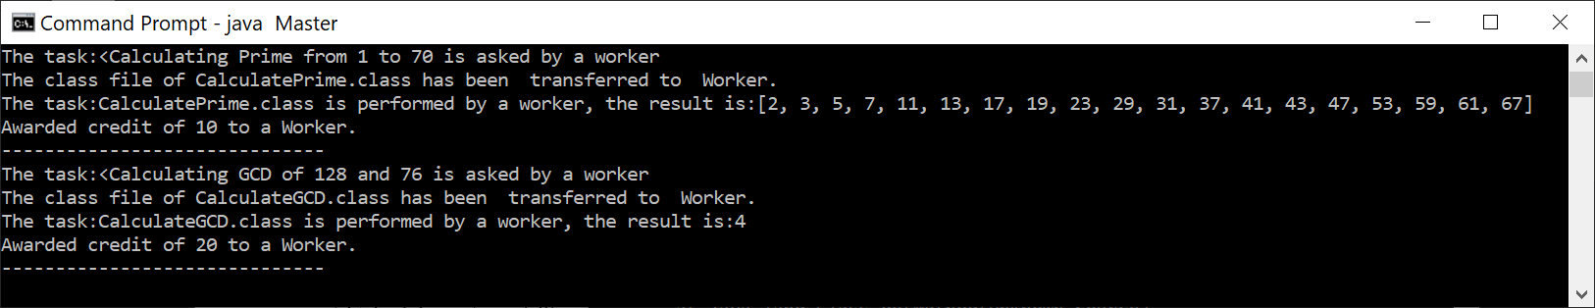

**Worker Console**

