Name :- Aman kumar Roll No.:-K18BYA08
Student Id :- 11803230
Email Address :- amankumargupta8252@gmail.com
GitHub Link :- https://github.com/amankr119/operating-system

1)Explain the problem in term of operating system concept?
Problem1:-In this project (problem) we had used shortest job first algorithm to manage the problem
In shortest job first scheduling the process with the lowest burst time, among the list of all process is going to schedule next. It significantly reduces the average wating time for the other process wating execution.
In the given problem there is an auto diver charges 10 per customer irrespective of the distance the customer has to travel withing the city. According to question all customer picked up the common point and there is n customer or which customer have least distance to travel among the list of all customer going to schedule next first and end first among all customer. Here all customer doing work just like process.
Problem2:-I had used bubble sort and system call structure to manage the problem we have to use bubble sort for enqueue and dequeue and structure name customer_process. A structure use to define type of variable that can hold several data types also structure is another user define data type. A structure is Creates data types that can be used for group item of possible different types.
2)Write the algorithm for proposed solution of the assign problem.
code of structure :

#include<stdio.h>
#include<unistd.h>
#include<sys/wait.h>
#include<stdlib.h>
#define NEW 0
#define READY 1
#define WAITING 2
#define RUNNING 3
#define EXIT 4
int moneyearned=0;
int ongoingtime=0,time_to_last=0,EXIT_STATE_ALL=0,CT_ALLOWED=1,n,i,j;
struct customer_process
{
int pid;
int state;
int timeleft_to_exec;
int at;
int wt,tat,ct,exect;
struct customer_process *prev;
struct customer_process *next;
} *proc_arr;
int chpp;
struct Queue
{
struct customer_process *front ,*rear;
}*RQueue;

void enqueue(struct customer_process *proc)
{
if(RQueue->front==NULL)
{
RQueue->front=proc;
RQueue->rear=proc;
proc->next=NULL;
}

else
{
if(proc->timeleft_to_exec<RQueue->front->timeleft_to_exec)
{
proc->next=RQueue->front;
RQueue->front->prev=proc;
RQueue->front=proc;
}
else if(proc->timeleft_to_exec==RQueue->front->timeleft_to_exec)
{
proc->next=RQueue->front->next;
proc->prev=RQueue->front;
RQueue->front->next=proc;
if(proc->next!=NULL)
{
proc->next->prev=proc;
}
}
else if(proc->timeleft_to_exec>RQueue->rear->timeleft_to_exec)
{
proc->next=NULL;
RQueue->rear->next=proc;
proc->prev=RQueue->rear;
RQueue->rear=proc;
}
else
{
struct customer_process *start=RQueue->front->next;
while(start->timeleft_to_exec<proc->timeleft_to_exec)
{
start=start->next;
}
if(start!=NULL&& proc->timeleft_to_exec==start->timeleft_to_exec)
{
proc->next=start->next;
start->next=proc;
proc->prev=start;

}
else
{
(start->prev)->next=proc;
proc->next=start;
proc->prev=start->prev;
start->prev=proc;
}

}
}
}
struct customer_process * deQueue()
{
if(RQueue->front==NULL)
{
return NULL;
}
struct customer_process * temp=RQueue->front;
RQueue->front=RQueue->front->next;
temp->next=NULL;
if(RQueue->front==NULL)
{
RQueue->rear=NULL;
}
return temp;
}
Code of bubble soart.
for (i = 1; i < n; i++) {
key = proc_arr[i];
j = i - 1;

while (j >= 0 && proc_arr[j].at > key.at) {
proc_arr[j + 1] = proc_arr[j];
j = j - 1;
}
proc_arr[j + 1] = key;
}

Code of SJF
printf("Gannt Chart\n====================================================================================================================\n");
while(1)
{
CQ();
if(EXIT_STATE_ALL==1)
{

break;
}

if(RQueue->front!=NULL && CT_ALLOWED==1)
{
time_to_last=1;
pr=deQueue();
moneyearned+=10;
printf(" %d| Passanger Id:%d [Drop+Return]||",ongoingtime,pr->pid);
pr->state=RUNNING;
pr->timeleft_to_exec--;
ongoingtime++;
if(time_to_last==pr->exect)
{
CT_ALLOWED=1;
pr->state=EXIT;
pr->ct=ongoingtime;
pr->tat=ongoingtime-pr->at;
pr->wt=pr->tat-pr->exect;
}
else
{
CT_ALLOWED=0;
}
}
else if(CT_ALLOWED==0&&pr!=NULL && pr->state==RUNNING )
{
if(pr->timeleft_to_exec==0)
{
CT_ALLOWED=1;
pr->state=EXIT;
pr->ct=ongoingtime;
pr->tat=ongoingtime-(pr->at);
pr->wt=(pr->tat)-(pr->exect);
continue;
}
time_to_last++;
pr->timeleft_to_exec--;
ongoingtime++;

if(pr->timeleft_to_exec==0)
{
CT_ALLOWED=1;
pr->state=EXIT;
pr->ct=ongoingtime;
pr->tat=ongoingtime-(pr->at);
pr->wt=(pr->tat)-(pr->exect);
}
else
{
CT_ALLOWED=0;
}

}
else
{
printf(" %d| IDLE ||",ongoingtime);
ongoingtime++;
}
}
printf("%d||\n",ongoingtime);
printf("***********************************************************************************************\n");
int sumwt=0,sumtat=0;
for(i=0;i<n;i++)
{
printf("\n\nprocess pid=%d\tct=%d\ttat=%d\twt=%d",proc_arr[i].pid,proc_arr[i].ct,proc_arr[i].tat,proc_arr[i].wt);
sumwt+=proc_arr[i].wt;
sumtat+=proc_arr[i].tat;

}
printf("\n\n Money Earned=%d \t Average WT=%f\n",moneyearned,(sumwt/(n*1.0)));
}
3)Calculate complexity of implemented algorithm.
Compare the proc_arr[i] till the last passenger O(n)
In while loop there is n time comparison O(n)
while (j >= 0 && proc_arr[j].at > key.at)
The complexity of the bubble sort is O(n^2) in both worst and average case, because the entire array need to be iterated for every process.
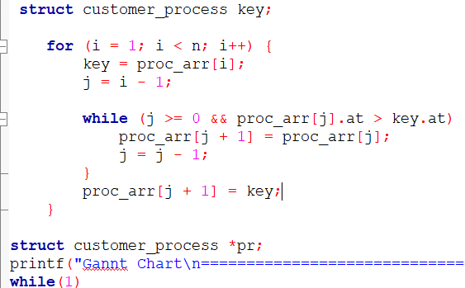
4)Explain all the constrain given in the problem. Attach the code snippet of the implemented constraint.
In this problem I used the structure in system call to define all the attributes and data.
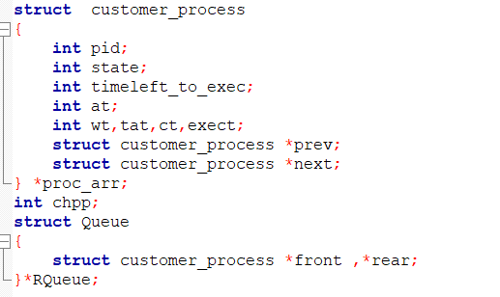
Also in this problem I used for n user, where we define n equals to 5 its gives me the answer of 5 customers (process) if I takes n equals to 10 it’s gives me the answer of 10 customers (process).
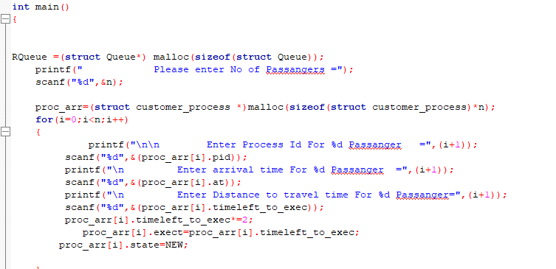

5)if you implemented any additional algorithm to support the solution explain the need and uses of the same
Bubble sort is the fastest sort available under a very specific circumstance. It originally became well known primarily because it was one of the first algorithm that was rigorously analysed, and the proof was found it was optimal under its limited circumstance.
6)Explain the boundary condition of the implemented code.
Boundary condition of bubble sort takes minimize time order of n if the data are already sorted.
7)Explain all the test cases applied on the solution of assigned problem.
this problem does not required any additional test case, we will gate a different output every time when we execute this code for different user and different input of this problem. When we use for three process (customers) or five customers. We will gate different out put in both the case. The screenshot of output are attached below.
1st Execution
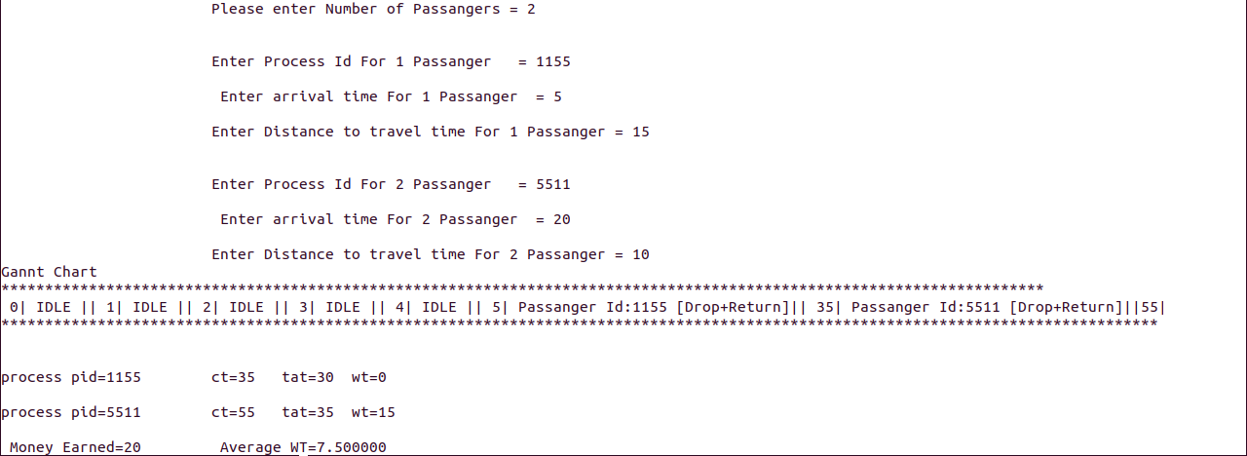

2nd Execution
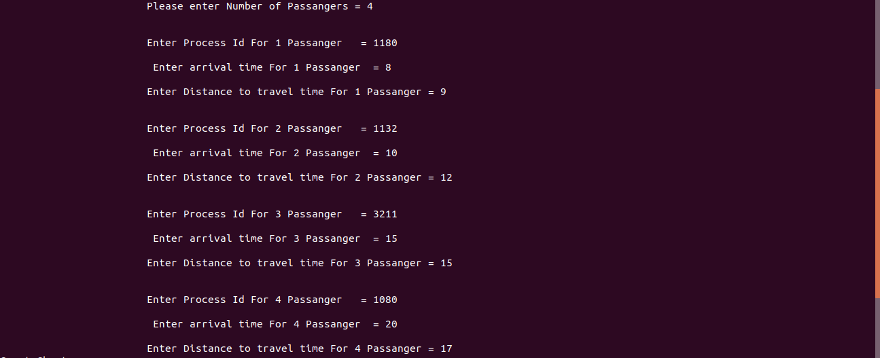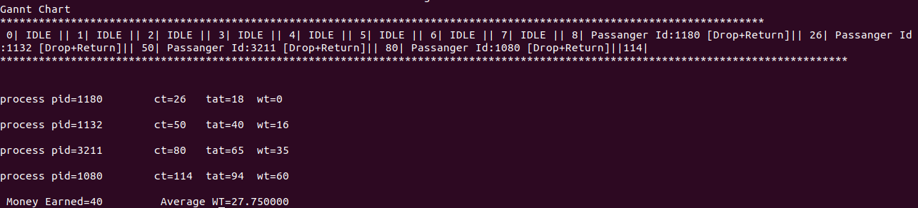
3rd Execution
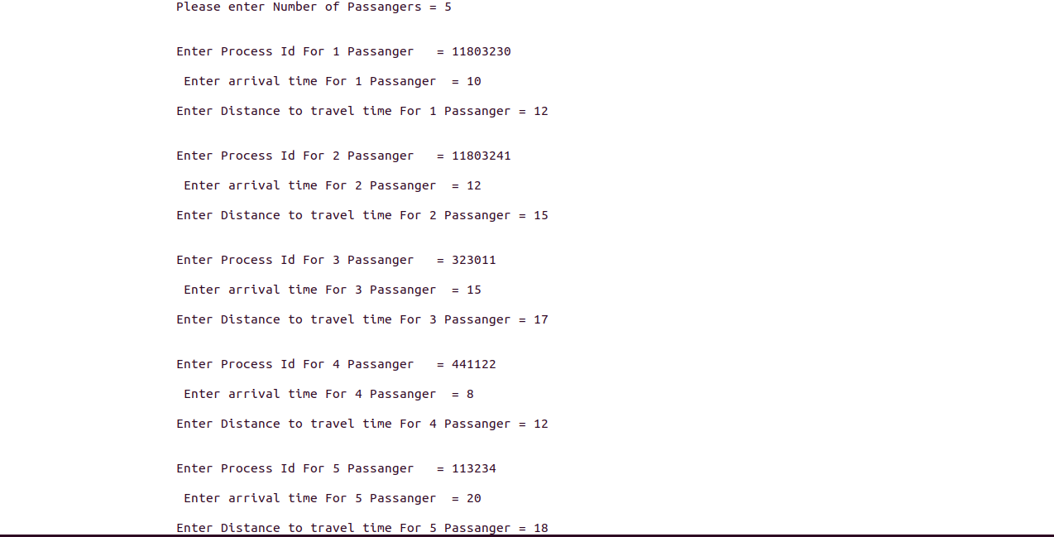
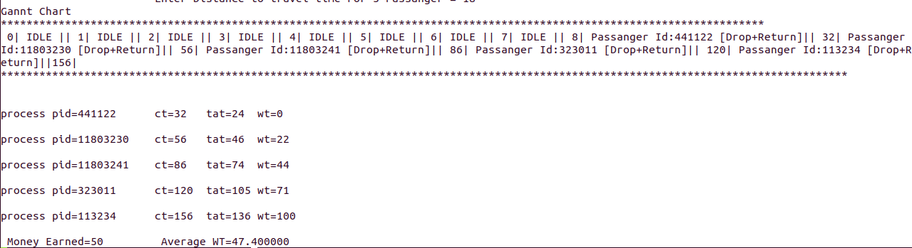
The End

