Experiment 10

Student Name: Aman Kumar UID: 25MCA20128
Branch: MCA Section/Group: 25MCA-1(A)
Semester: 2-SEM Date of Performance: 21/04/2026
Subject Name: Technical Training - 1 Subject Code: 25CAP-652

- Aim of the Session:

To understand and apply transaction control in PostgreSQL using BEGIN, COMMIT, ROLLBACK, and SAVEPOINT to maintain data integrity during database operations.

- Software Requirements:
- PostgreSQL
- pgAdmin
- Windows Operating System

- Objectives of the Session:

Apply transaction control commands for safe and reliable database updates.

- Theory:

Transaction control in PostgreSQL ensures that a group of database operations is executed safely as a single unit. Using BEGIN, a transaction starts; COMMIT permanently saves the changes, while ROLLBACK undoes them if an error occurs. SAVEPOINT allows partial rollback to a specific point within a transaction. These commands help maintain data integrity and consistency, especially during complex or multi-step operations.
- Practical / Experiment Steps:

Step 0: Table creation and data insertion.

Code:

Create table payroll(

emp_id int primary key,

emp_name varchar(50),

salary decimal(10,2) check(salary>0)

);

Insert into payroll values

(1,'Amit',30000),

(2,'Neha',40000),

(3,'Ravi',50000);

Output:

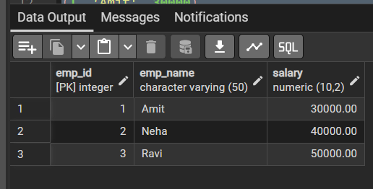

Step 1: Transaction with savepoint.

Code:

begin;

update payroll

set salary=salary+5000

where emp_id=1;

savepoint sp1;

update payroll

set salary=salary+7000

where emp_id=2;

update payroll

set salary=-1000

where emp_id=3;

rollback to sp1;

commit;

select * from payroll;

Output:

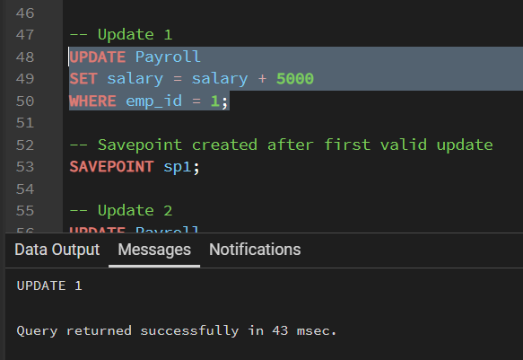

First valid update before savepoint

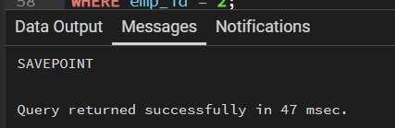

Savepoint created successfully

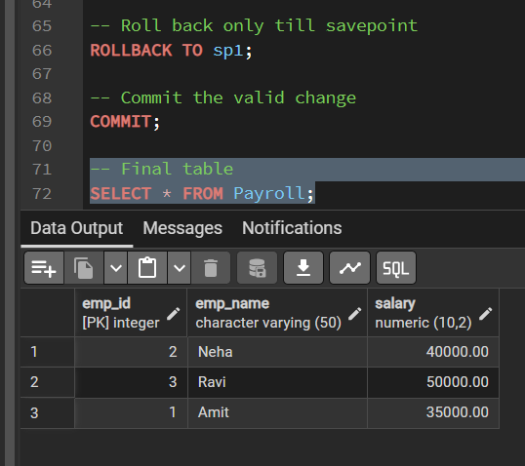

Final result after rollback to savepoint and commit

- Learning Outcomes (What I have learned):
- BEGIN starts a transaction block for grouping multiple SQL commands.
- ROLLBACK cancels changes made inside the transaction.
- SAVEPOINT allows partial rollback without losing all valid updates.
- CHECK constraint ensures salary remains greater than zero.
- PostgreSQL transaction control helps maintain consistency and data integrity.

