Authenticate for token

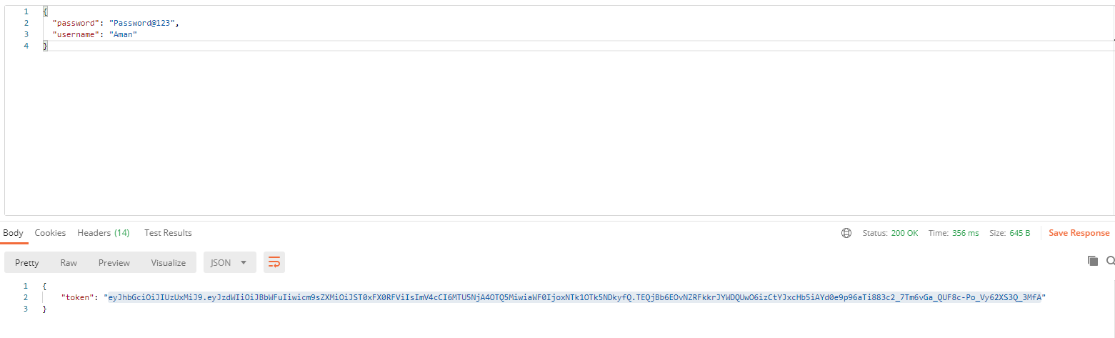

Leave Apply

Note: please do not provide leave ID as it is autogenerated.

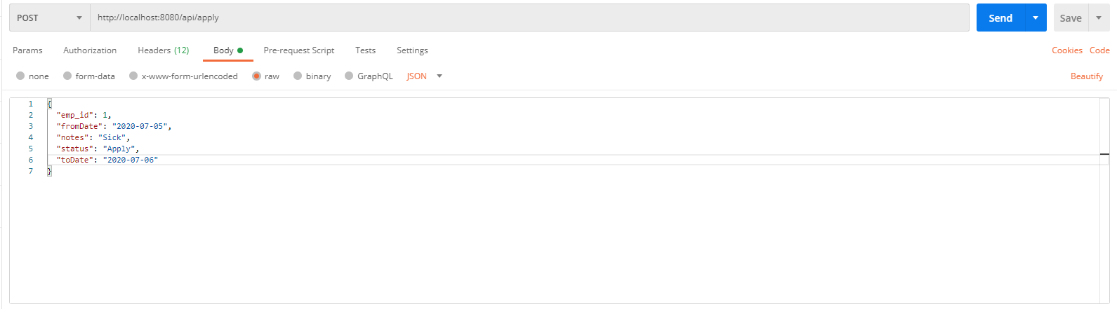

Leave Approve:

Approved

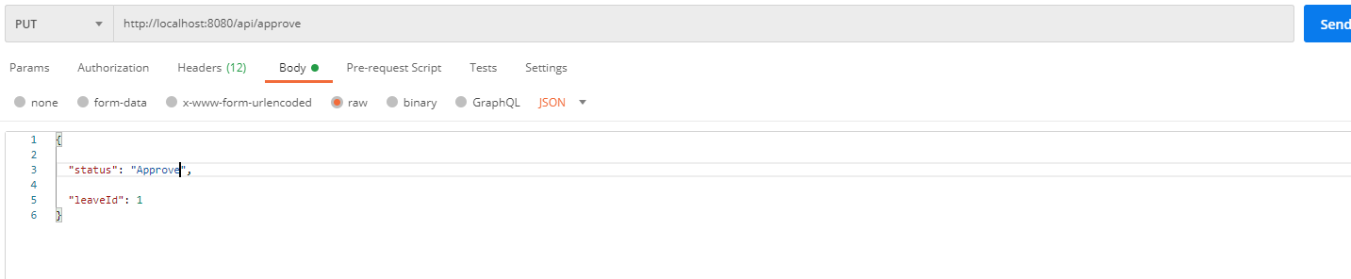

Reject:

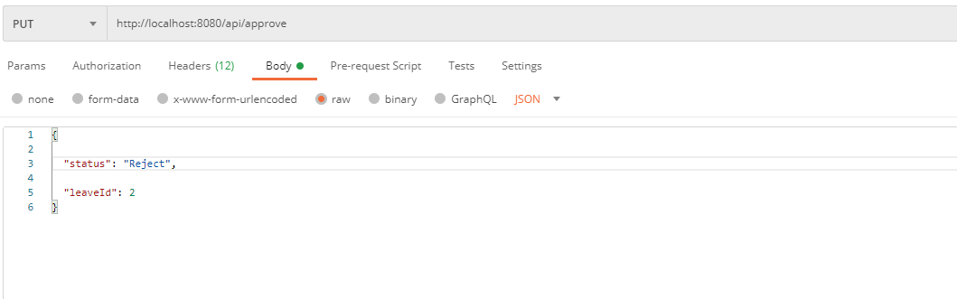

DB:

