**CE432A Lab Report 1**

Aman Kumar Singh  
200100

amanks20@iitk.ac.in

# Introduction

We were given two probems based on GIS where location was important.  
In the first, we need to find the location of a laboratory that is to be setup by a IITK student. It had certain requirements (i.e., constraints) and we had to find a suitable location for that.  
In the second we need to find the path with the shortest distance to travel from point A to point B with a constraint that the path need to cross hall1 boundary (partially or fully).

Both are problems of GIS where location is important and involves use of spatial data, and we need to sit down and analyze the to perform some spatial data operations with a map

The objectives of this exercise is to understand and interpret a map with information regarding different spatial features and also to carry out some basic spatial data operations.

# Methodology

Problem 1

A student in IIT Kanpur wants to set up his experimental system at a location with the following requirements:

* He needs a patch of at least 30 m X 30 m area in the open space.
* The land parcel should be minimum 15 m away from the centerlines of the roads in the campus (all types of road). Farther the patch from roads better is the patch.
* The land parcel should be within the academic area.
* The land parcel should be away from buildings by a minimum distance of 10 m. Larger the separation better is the patch.
* The preferred area of the parcel should be as near as possible from the boundary wall of the academic area as the experiment will need to drain an effluent out of the boundary through an underground pipe.

1. Make buffers on a tracing sheet of paper which are 15 m away from the centerline of the road by keeping the tracing paper above the Roads Map. Let us use (------) lines for this buffer border lines.
2. Now, keep the tracing paper above the Buildings Map and draw the buffers such that each buffer is away from the building by 10 m. Let us use (…….) lines for this buffer border lines.
3. Now, draw the boundary wall of the Academic Area in the Tracing Paper by keeping it above the Academic Area Boundary Map.
4. Now analyze the different locations of the building buffers that are intersecting with that of road buffers.
5. Look up for those area which are near to the academic area boundary so as to satisfy the constraint of effluent need to be drained out.
6. Check whether you can make construct a patch of 30 m x 30 m in that buffer or not.
7. After analyzing the different possibilities, number them in the priority order as 1, 2, 3 and so on. The priority order should be based on the nearness of patch from academic area boundary, farther from road, larger separation from buildings.

Note: All the measurements need to done by properly changing the scale of actual area to that of the map using the scale given on map.

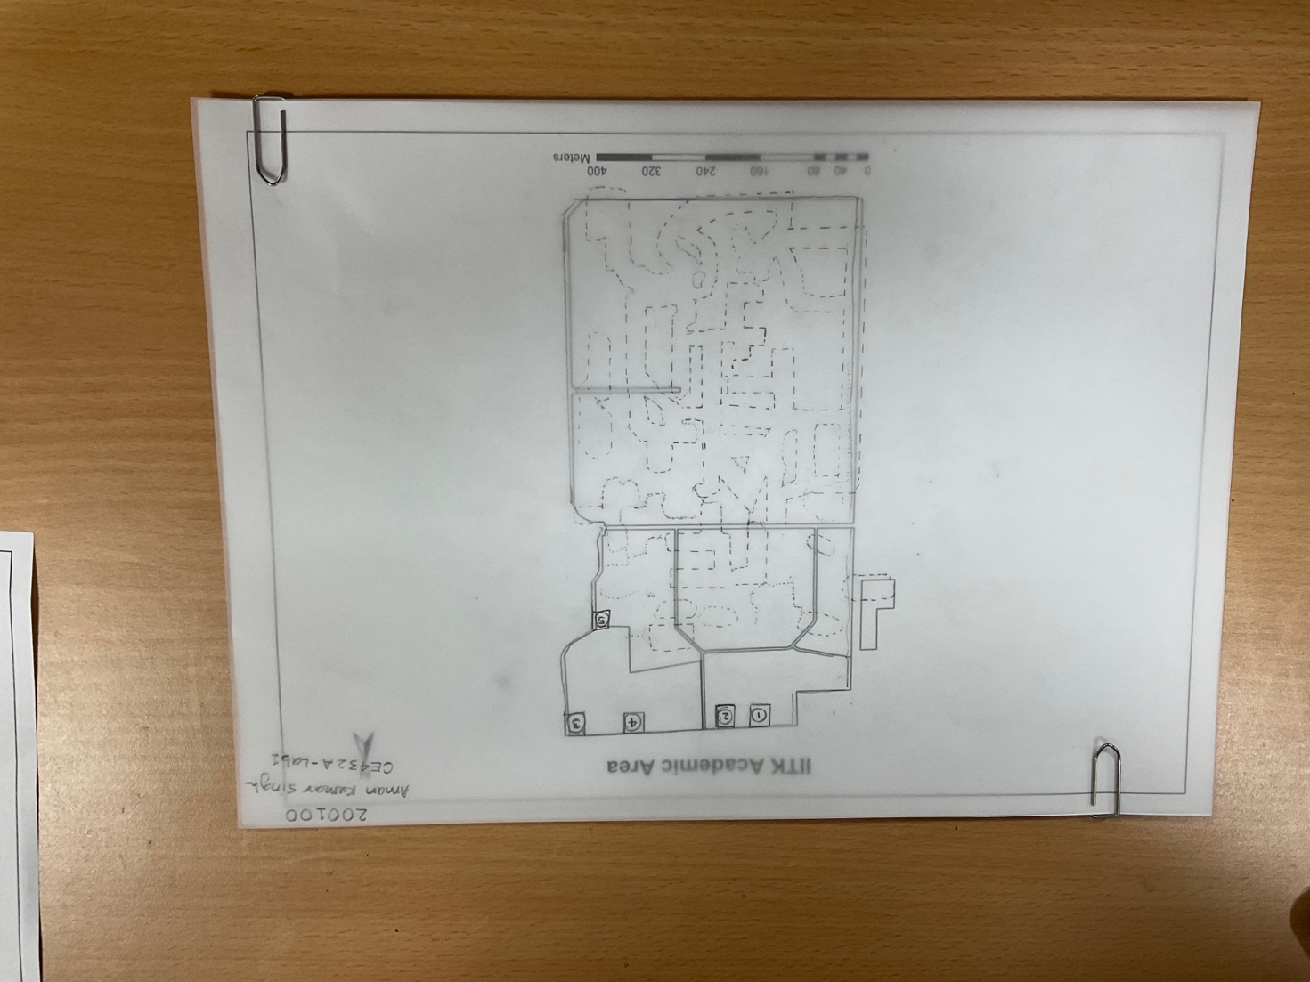

Problem 2

A sensitive instrument has to be moved from place A to place B (these places are marked on the map) via road such that:

* Travel path is least.
* Travel path must pass through any of the roads (partly or in full) around ‘Hall 1’ boundary before reaching point B.

1. Think of all the possible paths to travel from A to B such that it passes through hall1 boundary (partially or fully).
2. Now using a ruler measure the distance of all the possible paths.
3. Compare those distances and find the least of them
4. The path with the shortest distance between A and B such that it pass through hall1 boundary is found.
5. Convert distance using scale on map to find the actual distance of the path.

# Discussion

The path that we found shortest, there is a road that passes through a new factory that is being constructed so the shortest distance might not be the once possible because of construction.

# Conclusions

Different kinds of map with spatial data in it were understood and interpreted to find the possible laboratory locations in the Academic Area.

A map of IIT Kanpur was studied to find the shortest distance between a point A to a point B with the constraint of passing through hall 1 boundary (partly or fully)

# References

NA

# Questions

1. **Had you been permitted to use the computer how you would have done this problem? Write a few points on this step by step?**

Ans: If the use of computers were permitted for this I would make use of any GIS Software (such as ArcGIS or QGIS) and import the map in them and construct shape files of buffers (.shp files) and I will set some translucent color to those buffers. Now I will make a separate file of the intersection buffer so that I will have all the possible locations where the laboratory can be setup. After that I will try to fit in a shape file of a patch of 30 m x 30 m in those buffers and look for the possible location(s) where it can be setup and I will analyse and set priority order for those locations.

1. **Is there any possibility of shortest route from A to B if the condition of passing through Hall 1 road as discussed in Problem 2 is removed?**

Ans: The shortest route remains the same even when the condition of passing through Hall 1 road as discussed in Problem 2 is removed. Any other path that we take results in more distance covered or almost the same distance covered so the condition doesn’t makes any difference.