**CE432A Lab Report 2**

Aman Kumar Singh  
200100

amanks20@iitk.ac.in

# **Introduction**

# The main goal of this exercise is to gain a basic understanding of the ArcGIS Pro software and to provide an overview of the various tools available.

**ArcGIS Pro:** ArcGIS Pro is a GIS (GEOGRAPHICAL INFORMATION SYSTEM) software used to make maps, process, and analyze geospatial data and various other operations. It is maintained by ESRI and is professionally used around the globe.

# **Methodology**

1. Double click on the given package file for the lab. The projects are shared as a package file in ArcGIS.
2. On opening an empty screen comes and the maps and all other data can be added.
3. Add a new map shared in the package file and name it as Kolkata.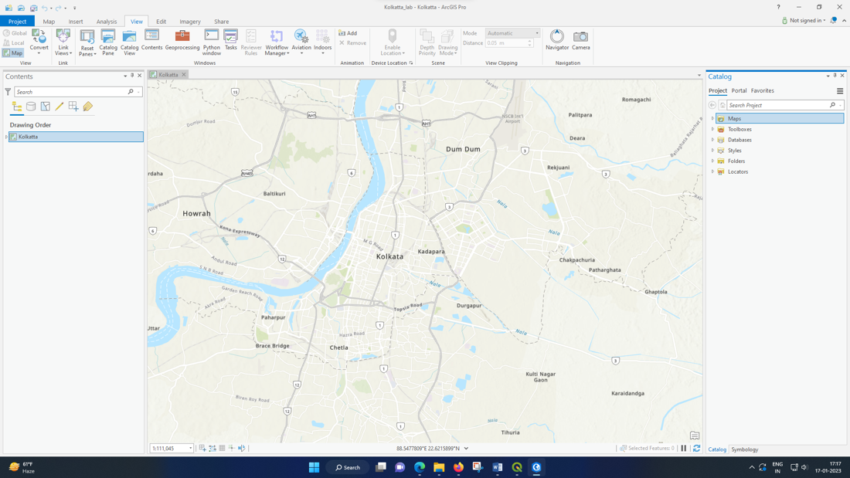
4. Add the feature layer to the map like Landmark, Parks, Road, Railway, Water by dragging them from the Catalog Pane.

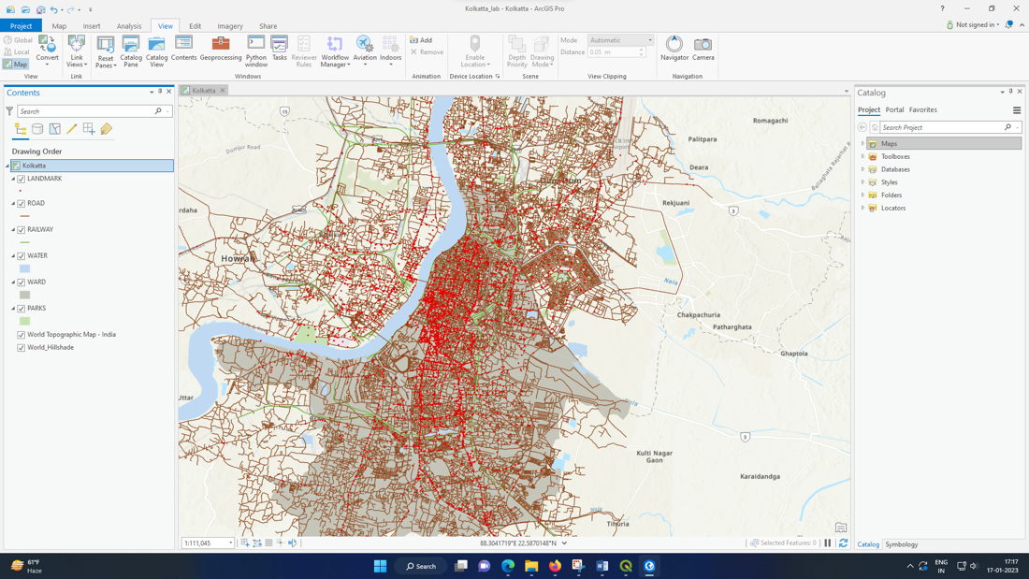

1. Using the left mouse button click on any Landmark its geospatial data can be viewed.

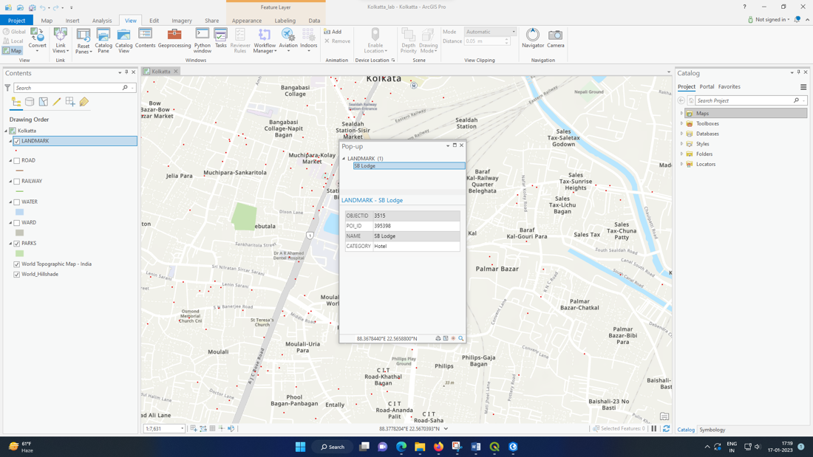

1. 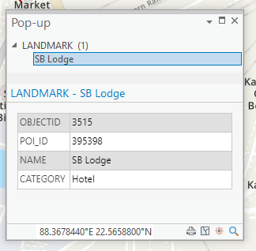Note the POI_ID, Name & Category of the Landmark.
2. 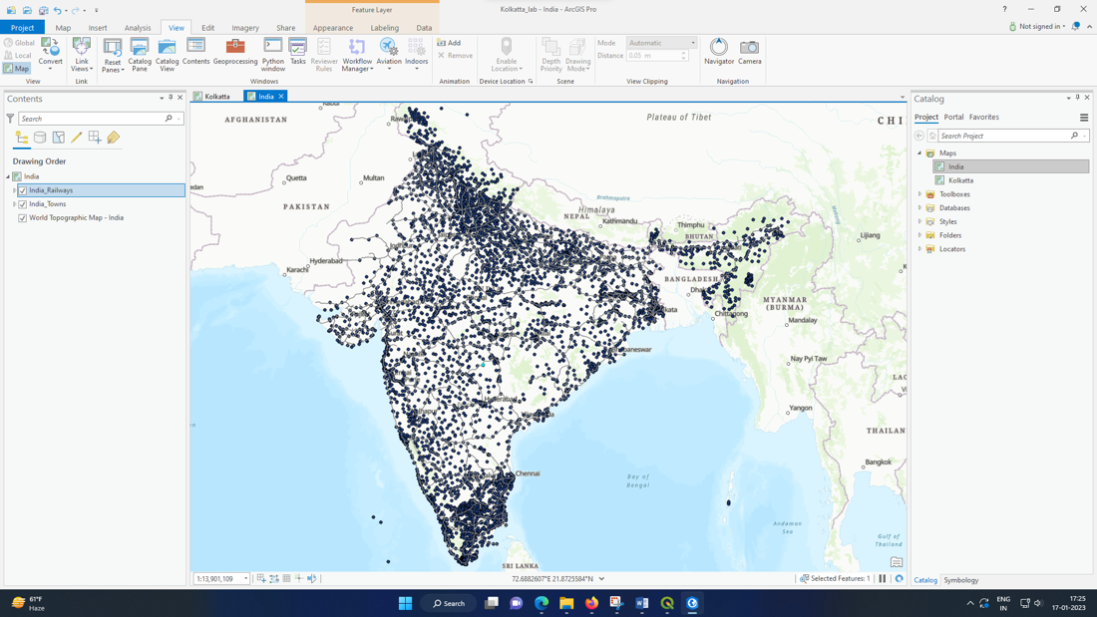Open one more map and Name it as ‘India’.
3. 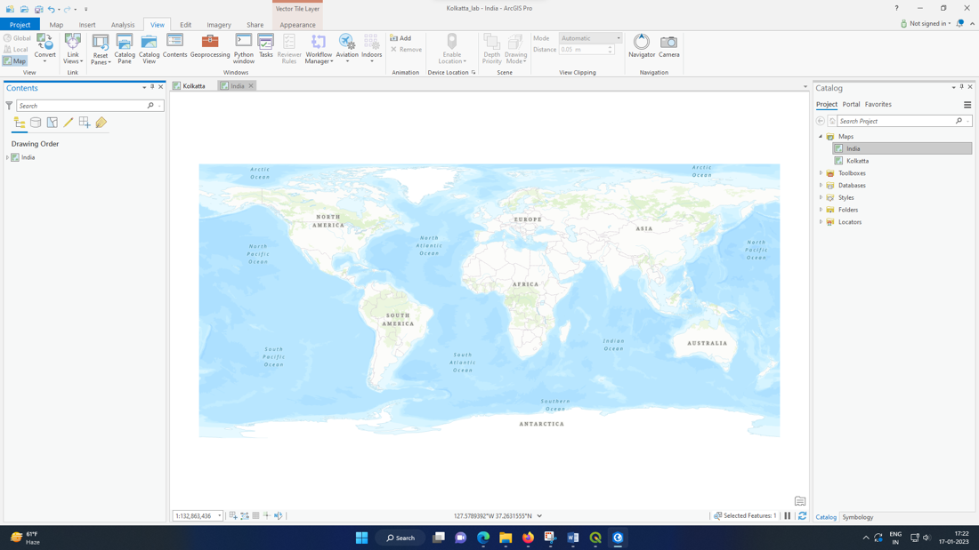Add the Feature Layers like India Railways & India Towns in it by dragging them down from the Catalog Pane.
4. 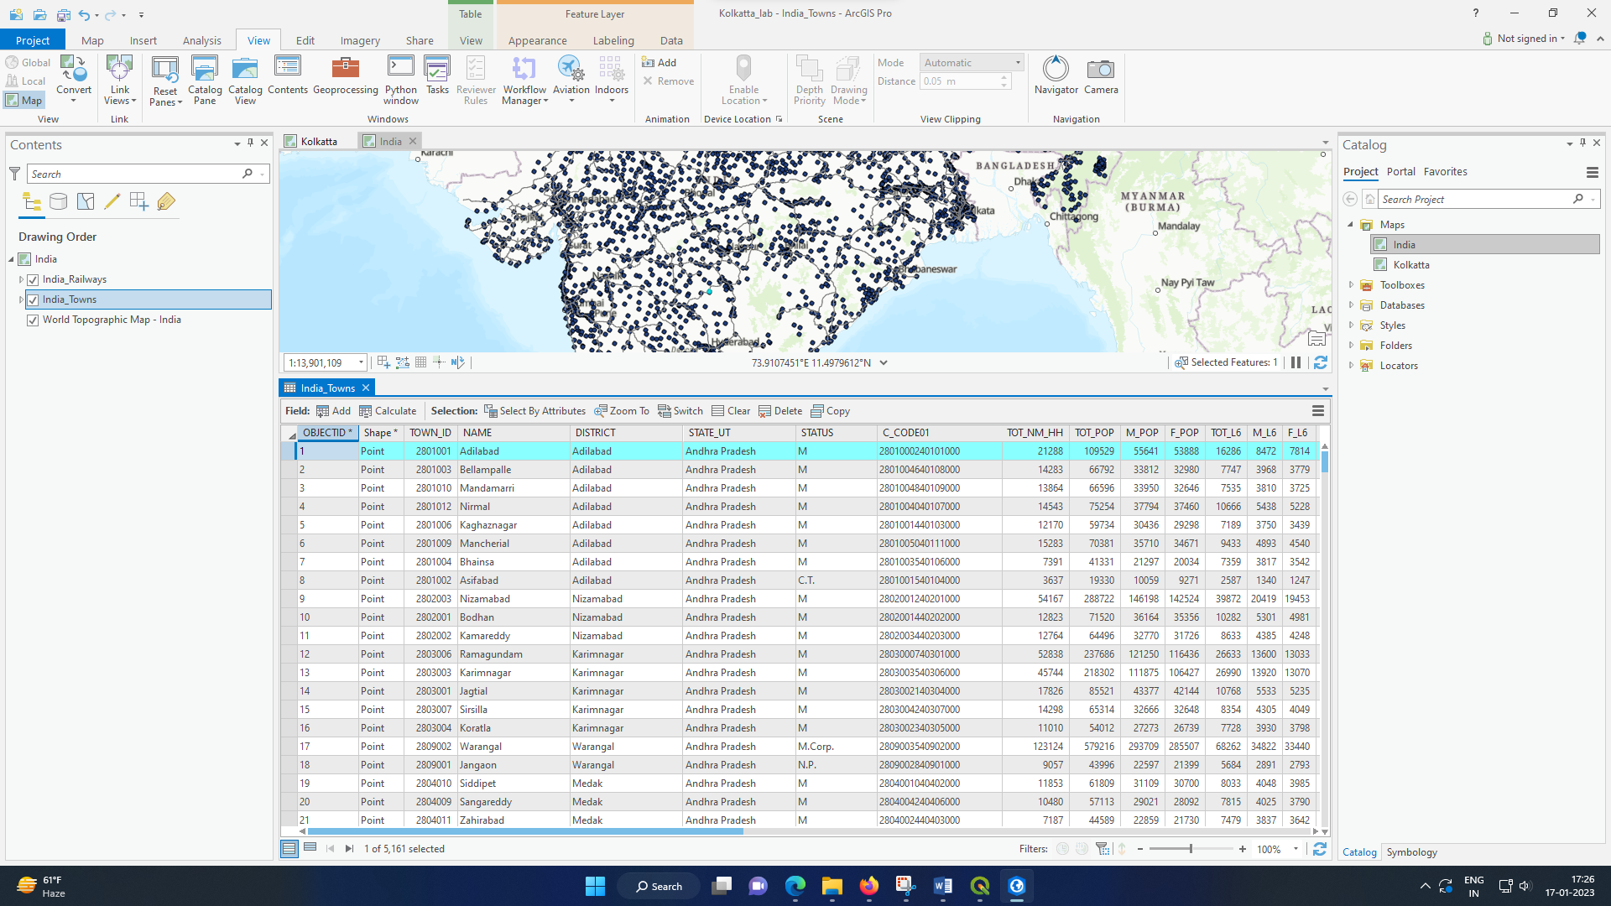Right click on the India Towns Feature Layer and open Attribute Table.
5. Note the No. of Towns India Towns Feature Class have.

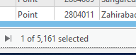

No of Towns = 5161 Towns

# **Discussion**

ArcGIS Pro has so many notable features as compared to any other GIS Software like QGIS. Moreover, by using it, the project can be shared with a single package file.

# **Conclusions**

* We were able to obtain a grasp on the fundamentals of using ArcGIS Pro after completing the lab.
* The interface's fundamentals—including it's layout, terminology, Catalog Pane, Content Pane and Tools was introduced.
* The fundamentals of viewing maps and working with data was learned.
* Creating and working on a project was learned
* The idea of creating a package file to allow for the easy sharing of a whole project was introduced.

# **References**

1. <https://learn.arcgis.com/en/paths/try-arcgis-pro/>
2. <https://www.esri.com/en-us/arcgis/products/arcgis-pro/resources>