AIM: Design a system for a gift-box such that whenever it is opened, it produces sound for 1000 ms and blinks red and green LEDs alternatively, as long as it is open.

*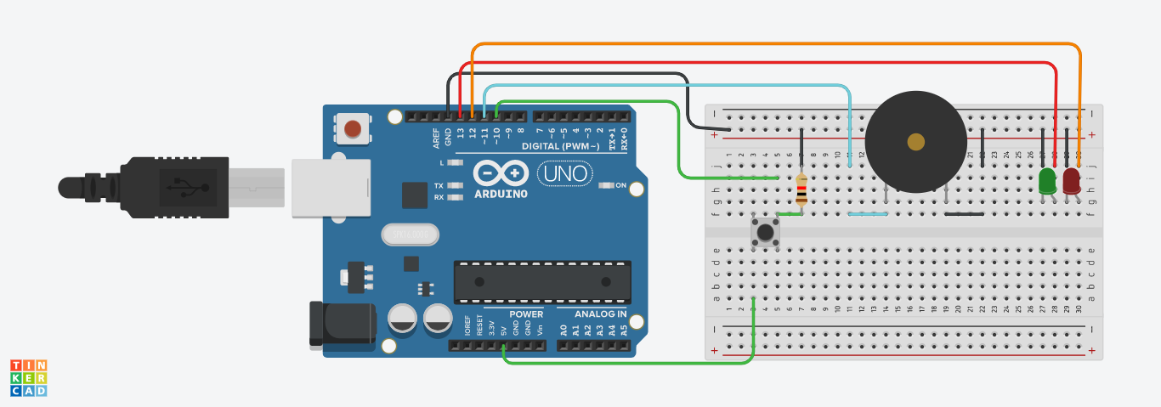*

Theory:

*LED:* A light emitting diode is a semiconductor device which emits light when current is passed through it.

*Arduino Board*: Arduino is an open source programmable circuit board that can be integrated into a wide variety of makerspace

projects both simple and complex. This board contains a microcontroller which is able to be programmed to sense and control objects

in the physical world. By responding to sensors and inputs, the Arduino is able to interact with a large array of outputs such as LEDs,

motors and displays.

*Push button:* A push button is a simple mechanism which controls the connection of circuit by either completing the circuit or breaking it.Push button is made up of plastic or a metal with a button on top and four legs. These legs are internally connected to each other, thus we can use two circuit lines with a single button.

Concept Used: When the gift box will be opened the push button will be pressed, when the push button is pressed the buzzer will buzz for one second and then the LED’s will keep blinking alternately as long as the push button is being pressed.

Learning and observation:

1. An LED consists of two legs, the longer leg is anode and shorter leg is cathode. If the legs are made equal by cutting then the cathode and anode are identified by checking the legs inside the LED, the pin closer to inner surface will be anode and the other one will be cathode.

2. Current always flows from anode to cathode and never in opposite direction.

3. Without resistor LED draws too much current and bursts.

Precautions:

1.The connections made should be proper.

2.One should be aware of errors while running to fix the problems.

3.In case of uploading error the USB cable or the port might be damaged and should be changed.

Learning Outcomes:

After performing this experiment skills gained are:

1.Able to form series or parallel connections.

2.Identify anode and cathode of an LED.

3.Know basic programming of Arduino board.