**NATIONAL INSTITUTE OF TECHNOLOGY RAIPUR**

**Department of Computer Applications**

A PROJECT REPORT ON

**ONLINE PARLOUR APPOINTMENT SYSTEM**

*A project submitted*

*in partial fulfilment of the requirements for the post graduate in*

*Master of Computer Applications.*

**Submitted by :**

MCA 5thsemester

Aman Kumar (17223006)

Atif khan (17223015)

Deepali Rajput (17223021)

Pooja Pancholi (17223043)

**Submitted to: Guided by:**

Head of Department Dr. Manju Pandey

Department of Computer Applications

NIT Raipur (C.G.)

**CERTIFICATE OF DECLARATION**

This is to declare that the project entitled **“Online Parlour Appointment System**” is and original work done by undersigned in partial fulfilment of the requirements for the degree “**Master of Computer applications**” at Computer application department, of National **Institute of Technology, Raipur.**

All the analysis, design, and system development have been accomplished by the undersigned. Moreover this project has not been submitted to any other college or university.

**ACKNOWLEDGMENT**

We would like to express our thanks of gratitude to our mentor “**Dr. Manju Pandey**” for their valuable guidance, supervision and encouragement in completing our project. We feel privileged to have had opportunity to work under them.

We take this opportunity to express deep sense of gratitude to Dr. **S. L. Sinha**, Head of Department of Computer applications for her encouragement and kind approval. Also, we thank him for providing the facilities available here.

A special thanks to all the Lab Assistants and Support Staff for their judicious and precious guidance and giving us the right direction in the lab which helped us in the completion of the project.

At last our thanks and appreciation to our parents and friends in developing the project and people who have willingly helped us out with their abilities.

**ABSTRACT**

**“ONLINE PARLOUR APPOINTMENT SYSTEM”** is a java & Oracle based project which will provide an online platform to the customers to book their appointment at any Parlour based on their searched locality. Customer will get their token number from the respective parlour and the estimate waiting time for his/her service after booking. Customer can also rate the service on basis of overall service provided by the shopkeeper to the customer.

It is providing a common platform for all the customers to book their appointment to the parlour. The project helps to search the parlour based on locality, parlour type and rating of shop online by internet connection. This project provides lots of features to manage in very well manner. This project contains a lot of advance modules which makes the back-end system very powerful. The project back end is developed by the DAO design pattern and MVC design pattern which makes the project very efficient.

This project is developed by using Waterfall Software Development model.

**Table Of Contents**

**Content Page no.**

Title page

Certificate of Declaration

Acknowledgement

Abstract

**1. Introduction**

1.1. Purpose --------------------------------------------------- 1

1.2. Document Conventions -------------------------------- 1 1.3. Product Scope ------------------------------------------- 1

1.4. References ----------------------------------------------- 2

**2. Overall description**

2.1. Product perspective ------------------------------------- 2

2.2. Product function ----------------------------------------- 2

2.2.1. Context Level DFD ------------------------------ 3

2.2.2. Level 0 DFD -------------------------------------- 4

2.2.3. Level 1 DFD -------------------------------------- 5

2.2.4. E-R Diagram -------------------------------------- 6

2.3. User classes and characteristics ----------------------- 6

2.4. Operating Environment -------------------------------- 6

2.5. Design and Implementation Constraints ------------- 7

**3. External interface requirements**

3.1. User interface ------------------------------------------- 9

3.2. Software interface -------------------------------------- 10

3.3. Hardware interface ------------------------------------- 10

**4. System Features**

4.1. Signup ---------------------------------------------------- 11

4.2. Login ----------------------------------------------------- 11

4.3. Take Appointment -------------------------------------- 13

4.4. Service Rating ------------------------------------------- 15

4.5. Shopkeeper Add Shop ---------------------------------- 16

4.6. Approve Appointment ---------------------------------- 16

**5. Other Non-Functional Requirement:**

5.1. Software Quality Attributes**---------------------------** 18

5.2. Business Rules**-----------------------------------------** 18

**6. Other Requirements**

6.1. Availability**----------------------------------------------** 18

6.2. Error Handling**-----------------------------------------** 18

6.3. Ease of Use**---------------------------------------------** 19

**7. References -------------------------------------------------------** 19

# 1

# **1.0. INTRODUCTION:**

## 1.1. Purpose:

This Software Requirements Specification provides a complete description of all the functions and specifications of a project “Online Parlour Appointment System”.The main purpose of this project is to provide an online platform to the customers to book their appointment at any Parlour based on their searched locality. Customer will get their token number from the respective parlour and the estimate waiting time for his/her service after booking. Customer can also rate the service on basis of overall service provided by the shopkeeper to the customer.

***1.2. Document Conventions:***

This Document was created based on the IEEE template for System Requirement Specification Documents.

***1.3. Product Scope:***

Initially, customers used to wait in queue at parlours in weekend or in peak hours. This was actually wastage of time. Customers who are new in city had lot of trouble finding the parlour of their choice

The proposed system will eliminate the drawbacks of existing system. The customers can get their appointment at the respective parlour on first come first serve basis. Customers will be given a token number and estimate waiting time; so that he/she can do their other productive works without wasting their time at parlour shop. Customers can search for the parlour based on the locality. The search list will show all the parlours with total number of persons waiting in queue and total waiting time for new service at the respective parlour. Every parlour will have their price menu for the various services offered.

***1.4. References:***

IEEE format for System Requirement Specification Documents:

<https://goo.gl/nsUFwy>

**2.0. Overall Description**

***2.1. Product Perspective:***

“ONLINE PARLOUR APPOINTMENT SYSTEM” is an online parlour appointment website which supports a number of functions for both the consumer and shopkeeper’s management.

The website must be available to anyone and as such must work correctly in both Internet Explorer and Mozilla Firefox. As stated by the customer, there are no hardware or software requirements beyond these including, but not limited to, memory or specific software packages that need to be utilized nor software packages that need not be utilized.

***2.2. Product Functions:***

“ONLINE PARLOUR APPOINTMENT SYSTEM” will provide a number of functions each is listed below.

* Allow any customer/shopkeeper to become a member through Sign up module.

3

* A customer/shopkeeper has a username (unique across all users), password (no restrictions), email address (no restrictions), and postal address (unverified).
* A shop has a shop name, shop type, shop owner, menu and menu price, GST NO, Email id of shop (optional).
* Shops are to be displayed based of shop rating, shop types and locality.
* Any Shopkeeper is able to add one or more shops to the website each time it will automatically generate unique shop id.
* Allow users to take appointment, track their appointment details.
* Allow shopkeeper to either accept or deny the request given by the customer.
* Allow shopkeeper to give expected waiting time while accepting the request to the customer.
* Allow customer to rate the shop on the basis of service provided by the shop.

**2.2.1. CONTEXT LEVEL DFD:**

CUSTOMER

## 0.00.0

## OPAS

SHOPKEEPER

4

***2.2.2. LEVEL 0 DFD:***

Sign Up Details

User Details

1.0

2.0

Login

User details

Login request

Sign up

CUSTOMER

SHOPKEEPER

Shop Search

details

4.0

3.0

ADD SHOP

SEARCH

SHOP DETAIL

**5**

***2.2.3. LEVEL 1 DFD:***

User Details

Sign Up Details

1.1

Login request

User Login

Login request

2.0

1.2

1.3

Sign up

Forgot password

Reset password

User details

Password change request

Password change request

SHOPKEEPER

CUSTOMER

User details

Add shop

Shop search

3.1

4.1

SEARCH

Add shop

details

Shop details

6

***2.2.4. E-R Diagram:***

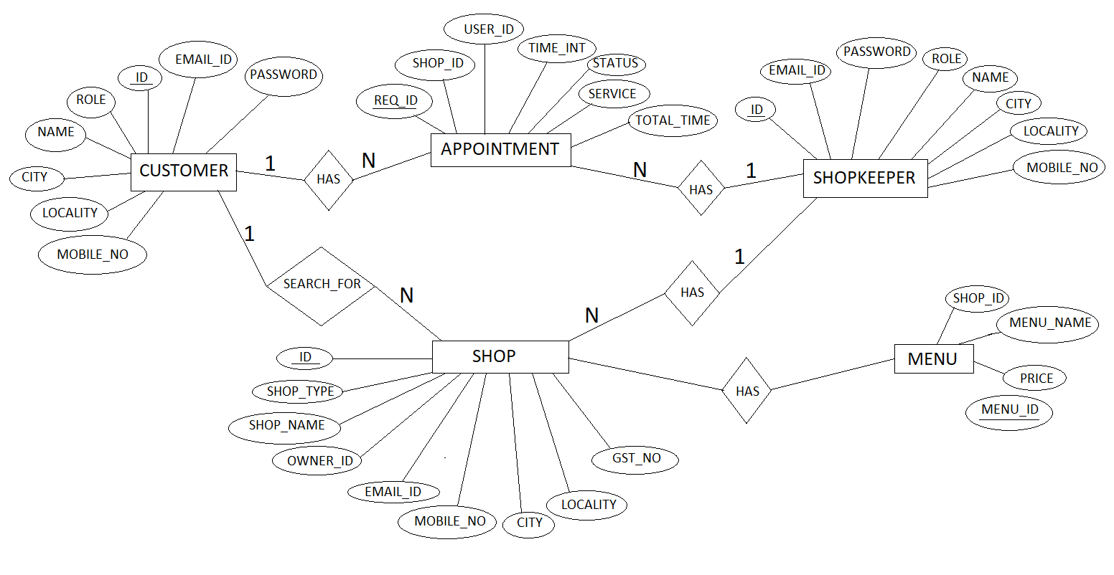

***2.3. User classes andCharacteristics:***

The users will be any customers if they need parlour services they can visit to our site and search for parlour shops based on locality. Other users of the system will be the shopkeeper who add parlour shops to our website and take the appointment of the customers. The customers will have full website also must accommodate on different operating systems like windows.

## 2.4. Operating Environment:

• Windows 2000

• Windows XP

• Windows Vista

7

• Windows 7

• Windows 8

• Windows 10

• Mac OS X

## 2.5. Design and Implementation Constraints:

“ONLINE PARLOUR APPOINTMENT SYSTEM” is developed in Java. It has been built on top of the Eclipse Platform. It uses a modular design where every feature is wrapped into a separate module and the modules depend on each other through well-written APIs. It has DAO Design pattern which will make the code efficient. It also uses MVC Design pattern.

The following schemas are used in maintaining the database of different shopkeeper/customers and shops used in the website.

USER DETAILS:

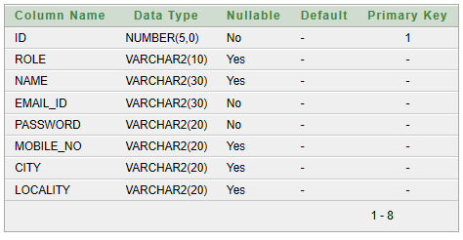

8

SHOP DETAILS:

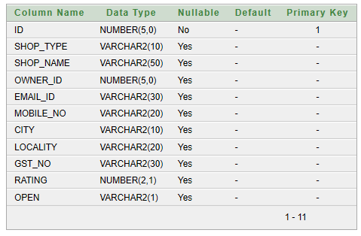

ORDER DETAILS:

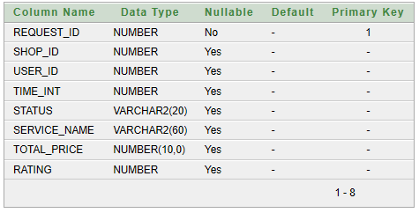

MENU DETAILS:

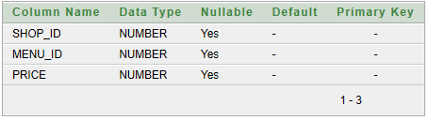

9

***3.0. External Interface Requirements:***

***3.1. User Interface:***

The user interface includes a home page where there is a search option to filter shops on the basis of shops types and locality.

Then there is a login button through which he/she can directly login and if he/she is not registered then he/she can register themselves using register button. For sign up there is an authentication is given i.e. OTP is generated which will send to the correct email id provided by the user. To avail the facility, he/she first register their account on the website,

After successfully login shopkeeper can add the shop details and take appointment and customer can search and request appointment.

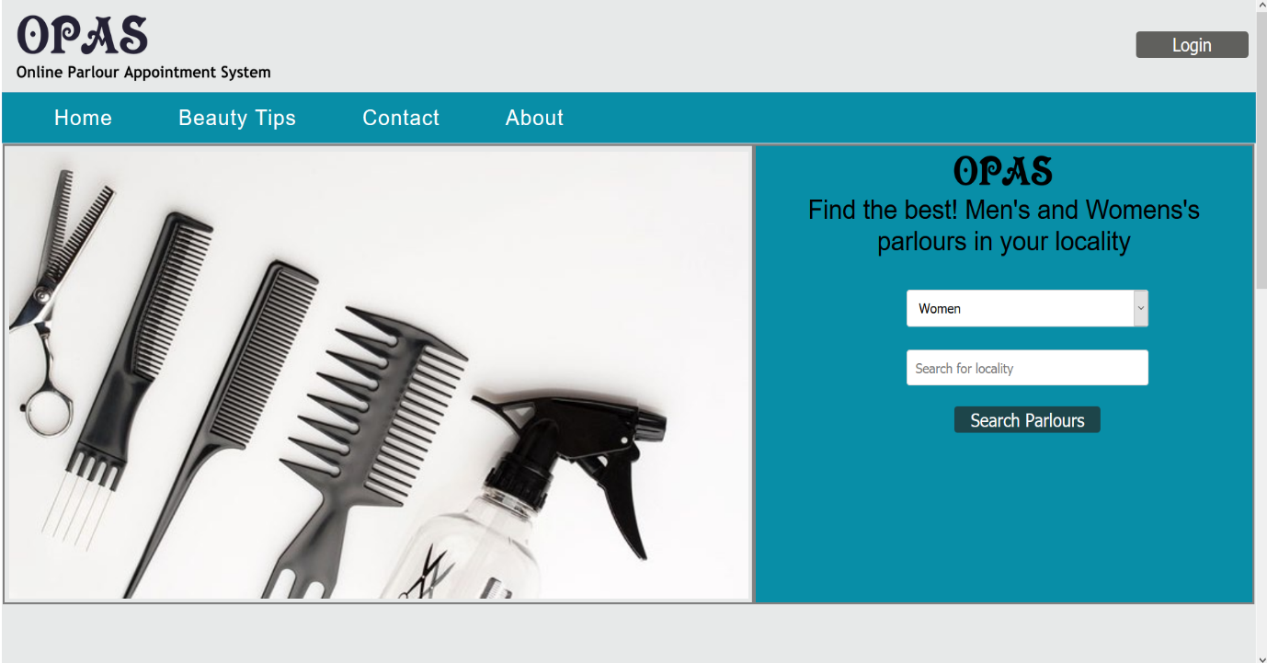

Fig. 1. Home page

**10**

***3.2. Hardware Interface:***

|  |  |
| --- | --- |
| Name of Component | Specification |
| Processor | Pentium III 630MHZ or more |
| Ram | 128 MB or more |
| Hard Disk | 20 GB or more |
| Monitor | 15° colour monitor or advance |

***3.3. Software Interface:***

|  |  |
| --- | --- |
| Name of Component | Specification |
| Operating system | Windows 98, Windows XP, Windows7, Windows Vista, Windows 8, Windows 2000 |
| Language | Java 2 Runtime Environment |
| Database | Oracle |
| Browser | Mozilla, Opera, Chrome etc. |
| Web Server | Tomcat 8.1 |
| Software Development Kit | Java JDK 1.7 or above |
| Scripting Language Enable | JSP |
| Database JDBC Driver | Oracle |

**11**

***4.0. System Features:***

***4.1. Login:***

The login section consists of Email id and Password. In case the password doesn’t match or there is new user then it has facility to register as a new user.

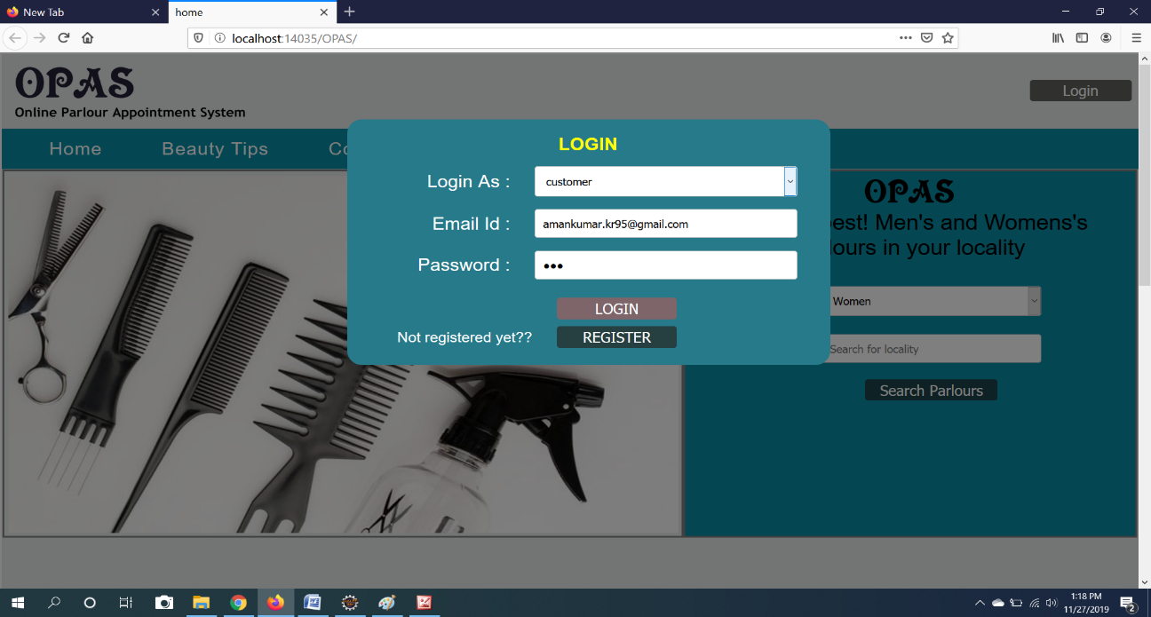

Fig. 2. Login Page

It will check whether the User Id exists or not. If not, it will give the facility to sign-up.

***4.2. Signup:***

The sign-up functionality helps the user to register into the system. In order to avail the facilities a valid account is must. The user needs to give an email id, password, name and Mobile Number etc.

12

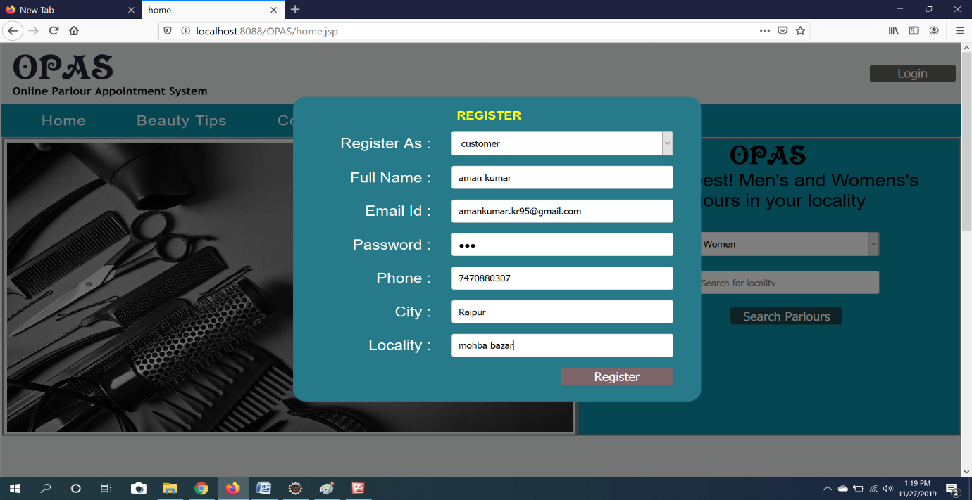

Fig 3. Register page

After filling all the necessary details, he/she will be successfully register to our website.

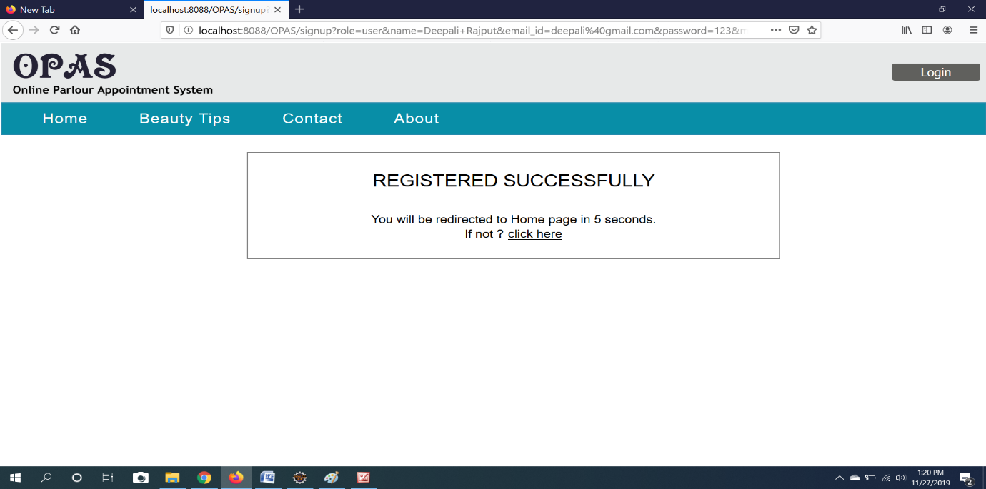

Fig. 4. Confirmation page

13

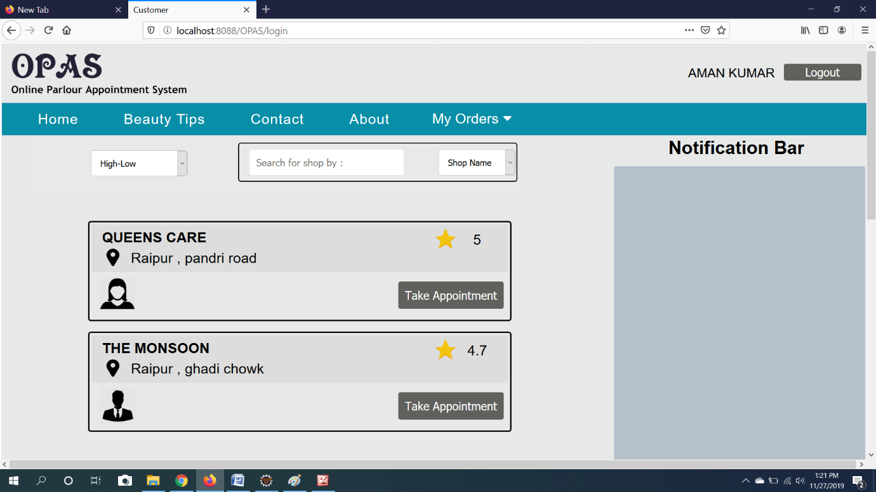

Fig. 5. Customer Dash Board

***4.3. Take Appointment:***

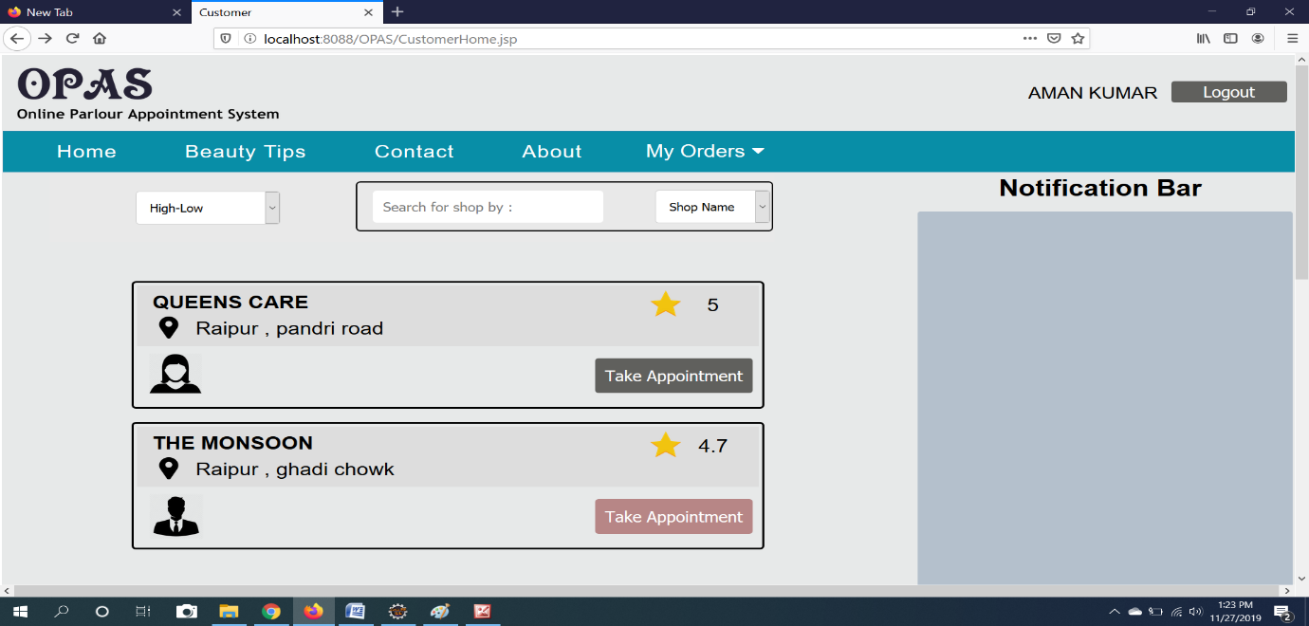

Fig. 6. Appointment Page

14

After Appointment button he/she will be asked for the services.

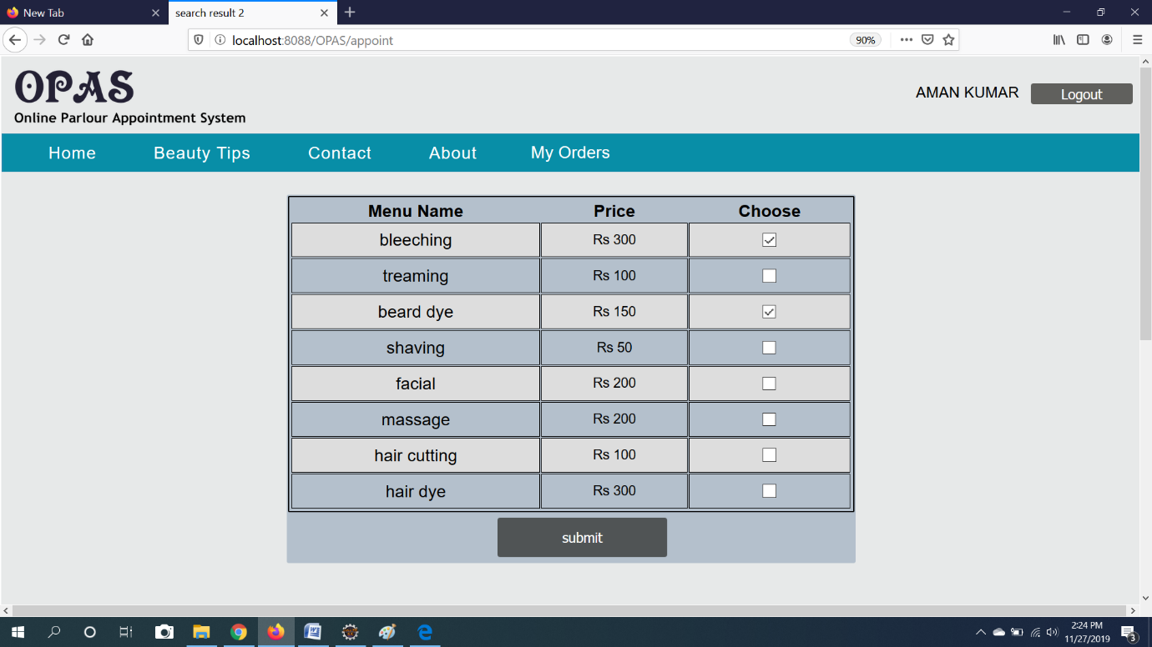

Fig 7. Menu list

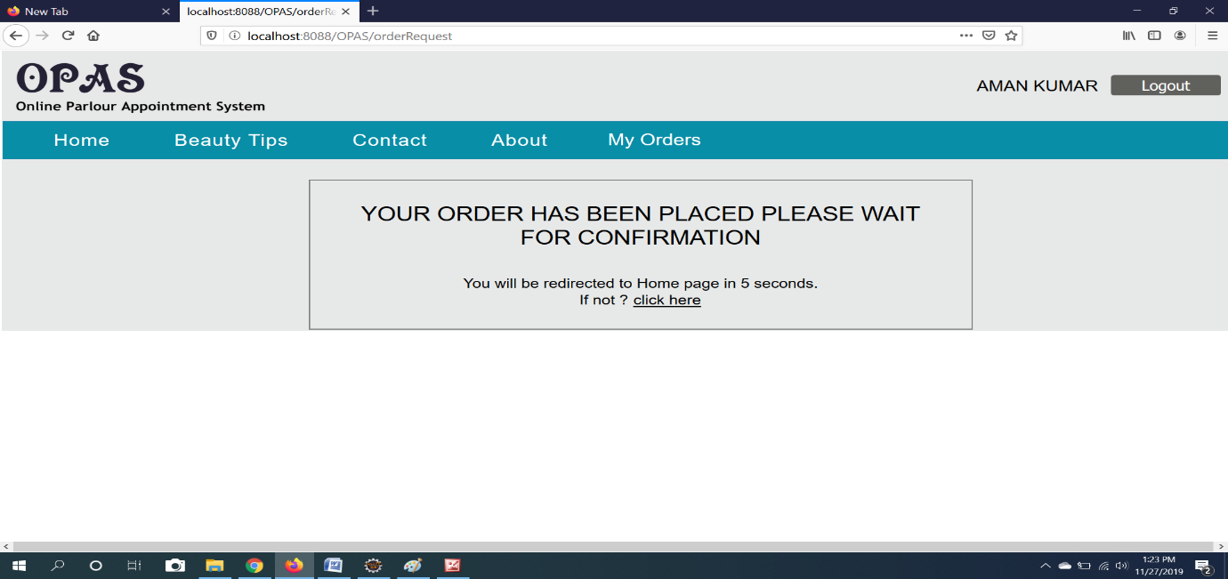

Fig 8. Appointment Confirmation Page

15

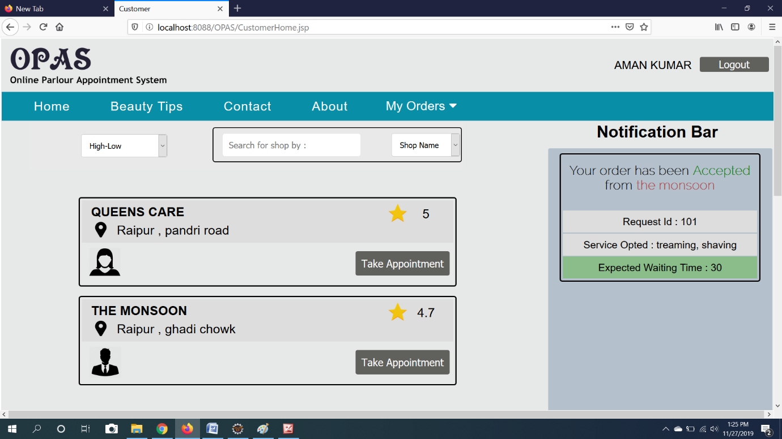

Fig 9. Appointment Confirmation message page

***4.4. Service Rating:***

Customer may rate the shop for the services provided by shopkeeper.

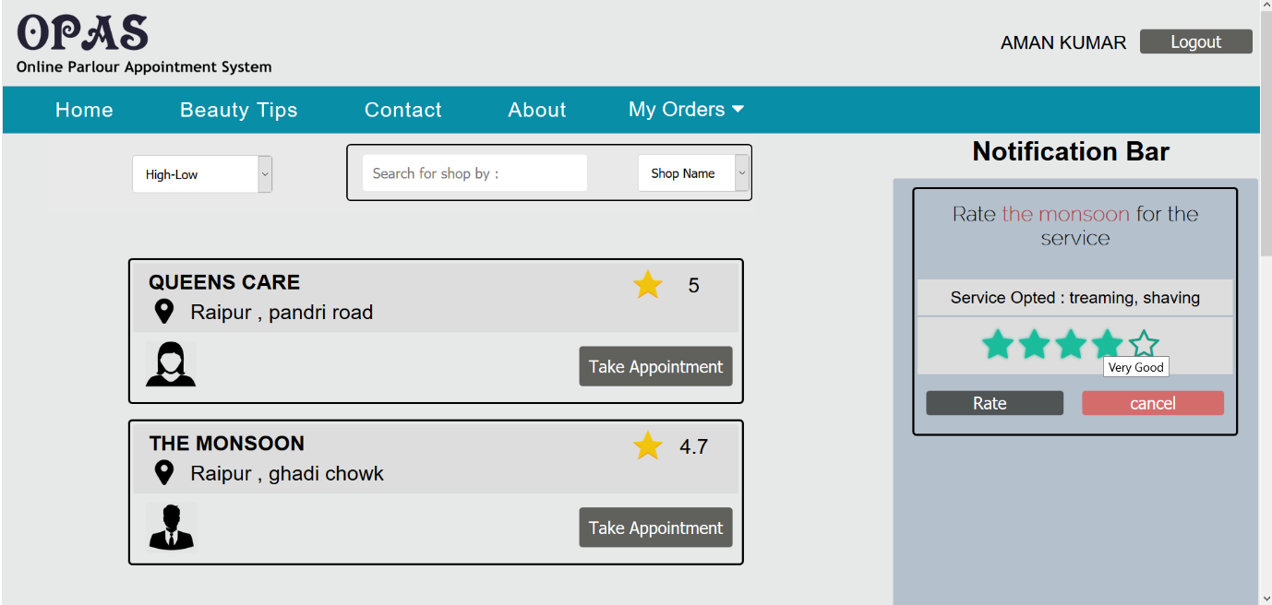

Fig 10. Customer rating Page

16

***4.5. Shopkeeper Add Shop:***

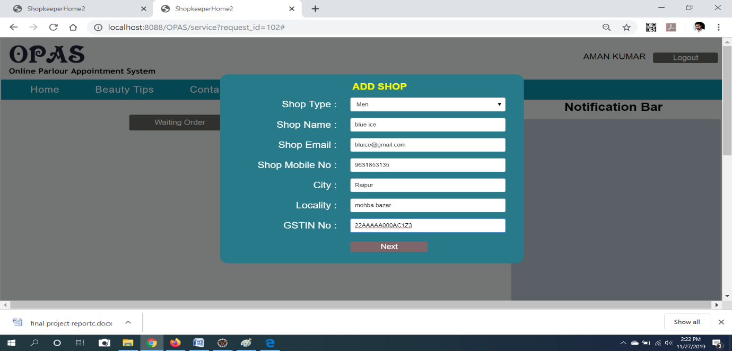

Fig 11. Add shop page

***4.6. Approve Appointment:***

Shopkeeper will receive the service request from the customer on the notification panel.

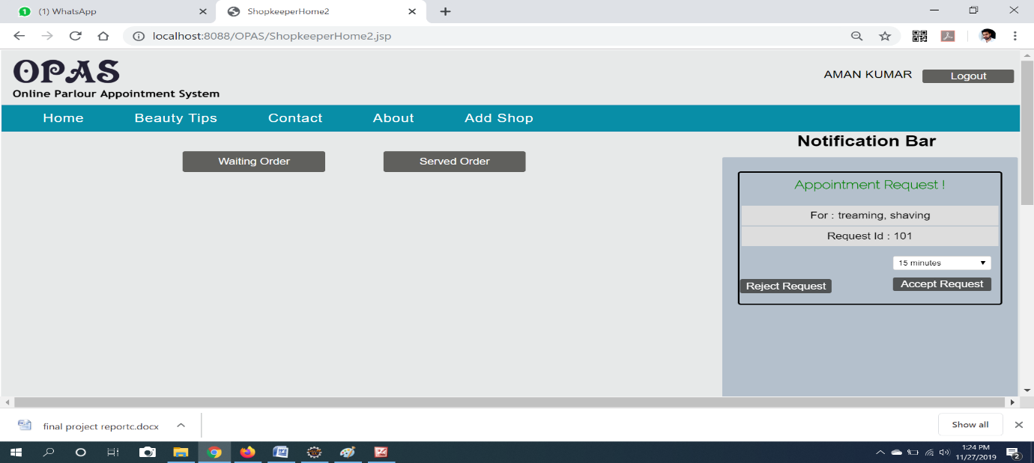

Fig 12. Appointment request

17

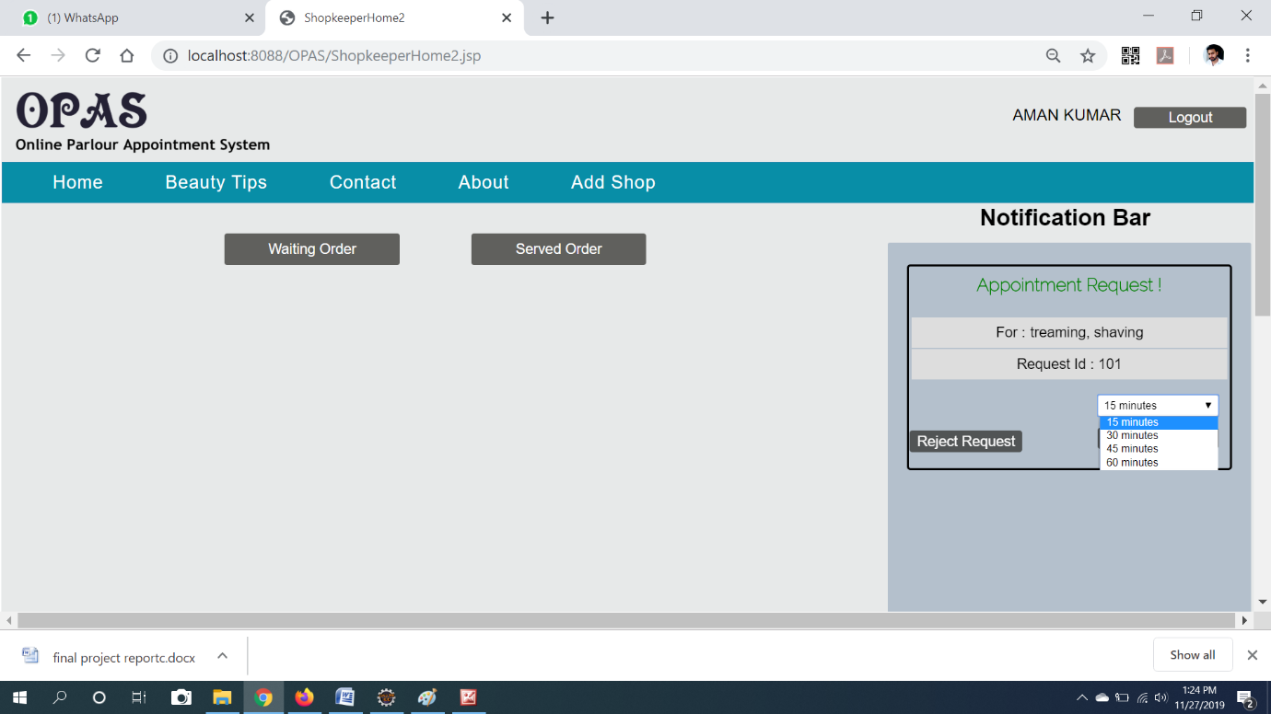

Fig 13. Appointment Confirmation by shopkeeper

After service of a customer shopkeeper will notify for the rating.

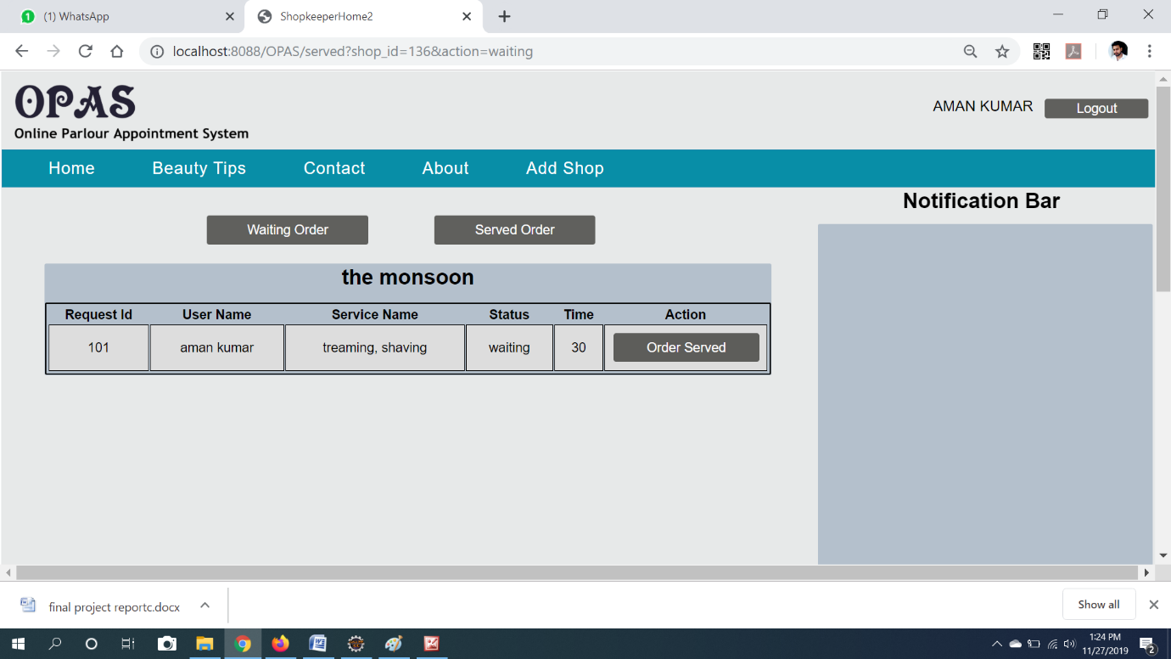

Fig 14. Request served page

18

## 5.0. Other Non-Functional Requirements:

## 5.1. Software Quality Attributes:

“ONLINE PARLOUR APPOINTMENT SYSTEM” provides the users with both simple and advanced features. Due to its well designed and easy to use interface it can be used by both experts and typical users. However, users must already have a basic knowledge of computers (or mobile) before using it.

## 5.2. Business Rules:

The user must log into the system with a valid username and password. Once the user logged in, he/she can use it very easily and upload their book photos according to their condition. This is basically used for helping purpose within the Nit.

***6.0.Other Requirements:***

## 6.1. Availability:

The system should always be available for access at 24 hours, 7 days a week. Also, in the occurrence of any major system malfunctioning, the system should be available in 1 to 2 working days, so that processes are not severely affected.

## 6.2. Error Handling:

Error should be considerably minimized and an appropriate message that guides the user to recover from an error should be provided. Validation of user’s input is highly essential. He/she can edit their entire book as per their requirement.

19

## 6.3. Ease of use:

Considered the level of knowledge possessed by the uses of this system, a simple but quality user interface must be developed to make it easy to understand and require less training.

***7.0. REFERENCE:***

* IEEE-SA Standards Board, “IEEE Recommended Practice for Software Requirements Specifications”, Software Engineering Standards Committee of the IEEE Computer Society, June 25th 1998.
* <https://www.javatpoint.com/java-tutorial>
* <https://www.geeksforgeeks.org/>
* https://www.w3schools.com/html/
* https://www.javatpoint.com/jsp-tutorial