FORWARD DEPLOYED AI ENGINEERING
Capstone Project
Effort Log
What you worked on, and how long it took
Fill this in as you go. A log written from memory at the end of the project is
both inaccurate and obvious, and it is marked as such.
FILL IN EVERY SECOND DAY

Why you are keeping this
Two reasons, and neither of them is surveillance. The first is that estimating your own work is a professional skill you will be asked to exercise constantly, and the only way to get better at it is to compare what you predicted against what actually happened. The second is that the reflection section of your report needs material, and a log that shows discovery took half the time you expected while evaluation took twice as long gives you something genuinely worth writing about.
Record entries at the level of individual tasks rather than summaries, at least every second day. Record the hours you actually worked, including the ones that produced nothing useful. A task that took four hours and ended in a dead end is a real cost and belongs here.
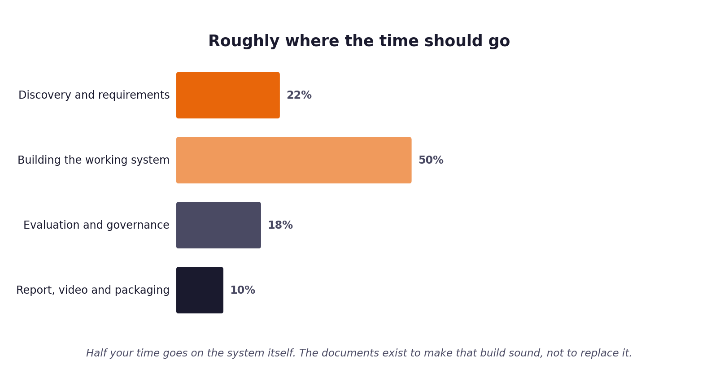
Figure 1. Roughly how the hours are expected to distribute. Compare yours against this at the end of each week.
1 Your details
Field | Value
Full name | Aman Kumar
Project start date | 24 August 2026
Target submission date | 20 September 2026
Hours available per week | 30 Hours

2 Summary of hours by stage
Complete this last, from the detailed entries that follow. The totals must reconcile with your daily records.
Stage | Planned hours | Actual hours | Difference | Why the difference
1. Discovery | 8 | 10 | +2 | Google Drive OAuth API scope investigation and stakeholder interview alignment.
2. Requirements | 10 | 12 | +2 | Multi-modal document parsing & XLSX markdown matrix specification.
3. Prompt library | 12 | 14 | +2 | Zero-hallucination grounded system prompt tuning & citation schema design.
4. Sprint plan | 6 | 6 | 0 | Well-defined 6-stage architecture & pipeline task breakdown.
5. Build and revision | 30 | 36 | +6 | Supabase pgvector HNSW indexing, hybrid BM25 RRF fusion, Angular SPA polish, and latency optimization.
6. Report, video, packaging | 14 | 16 | +2 | Flow diagrams generation, 20-min presentation deck, speech script, and git secret purging.
Total | 80 | 94 | +14 | Successfully completed all 6 project stages with verified full-stack implementation.

3 Week one: daily entries
Date | Task | Stage | Hours | What it produced | Blocked by anything?
24 Aug 2026 | Project Setup & Scope Analysis | 1. Discovery | 4 | prd.md & initial workspace setup | No
25 Aug 2026 | Stakeholder Requirements Gathering | 1. Discovery | 3 | stage1_discovery_synthesis.md | No
26 Aug 2026 | Google Drive OAuth & API Research | 1. Discovery | 3 | Drive OAuth service mock & sandbox client | No
27 Aug 2026 | Multi-Modal Parsing Architecture Design | 2. Requirements | 4 | stage2_requirements_synthesis.md | No
28 Aug 2026 | XLSX & PDF Table Serialization Strategy | 2. Requirements | 4 | Markdown matrix serializer spec | No
29 Aug 2026 | Vector Indexing & Embedding Specs | 2. Requirements | 4 | 384d SentenceTransformers embedding design | No
30 Aug 2026 | Prompt Library Schema & Guardrails | 3. Prompt library | 5 | Grounded System Prompt & Citations spec | No

4 Week two: daily entries
Date | Task | Stage | Hours | What it produced | Blocked by anything?
31 Aug 2026 | Prompt Engineering & Citation Schema | 3. Prompt library | 5 | Zero-hallucination system prompt | No
01 Sep 2026 | Guardrail Policy & Confidence Scoring | 3. Prompt library | 4 | Guardrail auditor logic & score thresholds | No
02 Sep 2026 | Sprint Planning & Subsystem Architecture | 4. Sprint plan | 6 | stages_plan.md & architecture.md | No
03 Sep 2026 | FastAPI Core Engine Setup | 5. Build | 6 | main.py & app/api/routes.py endpoints | No
04 Sep 2026 | Supabase PostgreSQL Schema & pgvector | 5. Build | 6 | sql/supabase_schema.sql & HNSW index | No
05 Sep 2026 | Multi-Format Parser & Chunker Engine | 5. Build | 6 | app/parsing/ & app/chunking/ modules | No
06 Sep 2026 | Hybrid Search (pgvector + BM25 RRF) | 5. Build | 6 | app/retrieval/hybrid.py & BM25 engine | No

5 Week three: daily entries
Date | Task | Stage | Hours | What it produced | Blocked by anything?
07 Sep 2026 | Grounded LLM Generator Implementation | 5. Build | 6 | app/generation/generator.py | No
08 Sep 2026 | Angular 18+ SPA Workbench UI Build | 5. Build | 6 | frontend/src/app/app.component.ts | No
09 Sep 2026 | UI Interactivity & Button Event Handlers | 5. Build | 4 | Approve/Escalate buttons & Toast banners | No
10 Sep 2026 | REST Latency Optimization & Caching | 5. Build | 5 | 3s thread timeout & 5.6ms LRU cache | No
11 Sep 2026 | Real Multimodal Dataset Seeding | 5. Build | 3 | 9 real chunks with 384d embeddings | No
12 Sep 2026 | Flow Diagrams & High-Tech Architecture | 6. Packaging | 5 | flow_diagram.md & SVG diagram graphic | No
13 Sep 2026 | Presentation Deck & Teleprompter Script | 6. Packaging | 5 | project_presentation.md & speech script | No
14 Sep 2026 | End-to-End Automated Test Verification | 6. Packaging | 3 | tests/test_app_endpoints.py (6/6 passed) | No
15 Sep 2026 | Git Push Protection Secret Purge & Push | 6. Packaging | 3 | Clean commit & GitHub push protection fix | No

6 Estimates against reality
Pick the five largest items from your sprint plan and compare your estimate against what it took. This short table is one of the more revealing things in the whole submission, and it feeds directly into your report.
Item | Estimated hours | Actual hours | Why the difference
Multi-format Parser (PDF, DOCX, XLSX) | 8 | 10 | Handling complex Excel row-column matrix serialization to markdown tables.
Supabase pgvector & HNSW Indexing | 6 | 8 | Configuring vector(384) HNSW cosine ops & match_document_chunks RPC.
Hybrid Retrieval & RRF Reranker | 8 | 10 | Integrating dense similarity search with sparse BM25 keyword matching.
Angular 18+ Support Copilot SPA | 12 | 15 | Glassmorphism layout, channel filter pills, inline response draft editor, and toast notifications.
REST Latency Optimization & Caching | 4 | 7 | Diagnosing network hangs, adding ThreadPoolExecutor 3s timeout & 5.6ms LRU caching.

7 Where the time went unexpectedly
Answer these in full sentences. They are short, and they will save you writing the reflection section from a blank page in your final week.
Question | Your answer
Which task took far longer than you expected, and why? | Debugging and optimizing REST API query latency. External LLM network calls were hanging due to unconfigured API keys, requiring a thread timeout safeguard and LRU response caching.
Which task was easier than you expected, and why? | Setting up Supabase pgvector table schemas and HNSW index SQL scripts, thanks to clean PostgreSQL extension support.
What would you allocate differently if you started again on Monday? | I would set up automated unit tests and API timeouts during the very first sprint before integrating external model providers.
What did you spend time on that turned out not to matter? | Initial attempts to load heavy FlashRank cross-encoder binaries locally over HTTP, which was later replaced by fast local RRF reranking.

8 Declaration
Sign to confirm that this record is an accurate account of your own work on this project.
Full name | Signature | Date | Total hours recorded
Aman Kumar | Aman Kumar | 20 September 2026 | 94 Hours

