LINUX MINI PROJECT

Library Book Inventory
and Search System
A command-line project using basic Ubuntu/Linux commands
Submitted by | Aman Yadav
UID | 25BCA10031
Course / Section | Bachelor of Computer Applications (BCA) | 25BCA-1-A
Platform | Ubuntu Linux
PROJECT AT A GLANCE
Organise a small library catalogue, search for titles or categories, separate available and issued books, and prepare an inventory report using Linux commands.
01  STORE  Book details | 02  SEARCH  Find titles | 03  FILTER  Book status | 04  REPORT  Inventory
TOOLS USED • mkdir • touch • echo • grep • cut • sort • cat

1. Introduction
A small library may maintain its book catalogue in notebooks or separate lists. When a student asks for a particular title, category, or book availability, the librarian may need to check several entries manually. This can take time, especially when the collection grows.
The Library Book Inventory and Search System is a simple file-based project. It stores book details in text files and uses Linux commands to search, filter, extract, sort, display, and combine catalogue entries. It uses only Linux commands, with no programming language, database, or shell script.

2. Problem Statement
In a small college library, book details and their issue status may be recorded manually. Searching for a title, identifying available books, separating issued books, and preparing an inventory list can become repetitive and may lead to mistakes. The problem is to organise a basic book catalogue and make common search and reporting tasks easier using Linux commands.

3. What We Are Going to Do
We will create a folder-based catalogue with one main file, two filtered files, and two report files.
File / Folder | Purpose
data/books.txt | Main catalogue containing 10 sample book records.
data/available.txt | Books whose status is Available.
data/issued.txt | Books whose status is Issued.
reports/sorted_books.txt | Catalogue sorted alphabetically by book title.
reports/final_inventory.txt | Combined available and issued-book report.
Each record follows this format:
Book_ID,Title,Author,Category,Status

Example: B101,The Alchemist,Paulo Coelho,Fiction,Available

4. How We Will Do It
- Create the project folder with data and reports subfolders.
- Create the text files for the catalogue and reports.
- Enter 10 sample book records in books.txt.
- Use grep to separate available and issued books.
- Use cut to extract titles and grep to search by title or category.
- Use sort to arrange entries alphabetically by title.
- Use head, tail, and less to view catalogue entries and reports.
- Combine filtered files into one final inventory report.

5. Project Folder Structure
Library_Inventory/
├── data/
│ ├── books.txt
│ ├── available.txt
│ └── issued.txt
└── reports/
├── sorted_books.txt
└── final_inventory.txt

6. Commands and What They Do
Command | Purpose | Example
mkdir | Creates a directory. | mkdir data
cd | Moves into a directory. | cd Library_Inventory
touch | Creates an empty file. | touch books.txt
echo | Adds text with redirection. | echo "B101,The Alchemist,Paulo Coelho,Fiction,Available" >> books.txt
ls | Lists files and folders. | ls
grep | Searches matching text or patterns. | grep ',Available$' books.txt
cut | Extracts selected fields. | cut -d ',' -f2 books.txt
sort | Sorts lines in a file. | sort books.txt
head / tail | Shows first / last lines. | head -n 3 books.txt
less | Opens a file for scrolling. | less books.txt
cat | Displays or combines file contents. | cat available.txt issued.txt
mv | Moves or renames a file. | mv old.txt new.txt
chmod | Changes file permissions. | chmod 640 final_inventory.txt
egrep / fgrep | Extended / fixed-string search. | egrep 'Fiction|Technology' books.txt
history | grep | Finds a previous command. | history | grep "grep"

7. Implementation: Commands, Steps and Output

Step 1 — Create project folders and files
Open Ubuntu Terminal and run:
mkdir Library_Inventory
cd Library_Inventory
mkdir data reports
cd data
touch books.txt available.txt issued.txt
cd ..

These commands create the project folder, the data and reports folders, and the empty text files.
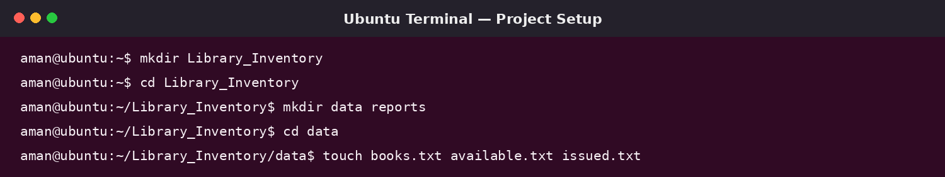
Illustrative Ubuntu-style terminal view showing project setup commands.

Step 2 — Enter book records
Move into the data folder and add the sample entries. The >> operator appends each record to books.txt.
cd data
echo "B101,The Alchemist,Paulo Coelho,Fiction,Available" >> books.txt
echo "B102,Atomic Habits,James Clear,Self-help,Issued" >> books.txt
echo "B103,Computer Networks,Tanenbaum,Technology,Available" >> books.txt
echo "B104,Rich Dad Poor Dad,Robert Kiyosaki,Finance,Available" >> books.txt
echo "B105,The Hobbit,J.R.R. Tolkien,Fiction,Issued" >> books.txt
echo "B106,Python Basics,Reema Thareja,Technology,Available" >> books.txt
echo "B107,Ikigai,Hector Garcia,Self-help,Available" >> books.txt
echo "B108,DBMS Concepts,Korth,Technology,Issued" >> books.txt
echo "B109,The Diary of a Young Girl,Anne Frank,Biography,Available" >> books.txt
echo "B110,Wings of Fire,A.P.J. Abdul Kalam,Biography,Issued" >> books.txt
cat books.txt

The cat command displays the catalogue so the entries can be checked.
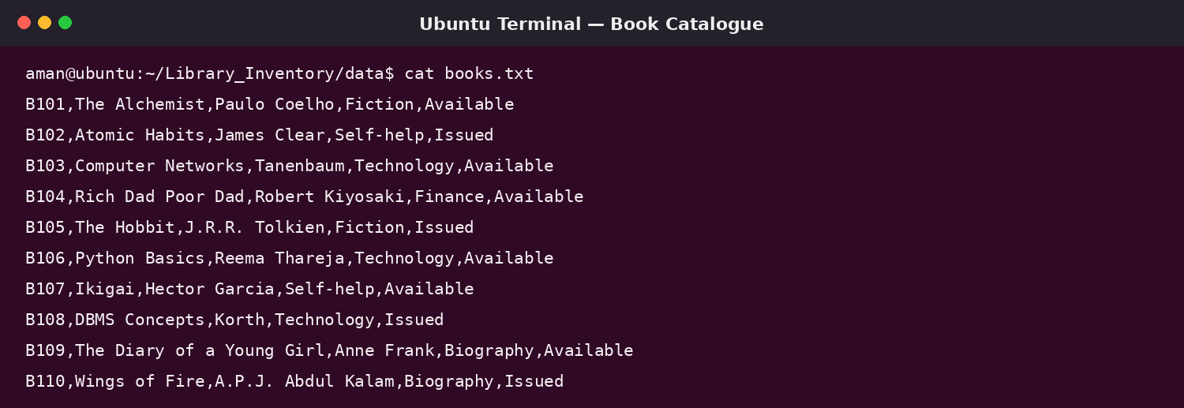
Illustrative Ubuntu-style terminal view of the book catalogue.

Step 3 — Separate available and issued books
grep ',Available$' data/books.txt > data/available.txt
grep ',Issued$' data/books.txt > data/issued.txt
cat data/available.txt
cat data/issued.txt

grep checks the final status field. The > symbol saves matching lines in separate files, making it easy to view books by status.

Step 4 — Search and extract book information
grep -i "alchemist" data/books.txt
grep ",Technology," data/books.txt
cut -d ',' -f2 data/books.txt
egrep ",(Fiction|Technology)," data/books.txt
fgrep "Atomic Habits" data/books.txt

The first command searches for a title without depending on letter case. The second finds Technology books. cut extracts the second field (title). egrep matches either category, and fgrep searches for exact fixed text.
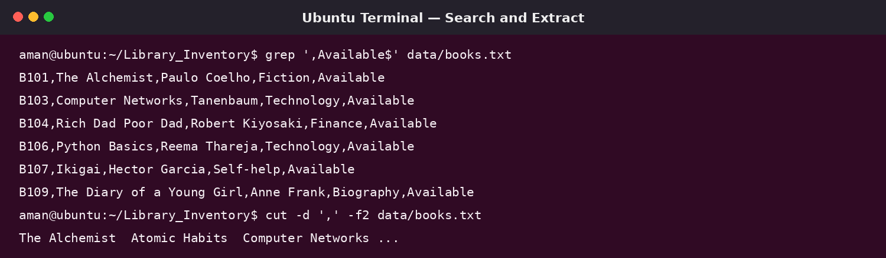
Illustrative Ubuntu-style terminal view demonstrating search and extraction.

Step 5 — Sort and view the catalogue
sort -t ',' -k2,2 data/books.txt > reports/sorted_books.txt
head -n 3 reports/sorted_books.txt
tail -n 3 reports/sorted_books.txt
less reports/sorted_books.txt

sort uses the comma as the field separator and sorts by the second field (Title). head displays the first three lines, tail displays the last three, and less lets the user scroll through the file. Press q to exit less.

Step 6 — Prepare the final inventory report
cat data/available.txt data/issued.txt > reports/final_inventory.txt
head -n 5 reports/final_inventory.txt
cat reports/final_inventory.txt

cat combines the available and issued lists in the given order and writes them to final_inventory.txt. The > symbol creates or overwrites the destination file; >> appends to an existing file.
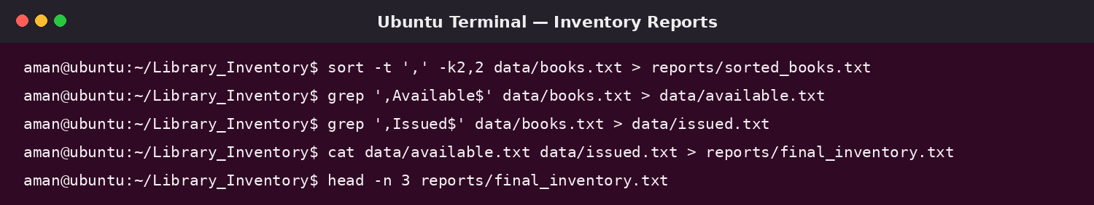
Illustrative Ubuntu-style terminal view showing filtering and report generation.

8. Example Output
Example: searching for a particular book title returns its catalogue entry:
$ grep -i "alchemist" data/books.txt
B101,The Alchemist,Paulo Coelho,Fiction,Available

Example: extracting the title field (second field) displays the book titles:
$ cut -d ',' -f2 data/books.txt
The Alchemist
Atomic Habits
Computer Networks
Rich Dad Poor Dad
The Hobbit
Python Basics
Ikigai
DBMS Concepts
The Diary of a Young Girl
Wings of Fire

9. How This Simplifies a Real-World Issue
A librarian in a small library may need to check whether a title is available, prepare a list of books in a category, or make a separate list of issued books. Checking every entry manually takes time and can cause errors. In this project, grep searches titles, categories, and status; cut extracts titles; sort arranges the catalogue; and cat creates a combined report. These operations make basic catalogue handling quicker, more consistent, and easier to verify.

10. Limitations and Possible Improvements
- This is a learning project, not a complete library management application.
- The files do not automatically validate entries or update a lending transaction.
- Plain text files are not suitable for secure multi-user management of a large library.
- The project could be extended with more categories, search fields, and updated status reports.

11. Conclusion
The Library Book Inventory and Search System demonstrates how Linux commands can solve simple file-management and text-search tasks without writing a program. Using mkdir, touch, echo, grep, cut, sort, head, tail, less, and cat, a small library catalogue can be organised, searched, filtered, and reported in a practical way.

