**ONE- TO-MANY**



Line 48 – receive the results (of Line 46); if we have any results

Line 49 – this_user 🡪 results is a list of dictionaries; give me the first one [0]

This is using the class (__init__) so it is only looking for the items in that class (even though it contains other information)

this_user is now the instance of the class

Line 50 – this is because we will have more than one thing returned; this will cycle through what’s there

Line 54 – if that row does not have a user_id (if it’s null) then break, and it will go to the next loop. If it is not none (it has something) that means they have a post

** This is where an empty list is created in order to 4

40:00 mark in week5lesson2 is where this is explained

Careful with below, as it depends on what’s at the top of your model files

**MANY-TO-MANY**

In example in video, it’s getAll in the Post class

(below) This is the query that allows a like button to work

“””



“””

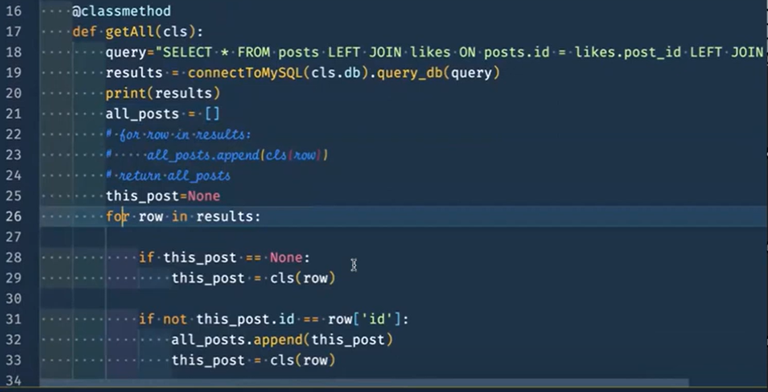

Black belt will be dialed down from the above

Line 25 – in the beginning, the post is blank

Line 26 – starts running through the information

Line 28 – if that post has nothing, we create an instance of the class (Line 29)

Line 31 – this is confirming that it’s a new post

If they match, that means it’s the same post; if they’re NOT equal, that means we have a new like

Line 33 – since we have a row that we haven’t seen before (new id) we can make a new object and that new object is new post

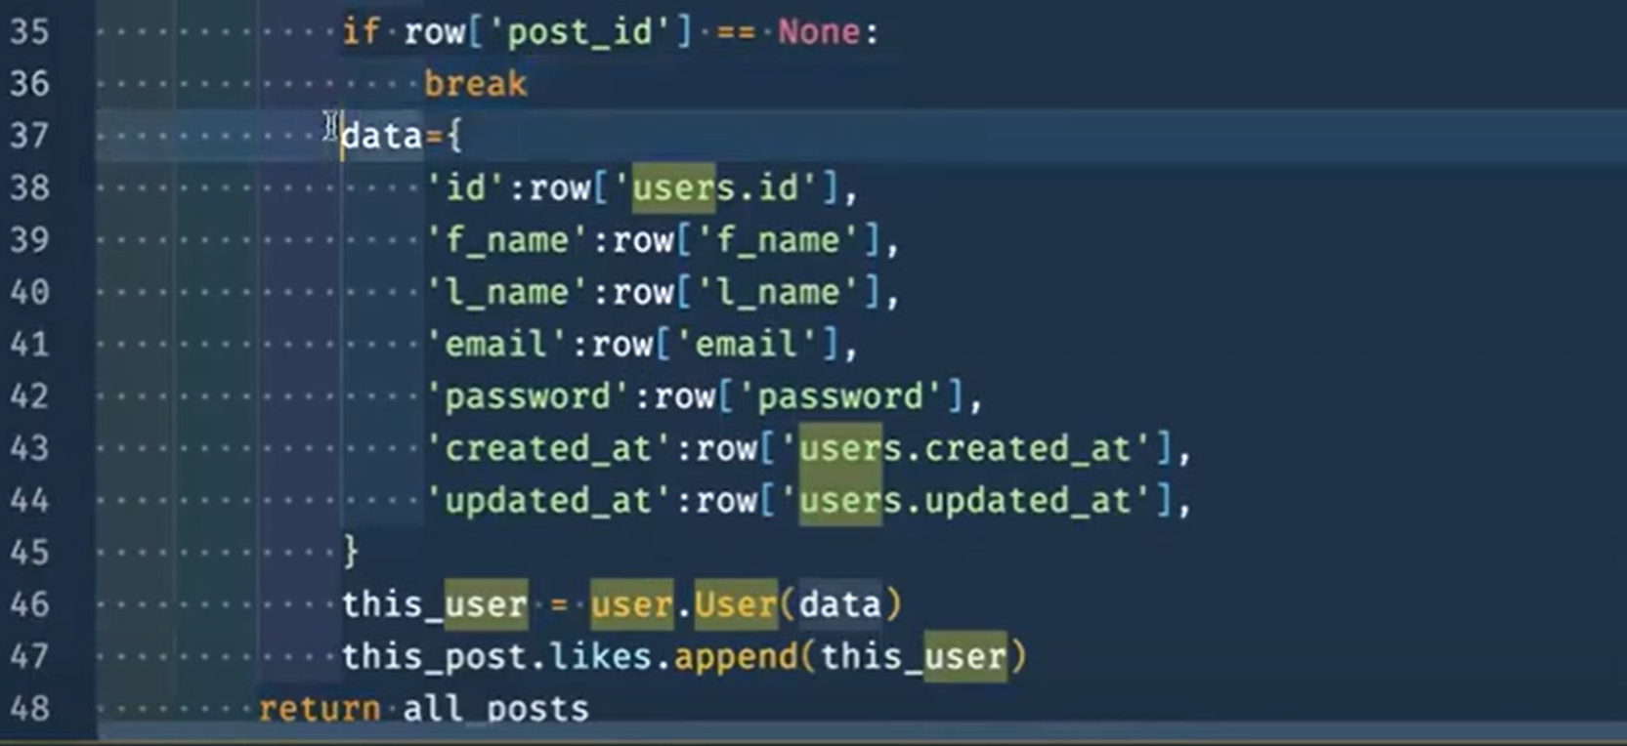

If a post has no likes it will break and start the loop on the next cycle

But if it is not empty, we’ll create Line 37

** Pay close attention to the key/value pair wording (e.g., Line 38)

Line 46 – calls User class and sends in data to create this user

Line 47 – We can now append it to this post’s likes (Line 13 below); whoever liked the post, they can be added to this list (Line 13 below)

**LOGIN, REGISTRATION, VALIDATION**

aaa