In a class, you can put an empty list to be filled in later:

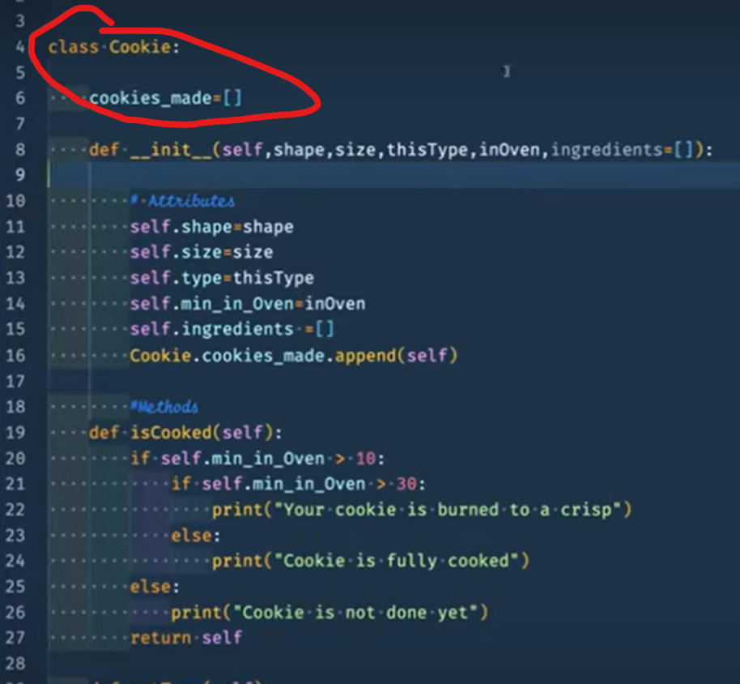

Classes have attributes for storing data, and methods for providing behavior.

Process of creating objects through the class is called ‘construction’ or ‘instantiation’. Class constructor is the tool for doing this.

Be sure to use ‘pass’ statements if you haven’t finished a method/function. That’ll let the code run without an error.

0209

Static method doesn’t need cls under it

Class method needs cls in it

If not Burger.validate_burger(request.form):

Read as “If ABOVE is not true”, then the action

Redirects can go to a new place (unlock) so this is how you can get to the dashboard

Hash password is an encoded password



This bcrypt… part is a standard function of bcrypt

Put error message block in a div above or below the create/login sections of your main page

EXAM

**Functions**

Create an instance of a User class

Allow users to interact with other users

Allow users to make posts

**Pages to create:**

Create a user / login

Dashboard

Create new post

TO DO]

Grab code blocks from lectures and keep on hand for use.

Do Ohana Rideshares to get prepped for the black belt

24 hours to finish AWS deployment

Other students have used many @app.route in their code.