**Report 1**

***Step 1:*** *Start*

***Step 2:*** Open database file that contains regular patient details

***Step 3:*** Read the first record

***Step 4:*** **While** not **eof()**

***Step 5:*** Print Patient No, Name, Age, Gender, DOB, Due Amount, Description

***Step 6:*** Read next record

***Step 7:*** **End While**

***Step 8:*** Close the database file

***Step 9***: *Stop*

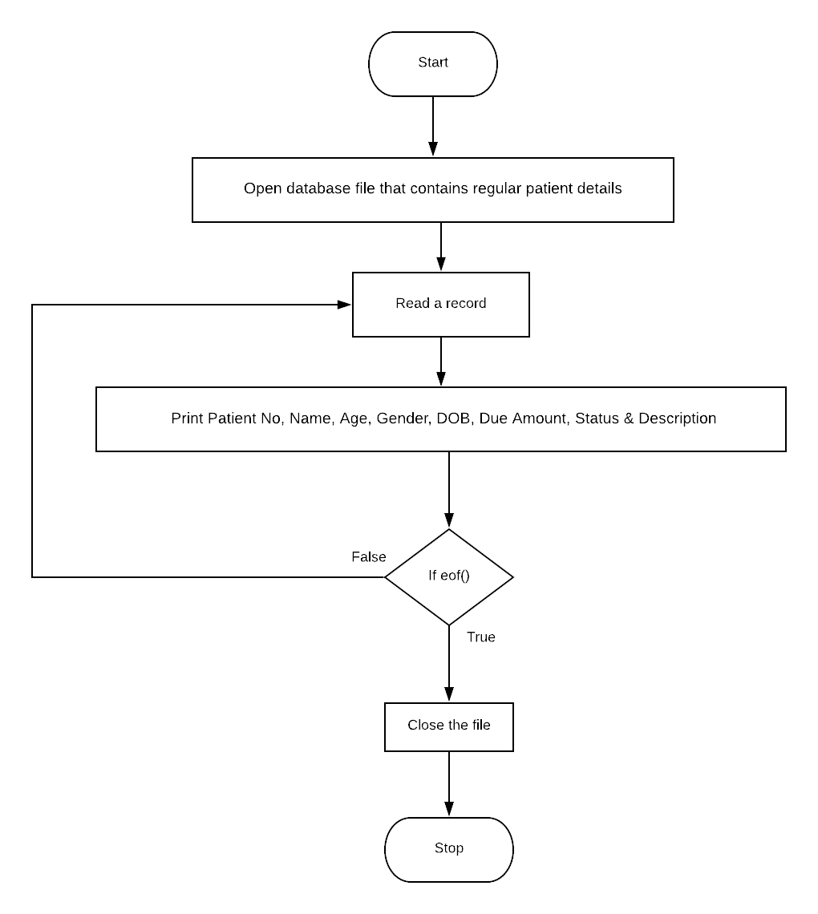

|  |  |  |  |  |  |  |  |
| --- | --- | --- | --- | --- | --- | --- | --- |
| **Dry Run: Display Regular Patient Details** | | | | | | | |
| **Patient No** | **Name** | **Age** | **Gender** | **DOB** | **Status** | **Due Amount** | **Description** |
| 1111 | John Williams | 21 | Male | 1997/09/21 | Discharged | 0.00 | None |
| 2222 | Mary Antoinette | 34 | Female | 1884/04/01 | Awaiting Surgery | 34592.34 | Suffers from a thyroid condition |
| 3333 | Chamila Perera | 56 | Female | 1962/05/23 | Awaiting Doctor | 2100.00 | None |

**Report 2**

***Step 1:*** *Start*

***Step 2:*** Open database file that contains patient payment details

***Step 3:*** Read the first record

***Step 4:*** **While** not **eof()**

***Step 5:*** **If** *Due Amount* ***>*** *0.00*

***Step 6:*** Print Patient No, Doctor Fee, Equipment Fee, Additional Charges & Due Amount

***Step 7:* EndIf**

***Step 8:*** Read next record

***Step 7:*** **End While**

***Step 8:*** Close the database file

***Step 9***: *Stop*

Flow Chart in next page

