**Student-Portal**

This is a simple PHP Student Portal with a MySQL Database. I made this as part of a university assignment, so you can login, logout, register, and view your details when successfully registered and/or logged in. For this to function properly you will need a {student} database, with tables for {registration, info, login history, and results}. Here is a simple flow chart to show the layout of the application.

[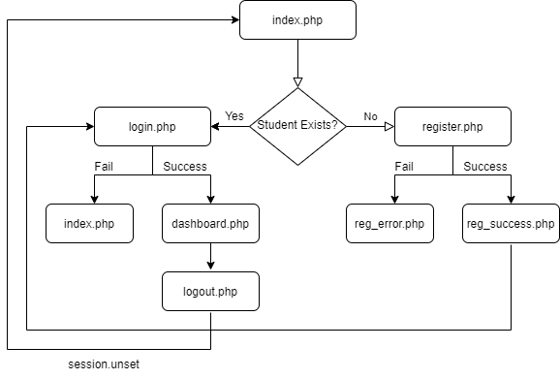](https://user-images.githubusercontent.com/87696858/144178299-498874d1-aa12-4289-bea8-65a024ef30bd.png)

Do note that this application does contain cookies and sessions to allow users to store their passwords/username, and it will auto destroy cookies according to the set time. If you use this, add better security to the application!!!

**MAIN UI**

