NIKE
SALES ANALYSIS
Business Insights Report
POWER BI DASHBOARDS | INSIGHTS | DATA SUMMARY

Executive Summary
This report reviews two Power BI dashboards on Nike sales and the cleaned dataset behind them. It highlights what is selling, where profit comes from and what needs attention.

Headline numbers (Excel dataset, 100 orders)
KPI | Value
Total profit | ₹113,107
Profit margin on MRP | 18.1%
Average profit per order | ₹1,131
Units sold | 170
Profitable orders | 74%
Top product line by profit | Training (₹34,146)
Top region by profit | Pune (₹30,953)
Top gender category by profit | Kids (₹48,327)
Online share of profit | 58% (₹65,778)

Key messages
- Broad profit base. Profit is healthy and broad-based: every product line and region earns a positive profit.
- Discount discipline matters. Low discounts (under 80%) deliver about 95% of profit. Medium and high discounts add little.
- Loss-making orders. About one in four orders loses money (26% in the Excel data, 23.7% on the dashboard).
- Channel mix. Online earns more profit than retail in four of six regions; Delhi and Mumbai are retail-led.
- Data quality. Revenue fields have gaps and some values look inconsistent (see Data Quality), so they should be fixed before the numbers are used for decisions.

1. Dashboard Images

Dashboard 1: Nike Sales Dashboard
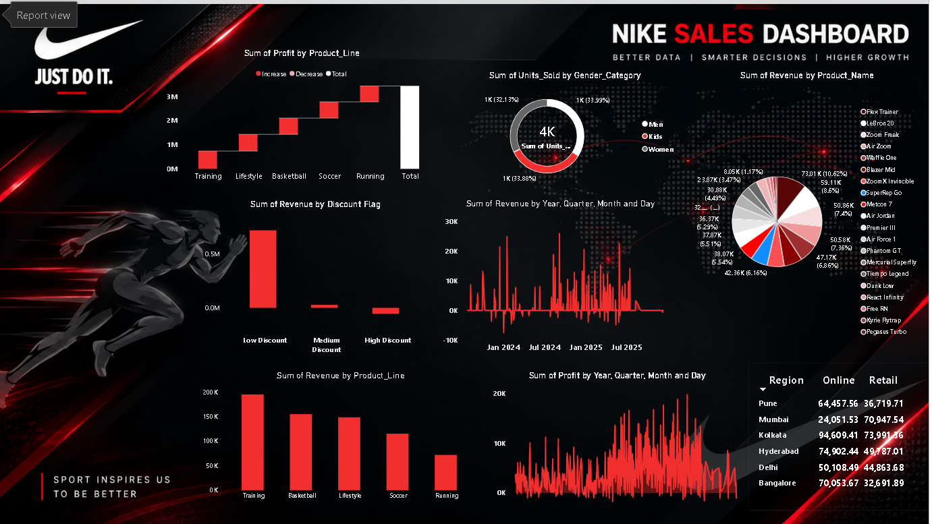

Dashboard 2: Dashboard on Nike Sales
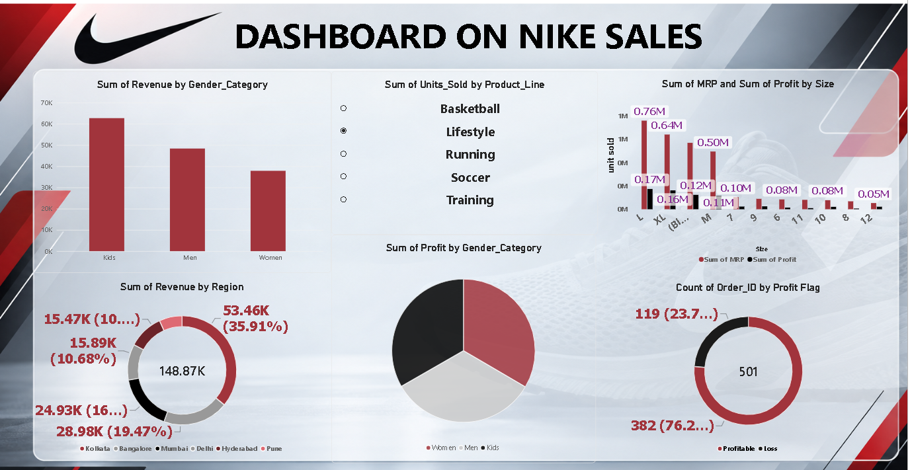

2. Key Insights from the Dashboards

Dashboard 1: Nike Sales Dashboard
- Product lines: Training is the top product line by revenue (about 195K), followed by Basketball (~155K) and Lifestyle (~148K). Running is the weakest at roughly 75K, less than 40% of Training.
- Profit build-up: Every product line adds to total profit, which builds to more than 3M in the waterfall. No line is a drag on profit, so the gap between lines is about scale, not loss-making.
- Gender mix: Units sold are split almost evenly: Men 33.99%, Kids 33.88% and Women 32.13% (about 4K units in total). No single gender segment dominates volume.
- Discounts: Low-discount orders generate nearly all the positive revenue (about 0.28M). Medium and high discounts contribute little or negative revenue, so deep discounting is not paying off.
- Product concentration: Revenue is spread thinly across 20 products. The largest slice is about 73K (10.6%), then 59K (8.6%) and 51K (7.4%). There is no heavy dependence on a single shoe.
- Regions and channels: Kolkata has the highest online figure (94.6K) and Hyderabad (74.9K), Bangalore (70.1K) and Pune (64.5K) follow, so online leads in five of six cities. Mumbai is the exception and is retail-led (70.9K retail vs 24.1K online). Channel strategy should differ by city.
- Trends over time: Daily revenue is very spiky with several dips below zero (returns or refunds), while daily profit shows more activity from 2025 onward.

Dashboard 2: Dashboard on Nike Sales
- Gender: Kids lead revenue at about 63K, ahead of Men (~48K) and Women (~38K). Profit by gender is split almost in thirds.
- Regional revenue: Total revenue is 148.87K. Kolkata is the largest region at 53.46K (35.9%), followed by Bangalore (28.98K, 19.5%) and Mumbai (24.93K). Delhi, Hyderabad and Pune contribute the smallest shares (about 10% or less each).
- Order profitability: Of 501 orders, 382 (76.2%) are profitable and 119 (23.7%) are loss-making. Roughly one in four orders loses money, which is worth investigating.
- Sizes: Sizes L, XL and M account for the highest MRP value (0.76M, 0.64M and 0.50M) but profit per size is small (0.17M, 0.16M and 0.12M). Shoe sizes 6 to 12 are far smaller, around 0.05M to 0.10M.
- Interactivity: Lifestyle is the product line selected in the slicer, so the view can be filtered by line for a closer look.

Recommendations
- Focus promotions on low-discount offers, which drive almost all of the revenue, and review the medium and high discount rules.
- Investigate the 23.7% of loss-making orders and the negative revenue days (returns or refunds).
- Grow Running, which has the lowest revenue, through bundling or targeted campaigns.
- Tailor channel strategy by city: strengthen retail in online-led cities and online in Mumbai.
- Keep Kids and Men inventory strong, as Kids is the top revenue segment on Dashboard 2.

3. Charts from the Excel Data
The charts below are built from nike_sales.xlsx and complement the Power BI dashboards.
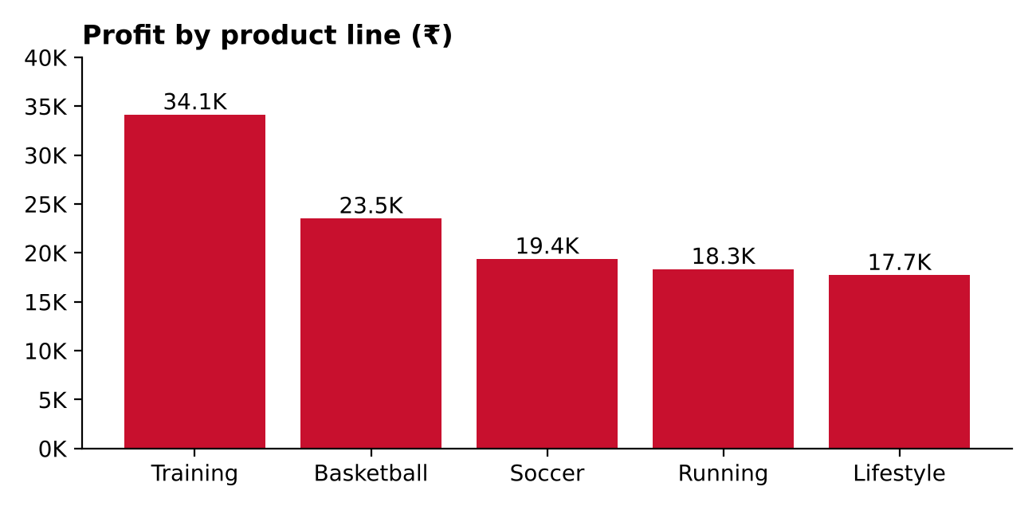
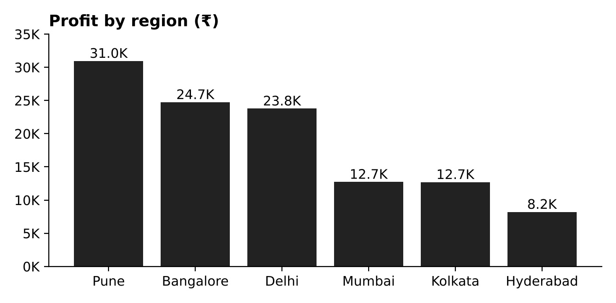
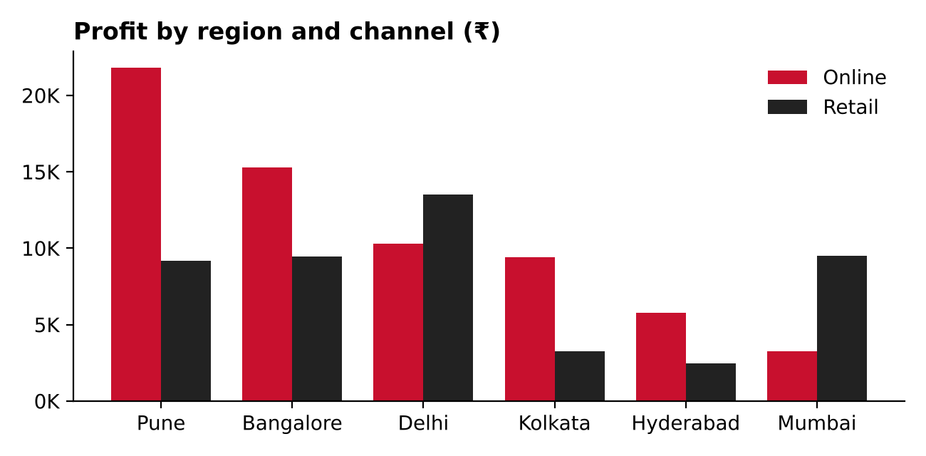
- Training leads profit and Lifestyle is lowest, but all five lines are positive.
- Pune, Bangalore and Delhi together earn about 70% of profit.
- Online profit is far ahead in Pune, Bangalore and Kolkata; Mumbai and Delhi are stronger in retail.
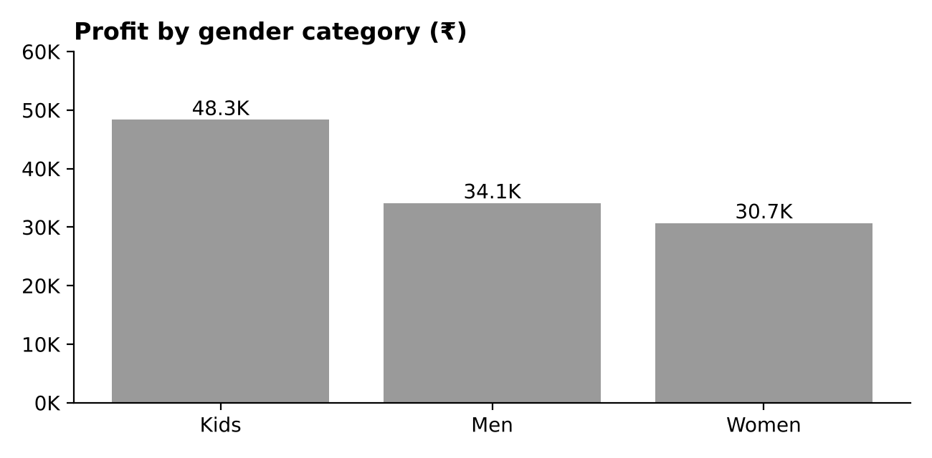
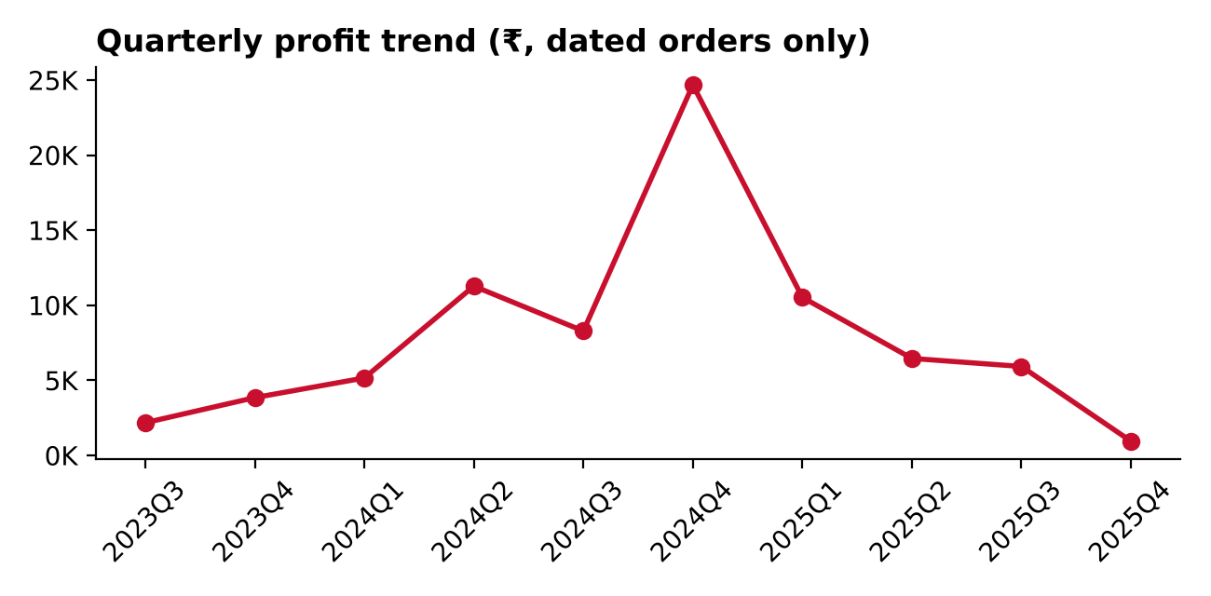
- Kids is the largest profit category, ahead of Men and Women.
- Profit peaked in Q4 2024, the busiest quarter by order count (20 orders). Q4 2025 only covers the first days of November, so it is not a full quarter.

4. Data Summary (nike_sales.xlsx)
The file has 100 orders and 16 columns (Order_ID, Gender_Category, Product_Line, Product_Name, Size, Units_Sold, MRP, Discount_Applied, Revenue, Order_Date, Sales_Channel, Region, Profit, Profit Flag, Discount Flag, Revenue Flag). Orders run from 6 Sep 2023 to 4 Nov 2025.

Overall totals
Metric | Value
Orders | 100
Units sold | 170
Total MRP | 625,552
Total revenue (₹) | 33,666
Total profit (₹) | 113,107
Profitable orders | 74 (74%)
Loss-making orders | 26 (26%)
Online / Retail orders | 55 / 45

By gender
 | Orders | Units | Revenue (₹) | Profit (₹)
Kids | 32 | 54 | 11,841 | 48,327
Men | 39 | 63 | 1,224 | 34,100
Women | 29 | 53 | 20,601 | 30,680

By product line
 | Orders | Units | Revenue (₹) | Profit (₹)
Training | 28 | 40 | 5,500 | 34,146
Basketball | 21 | 48 | 15,101 | 23,523
Soccer | 16 | 21 | 2,515 | 19,384
Running | 19 | 28 | -2,579 | 18,339
Lifestyle | 16 | 33 | 13,129 | 17,715

By region
 | Orders | Units | Revenue (₹) | Profit (₹)
Pune | 14 | 33 | 20,031 | 30,953
Bangalore | 21 | 37 | 0 | 24,740
Delhi | 19 | 36 | 2,515 | 23,777
Mumbai | 17 | 28 | 6,619 | 12,731
Kolkata | 13 | 16 | 0 | 12,698
Hyderabad | 16 | 20 | 4,501 | 8,208

By sales channel
 | Orders | Units | Revenue (₹) | Profit (₹)
Online | 55 | 90 | 9,134 | 65,778
Retail | 45 | 80 | 24,532 | 47,329

By discount band
 | Orders | Units | Revenue (₹) | Profit (₹)
Low (16% to 78%) | 89 | 150 | 30,202 | 107,058
Medium (82% to 94%) | 5 | 10 | 3,634 | 3,425
High (above 100%) | 6 | 10 | -170 | 2,624

Top and bottom products by profit
 | Orders | Units | Revenue (₹) | Profit (₹)
Air Jordan | – | 20 | 15,101 | 16,636
SuperRep Go | – | 12 | 0 | 14,720
Flex Trainer | – | 13 | 5,500 | 11,292
Premier III | – | 11 | 2,515 | 10,155
LeBron 20 | – | 6 | 0 | -77
Metcon 7 | – | 5 | 0 | -702

Data Quality Notes
- 92 of 100 orders have zero revenue (Revenue Flag "No Revenue"), only 6 have positive revenue and 2 are negative. Revenue looks incomplete or defined differently from profit.
- Missing values: Size is blank for 18 orders and Order_Date for 27 orders.
- 20 orders have zero or negative units sold, and 6 orders have discounts above 100% (up to 117%). These look like returns or data-entry issues and should be validated.
- The dashboards show 501 orders and 148.87K revenue, while this file has 100 orders and 33.7K revenue, so the file appears to be a sample or a different version of the data behind the dashboards. The insights in section 2 are read from the dashboards, and the summary in section 3 is computed from the Excel file.

5. Action Plan
Priority | Action | Why | Owner
High | Fix revenue calculation and review discounts above 100% | 92% of orders show zero revenue | Data team
High | Investigate the ~24% loss-making orders | Direct profit leakage | Sales / Finance
Medium | Cap medium and high discount offers | They add little profit | Marketing
Medium | Boost Running and Lifestyle with campaigns and bundles | Lowest profit lines | Product / Marketing
Medium | Set channel strategy per city | Online vs retail varies by region | Regional heads
Low | Fill missing Size and Order_Date values | Better trend and size analysis | Data team

6. Conclusion
Nike sales are profitable across product lines, regions and channels, with Training, Pune and Kids leading. The biggest opportunities are tighter discount control, fewer loss-making orders and a clearer channel strategy by city. Cleaning the revenue and date fields will make the next round of dashboards more reliable.

