**Walking Directions to 6710B Rockledge Drive   
(~0.7 mi/15 min)**

1. Exit Bethesda Marriott Suites and turn left on Democracy Plaza Marriott Loop
2. Walk ~0.2 miles and turn right towards Fernwood Drive.
3. 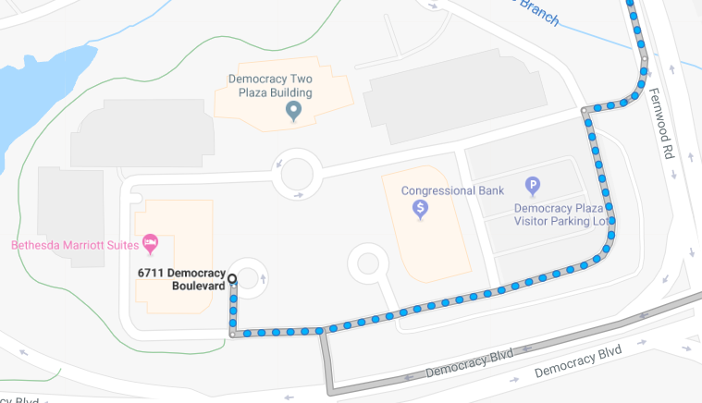Make your first left onto Fernwood Drive
4. Walk ~0.2 miles and turn right onto Rock Spring Drive  
   (Marriott International Headquarters will be on your left)

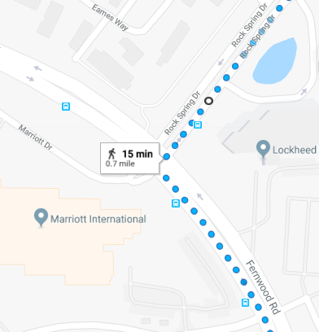

1. ~0.2 miles turn left
2. ~0.2 miles turn right   
   (Rock Spring Children’s Center will be on your left)
3. The second building on your right will be 6710B Rockledge Drive
4. 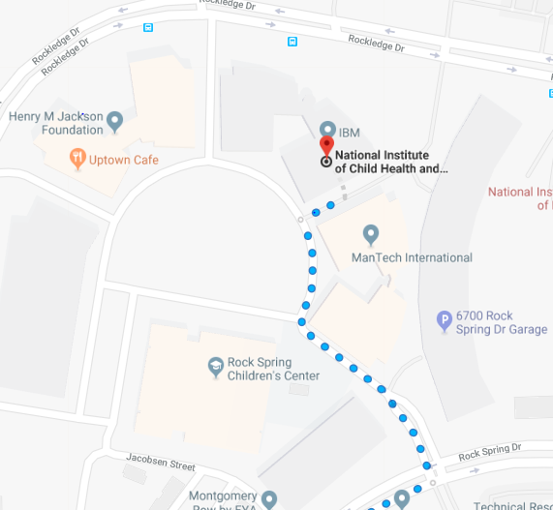There will be signs in the 6710B lobby to direct you to the meeting room.

**6710B Entrance**

If you have any questions please feel free to call Alex Simpson directly at   
703-926-4640.