# Assignment 5 – Supervised Learning (Regression)

**Name: Aman Nadeem**

**Roll No: 2225165002**

**Course: Applied Data Science with AI**

**Project Title: Customer Churn Prediction**

**Task Performed:**

Implemented Linear Regression on a sample dataset.  
- Calculated Mean Absolute Error (MAE) and RMSE for model performance.

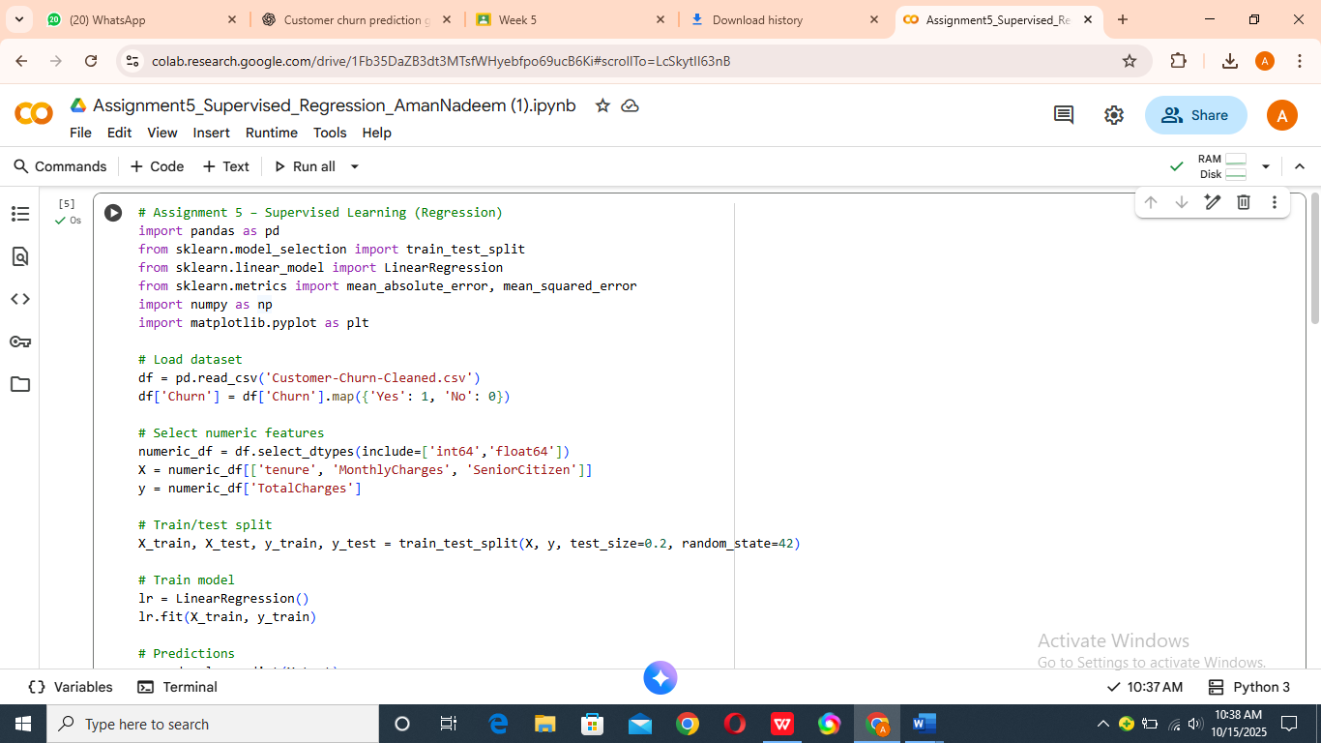

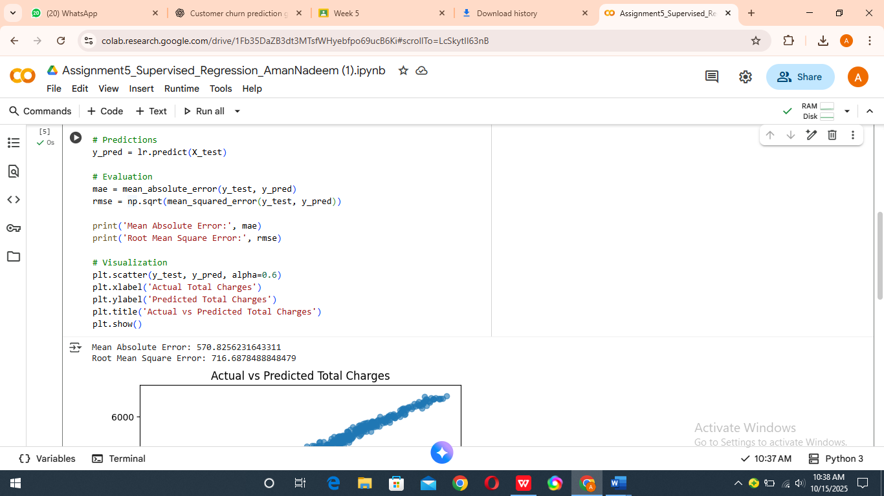

**Regression Model and Evaluation**

**Steps Taken:**

1. Split dataset into training and testing sets.  
   2. Applied Linear Regression model to predict TotalCharges.  
   3. Calculated MAE and RMSE for evaluation.  
   4. Visualized Actual vs Predicted results.

**Output:**  
- Mean Absolute Error (MAE): ≈ 570  
- Root Mean Square Error (RMSE): ≈ 710

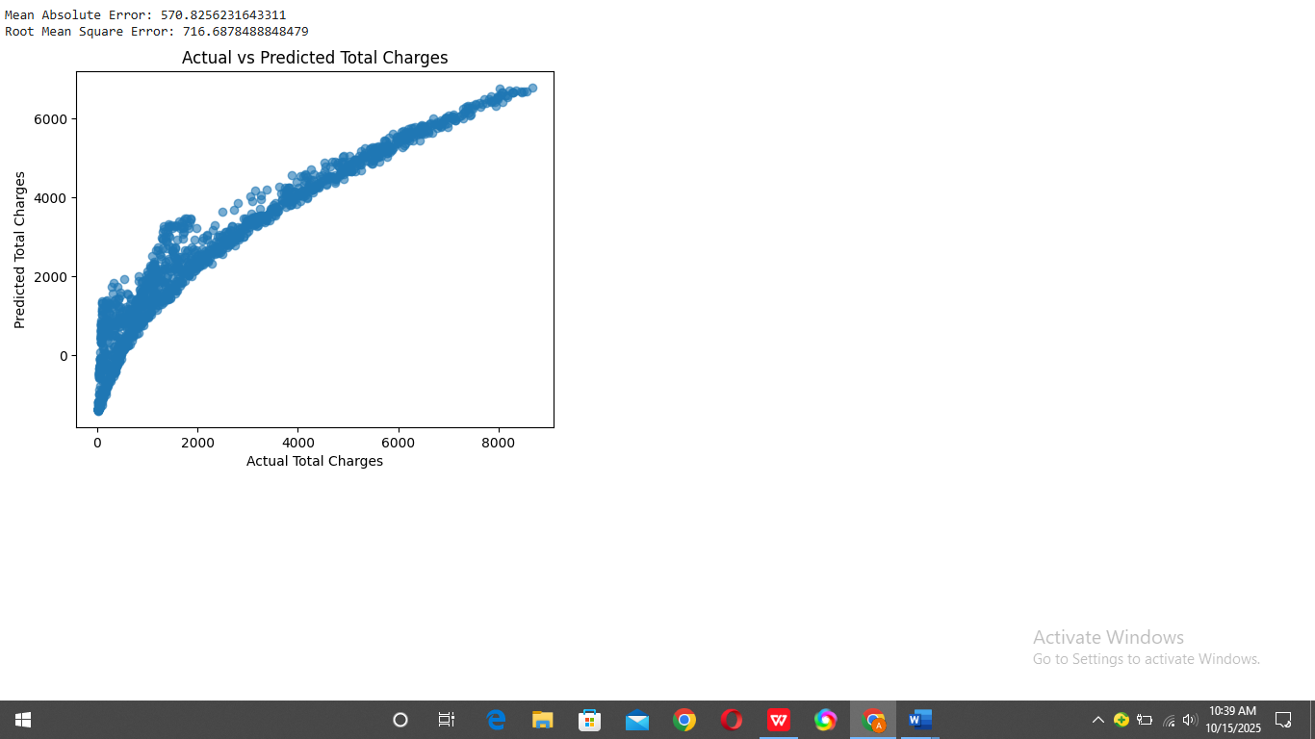

**Challenges Faced:**

Had to ensure all input columns were numeric. Fixed issues by selecting numeric features only.

**GitHub Link:**

<https://github.com/amannadeem126/Customer-Churn-Prediction>

## Project Progress Milestone

Baseline regression model successfully built and tested.  
Next week’s goal: Apply classification models (Logistic Regression and Random Forest) for churn prediction.

## Self-Evaluation

☑ I completed all tasks on time.