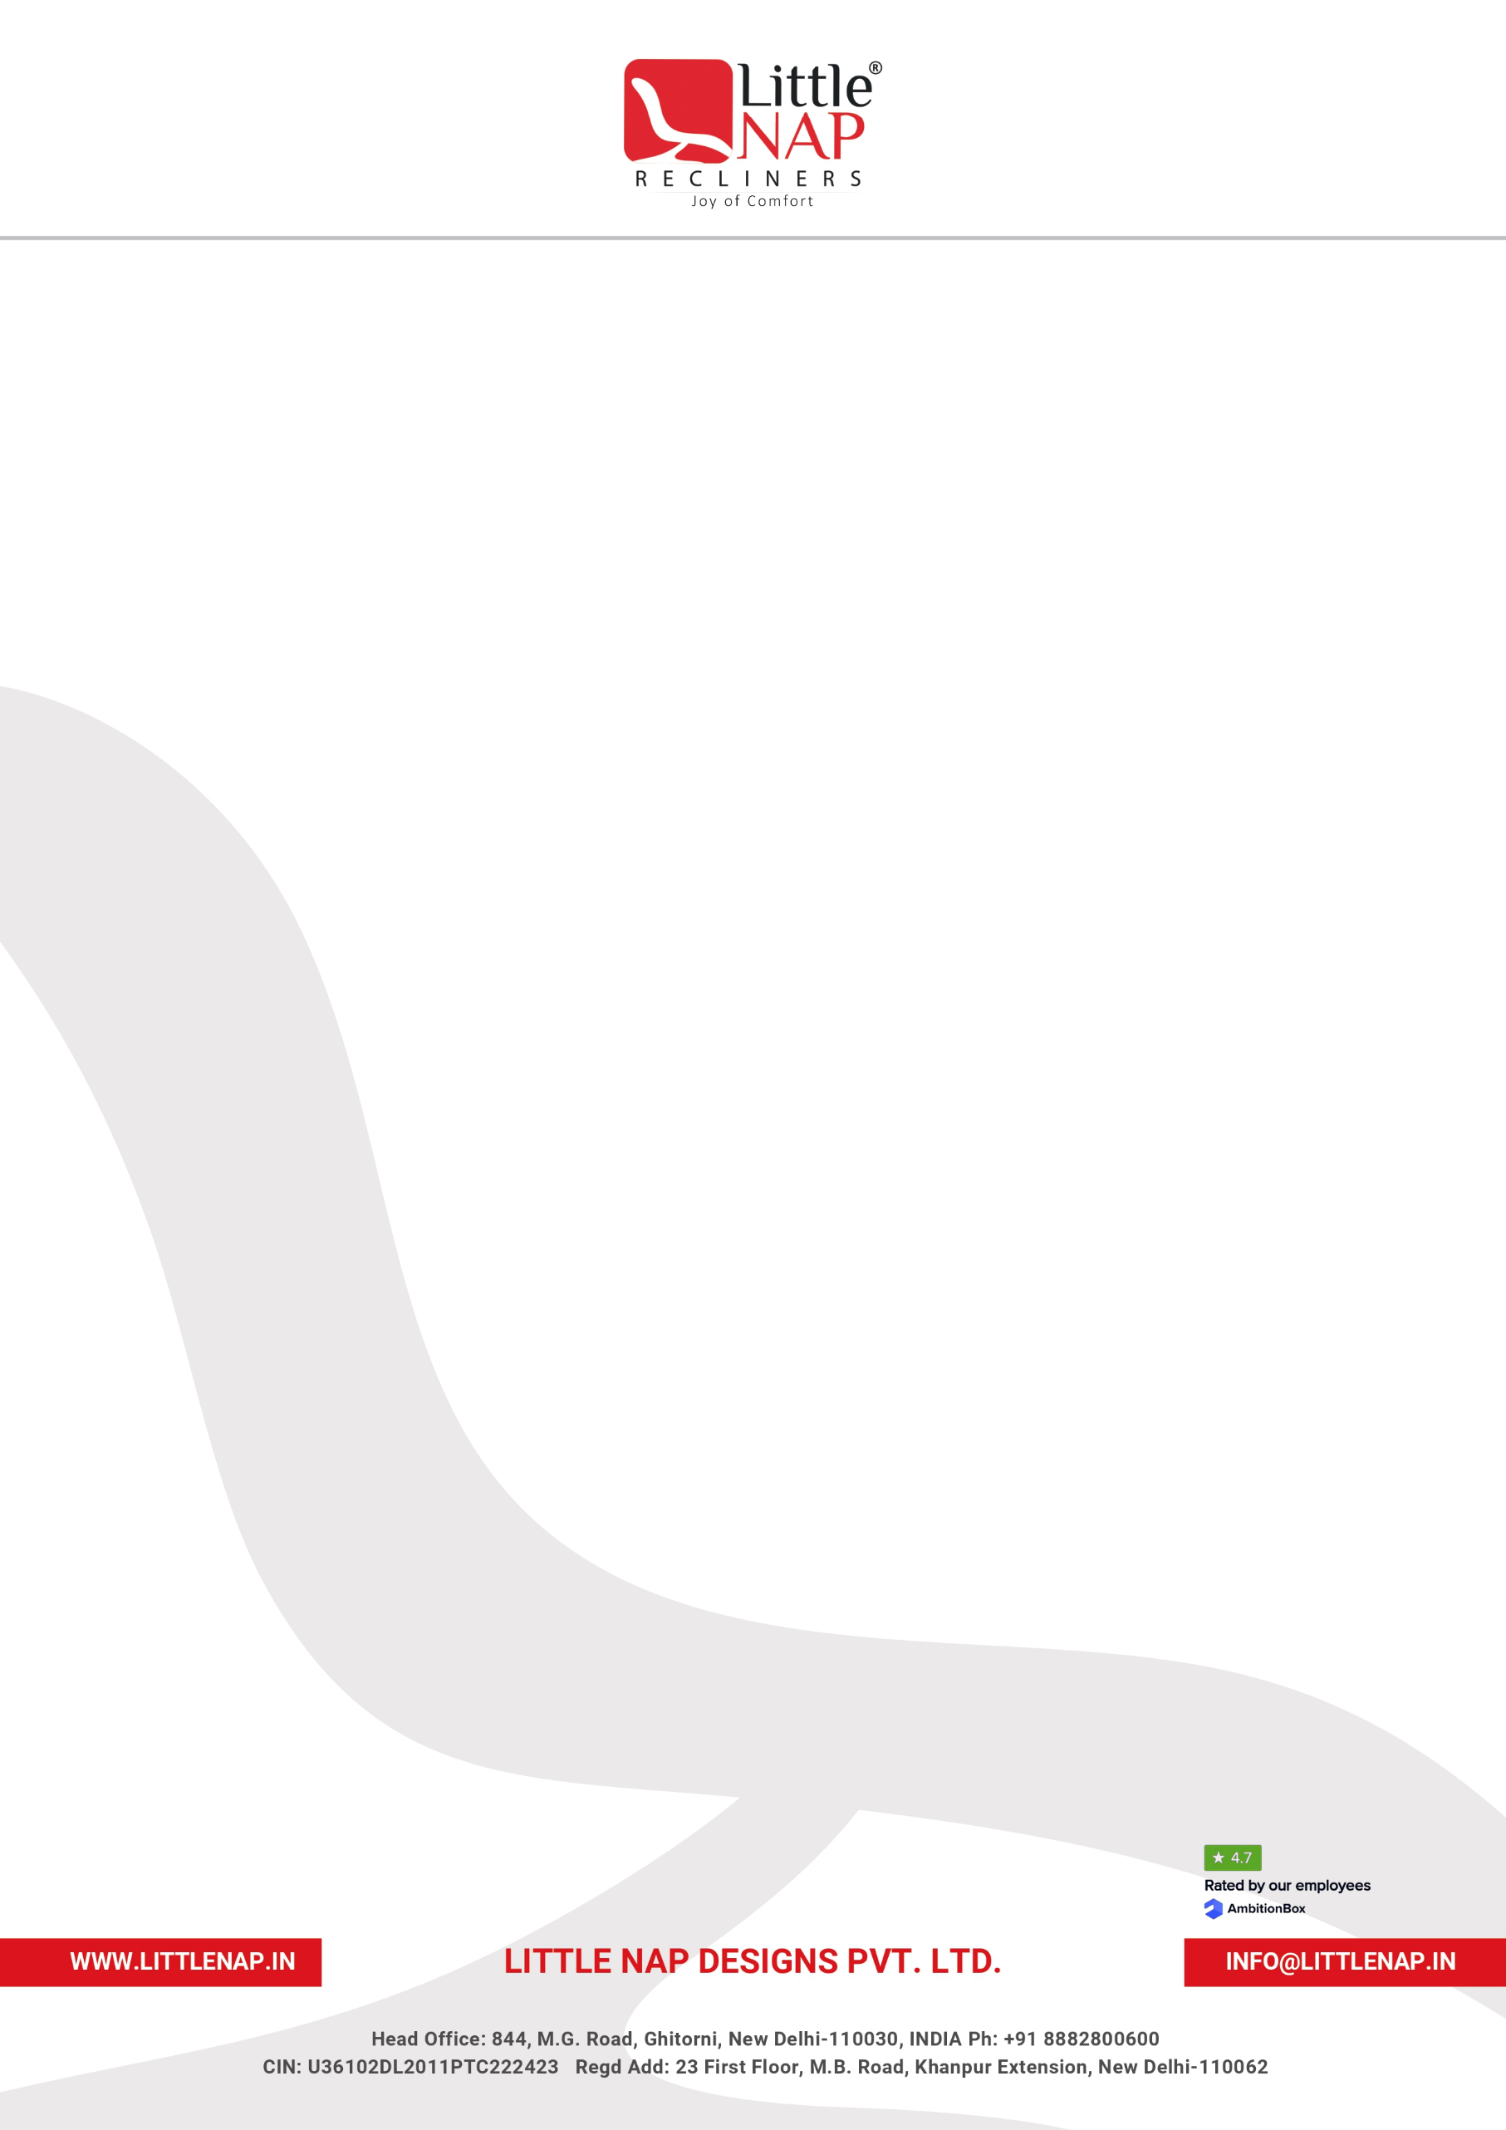
LITTLE NAP DESIGNS PRIVATE LIMITED
``
INTERNSHIP OFFER & ENGAGEMENT LETTER

Date: [DD Month YYYY]
To,
Mr./Ms. [Intern Full Name]
[Address]
[Email ID]
[Contact Number]
Subject: Internship Engagement with Little Nap Designs Private Limited
Dear [Intern Full Name],
We are pleased to offer you an opportunity to undertake an internship with Little Nap Designs Private Limited (“Company”) as [Designation] for a fixed internship period from [Start Date] to [End Date].
We believe this internship will provide you with meaningful practical exposure to a professional work environment and an opportunity to develop your knowledge and skills through interaction with experienced professionals within the organisation.
1. INTERNSHIP DETAILS
Intern Name | [Intern Full Name]
Internship Position | [Designation]
Department / Function | [Department]
Reporting Manager | [Name & Designation]
Internship Location | [Location]
Start Date | [Start Date]
End Date | [End Date]
Working Days | [Days]
Working Hours | [Time]
Stipend | ₹[Amount] per month
Payment Cycle | [Monthly / Other]

2. NATURE AND PURPOSE OF INTERNSHIP
The internship is intended primarily as a learning and practical exposure opportunity. During the internship, you may be assigned projects, tasks and responsibilities relevant to your area of study and the requirements of the Company.
Your assignments may include, but will not be limited to:
- Supporting the assigned department in day-to-day activities;
- Assisting with specific projects and assignments;
- Conducting research, analysis and documentation;
- Preparing reports, presentations and other work-related material;
- Learning and applying relevant professional processes and practices;
- Working collaboratively with team members and other functions; and
- Such other reasonable learning or project-related responsibilities as may be assigned by your reporting manager.
The scope of your internship may be modified from time to time depending upon business requirements and learning objectives.
3. STIPEND
During the internship period, you will be eligible for a stipend of ₹[Amount] per month, subject to applicable conditions and satisfactory participation in the internship.
The stipend is intended as internship support and shall not be construed as a salary or as establishing a regular employment relationship with the Company.
Any applicable statutory deductions or taxes, if required, shall be dealt with in accordance with applicable law.
4. ATTENDANCE AND WORKING HOURS
You are expected to maintain regular attendance and adhere to the working hours, attendance procedures and workplace requirements applicable to interns at the Company.
Any absence should be discussed and approved in advance by your reporting manager, except in genuine emergencies.
Unauthorised or prolonged absence, repeated late attendance, or failure to maintain satisfactory participation may result in discontinuation of the internship.
5. CONDUCT AND PROFESSIONAL STANDARDS
During your internship, you are expected to maintain high standards of professional conduct and comply with all applicable Company policies, procedures, safety requirements and reasonable instructions.
You are expected to:
- Maintain professionalism and respect towards colleagues, managers, customers, vendors and other stakeholders;
- Maintain confidentiality of Company information;
- Use Company property, systems and resources responsibly;
- Follow applicable workplace safety and security requirements;
- Avoid any conduct that may adversely affect the Company’s reputation or business interests; and
- Comply with all applicable policies relating to workplace conduct, information security, anti‑harassment and ethical behaviour.
Any serious misconduct, breach of policy, confidentiality violation or inappropriate behaviour may result in immediate discontinuation of the internship, subject to applicable law and Company procedure.
6. CONFIDENTIALITY
During the internship, you may have access to confidential or proprietary information relating to the Company, its employees, customers, vendors, products, designs, processes, pricing, business plans, financial information, technology, systems and other business matters.
You agree to keep such information strictly confidential and not disclose, reproduce, copy, transfer or use such information for any purpose other than your authorised internship responsibilities.
This confidentiality obligation shall continue even after completion or discontinuation of your internship.
You shall return or permanently delete, as instructed by the Company, any confidential documents, records, data or materials in your possession upon completion or discontinuation of the internship.
7. INTELLECTUAL PROPERTY
Any work product, document, report, design, concept, analysis, presentation, process improvement, content, research output, material or other intellectual property created specifically in connection with your internship assignments or using Company resources shall be subject to the Company’s rights to the extent permitted under applicable law.
You shall not independently publish, reproduce, commercialise, distribute or otherwise use such material without prior written approval from the Company.
8. COMPANY PROPERTY AND INFORMATION SYSTEMS
Any laptop, equipment, ID card, documents, samples, files, access credentials or other property provided to you shall remain the property of the Company.
You must safeguard such property and return it immediately upon completion or discontinuation of the internship.
You must not share passwords, access credentials or system access with any other person.
9. PERFORMANCE AND REVIEW
Your internship performance may be reviewed periodically based on factors including:
- Quality of work;
- Learning ability;
- Ownership and initiative;
- Attendance and punctuality;
- Professional conduct;
- Ability to meet assigned timelines;
- Teamwork and communication; and
- Overall contribution to assigned projects.
The Company may provide feedback during or at the conclusion of the internship.
Completion of the internship does not automatically create an entitlement to permanent employment with the Company.
10. CERTIFICATE OF INTERNSHIP
Subject to satisfactory completion of the internship and compliance with applicable Company requirements, the Company may issue an Internship Completion Certificate confirming the period and nature of your internship.
The issuance of any certificate shall be subject to completion of applicable exit formalities and return of Company property.
11. EMPLOYMENT / FUTURE OPPORTUNITY
This internship is for a fixed period and does not constitute an offer of regular employment.
Any future employment opportunity with the Company, if considered, shall be subject to a separate selection process, business requirements, performance, available vacancies and applicable Company policies.
Nothing in this letter shall be interpreted as creating a promise or guarantee of future employment.
12. TERMINATION / DISCONTINUATION
The internship may be discontinued by either the intern or the Company in accordance with the applicable terms communicated for the internship.
The Company reserves the right to discontinue the internship earlier in cases including, but not limited to:
- Serious misconduct;
- Breach of confidentiality;
- Violation of Company policies;
- Unsatisfactory performance;
- Unauthorised absence;
- Misrepresentation of information or documents;
- Misuse of Company property or systems; or
- Business or operational circumstances requiring discontinuation.
Any such action shall be taken in accordance with applicable law and the circumstances of the case.
13. BACKGROUND / DOCUMENTATION
You may be required to provide documents reasonably required by the Company for verification and internship administration, including proof of identity, educational details, address and other relevant documents.
Any material misrepresentation or submission of false information may result in withdrawal or discontinuation of the internship.
14. POLICIES AND AMENDMENTS
You shall comply with the applicable policies, procedures, safety requirements and instructions of the Company as communicated from time to time.
The Company may reasonably modify internship processes or requirements in accordance with business needs and applicable law.
15. ACCEPTANCE
Please sign and return a copy of this letter as confirmation that you have read, understood and accepted the terms and conditions of your internship.
We look forward to having you with Little Nap Designs Private Limited and hope that this internship provides you with a valuable opportunity to learn, contribute and gain meaningful practical experience.
We wish you a successful and enriching internship with us.
For Little Nap Designs Private Limited
[Authorised Signatory Name]
[Signatory Designation]

ACKNOWLEDGEMENT & ACCEPTANCE
I, [Intern Full Name], confirm that I have read and understood the terms and conditions contained in this Internship Offer & Engagement Letter and agree to abide by the applicable Company policies, procedures and requirements during my internship.

Name | [Intern Full Name]
Signature | [%Signature]
Date | [Acknowledgement Date]
Place | ______________________________________

