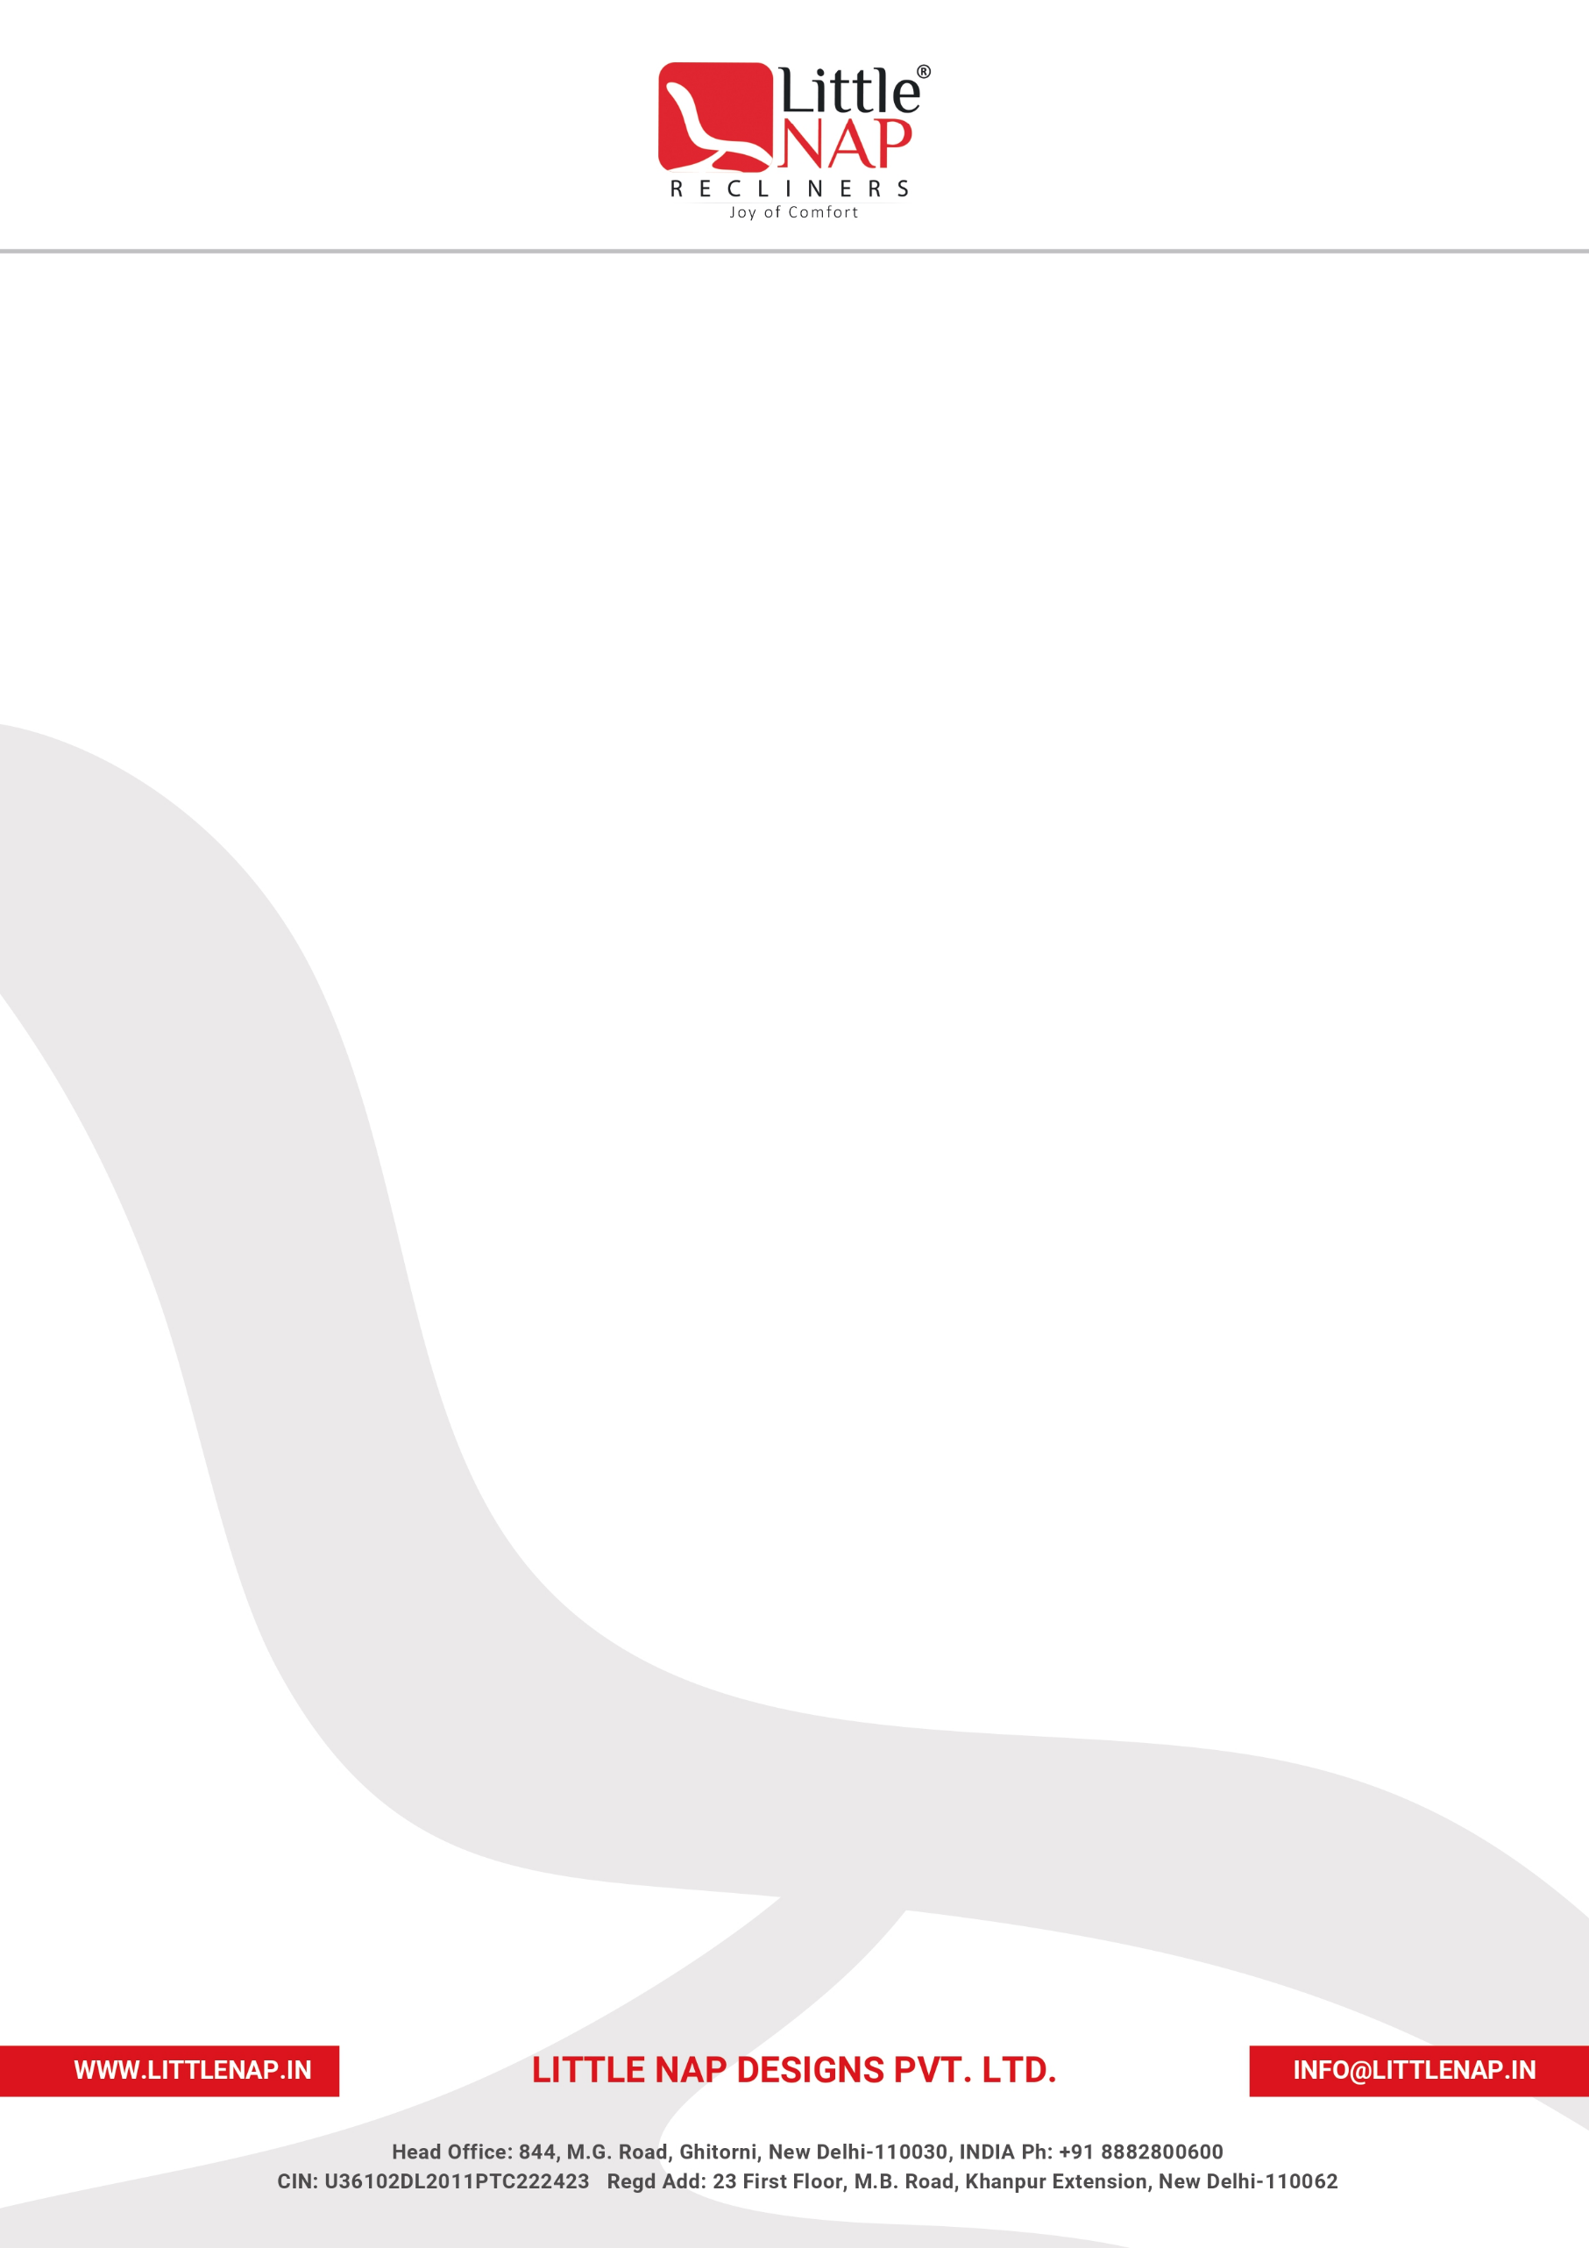

INTERNSHIP EXPERIENCE & COMPLETION LETTER

Date: [DD Month YYYY]
TO WHOM IT MAY CONCERN
This is to certify that Mr./Ms. [Intern Full Name] was engaged as an intern with Little Nap Designs Private Limited and has successfully completed the internship with the Company. The particulars of the engagement are recorded below:

INTERNSHIP DETAILS
Name of Intern | [Intern Full Name]
Designation | [Intern Designation]
Department | [Department]
Reporting Manager | [Reporting Manager – Designation]
Internship Period | [Start Date] to [End Date]
Work Location | [Work Location]

Working under the guidance of [Reporting Manager – Designation], he/she was associated with assignments and projects relating to [area / project], and gained practical exposure to the Company's working environment, professional standards and day-to-day business processes.
Throughout the tenure, he/she approached the responsibilities entrusted with professionalism, sincerity and discipline, maintained a consistent willingness to learn, and conducted himself/herself courteously in all interactions with colleagues and stakeholders. To the best of our knowledge, his/her association with the Company was satisfactory in all respects.
We place on record our appreciation for the effort and contribution made during the internship, and wish him/her continued success in his/her future academic and professional endeavours.
This letter is issued upon request solely for the purpose of confirming the internship experience and tenure with the Company, and does not constitute an offer or contract of employment.

Best Regards,  Human Resources Department  Little Nap Designs Pvt. Ltd. | 

