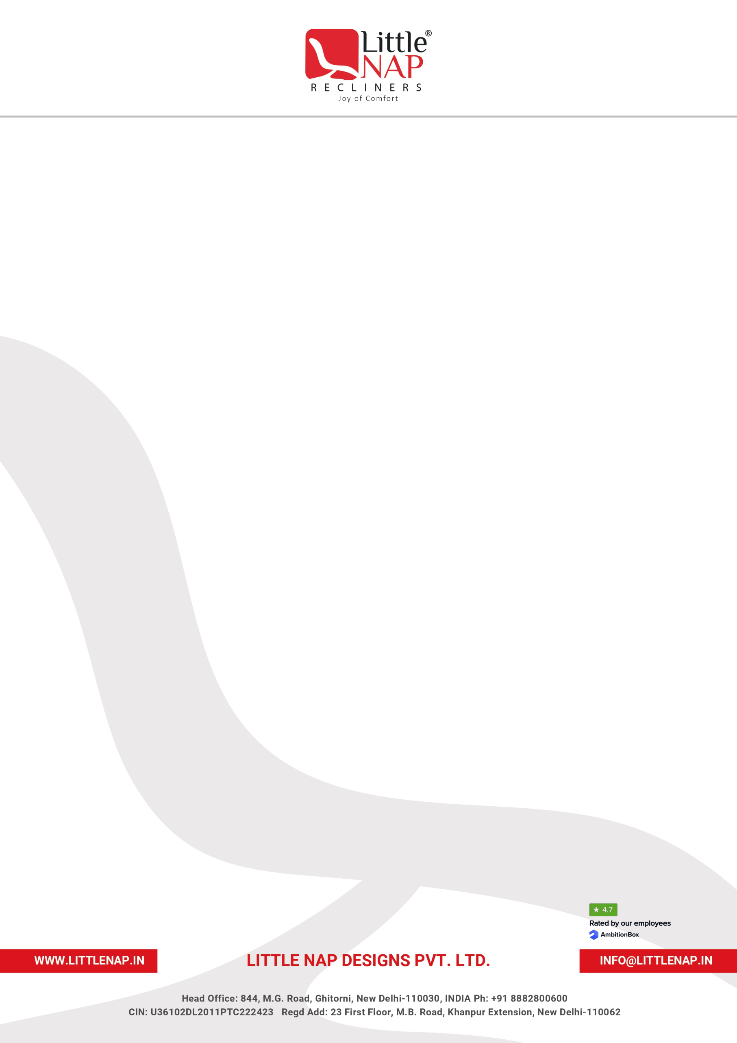

EXPERIENCE LETTER

[Letter Date]
To Whomsoever It May Concern,
EMPLOYEE DETAILS
Name | [Employee Name]
Employee Code | [Employee Code]
Designation | [Designation]
Department | [Department]
Date of Joining | [Date of Joining]
Last Working Date | [Last Working Date]

This is to certify that Mr./Ms. [Employee Name] (Employee Code: [Employee Code]) was employed with Little Nap Designs Pvt. Ltd. from [Date of Joining] to [Last Working Date], holding the position of [Designation] in the [Department] department.
During this tenure, [Employee Name] demonstrated strong professional commitment, dedication, and integrity, and made a valuable contribution to the organization. Key responsibilities held during this period included, but were not limited to:
• [Responsibility 1 – factual, role-based]
• [Responsibility 2 – factual, role-based]
• [Responsibility 3 – factual, role-based]
• [Responsibility 4 – factual, role-based]

We found [Employee Name] to be sincere, hardworking, and professional throughout the tenure with the organization.
[Employee Name] has been relieved from all duties and responsibilities with effect from [Last Working Date], and all dues payable as per company policy have been duly settled.
We wish [Employee Name] continued success in all future professional endeavours.

Best Regards,
Human Resources Department
Little Nap Designs Pvt. Ltd.

