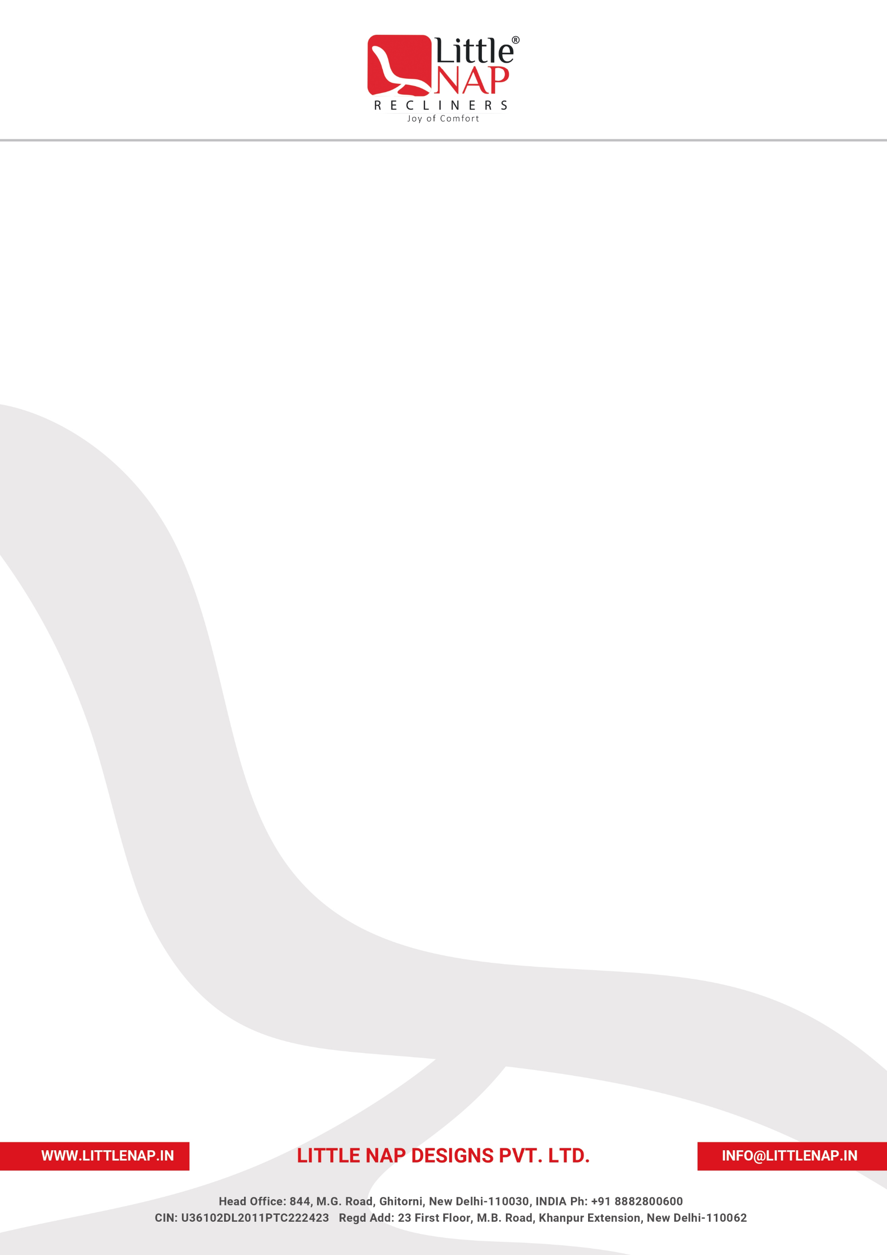

INCREMENT LETTER

[Letter Date]
Mr./Ms. [Employee Name]
Designation: [Designation]
Location: [Location]
Dear [Employee Name],
Congratulations on Your Well-Deserved Salary Increment!
In recognition of your continued dedication, commitment, and valuable contribution to the organization, we are pleased to revise your compensation, effective [Effective Date].
Your annual CTC has been enhanced from [Existing Annual CTC] to [New Annual CTC]
reflecting our appreciation of your performance and the trust we place in your abilities.

All other terms and conditions of your employment remain unchanged. Your compensation details are provided in the attached sheet for your reference.
We sincerely appreciate your hard work and look forward to your continued contributions to the success of the organization. Wishing you all the very best in your professional journey with us.
Please sign and return the duplicate copy of this letter as a token of your acceptance.


Best Regards,
Chief Financial Officer

Little Nap Designs Pvt. Ltd.
LITTLE NAP DESIGNS PVT. LTD.
COMPENSATION BREAK-UP
Name | [Employee Name]
Employee Code | [Employee Code]
Designation | [Designation]
Location | [Location]
Department | [Department]
Effective From | [Effective Date]
Date of Joining | [Date of Joining]
Component | Existing (Monthly) | New (Monthly) | Annually (₹)
Basic | [Existing Basic] | [New Basic] | [Annual Basic]
House Rent Allowance | [Existing HRA] | [New HRA] | [Annual HRA]
Conveyance | – | [New Conveyance] | [Annual Conveyance]
Special / Other Allowances | [Existing Special Allowances] | – | –
Medical Allowance | – | – | –
Bonus | – | – | –
Total Gross | [Existing Total Gross] | [New Total Gross] | [Annual Total Gross]
Employee PF Contribution (12%) | [Existing Employee PF] | [New Employee PF] | [Annual Employee PF]
Employee ESIC Contribution (0.75%) | – | – | –
LWF | – | – | –
Take Home | [Existing Take Home] | [New Take Home] | [Annual Take Home]
Company PF Contribution (12%) | [Existing Company PF] | [New Company PF] | [Annual Company PF]
Company ESIC Contribution (3.75%) | – | – | –
LWF | – | – | –
TOTAL CTC | [Existing Total CTC] | [New Total CTC] | [Annual Total CTC]

Best Regards,
Chief Financial Officer
Little Nap Designs Pvt. Ltd.

