
Home | About Us | Research | Alumni

The College of Business at The University of Texas at San Antonio offers a comprehensive curriculum at the undergraduate, master's and doctoral level that expands the boundaries of a traditional business education.

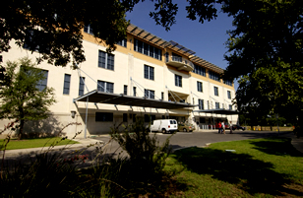With over 5,700 students, the college is the 31st largest undergraduate business program and the 38th largest business school in the nation.
Nationally ranked and recognized, the College of Business was named one of the Top 5 undergraduate business programs in Texas by Bloomberg Businessweek. At the graduate level, the college was ranked the No. 10 graduate business school in the nation for Hispanics by Hispanic Business. Additional MBA accolades include being named one of the top 10 MBA programs for minority students by the Princeton Review for the past ten years and receiving the Brillante Award for Educational Excellence from the National Society of Hispanic MBA's in 2013.
UTSA was named the #1 ranked cyber security program in the country according to a national survey of certified information technology security professionals conducted by the Ponemon Institute. UTSA is one of 47 universities designated as a Center of Academic Excellence in Information Assurance Research by the National Security Agency and the Department of Homeland Security. UTSA has also been designated as a Center of Academic Excellence in Information Assurance/Cyber Defense education. This designation was based on the curriculum and programs in the College of Business.
The UTSA College of Business transforms students from the curious and hopeful into confident and career-ready young professionals. We aim to be the best in class by focusing on educational programs that provide both applied business and technical skills in areas of high-workforce demand as well as professional and entrepreneurial skills that help students create value for their organization and integrate into the workforce. We are a community of scholars who advance the art and science of business through rigorous and relevant research that is published in outlets of distinction and translated for practice in the classroom.

© The University of Texas at San Antonio | One UTSA Circle, San Antonio TX 78249 | Information: 210-458-4011 | UTSA Police: 210-458-4242
About COB Home
Mission Statement
College Profile
About the Dean
Administration
History
About UTSA
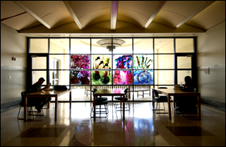 | The College of Business is accredited by AACSB International, the Association to Advance Collegiate Schools of Business. This accreditation addresses curriculum issues, credentials of professors, student to teacher ratio issues and educational resources. The college is a member of the European Foundation for Management Development, BALAS and CLADEA.

