# Jenkins Email notification for Production environment:

For Configuring Email Notification, we have to configure the following steps:

Step1:

Login into Jenkins in Jenkins Dashboard left side menu we have to click on the

Manage Jenkins ==> under system configuration we have configure system option we click on this.

Add email Address in system admin email Address section. Through this email id only Jenkins send mail notification to respective persons mail ids we added in Jenkins pipeline script in Jenkins pipeline job.

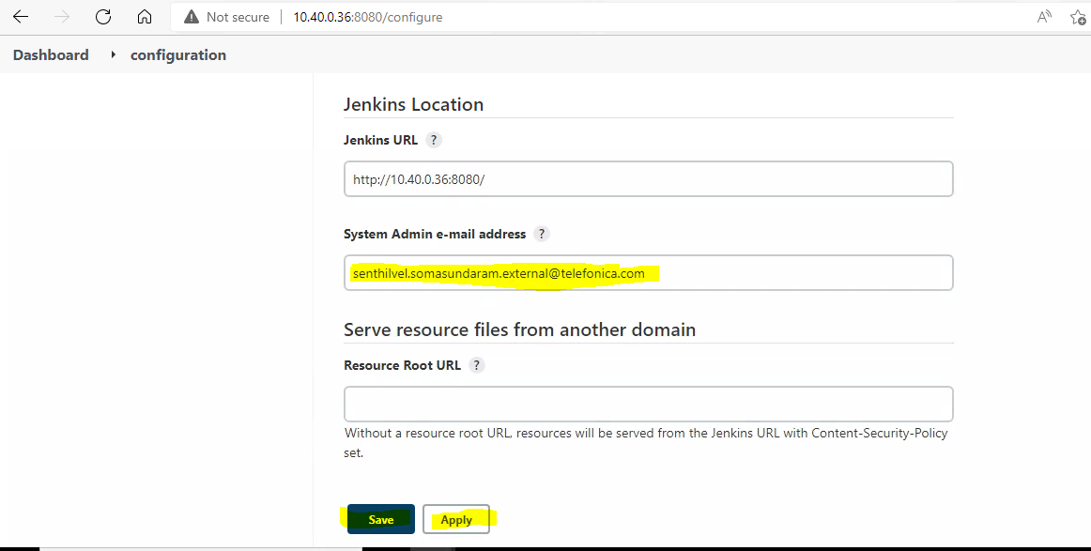

Under configure system Goto the Email Notification section and add the SMTP server and email suffix details then click on the Apply and save button to save the configurations.

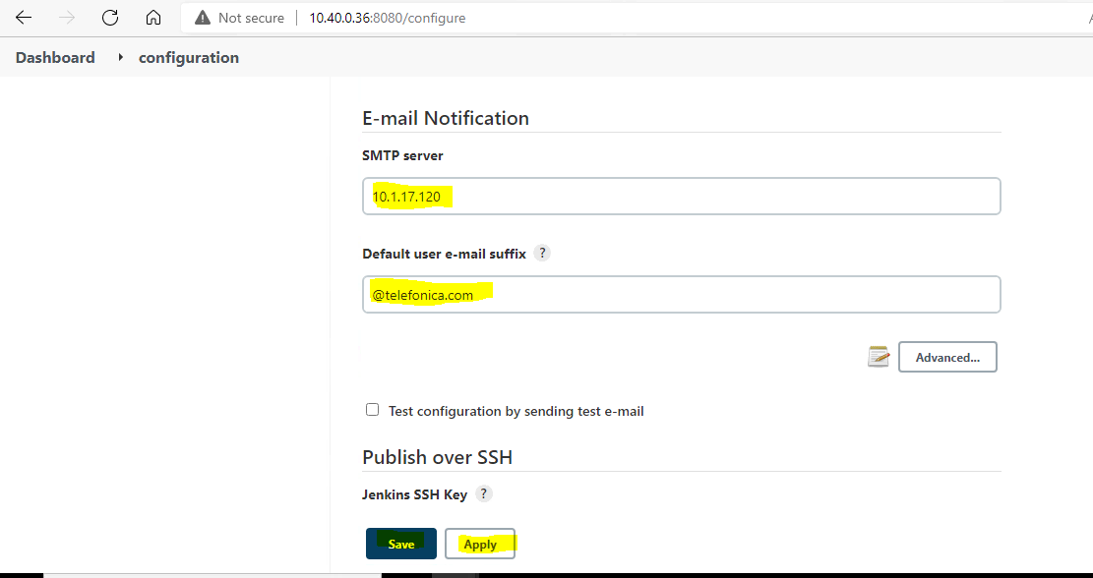

After configuring Goto respective Jenkins pipeline job and add the below script for sending email notifications and save the Job.

Script:

Now, click on the build now option Available on left side menu under respective Pipeline job.

Below stage view appears once we build the job.

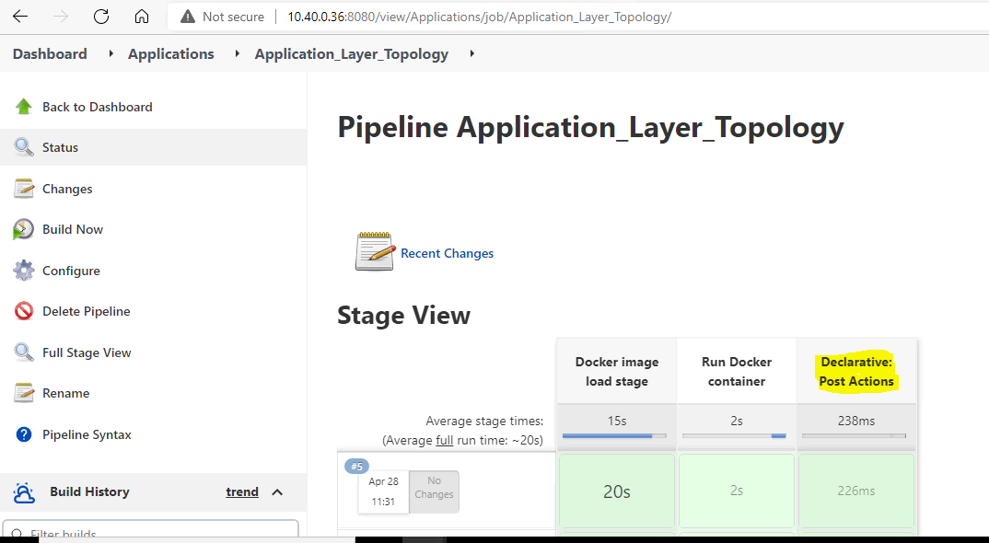

After building Job, click on the console output section and check the logs which are available on the left side click on the particular build number.

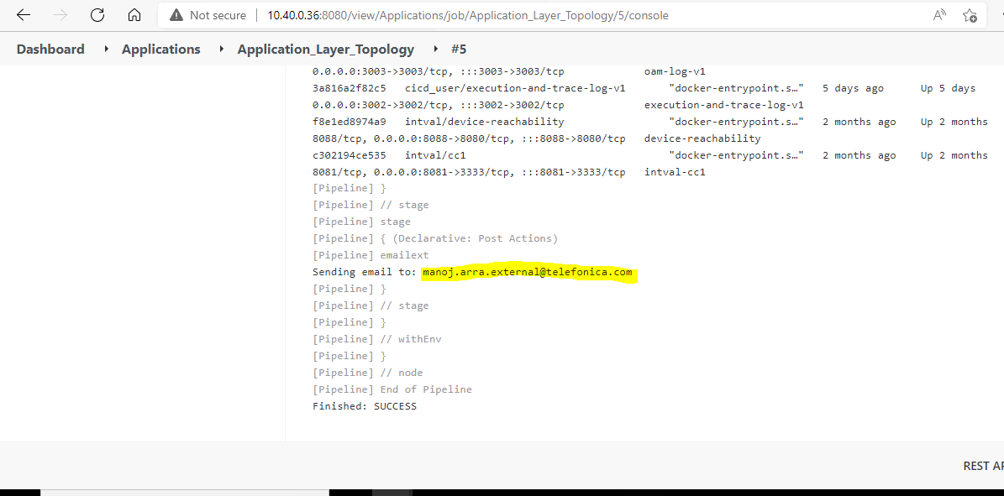

Finally, we receive emails from Jenkins system Admin email address which we configured earlier with complete Jenkins job logs.

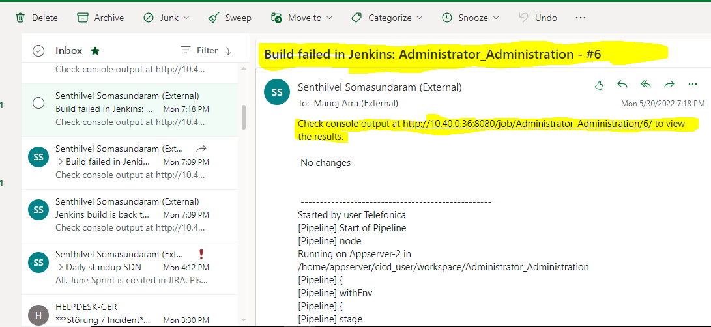

Now, we successfully configured Jenkins Email Notifications for the production environment.

For Ubuntu:

For Redhat:

Install Git:

$ sudo dnf update –y

$ sudo dnf install git –y

$ git –version

Output

git version 2.18.2

Referral link:

<https://www.digitalocean.com/community/tutorials/how-to-install-git-on-centos-8>

Install Java:

$ dnf update

$ dnf install java-1.8.0-openjdk-devel #install JDK 8  
$ dnf install java-11-openjdk-devel #install JDK 11

$ java –version

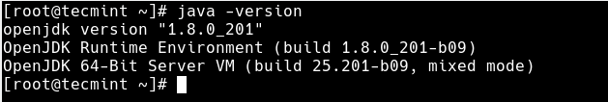**Check Java Version in RHEL 8**

**Referral link:**

[**https://www.tecmint.com/install-java-on-rhel-8/**](https://www.tecmint.com/install-java-on-rhel-8/)

**Install Docker:**

$ dnf update –y ; reboot

#### **Enable Docker CE Repository**

$ dnf config-manager --add-repo=https://download.docker.com/linux/centos/docker-ce.repo

#### **Install Docker CE using dnf command**

$ dnf list docker-ce  
Docker CE Stable - x86_64 1.7 kB/s | 3.8 kB 00:02  
Available Packages  
docker-ce.x86_64 3:19.03.13-3.el8 docker-ce-stable

Now, use beneath dnf command to install latest version of docker,

$ dnf install docker-ce --nobest –y

After the installation of docker, start and enable its service using the following systemctl commands

$ systemctl start docker  
$ systemctl enable docker

Run the following command to verify installed docker version

$ docker --version  
Docker version 19.03.13, build 4484c46d9d

#### **Verify and test Docker CE Engine**

To verify whether docker ce engine has been setup correctly or not, try to spin up a “hello-world” container using below docker command,

$ docker run hello-world

Output of above command

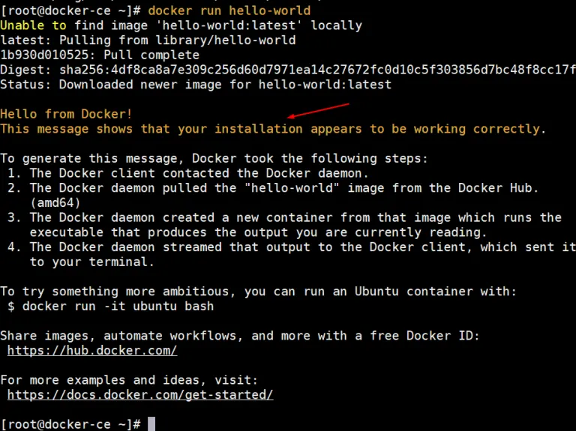

Referral link:

<https://www.linuxtechi.com/install-docker-ce-centos-8-rhel-8/>

Install NodeJS and NPM packages:

$ sudo dnf module list nodejs

$ sudo dnf module info --profile nodejs

$ sudo dnf install nodejs

**node -v**   
  
v16.2.0

**npm -v**   
  
7.13.0

Referral link:

<https://linuxconfig.org/how-to-install-node-js-on-redhat-8-linux>

Install Newman packages and Newman reporter htmlextra package

$ npm install -g newman

$ npm install -g newman-reporter-htmlextra