Effects of COVID-19 on the Academic Performance of College Students
Figures
2025-12-09

Figure 1: Average final GPA in ECO 1001 across semesters
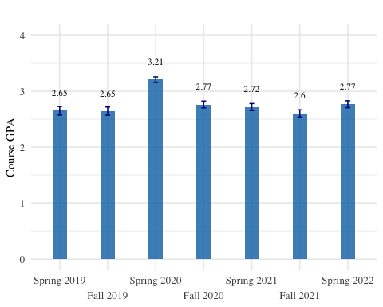

Figure 2: Withdrawal rates in ECO 1001 across semesters
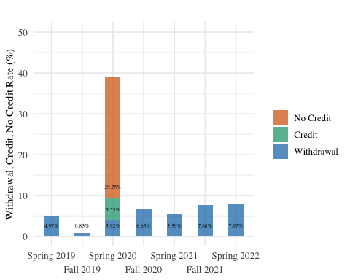

Figure 3: Dynamic effects of COVID-19 on students’ performance
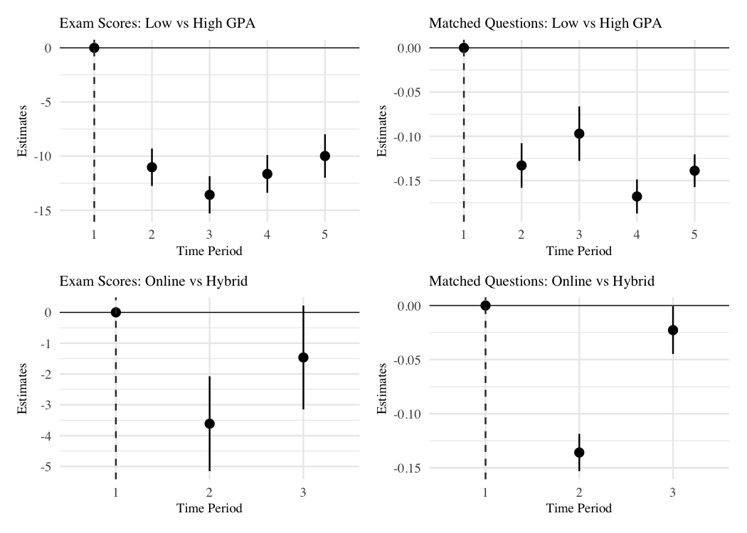

Figure 1A: Average final exam scores in ECO 1001 across semesters
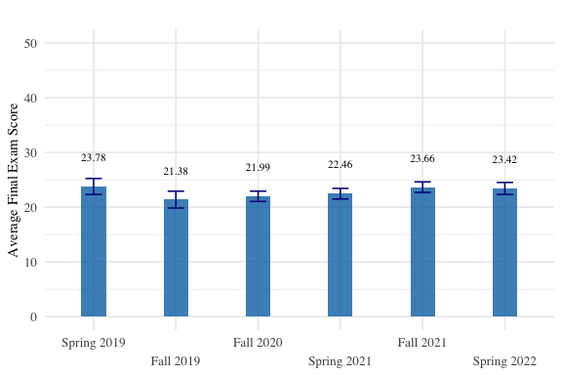

Figure 2A: Share of High vs Low GPA Students
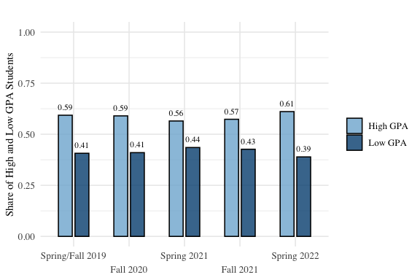

Figure 3A: Average GPA in High vs Low GPA Group of Students
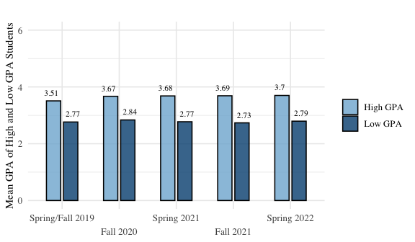

Figure 4A: Share of the Students in Hybrid vs Online Classes
