LAB_MST

Student Name:Aman Raj Ojha |  |  | UID: 24BAI70520
Branch: CSE - AIML |  |  | Section/Group: 24AIT_KRG-1_B
Semester: 5 |  |  | Date of Performance: 28/09/2026
Subject Name: ADBMS |  |  | Subject Code: 24CSP-310

Q1. A company stores employees and their departments. Display employees whose salary is greater than the average salary of their own department, but only from departments having at least 3 employees.
Display Department Name, Employee Name, and Salary.
Constraint: Only a solution using JOINS and SUBQUERIES is allowed. Window Functions are not allowed.

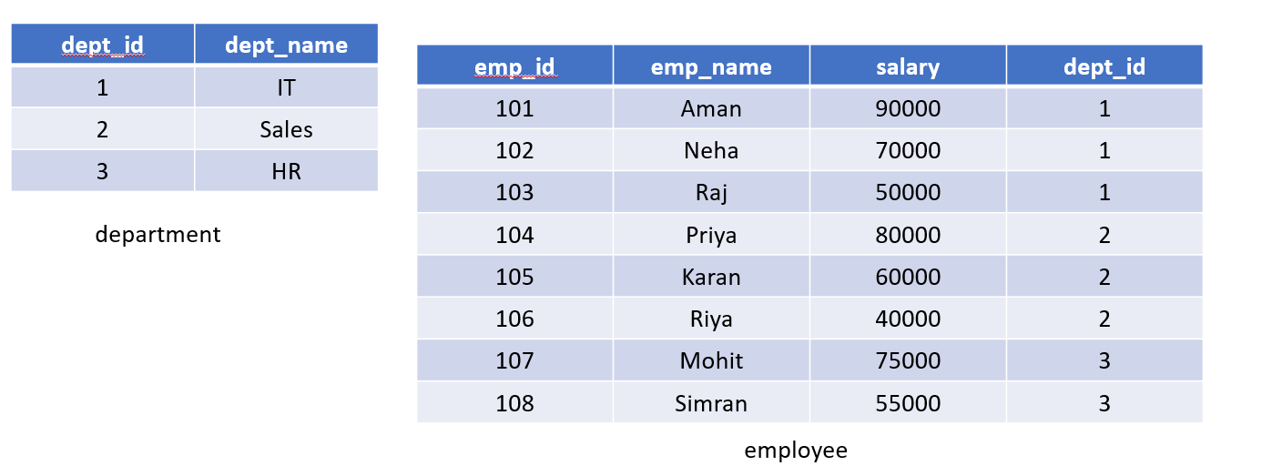

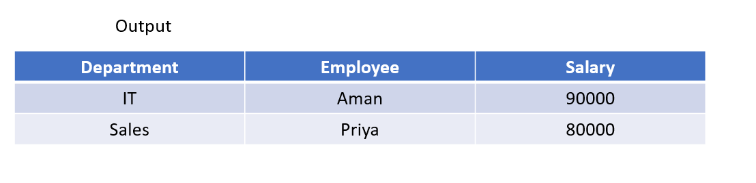

Code:--
CREATE TABLE department (
dept_id INT PRIMARY KEY,
dept_name VARCHAR(30)
);

CREATE TABLE employees (
emp_id INT PRIMARY KEY,
emp_name VARCHAR(50),
salary NUMERIC(10,2),
dept_id INT REFERENCES department(dept_id)
);
INSERT INTO department VALUES
(1, 'IT'),
(2, 'Sales'),
(3, 'HR');

INSERT INTO employees VALUES
(101, 'Aman', 90000, 1),
(102, 'Neha', 70000, 1),
(103, 'Raj', 50000, 1),
(104, 'Priya', 80000, 2),
(105, 'Karan', 60000, 2),
(106, 'Riya', 40000, 2),
(107, 'Mohit', 75000, 3),
(108, 'Simran', 55000, 3);
SELECT
d.dept_name AS Department,
e.emp_name AS Employee,
e.salary AS salary
FROM department AS d
JOIN employees AS e
ON d.dept_id = e.dept_id
JOIN (
SELECT
dept_id,
AVG(salary) AS avg_salary
FROM employees
GROUP BY dept_id
HAVING COUNT(*) >= 3
) AS dept_avg
ON e.dept_id = dept_avg.dept_id
WHERE e.salary > dept_avg.avg_salary;

Query output:--
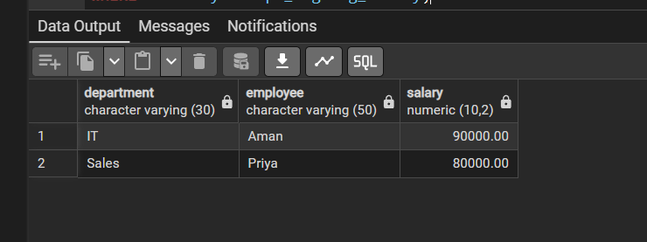

Q2.
A bank maintains customer information in bank_customer. Create a PostgreSQL trigger that automatically stores a log in customer_audit whenever a customer is inserted or deleted. Store Customer ID, Customer Name, action (ADDED/REMOVED), and current timestamp.

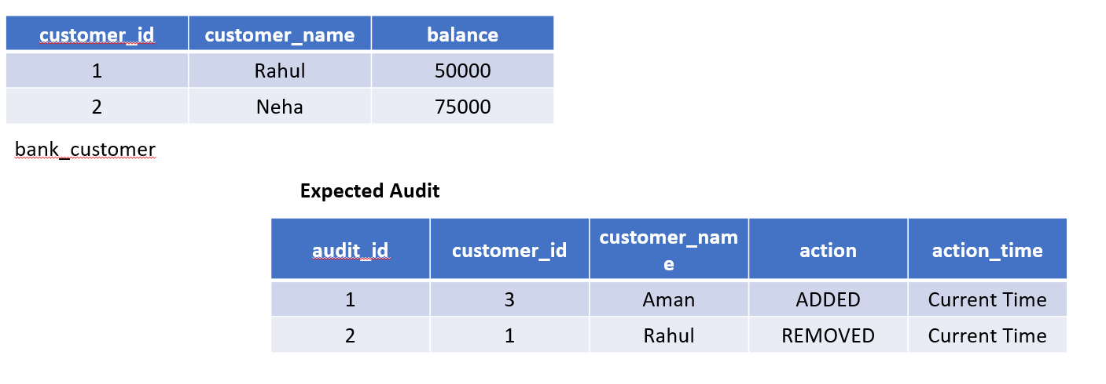

Code:-
CREATE TABLE bank_customer (
customer_id INT PRIMARY KEY,
customer_name VARCHAR(50),
balance NUMERIC(10,2)
);

CREATE TABLE customer_audit (
audit_id SERIAL PRIMARY KEY,
customer_id INT,
customer_name VARCHAR(50),
action VARCHAR(20),
action_time TIMESTAMP
);

INSERT INTO bank_customer VALUES
(1, 'Rahul', 50000),
(2, 'Neha', 75000);

CREATE OR REPLACE FUNCTION audit_bank_customer()
RETURNS TRIGGER AS $$
BEGIN
IF (TG_OP = 'INSERT') THEN
INSERT INTO customer_audit (customer_id, customer_name, action, action_time)
VALUES (NEW.customer_id, NEW.customer_name, 'ADDED', CURRENT_TIMESTAMP);
RETURN NEW;
ELSIF (TG_OP = 'DELETE') THEN
INSERT INTO customer_audit (customer_id, customer_name, action, action_time)
VALUES (OLD.customer_id, OLD.customer_name, 'REMOVED', CURRENT_TIMESTAMP);
RETURN OLD;
END IF;
RETURN NULL;
END;
$$ LANGUAGE plpgsql;

CREATE TRIGGER trg_bank_customer_audit
AFTER INSERT OR DELETE ON bank_customer
FOR EACH ROW
EXECUTE FUNCTION audit_bank_customer();

INSERT INTO bank_customer VALUES (3, 'Amit', 60000);
DELETE FROM bank_customer WHERE customer_id = 2;

SELECT * FROM customer_audit;

Query screenshot:
