Experiment 4
Name: Aman Raj Ojha UID: 24BAI70520
Branch: B.E. CSE (AIML) Section: 24AIT_KRG-G1
Semester: 4 Date of Performance: 30.01.2026
Subject Name: Database Subject Code: 24CSH-298
Management System
AIM: To design and implement PL/SQL programs utilizing conditional control statements such as IF–ELSE, ELSIF, ELSIF ladder, and CASE constructs in order to control the flow of execution based on logical conditions and to analyze decision-making capabilities in PL/SQL blocks.
OBJECTIVES:
• To understand and implement decision-making statements in PL/SQL.
• To use IF–ELSE statement for basic conditional execution.
• To use IF–ELSIF–ELSE for multiple condition checking.
• To implement ELSIF ladder for performance evaluation.
• To apply CASE statements for selecting output based on choices.
SOFTWARE REQUIREMENTS:

 Oracle FreeSQL
PRACTICAL/EXPERIMENT STEPS:
- Start the PostgreSQL environment using pgAdmin.
- Open the Query Tool to execute PL/SQL blocks.
- Write programs using conditional statements such as IF–ELSE, ELSIF ladder, and CASE.
- Execute the blocks and verify the output.
- Observe how decision-making is performed inside PL/SQL.
- Analyze the result for each conditional structure.

1. Problem Statement – IF–ELSE Statement
- Program:
- Write a PL/SQL program to check whether a given number is positive or non-positive using the IF–ELSE statement.
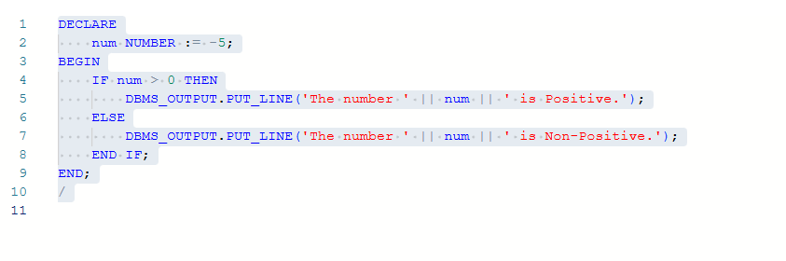
OUTPUT:
The number -5 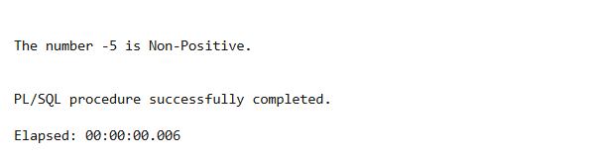is Non-Positive.

2. Problem Statement – IF–ELSIF–ELSE Statement
Program:
Write a PL/SQL program to evaluate the grade of a student based on marks.
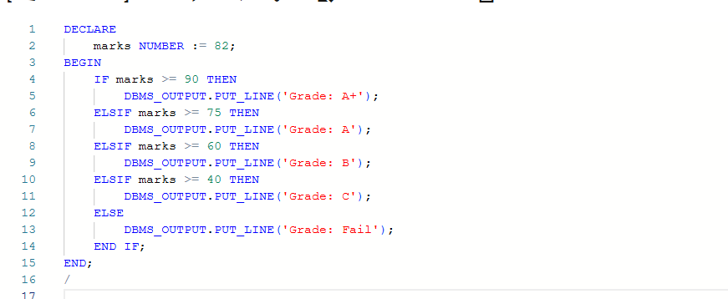
Output:-
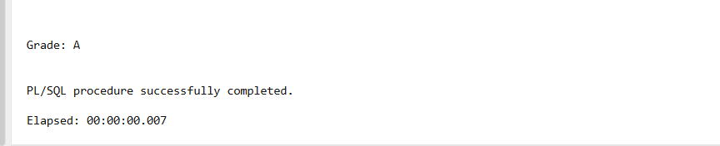

3. ELSIF Ladder
Program: Determine performance status based on marks
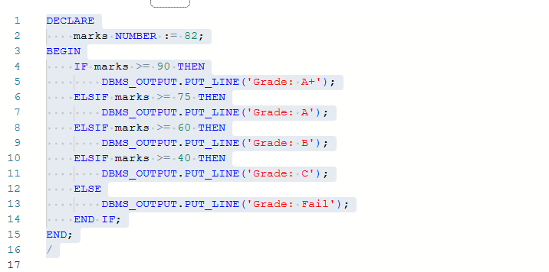
Output:-
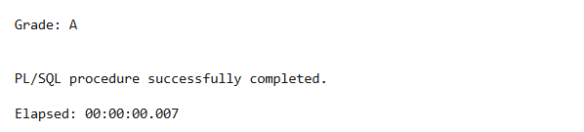
4. CASE Statement
Program: Display day name based on day number
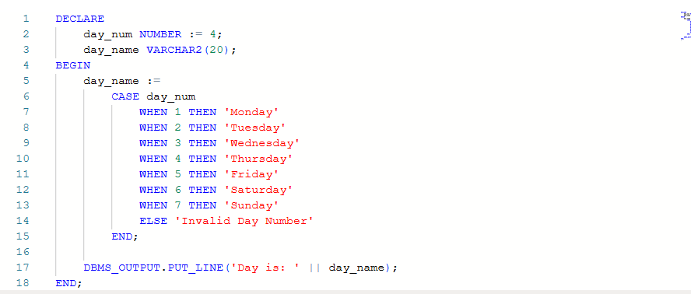
Output:-
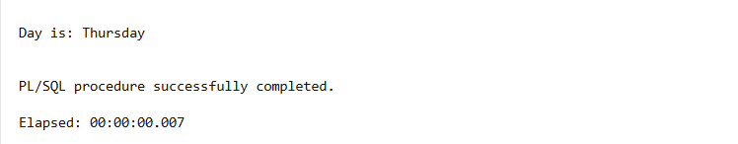

CODE:
1. IF–ELSE Statement
Program: Check whether a number is positive or non-positive
CODE (Oracle PL/SQL)
DECLARE
num NUMBER := -5;
BEGIN
IF num > 0 THEN
DBMS_OUTPUT.PUT_LINE('The number ' || num || ' is Positive.');
ELSE
DBMS_OUTPUT.PUT_LINE('The number ' || num || ' is Non-Positive.');
END IF;
END;
/
2. IF–ELSIF–ELSE Statement
Program: Evaluate grade of a student based on marks
✅ CODE (Oracle PL/SQL)
DECLARE
marks NUMBER := 82;
BEGIN
IF marks >= 90 THEN
DBMS_OUTPUT.PUT_LINE('Grade: A+');
ELSIF marks >= 75 THEN
DBMS_OUTPUT.PUT_LINE('Grade: A');
ELSIF marks >= 60 THEN
DBMS_OUTPUT.PUT_LINE('Grade: B');
ELSIF marks >= 40 THEN
DBMS_OUTPUT.PUT_LINE('Grade: C');
ELSE
DBMS_OUTPUT.PUT_LINE('Grade: Fail');
END IF;
END;
/
3. ELSIF Ladder
Program: Determine performance status based on marks
CODE (Oracle PL/SQL)
DECLARE
marks NUMBER := 55;
BEGIN
IF marks >= 90 THEN
DBMS_OUTPUT.PUT_LINE('Performance: Excellent');
ELSIF marks >= 75 THEN
DBMS_OUTPUT.PUT_LINE('Performance: Very Good');
ELSIF marks >= 60 THEN
DBMS_OUTPUT.PUT_LINE('Performance: Good');
ELSIF marks >= 40 THEN
DBMS_OUTPUT.PUT_LINE('Performance: Average');
ELSE
DBMS_OUTPUT.PUT_LINE('Performance: Poor');
END IF;
END;
/

4. CASE Statement
Program: Display day name based on day number
✅ CODE (Oracle PL/SQL)
DECLARE
day_num NUMBER := 4;
day_name VARCHAR2(20);
BEGIN
day_name :=
CASE day_num
WHEN 1 THEN 'Monday'
WHEN 2 THEN 'Tuesday'
WHEN 3 THEN 'Wednesday'
WHEN 4 THEN 'Thursday'
WHEN 5 THEN 'Friday'
WHEN 6 THEN 'Saturday'
WHEN 7 THEN 'Sunday'
ELSE 'Invalid Day Number'
END;

DBMS_OUTPUT.PUT_LINE('Day is: ' || day_name);
END;
/
I/O ANALYSIS:
This experiment demonstrates the use of conditional control structures in PL/SQL.
The programs implement decision-making using:
- IF–ELSE for basic conditions
- IF–ELSIF–ELSE for grading system
- ELSIF ladder for performance evaluation
- CASE statement for day selection
These control statements help in managing the execution flow based on logical conditions.

LEARNING OUTCOMES:
- Understand the working of conditional statements in PL/SQL.
- Learn to implement IF–ELSE and IF–ELSIF–ELSE constructs.
- Gain knowledge of ELSIF ladder for multiple decision paths.
- Learn the use of CASE statements for selection-based execution.
- Develop confidence in writing PL/SQL decision-making blocks.

