Student Name: Aman Raj Ojha UID: 24BAI70520 Branch: AIT-CSE (AIML) Section/Group: 24AIT_KRG-G2 Semester: 4 Subject Name: Database Management System Subject Code: 24CSH-298

Experiment 6 – Understanding and Implementing Cursors for Row-by-Row Data Processing (Oracle, Accenture, Scaler, D. E. Shaw & Co)

Experiment
Experiment 6: Working with PL/SQL cursors to process multiple rows of a table individually. This experiment demonstrates the use of implicit cursors, explicit cursors, and cursor attributes to implement business logic on row-by-row data in Oracle and PostgreSQL.

Aim
To understand the concept and working of cursors in PL/SQL for row-by-row data processing, and to analyze how implicit cursors, explicit cursors, and cursor attributes are used to implement business logic on multiple rows in a database table.

Objective
- To implement and analyze implicit cursors for single-row operations.
- To implement explicit cursors to fetch and process multiple records.
- To apply cursor attributes (%FOUND, %NOTFOUND, %ROWCOUNT, %ISOPEN) for controlling program flow.
- To process employee records row by row and apply business logic effectively.

Software Requirements
Database Management System:
- Oracle Database Express Edition (Oracle XE)
- PostgreSQL Database
Database Administration Tool / Client Tool:
- Oracle SQL Developer (for Oracle XE)
- pgAdmin (for PostgreSQL)

Problem Statement
In real-world enterprise applications, database queries often return multiple rows that need to be processed individually to apply specific business rules. Using cursors allows row-by-row processing for detailed business logic implementation.

Practical / Experiment Steps
- Design PL/SQL programs that demonstrate:
  - The use of implicit cursors for single-row DML operations o The use of explicit cursors to fetch and process multiple records
  - The application of cursor attributes to control program execution
- Create PL/SQL programs to:
  - Fetch employee records from a database table using cursors o Process each record individually
  - Display results or apply business logic using cursor attributes

Procedure
- Open Oracle SQL Developer or pgAdmin and connect to the database.
- Create an employee table with sample data (id, name, department, salary).
- Write an anonymous PL/SQL block demonstrating implicit cursor operations.
- Write a PL/SQL block using an explicit cursor to fetch and process multiple records.
- Apply cursor attributes such as %FOUND, %NOTFOUND, %ROWCOUNT, %ISOPEN to control execution flow.
- Execute the blocks and observe the output.
- Capture results and screenshots for documentation.

Input / Output Details Input
employee table:
- id (Integer)
- name (Varchar)
- department (Varchar)
- salary (Integer)
Cursor logic used:
- Implicit cursor for single-row processing
- Explicit cursor for multi-row processing
- Cursor attributes (%FOUND, %NOTFOUND, %ROWCOUNT, %ISOPEN)

Step-wise Output
Step 1 – Create employee Table
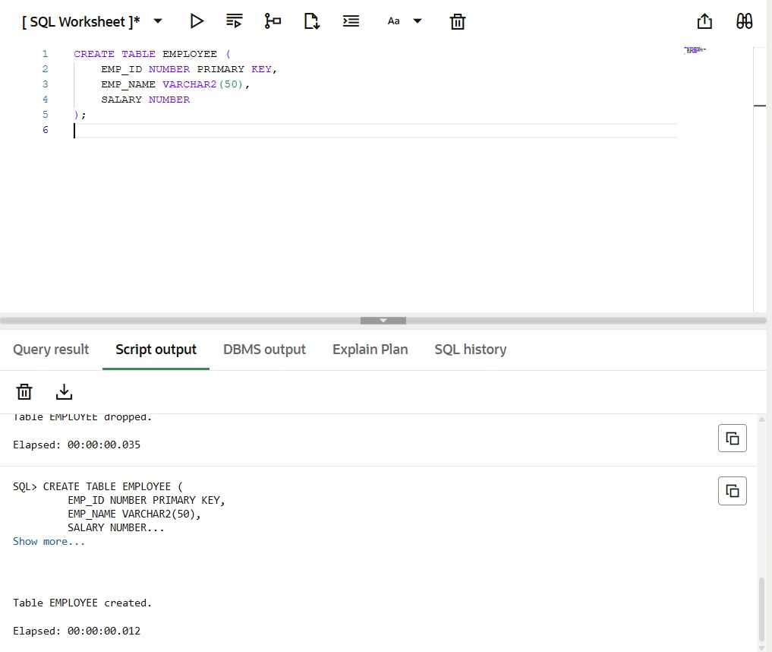
Step 2 – Insert Data into employee Table
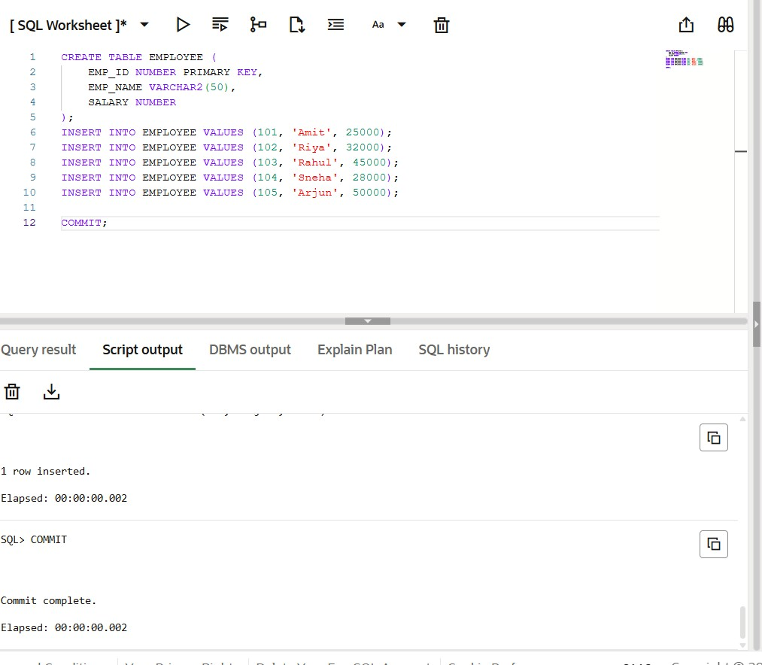
Step 3 – Implicit Cursor Operation
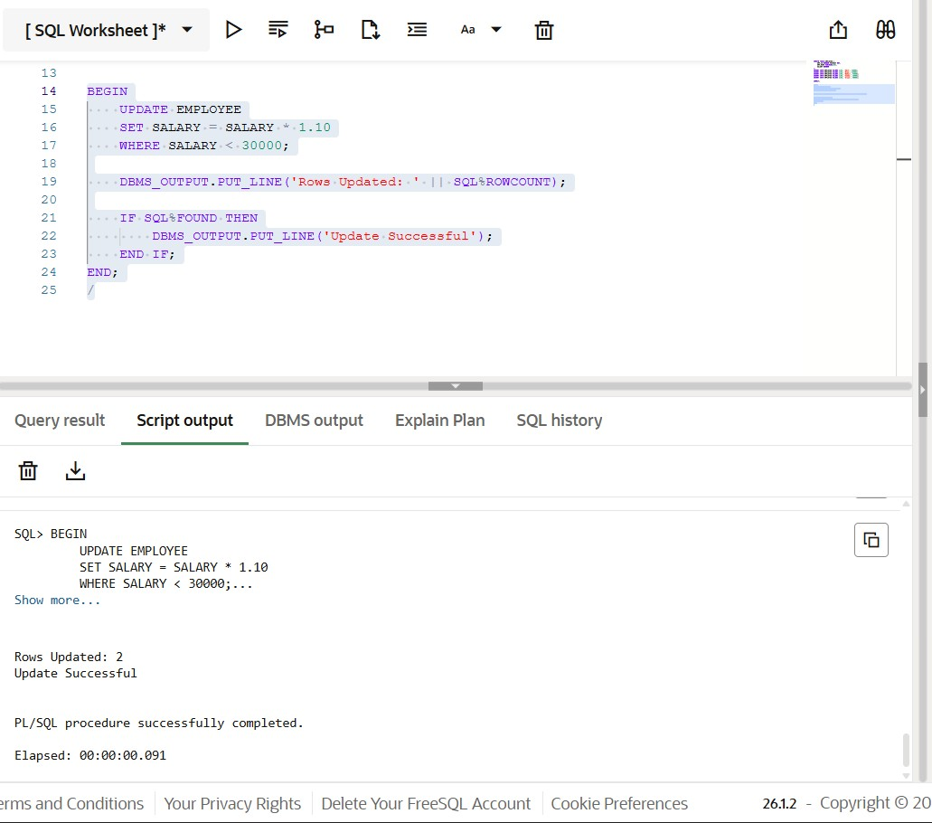
Step 4 – Explicit Cursor Declaration and Fetch
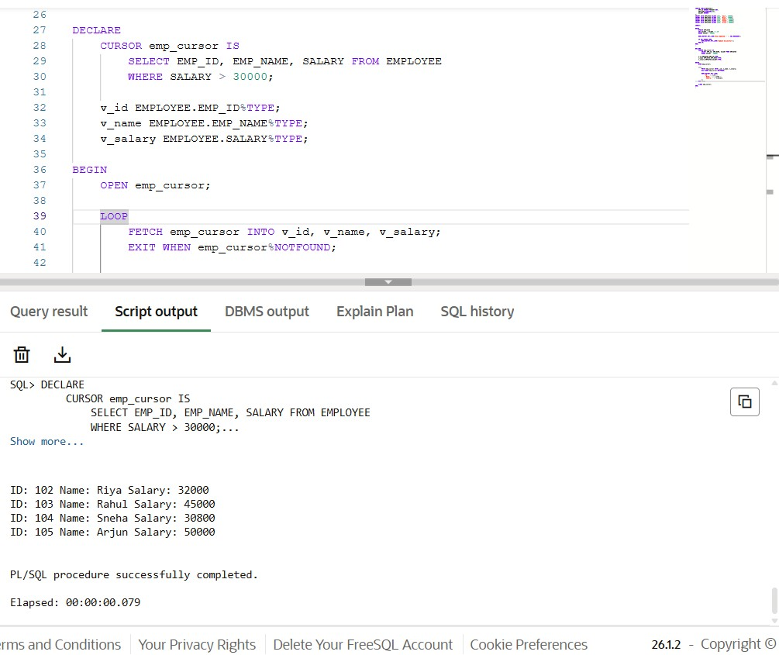
Step 5 – Process Records Using Cursor Attributes
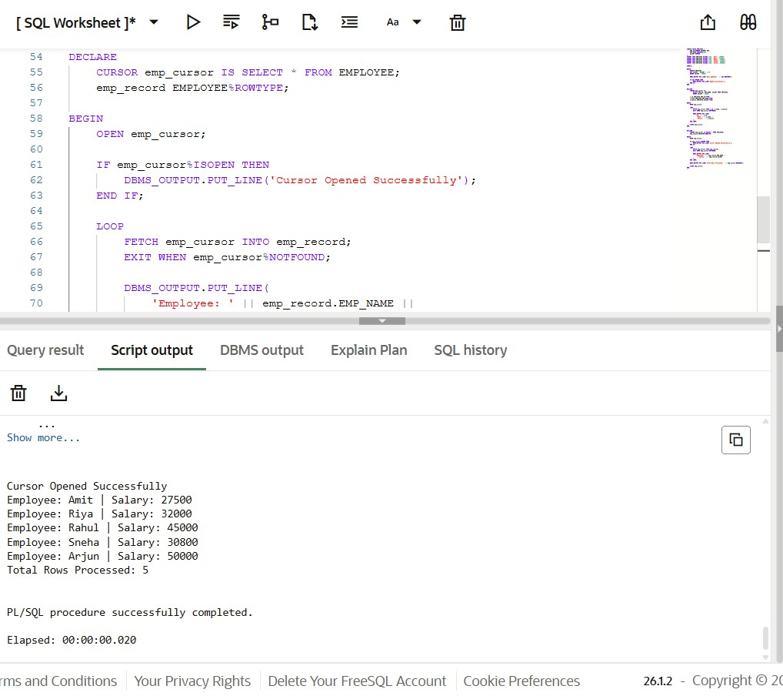

Learning Outcome
After completing this experiment, the learner will be able to:
- Understand the role of cursors in PL/SQL for handling multi-row query results.
- Differentiate between implicit cursors and explicit cursors.
- Use cursor attributes such as %FOUND, %NOTFOUND, %ROWCOUNT, and %ISOPEN.
- Develop PL/SQL programs that process database records row by row.
- Apply cursor-based logic in real-world business scenarios used in organizations like Oracle, Accenture, Scaler, and D. E. Shaw & Co.

