Student Name: AMAN RAJ OJHA UID: 24BAI70520 Branch: AIT-CSE-AIML Section/Group: 24AIT_KRG-G2 Semester: 4 Subject Name: Database Management System Subject Code: 24CSH-298

Experiment 5 – SQL Conditional Logic (Odd & Even Values)
SQL Conditional Logic using the MOD (%) operator to classify employee salary values as Odd or Even. This experiment demonstrates numerical analysis and conditional evaluation using SQL queries in Oracle and PostgreSQL.

Aim
To understand and apply conditional logic in SQL by using the modulus operator (MOD / %) to analyze numerical data and classify employee salaries as odd or even, thereby improving data analysis and decision-making skills in SQL.

Objective
- To write and execute SQL queries using the MOD (%) operator.
- To retrieve salary details from an employee table.
- To classify salaries into Odd and Even categories.
- To display odd and even salary values separately.

Software Requirements
Database Management System:
Oracle Database Express Edition (Oracle XE)
PostgreSQL Database
Database Administration Tool / Client Tool: Oracle SQL Developer (for Oracle XE) pgAdmin (for PostgreSQL)

Practical / Experiment Steps
- Create an employee table with columns: id
name department salary
- Insert sample employee salary records into the table.
- Write a SQL query to retrieve employee salary details.
- Use the MOD(salary, 2) function (Oracle) or salary % 2 (PostgreSQL) to check whether the salary is odd or even.
- Use a CASE statement to classify salaries as:
'Odd Salary'
'Even Salary'
- Execute separate queries to:
Display only employees with Odd salaries.
Display only employees with Even salaries.
- Observe and record the output results.

Procedure
- Open Oracle SQL Developer or pgAdmin.
- Connect to the database.
- Create the employee table using CREATE TABLE.
- Insert sample records using INSERT INTO.
- Execute SELECT queries with the MOD operator.
- Apply CASE statement for conditional classification.
- Display results and capture screenshots.
Input / Output Details

Input
Table Name: employee
Columns:
id (Integer) name (Varchar) department (Varchar) salary (Integer)
Logic Used:
MOD(salary, 2) or salary % 2 CASE statement

Step-wise Output
Step 1 – Create employee Table
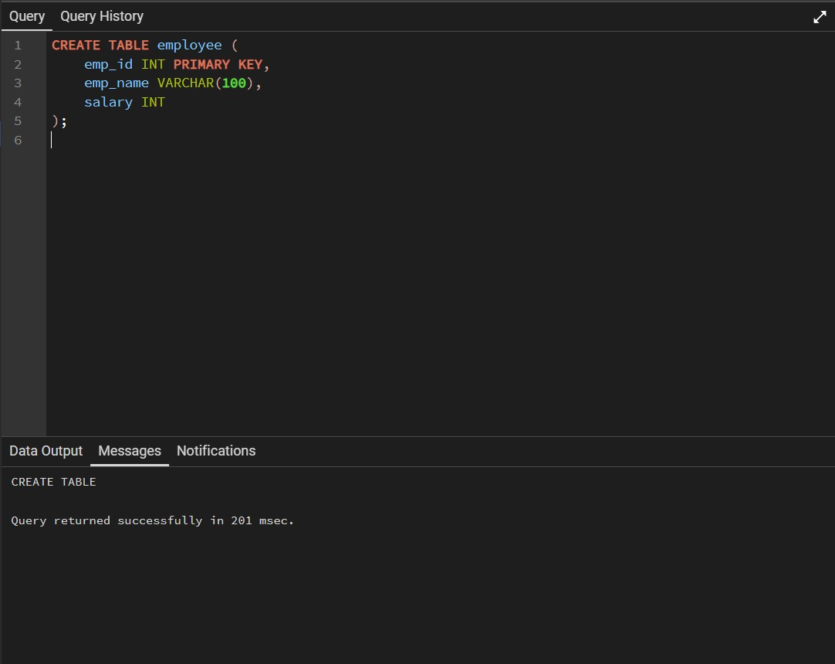
Step 2 – Insert Data into employee Table
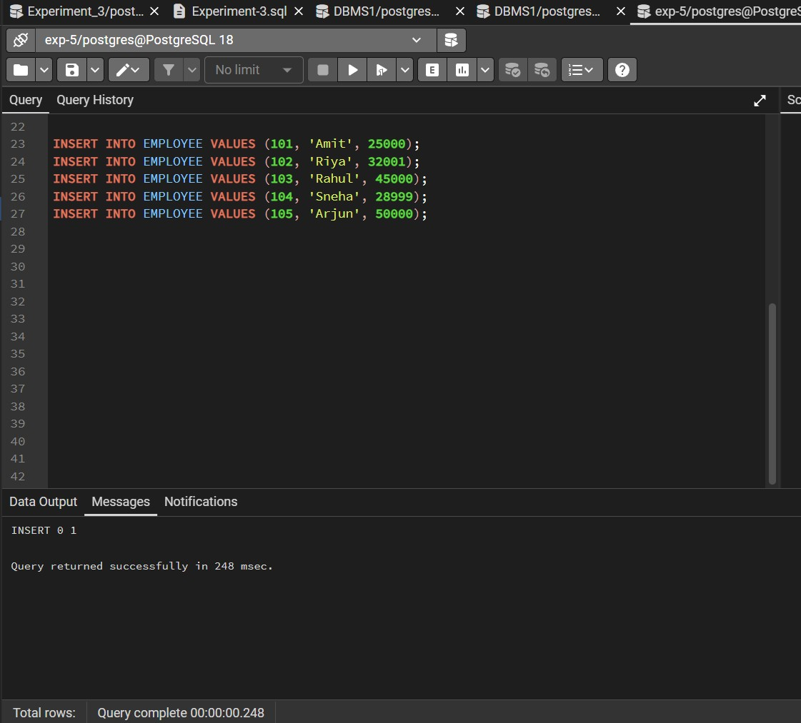
Step 3 – Display Employee Salary Records
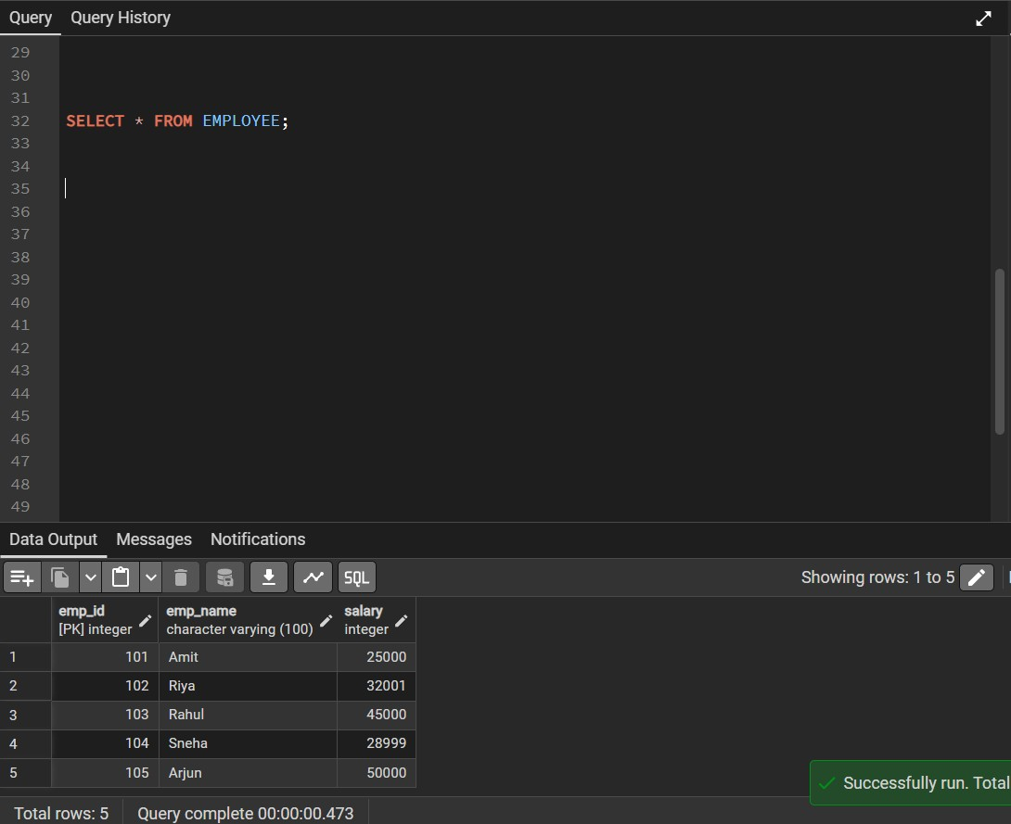
Step 4 – Classify Salaries as Odd or Even
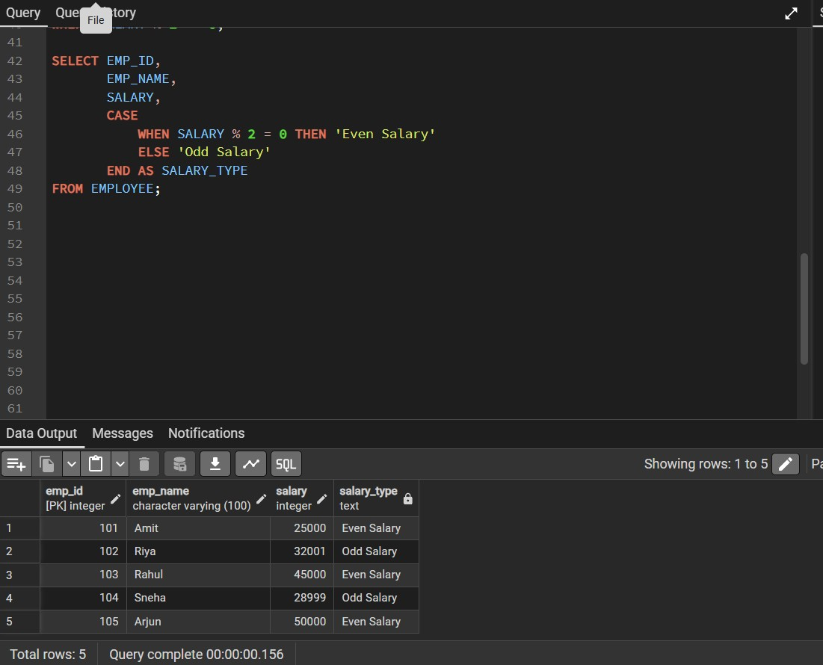
Step 5 – Display Only Odd Salaries
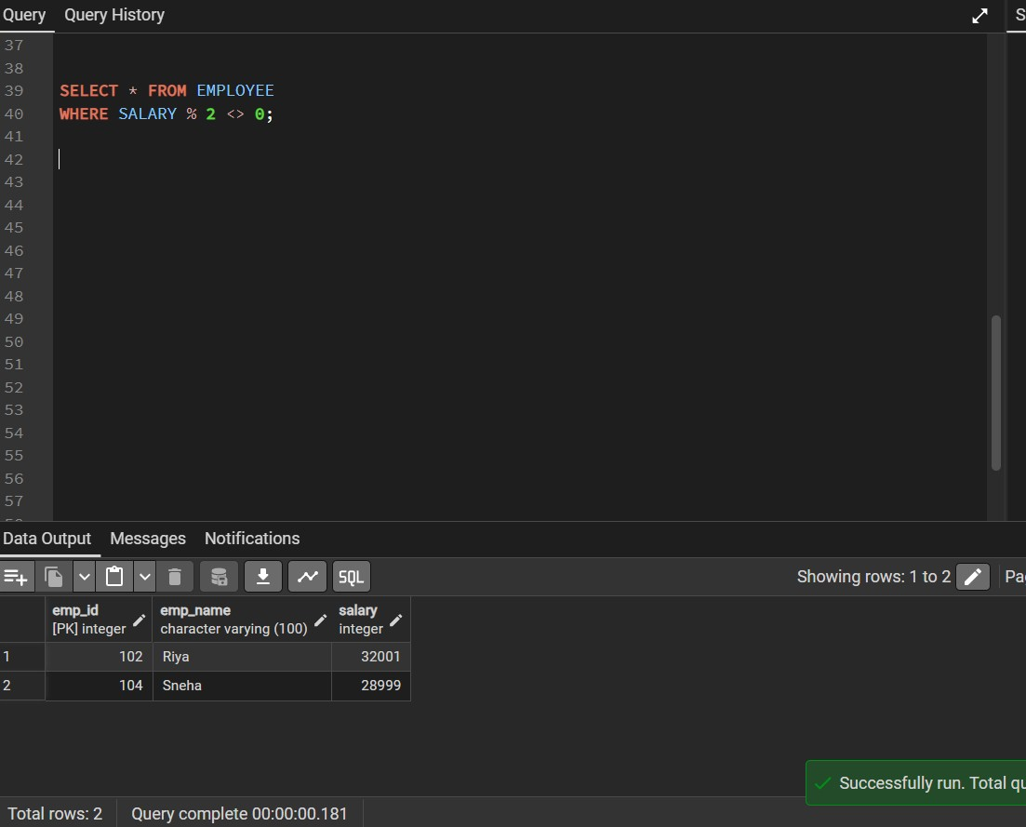
Step 6 – Display Only Even Salaries
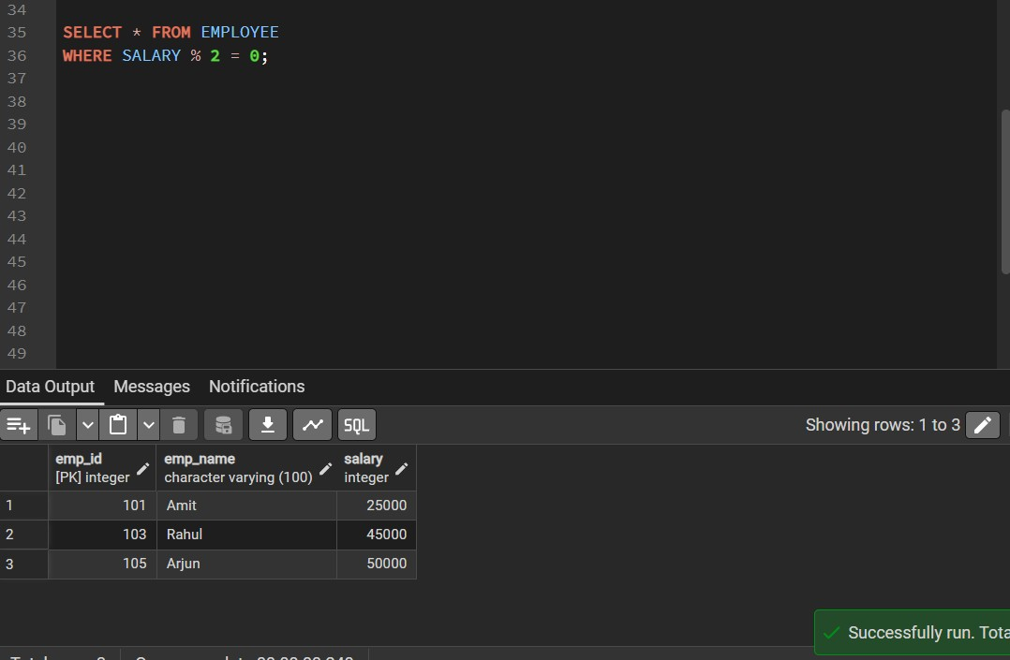

Learning Outcome
After completing this experiment, the learner will be able to:
- Understand conditional logic in SQL queries.
- Use the MOD (%) operator for numerical analysis.
- Classify numeric values into odd and even categories.
- Write efficient SQL queries for payroll data analysis.
- Apply SQL logic in real-world enterprise environments.

