Student Name: Aman Raj Ojha UID: 24BAI70520
Branch: AIT-CSE (AI-ML) Section/Group: 24AIT_KRG-G1
Semester: 4 Date of Performance: 01/04/2026
Subject Name: Database Management System Subject Code: 24CSH-298

WORKSHEET-8
AIM: To design and implement a stored procedure that accepts gender as an input parameter and returns the total number of employees based on the gender passed, thereby demonstrating procedural programming and parameterized logic in PL/SQL.

S/W Requirement: • Database Management System: PostgreSQL / Oracle Database Express Edition
• Database Administration Tool: pgAdmin

OBJECTIVES:
-Understand the structure and components of a stored procedure.
-Implement IN and OUT parameters in PL/SQL procedures.
-Pass dynamic input values to stored procedures.
-Apply aggregate functions within procedures for data analysis.

PROBLEM STATEMENT:
Organizations often require flexible reporting mechanisms to analyze workforce distribution based on gender for compliance and internal analytics. A reusable database logic is needed to dynamically compute these counts based on user input.
TABLE STRUCTURE:

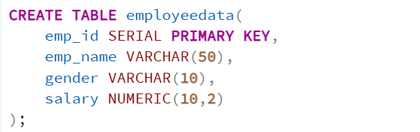

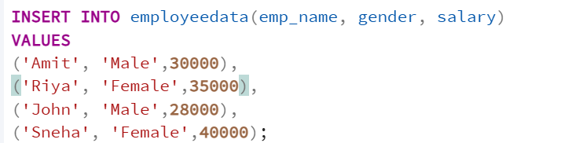

1. PROBLEM STATEMENT – Stored Procedure Design

Create a stored procedure that accepts a gender string as input and returns the count of employees matching that gender.
PROGRAM:
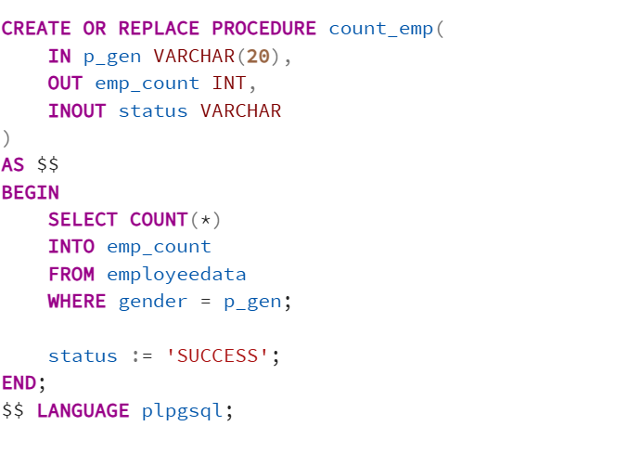
OUTPUT:
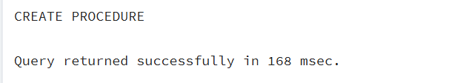

2. PROBLEM STATEMENT – Procedure Execution
Execute the stored procedure using a PL/SQL block to retrieve and display the count for a specific gender (e.g., 'Male').
PROGRAM:
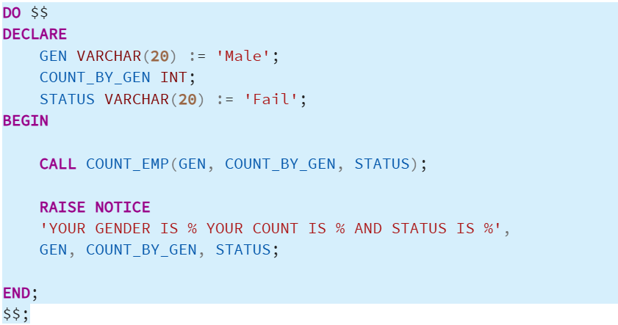
OUTPUT:

LEARNING OUTCOMES:
1. Understood the structure and components of a stored procedure.
2. Learned to implement IN parameters for input and OUT parameters for returning values.
3. Successfully passed dynamic input values to filter database results.
4. Applied the COUNT() aggregate function within a procedural block.
5. Developed reusable database logic applicable to real-world scenarios at companies like CData and Toddle.

CONCLUSION:
This experiment demonstrated the effectiveness of parameterized stored procedures in PL/SQL. By using IN and OUT parameters, we created a flexible and reusable logic that can dynamically analyze workforce data, improving efficiency and reducing code redundancy in database management systems.

